
 | MINISTRY OF EDUCATION AND TRAINING

FPT UNIVERSITY
Capstone Project Document
IQGS

GSU26SE52
Group Members | Nguyễn Minh Nam - Leader - SE182871  Nguyễn Trung Hiền - Member - SE183609  Phan Thành Tú - Member - SE182945  Hoàng Đăng Khoa - Member - SE183522
Supervisor | Phan Minh Tam
Ext Supervisor | N/A
Capstone Project code | SU26SE102

Ho Chi Minh, August 2026
CONTENTS
Nội dung
Acknowledgement 1
Definition and Acronyms 1
I. Project Introduction 2
1. Overview 2
1.1 Project Information 2
1.2 Project Team 2
2. Product Background 2
3. Existing Systems 3
3.1 HackerRank 4
3.2 Interview Query 5
4. Business Opportunity 6
5. Software Product Vision 7
6. Project Scope & Limitations 8
6.1 Major Features 8
6.2 Limitations & Exclusions 10
II. Project Management Plan 11
1. Overview 11
1.1 Cost & Time Estimations 11
1.2. Project Objectives 14
1.3 Project Risks 14
2. Management Approach 16
2.1 Project Process 16
2.2 Quality Management 19
2.3 Project Training Plan 20
3. Responsibility Assignments 22
3.1. Project Organisation 22
3.2 Responsibility 22
4. Project Communications 24
5. Configuration Management 27
5.1 Document Management 27
5.2 Source Code Management 27
5.3 Tools & Infrastructures 28
III. Software Requirement Specification 29
1. Product Overview 29
2. User Requirements 30
2.1 Actors 30
2.2 Use Cases 32
3. Functional Requirements 39
3.1 System Functional Overview 39
3.2 Web Application 42
4. Non-Functional Requirements 84
4.1 External Interfaces 84
4.2 Quality Attributes 89
5. Requirement Appendix 90
5.1 Business Rules 90
5.2 Common Requirements 92
5.3 System Messages List 93
IV. Software Design Description 95
1. System Design 95
1.1 System Architecture 95
1.2 Package Diagram 96
1.3 Database Design 99
3. Detailed Design 112
3.1 Authentication Management / Quản lý xác thực 112
3.2 Profile Management / Quản lý hồ sơ cá nhân 117
3.3 User and Role Management / Quản lý người dùng và vai trò 120
3.4 HR Company Management / Quản lý công ty của HR 124
3.5 Job Description Management 129
3.6 Knowledge Base Management / Quản lý kho tri thức 133
3.7 AI Question Generation Management / Quản lý sinh câu hỏi bằng AI 138
3.8 Question Set Management / Quản lý bộ câu hỏi 143
3.9 Marketplace Management / Quản lý chợ bộ câu hỏi 145
3.10 Practice Session Management / Quản lý phiên luyện tập 3.10.1. Start Practice Sessions 147
3.10.2. Answer Question & Navigate 148
3.10.3. Submit Answers 148
3.10.4. View Practice History 149
3.11 AI Answer Evaluation and Feedback Management / Quản lý đánh giá và phản hồi AI 150
3.12 Candidate–HR Contact Management / Quản lý liên hệ giữa ứng viên và HR 152
3.13 HR Analytics Management / Quản lý phân tích dữ liệu cho HR 153
3.14 RAG Quality Evaluation Management / Quản lý đánh giá chất lượng RAG 154
3.15 Subscription and Payment Management / Quản lý gói đăng ký và thanh toán 159
3.16 Notification Management / Quản lý thông báo 159
3.17 Audit Log and Error Handling Management / Quản lý nhật ký và xử lý lỗi 161
3.18 System Configuration Management / Quản lý cấu hình hệ thống 163
V. Software Testing Documentation 166
1. Scope of Testing 166
1.1 In-Scope Items 166
1.2. Out-of-Scope Items 166
1.3. Test Levels 166
1.4. Assumptions & Constraints 166
2. Test Strategy 166
2.1 Testing Types 166
2.2 Test Levels 166
2.3 Supporting Tools 166
3. Test Plan 166
3.1 Human Resources 166
3.2 Test Environment 166
3.3 Test Milestones 166
4. Test Cases 166
5. Test Reports 166
5.1 Test Statistics 166
5.2 Test Analysis 166
5.3 Conclusion 166
VI. Release Package & User Guides 166
1. Deliverable Package 166
2. Installation Guides 167
2.1 System Requirements 167
2.2 Installation Instruction 170
3. User Manual 172
3.1 Overview 172
3.2 Workflow 1: HR – Upload and Ingest Knowledge Base Document 172
3.3 Workflow 2: HR – AI-Powered Interview Question Generation 174
3.4 Workflow 3: HR – Ask AI (Chat-Assisted Question Refinement) 176
3.5 Workflow 4: HR – Manual Question Builder 177
3.6 Workflow 5: HR – Invite Candidate to Practice 178
3.7 Workflow 6: HR – Candidate Overview and AI Recommendation 179
3.8 Workflow 7: Candidate – Upload and AI Parse CV 180
3.9 Workflow 8: Candidate – Browse Marketplace and Start Practice Session 182
3.10 Workflow 9: Candidate – AI Evaluation and Feedback (Freemium vs Premium) 184
3.11 Workflow 10: Candidate – Dashboard and Practice History 185
3.12 Workflow 11: Admin – Knowledge Base Oversight and RAG Status Monitoring 187
3.13 Workflow 12: Subscription Upgrade and SePay Payment (Realtime Confirmation) 188

Acknowledgement
The project team would like to express our sincere gratitude to FPT University for providing a professional learning and working environment. In particular, we would like to express our deep gratitude to our supervisor, Mr. Phan Minh Tam, who enthusiastically instructed, guided, and gave valuable advice to help the team complete this project.
We would also like to thank our friends and lecturers in the Software Engineering department for their support and feedback throughout the project implementation process. Sincerely, IQGS Project Team.

Definition and Acronyms

Acronym | Definition
AI | Artificial Intelligence
API | Application Programming Interface
CV | Curriculum Vitae
HR | Human Resources
JD | Job Description
JWT | JSON Web Token
LLM | Large Language Model
RAG | Retrieval-Augmented Generation
RBAC | Role-Based Access Control
SDD | Software Design Description
SRS | Software Requirement Specification
WBS | Work Breakdown Structure

I. Project Introduction

1. Overview

1.1 Project Information
- Project name: IQGS – AI-Powered Interview Question Generation System Using RAG and LLM – A Dual-Sided Platform for Recruiters and Job Seekers.
- Vietnamese name: IQGS – Hệ thống Sinh Câu hỏi Phỏng vấn Tự động sử dụng RAG và LLM – Nền tảng hai phía kết nối Nhà tuyển dụng và Người tìm việc.
- Project code: SU26SE102
- Group name: GSU26SE52
- Software type: Web Application

1.2 Project Team
For this project, our team consists of four members and one supervisor. Detailed information about the team members is presented in the table below:
Full Name | Role | Email | Mobile
Phan Minh Tam | Lecturer | tampm@fe.edu.vn | 0903 016 480
Nguyễn Minh Nam | Leader | namnmse182871@fpt.edu.vn | 0827 828 553
Nguyễn Trung Hiền | Member | hienntse183609@fpt.edu.vn | 0379 125 305
Phan Thành Tú | Member | tuptsE182945@fpt.edu.vn | 0982 413 244
Hoàng Đăng Khoa | Member | khoahdse183522@fpt.edu.vn | 0703 843 532
Table 1: Project team

2. Product Background
In today's competitive hiring landscape, organisations increasingly rely on structured technical interviews to evaluate software engineering candidates. However, designing high-quality, role-specific interview question sets remains time-consuming and inconsistent: HR managers and technical interviewers often reuse outdated question banks or depend on individual judgement, leading to uneven skill coverage and poor alignment with actual job description (JD) requirements. The absence of a standardised, AI-assisted generation tool forces recruiting teams to invest considerable time in manual preparation, a burden made heavier by growing competition for IT talent.
From the job seekers' side, candidates preparing for technical interviews struggle to find relevant, company-specific practice materials and structured feedback on their responses; most available resources offer only generic question sets. Based on surveys and research, the team identified two key gaps: no widely available platform lets HR managers generate structured, JD-aligned question sets with AI, review and refine them, and publish them under their company brand; and job seekers lack a dedicated space to discover such question sets, practise through timed simulations, receive AI feedback, and proactively connect with recruiters using their practice records as evidence of capability.
Based on these realities, IQGS (Interview Question Generation System) is proposed as a dual-sided platform leveraging Retrieval-Augmented Generation (RAG) and Large Language Models (LLMs) to address both gaps. The system enables HR managers to automatically generate structured question sets from job descriptions — reducing preparation time while maintaining quality and consistency — while creating a branded repository of company-published question sets that job seekers can practise against, receive AI-powered feedback on, and use to signal their readiness to prospective employers. By integrating a pre-indexed knowledge base drawn from recognised industry standards, IQGS keeps generated questions technically accurate and aligned with each JD's required skills, functioning as a trusted bridge between employers and job seekers that improves interview quality and reduces time-to-hire.

3. Existing Systems
During the development of IQGS, the team reviewed the two closest categories of existing systems — HackerRank (automated technical assessment) and Interview Query (candidate-facing interview preparation) — to identify strengths, gaps, and opportunities for differentiated value on both sides of the hiring process. This comparative analysis provided the foundation for the system design decisions described below.

3.1 HackerRank

Figure 1: HackerRank
- Brief descriptions: HackerRank is one of the most widely used technical assessment platforms for software engineering roles. It allows companies to create and publish coding challenges, and enables candidates to complete them in a built-in IDE.

- Reference:
- Website: HackerRank (https://www.hackerrank.com)
- Main features:
- Companies can create custom assessments with configurable time limits, question types (coding, multiple choice, project-based), and anti-plagiarism settings.
- Automated scoring reports are generated after candidates complete assessments, enabling efficient filtering and ranking of applicants.
- Candidates can access a library of practice problems organised by difficulty and topic, including data structures, algorithms, and system design.
- Advantages:
- Large, well-curated question library covering a broad range of technical topics suitable for various engineering roles.
- Automated scoring reduces HR workload and provides objective, standardised evaluation results.
- Widely recognised in the industry, reducing onboarding friction for both companies and candidates.
- Disadvantages:
- Focuses almost exclusively on algorithmic coding challenges; does not support AI-powered question generation from job descriptions.
- Candidates receive only automated code-correctness scores without AI-driven qualitative feedback.
- Does not support a marketplace model where companies publish branded question sets for independent candidate practice.

3.2 Interview Query

Figure 2: Interview Query
- Brief descriptions: Interview Query (interviewquery.com) is a specialised interview preparation platform focused on software engineering and data roles, offering company-specific question sets based on real interview experiences.
- Reference:
- Website: Interview Query (https://www.interviewquery.com)
- Main features:
- Job seekers can browse and practise company-specific question sets, filtered by role, industry, and seniority.
- Users can manage lists of saved, viewed, and applied jobs alongside their practice history.
- Companies can post job listings and view basic candidate engagement data.
- Advantages:
- Deep and relevant question library derived from real company interview experiences, enabling targeted preparation.
- Supports filtering by company, role, and difficulty, helping candidates focus their study effectively.
- Disadvantages:
- Does not provide AI-powered question generation from job descriptions; companies cannot publish custom branded question sets.
- No direct mechanism for job seekers to contact recruiters with their practice results as supporting evidence.
- Does not support a closed-loop marketplace model that creates mutual value for both HR managers and job seekers.

4. Business Opportunity
The demand for structured, AI-assisted hiring tools is growing rapidly across the technology sector in Vietnam and globally. According to recent industry research and market reports:
- Over 60% of HR professionals report that designing role-specific interview questions manually is time-consuming and produces inconsistent quality across interviewers.
- The global AI in recruitment market is projected to grow significantly, driven by the increasing need for faster, more accurate, and cost-effective candidate screening solutions.
- Job seekers, particularly those targeting software engineering roles, increasingly seek structured, company-specific practice materials and feedback to improve interview readiness.

IQGS addresses this gap by combining AI-powered question generation with a candidate-facing practice marketplace in a single, closed-loop platform. Business opportunities include:
- Direct revenue: subscription fees from HR managers (Pro tier) enabling AI-powered question generation, advanced analytics, and candidate contact features.
- Indirect revenue: enterprise partnerships with technology companies, integration agreements with training organisations and universities.
- Competitive advantage: combining AI question generation with a structured candidate practice marketplace — a model currently underserved by existing platforms such as HackerRank and Interview Query.

5. Software Product Vision
With a short-term vision, IQGS aims to deliver a stable, easy-to-use platform that fully meets the needs of both HR managers and job seekers within the IT sector. The system focuses on establishing core functionalities including user authentication and role-based access control, AI-powered question generation from job descriptions, question set management and publication, a candidate practice marketplace with timed simulations and AI feedback, HR analytics and candidate pipeline management, subscription and payment handling, and administrative tools for knowledge base and system configuration. The primary objective is to create a coherent, end-to-end platform that reduces the time HR teams spend on interview preparation while providing job seekers with a structured, feedback-driven environment to improve their interview readiness.
From a long-term perspective, IQGS aims to evolve into an intelligent and scalable technical hiring ecosystem. In subsequent phases, the platform will be enhanced to support multi-language question sets, expand beyond the IT sector to cover other technical disciplines, and integrate advanced analytics to help HR teams identify trends in candidate performance and question effectiveness. The system is oriented toward regional expansion, initially targeting technology hubs in Southeast Asia. The ultimate goal is for IQGS to become a trusted, evidence-based bridge between qualified candidates and forward-looking organisations, making technical hiring more consistent, efficient, and transparent for all stakeholders.

6. Project Scope & Limitations

6.1 Major Features
Based on the requirements analysis process, the team has identified the core features of the IQGS platform. These features are summarised below
6.1.1 Administrator
- FE-01: User Management
  - View and search all user accounts (HR Manager, Job Seeker)
  - Activate, suspend, or deactivate accounts
  - Manage user roles and access permissions
- FE-02: Knowledge Base Management
  - Upload source documents (PDF, DOCX, TXT) to build the RAG knowledge base
  - Monitor document indexing status and vector database health
  - Remove or update outdated knowledge base entries
- FE-03: RAG Quality Evaluation
  - Trigger baseline experiments comparing RAG vs. zero-shot generation modes
  - Review blinded HR reviewer ratings for generated question sets
  - Export evaluation results for system improvement analysis
- FE-04: System Configuration & Monitoring
  - Manage platform-wide settings, feature flags, and system parameters
  - Monitor system performance metrics and active usage analytics
  - Review transaction logs and audit subscription records

6.1.2 HR Manager / Recruiter
- FE-05: AI Question Generation
  - Input a job description via text or file upload (PDF, DOCX, TXT)
  - System extracts required skills and generates a structured question set using RAG and LLM
  - Generation runs asynchronously; HR continues working while the system processes
- FE-06: Question Set Management
  - Create named question sets with configurable visibility (Public / Link-only / Private)
  - Review, edit inline, or reject individual generated questions before publishing
  - Export question sets as PDF or Excel
- FE-07: HR Analytics Dashboard
  - View per-question-set analytics: practitioner count, completion rate, average score
  - Track candidate contact requests received and manage responses
  - Monitor subscription usage and remaining feature quotas
- FE-08: Candidate Contact Inbox
  - Receive contact requests from job seekers with practice summary attached
  - Review candidate performance data before deciding to respond
  - Accept or decline contact requests through the platform

6.1.3 Job Seeker / Candidate
- FE-09: Practice Marketplace
  - Browse and filter published question sets by role, tech stack, seniority, and company
  - View question set details: time limits, skill tags, and publisher information
  - Join timed practice sessions with sequential question answering and submission
- FE-10: AI Feedback & Performance Review
  - Receive AI-generated feedback on answers: strengths, missing points, and suggestions
  - View an overall performance summary after completing each practice session
  - Track personal practice history and score progression over time
- FE-11: Contact Request Management
  - Send contact requests to HR managers with practice results automatically attached
  - Track the status of submitted requests (pending, accepted, declined)

6.1.4 All Users
- FE-12: Authentication & Access Control
  - Register and log in using email and password
  - Role-based access control (RBAC) enforced at both API and UI levels
  - Password recovery via verified email link
- FE-13: Profile Management
  - View and update personal profile information
  - Job Seekers: set target role, seniority, and technology stack
  - HR Managers: update company information and public branding
- FE-14: Subscription & Payment
  - Choose between Free and Pro subscription tiers
  - Upgrade plan through secure in-app payment
  - View transaction history and current subscription status

6.2 Limitations & Exclusions
To ensure a clear understanding of the system's scope, the following limitations apply to the current version of IQGS:
- LI-01:Platform Scope: The system is designed for software engineering roles only. Mobile applications are out of scope for this version.
- LI-02:Manual HR Account Approval: HR manager accounts require manual administrator review and approval before gaining full access to AI generation features.
- LI-03: Bilingual Support Only: The current system exclusively supports Vietnamese and English for job description parsing, processing, and question generation. Localizations and support for other languages (e.g., Japanese, Korean, etc.) are completely out of scope for this version.
- LI-04:No Automatic Credential Verification: Company information provided by HR managers is not automatically verified against external databases or registries.
- LI-05:Basic Security Measures Only: The system supports registration, login, and password recovery. Advanced features such as two-factor authentication are out of scope.
- LI-06:Limited Payment History: The system records only the payment code, payment date, and selected subscription tier. Detailed billing breakdowns are not provided.
- LI-07:No Integrated Refund Workflow: Refund processing must be handled manually outside the system. An automated refund mechanism is not included in this version.

II. Project Management Plan

1. Overview

1.1 Cost & Time Estimations
This section presents the detailed Work Breakdown Structure (WBS) of the IQGS project.
The WBS organises the project into seven phases aligned with Scrum sprints. Each work item is assigned a complexity level and an estimated effort in man-days. The total estimated effort is 236 man-days across four development sprints.

# | WBS Item | Complexity | Efforts (man-days)
1 | Initiation |  | 3
1.1 | Project initiation and scope finalization with supervisor | Simple | 3
2 | Planning |  | 8
2.1 | Market research and competitive analysis | Medium | 3
2.2 | System architecture and technology stack planning | Medium | 5
3 | Sprint 1 – Foundation and Authentication |  | 40
3.1 | System architecture analysis and detailed design | Medium | 5
3.2 | Infrastructure setup, CI/CD pipeline and Docker configuration | Medium | 8
3.3 | Database schema design and Entity Framework Core setup | Medium | 7
3.4 | User registration, email verification and login/logout | Simple | 10
3.5 | JWT authentication, forgot/reset password and role-based access | Simple | 6
3.6 | Unit testing and integration testing for Sprint 1 | Medium | 4
4 | Sprint 2 – AI Question Generation and Set Management |  | 60
4.1 | Job description input and parsing (text, PDF, DOCX upload) | Medium | 10
4.2 | RAG pipeline: chunking, embeddings and pgvector indexing | Complex | 15
4.3 | AI question generation via OpenAI API and async Hangfire jobs | Complex | 15
4.4 | Question set CRUD, visibility control and publishing workflow | Medium | 12
4.5 | Manual question editing, reordering and inline rejection | Simple | 8
5 | Sprint 3 – Marketplace, Practice and Analytics |  | 60
5.1 | Browse, search and filter published question sets | Medium | 10
5.2 | Interview practice session engine with AI evaluation | Complex | 15
5.3 | AI feedback display, scoring, rating and practice history | Medium | 10
5.4 | HR profile management and analytics dashboard | Medium | 12
5.5 | Blinded reviewer rating UI and evaluation report export | Medium | 8
5.6 | Unit and integration testing for Sprint 3 | Medium | 5
6 | Sprint 4 – Document Q&A, Subscription and Payment |  | 55
6.1 | Document upload, chunking, embedding and vector indexing pipeline | Medium | 12
6.2 | Document Q&A chatbot and ingestion analytics dashboard | Simple | 10
6.3 | Subscription plan management and feature-tier access control | Medium | 10
6.4 | In-app payment processing and transaction history | Medium | 8
6.5 | System-wide integration, performance and security testing | Medium | 10
6.6 | Final bug fixes, code refactoring and technical documentation | Simple | 5
7 | Deployment |  | 10
7.1 | Deploy to production server with Docker Compose and Azure Blob | Medium | 3
7.2 | Full system testing, performance and load evaluation | Medium | 4
7.3 | Product evaluation after deployment and user acceptance | Simple | 3
 | TỔNG EFFORTS (man-days) |  | 236
Table 1: Scope and Estimation

1.2. Project Objectives
# | Testing Stage | Test Coverage | No. of Defects | % of Defect | Notes
1 | Reviewing | ≥90% docs reviewed | ≤2 | <1% | All design and requirements documents reviewed by all members before Sprint kickoff.
2 | Unit Test | ≥75% code coverage | ≤5 | <2% | Each service-layer method in ASP.NET Core and RAG service operates correctly in isolation.
3 | Integration Test | 100% API endpoints tested | ≤5 | <2% | All REST API endpoints and service-layer interactions verified via Postman and Swagger.
4 | System Test | 100% user stories covered | ≤3 | <2% | Full end-to-end system operates stably and meets all functional and non-functional requirements.
Table 2: Defect Distribution

1.3 Project Risks
To proactively manage factors that may affect the project’s schedule and quality, the team has identified and assessed potential risks throughout the implementation process. The table below presents the list of key risks, their impact levels, likelihood of occurrence, and corresponding mitigation plans, in order to ensure the project can respond promptly and minimise negative effects when risks arise.

# | Risk Description | Impact | Possibility | Response Plans
1 | Team member unfamiliar with AI/RAG technology (pgvector, OpenAI API, embeddings). | High | Medium | Allocate 1 week of guided study in Sprint 1. Assign experienced member to lead the RAG module.
2 | OpenAI API cost overrun or service outage during development. | High | Low | Set billing alert at $35 USD cap. Implement response caching with Redis. Prepare Gemini API as fallback.
3 | Scope creep in AI-generated features beyond the initial requirements. | High | Medium | Freeze feature scope after Sprint 1 planning. Log and formally approve all scope changes via Jira.
4 | Integration issues between ASP.NET Core backend and Python RAG microservice. | Medium | Medium | Build an early working prototype in Sprint 1. Maintain a mock RAG service to enable parallel development.
5 | Source code conflicts due to concurrent multi-module development. | Medium | High | Enforce PR-based merge policy via GitHub branch protection. No direct push to main or dev branch.
Table 3: Project Risk

2. Management Approach

2.1 Project Process
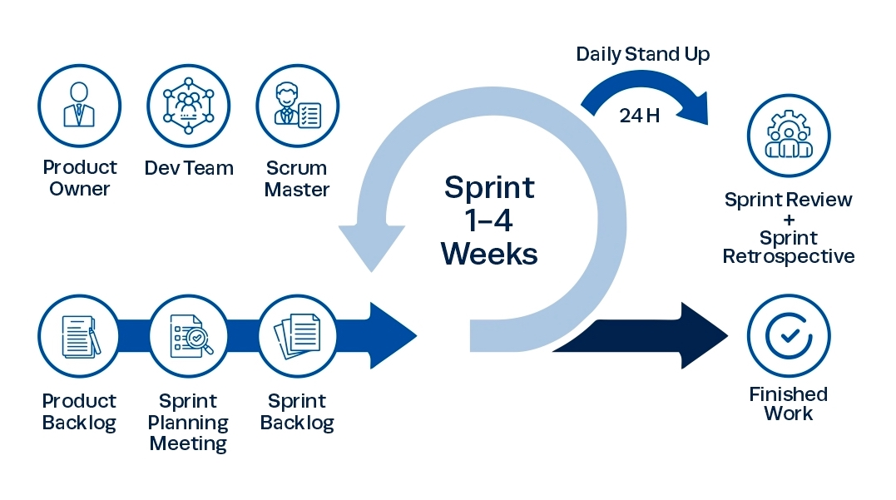
Figure 1: Scrum Model Process (Link)
The IQGS team adopted the Scrum framework for the implementation of IQGS — an AI-powered interview question generation and practice platform. Scrum was selected because the system's core AI components (RAG pipeline, LLM-based evaluation, vector search) require continuous inspection and adaptation across sprints, and requirements from both HR managers and job seekers are clarified incrementally through sprint reviews and stakeholder feedback. Each sprint produces a working, tested software increment that builds upon the previous one.
All tasks, bugs, and sprint progress are tracked using Jira. Each work item is created as a Jira issue, assigned to a team member, and progressed through the workflow: To Do → In Progress → In Review → Done. Sprint boards are reviewed in Daily Scrums and Sprint Retrospectives to ensure visibility and accountability across the team. The Product Backlog is maintained and prioritised by the Project Manager (acting as Product Owner) before each Sprint Planning session.
The project is structured into four Sprints, each lasting three weeks and delivering a tested, functional increment aligned with the Product Backlog and WBS in Section 1. Each Sprint follows the standard Scrum cycle: Sprint Planning → Daily Scrum → Sprint Review → Sprint Retrospective.
● Sprint 1 (3 weeks — 01/06/2026 to 21/06/2026) Focus: Foundation, Infrastructure, and Authentication
- Goal: "Deliver a fully functional authentication system with infrastructure setup" (WBS 3.1–3.6).
- Implementation: set up project repositories (frontend and backend), a CI/CD pipeline via GitHub Actions, and a PostgreSQL database with Entity Framework Core; implemented the full User Management module — registration, email verification, login/logout, JWT-based authentication, forgot/reset password, and Role-Based Access Control (RBAC).
- Testing: unit-tested all authentication service-layer methods with xUnit and integration-tested all authentication API endpoints via Postman; defects logged in Jira, with test cases and results documented in Google Sheets.

● Sprint 2 (3 weeks — 22/06/2026 to 12/07/2026) Focus: AI Question Generation and Question Set Management
- Goal: "Deliver a working RAG-based question generation pipeline and question set management module" (WBS 4.1–4.5).
- Implementation: built the JD input and parsing module (text input and file upload: PDF, DOCX, TXT); implemented the RAG pipeline — text chunking, embedding generation, pgvector indexing, semantic retrieval, and LLM question generation via the OpenAI API — with Hangfire handling asynchronous background processing; built Question Set CRUD, visibility control (Public/Link-only/Private), inline editing, and the publishing workflow.
- Testing: unit-tested the RAG pipeline components and question set service methods; integration-tested all JD input, generation, and question set management API endpoints.

● Sprint 3 (3 weeks — 13/07/2026 to 02/08/2026) Focus: Marketplace, Practice Session, and HR Analytics
- Goal: "Deliver a fully functional candidate practice marketplace with AI evaluation and HR analytics dashboard" (WBS 5.1–5.6).
- Implementation: built the Practice Marketplace (browse, search and filter published question sets by role, tech stack, seniority and company); implemented the Interview Practice Session engine with timed question answering and submission; implemented AI-based answer evaluation — scoring rubric, LLM feedback generation (strengths, missing points, suggestions), and overall performance summary; built the HR Analytics Dashboard and Candidate Contact Inbox.
- Testing: unit-tested the practice session engine, AI evaluation service, and analytics query methods; integration-tested all marketplace, practice, feedback, and analytics API endpoints.

● Sprint 4 (3 weeks — 03/08/2026 to 23/08/2026) Focus: Subscription, Payment, Admin Dashboard, and Deployment
- Goal: "Deliver subscription and payment module, Admin Dashboard, and deploy the full system to production" (WBS 6.1–6.6, 7.1–7.3).
- Implementation: implemented subscription plan management and Pro/Free feature-tier access control; built in-app payment processing (VietQR) and transaction history; implemented the Admin Dashboard (user management, knowledge base upload/indexing, system monitoring analytics, RAG baseline experiment management); ran system-wide integration, performance and security testing, completed final bug fixes and documentation, and deployed the full system to production with Docker Compose and Azure Blob Storage.
- Testing: full end-to-end system testing covering all user flows and non-functional requirements (page load < 2 s, AI response < 8 s, uptime ≥ 99%), payment sandbox testing, and JWT security validation; defects logged in Jira and the final test report documented in Google Sheets.

2.2 Quality Management
2.2.1 Defect Prevention
To minimise defects before each sprint begins:
- Nam (Project Manager) defines the sprint strategy and adjusts it during retrospectives; a training plan (Section 2.3) ensures all members are proficient with ASP.NET Core, React.js, and the RAG/OpenAI stack before coding begins; and the team maintains a shared checklist of common errors (async deadlocks, EF Core migration conflicts, embedding dimension mismatches) in Google Drive.
2.2.2 Reviewing
- All reports (SRS, SDD, test plans) are reviewed by at least two members before supervisor submission, and architecture/API design documents are checked for consistency with the Clean Architecture layer structure (Domain, Application, Infrastructure, Presentation).
- All pull requests require peer code review before merging to dev, with GitHub branch protection rules preventing direct pushes to main/dev; IQGS is also periodically benchmarked against existing AI interview tools (e.g., Interviewing.io, HireVue) to verify product direction and differentiation.
2.2.3 Unit Testing
- Test cases must cover all service-layer methods with both happy-path and edge-case scenarios, targeting at least 75% code coverage.
- xUnit is used for unit testing the ASP.NET Core service layer. Pytest is used for the Python RAG microservice. Both suites run automatically on every PR via GitHub Actions CI.
- Defects are logged as Jira issues with severity, reproduction steps, and assigned owner.
- Developers assigned to a defect must resolve it within the same sprint or escalate to the PM if it risks the sprint goal.
2.2.4 Integration Testing
  - All unit tests must pass before integration testing begins for each sprint.
  - Verify that all REST API endpoints respond correctly and that the ASP.NET Core backend integrates properly with the Python RAG service, PostgreSQL, Redis, and Azure Blob Storage.
  - Test cases and results are tracked in Jira and documented in Google Sheets, with each test case specifying preconditions, seeded test data, steps and expected results; Postman collections and Swagger UI are used to exercise all API endpoints, and Postman Newman automates API tests in the CI pipeline.
2.2.5 System Testing
  - Full integration test sign-off is required before system testing begins.
  - Verify all 44 user stories meet their acceptance criteria. Non-functional targets: page load under 2 s, question generation under 8 s, system uptime ≥ 99%.
  - The system test plan covers: end-to-end user flows, AI generation accuracy evaluation, load testing (50 concurrent users), JWT security validation, and payment sandbox testing.

2.3 Project Training Plan
To ensure that all project members are proficient in the necessary technologies, tools, and processes before the official implementation, the project team has developed a detailed training plan for each area of expertise. The table below describes the mandatory training topics, the list of participants, the schedule, and the exemption criteria. Detailed content is presented in the table below:

Training Area | Participants | When, Duration | Waiver Criteria
Git & GitHub (branching, pull requests, code review) | Nam, Hiền, Tú, Khoa | 16/05/2026 - 22/05/2026 | Mandatory
ASP.NET Core (.NET 8) & Clean Architecture (4-layer) | Nam, Hiền | 16/05/2026 - 29/05/2026 | Mandatory
React.js / Next.js (components, routing, state management) | Tú, Khoa | 16/05/2026 - 29/05/2026 | Mandatory
PostgreSQL & Entity Framework Core (migrations, queries) | Nam, Hiền | 16/05/2026 - 22/05/2026 | Mandatory
OpenAI API & RAG fundamentals (embeddings, pgvector) | Nam, Hiền, Tú, Khoa | 23/05/2026 - 29/05/2026 | Mandatory
CI/CD ( GitHub Actions) | Hiền, Khoa | 23/05/2026 - 29/05/2026 | Mandatory
Testing methodologies (xUnit, Pytest, Postman, Swagger) | Nam, Hiền, Tú, Khoa | 30/05/2026 - 05/06/2026 | Mandatory
Table 4: Training plan

3. Responsibility Assignments

3.1. Project Organisation
To ensure that the project is executed efficiently, transparently, and with a high level of collaboration among team members, the project team is organised according to a clear hierarchical model, with specific roles and responsibilities assigned. The diagram below provides a detailed view of the project’s organisational structure, including the Supervisor, Project Manager, and teams responsible for Business Analysis, Development, and Testing.

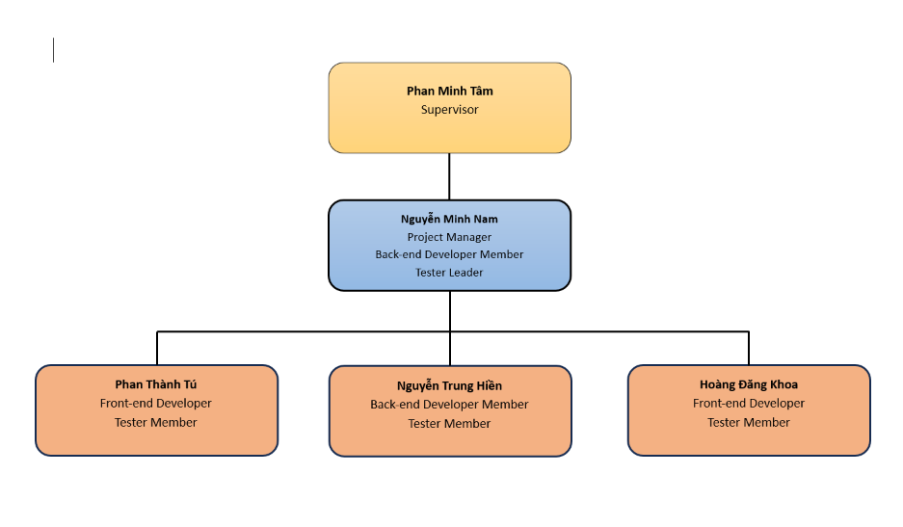
Figure 2: Project Organisation

3.2 Responsibility
To ensure that project activities are clearly assigned and executed efficiently, the project team has developed a Responsibility Matrix based on the D–R–S–I model, in which each member is assigned a specific role for each task :
- D (Do) – directly responsible for performing the task
- R (Review) – reviews and evaluates the task
- S (Support) – assists in performing the task
- I (Informed) – am kept informed about the task
The table below provides a detailed description of each team member’s responsibilities for each work item.
Responsibility | NamNM | TuPT | HienNM | KhoaHD
Document and Report
Project Introduction Document | D | S, R | S, R | S, R
Project Management Plan Document | D | D | S, R | S, R
Software Requirements Specification (SRS) Document | D | D | S, R | S, R
Software Design Document | D, R | D, R | D, R | D, R
Testing Document | D, R | D, R | D, R | D, R
User Manual / System Usage Guide | S, R | S, R | D | S, R
Final Project Report | S, R | S, R | S, R | D
Presentation Slides | S, R | S, R | S, R | S, R
Analysis & Design
Context Diagram | D | I | I | I
Use case diagram | D | D | S, R | S, R
Main workflow | D | S, R | D | S, R
Screen flow diagram | S, R | S, R | D | S, R
Entity relationship diagram | D | S, R | S, R | S, R
System architecture diagram | D | S, R | S, R | S, R
Sequence diagram | D, R | D, R | D, R | D, R
Class diagram | D, R | D, R | D, R | D, R
Database design | D | S, R | S, R | S, R
UI design | R | D | R | S
Package diagram | R | R | D | R
Implementation
Source code management | D | D | D | I
Code Front-end | I | D | I | D
Code Back-end | D | I | D | I
Deploy web | S | D | D | S
Testing
Develop the Test Plan | R | D | I | I
Create Unit Test Cases and Execute Testing | D | I | I | D
Create Integration Test Cases and Execute Testing | D, R | D, R | D, R | D, R
Create System Test Cases and Execute Testing | D, R | D, R | D, R | D, R
Prepare Test Reports | S, R | D | S | S
Table 5: Responsibility

4. Project Communications
Communication Item | Who / Target | Purpose | When / Frequency | Type, Tool, Method(s)
Daily Meeting | All team members | To quickly update yesterday's progress, today's tasks, and flag technical blockers so the team can support immediately | Daily (Mon - Fri)8:00 - 8:30 | Online  Voice calls via Google Meet; updating tasks on the Jira Board.
Weekly Meeting | All team members | To review weekly results, lock current Sprint progress, discuss FE-BE integration issues, and distribute the workload evenly for the next week | Every Saturday or Sunday evening. | Hybrid (Online/Offline)  Google Meet or face-to-face meetings at the campus library.
Meeting with Supervisor | All team members and Mr. Phan Minh Tâm | To report milestone progress, get feedback on the RAG pipeline | Weekly (Thursdays or scheduled in advance with the supervisor). | Offline or Online  On-campus meetings or online via Google Meet.
Iteration Review | All team members | To accept completed features, run system demos | At the end of each Sprint (every 2 to 3 weeks). | Online  Google Meet discussion paired with Jira evaluation.
Emergency Meeting | Relevant members or the whole team | To handle critical unexpected issues immediately (e.g., Azure deployment server crash, heavy Git merge conflicts, or sudden requirement changes). | Whenever a critical emergency occurs. | Urgent Online Meeting  Quick notification via pinned Zalo messages, moving instantly to Google Meet.
Code Review | Developer and designated Reviewer | To verify code conventions and optimize logic. | Whenever a feature or bugfix is completed on GitHub. | Asynchronous  Pull Request (PR) creation on GitHub; discussion via line comments or Zalo.
Document Review | All team members (evenly distributed sections) | To cross-review chapters in Report 2 and the SRS to catch typos, formatting errors, or inconsistencies between FE and BE descriptions. | Before submission deadlines or document freezing dates. | Asynchronous  Comments and "Suggesting" mode directly on Google Docs.
UI/UX Discussion | All team members | To align on User Flows for all actors | Early project phases or before starting a sprint with new user interfaces. | Online Visual  Reviewing designs on Figma while discussing via Google Meet.

5. Configuration Management

5.1 Document Management
We use Google Drive as the primary document management system for the project. This approach ensures that all documents are stored centrally, easily accessible, and version control is effectively maintained. Specific Google Workspace tools are used for each type of document as follows:
- Google Drive: Serves as the central repository to store and organise all project documents within a clear folder structure. (Link)
- Google Docs: Used for main text documents, including Project Reports and Meeting Minutes. (Link)
- Google Sheets: Used for tabular documents and numerical data, specifically Test Reports and Project Tracking.
- Canva: Used to create and manage project presentations.
- Our document management process includes:
- Version History Tracking: The team uses the built-in Version History feature in Google Docs and Sheets to track specific edits by author. This allows the team to roll back to older versions if human errors or accidental deletions occur.
- Access and Sharing: Permissions and sharing features are used to control who can view, edit, or comment on documents.
- Document Approval Process: A clear approval workflow is implemented for important documents, and comments are used to collect feedback.

5.2 Source Code Management
We use GitHub for source code management to ensure version control, collaboration, and traceability of all code changes throughout the project lifecycle. Our source code management process includes:
- Separate Repositories for the Project: Maintain separate GitHub repositories for the backend and frontend to enhance clarity and improve management.
- Frontend Repository: Contains all client-side code, user interface, and related resources. Link source: GitHub Frontend
- Backend Repository: Contains all server-side code, APIs, and database-related logic. Link source: GitHub Backend
- Branching Strategy: Apply a standard branching strategy (Git Flow) to manage the development workflow:
- Main Branch: This branch contains production-ready code. All merges into this branch undergo careful review and testing.
- Develop Branch: Serves as the central branch for development and code integration. All new features are merged into this branch before being ready for release.
- Feature Branches: Each new feature or task is developed in a separate feature branch, named according to the convention developer_name/feature_name, branched off from develop.
- Bugfix Branches: Dedicated branches are used for bug fixes, named according to the convention bugfix/developer_name/bug_description, branched off from development depending on the severity and urgency.
- Protection Rules: Enforce the use of Merge Requests to prevent direct pushes to the main and develop branches, thereby avoiding conflicts.

5.3 Tools & Infrastructures
The table below lists the main tools applied in the project, categorised by functional groups to support an efficient project development and management process.
Category | Tools / Infrastructure
Communication | Zalo, Messenger, Google Meet
Technology | ASP.NET Core, React / Next.js, Python
Database | PostgreSQL
IDEs/Editors | Visual Studio Code, Visual Studio
Diagramming | Drawio, Sequencediagram.org
Design tool | Figma
Documentation | Google Docs/Sheets/Slides
Version Control | GitHub (Source Codes), Google Drive (Documents)
Testing | Postman, Swagger, xUnit
Deployment server | Azure
Project management | Jira
Table 7: Tools & Infrastructures

III. Software Requirement Specification

1. Product Overview
IQGS (Interview Question Generation System) is an AI-powered dual-sided web platform that automates the creation and delivery of technical interview question sets using Retrieval-Augmented Generation (RAG) and Large Language Models (LLMs). The system is designed to solve a critical pain point in the IT hiring industry: the time-consuming and inconsistent process of manually crafting role-specific interview questions.
On the HR Manager / Recruiter side, the system allows users to input or upload a job description (JD) in PDF, DOCX, or plain text format. The platform then processes the JD through a RAG pipeline — extracting and embedding the JD content, retrieving semantically relevant context from a curated Knowledge Base sourced from SWEBOK, ACM/IEEE Computing Curricula, Tech Interview Handbook, and System Design Primer, constructing a structured prompt, and invoking a configurable production LLM to generate role-specific, difficulty-tiered interview questions. The selected LLM can be changed based on cost, quality, latency, and provider availability without changing the core RAG workflow.
The generated questions are presented for HR review, editing, and organization into named question sets. Approved sets can be published to the platform marketplace, making them visible to job seekers.
On the Job Seeker / Candidate side, users can browse and search the public marketplace of published question sets by company, skill domain, or difficulty tier. Candidates can initiate timed practice sessions, submit text-based answers, and receive detailed AI-generated feedback powered by the same configurable LLM service. The feedback evaluates each answer for relevance, technical correctness, and clarity, providing actionable suggestions for improvement. Candidates may also share their practice scorecard directly with the hiring company's HR inbox.
The platform operates on a freemium subscription model: HR Managers pay for AI generation quota, while candidates access a free tier with limited question visibility and a premium tier for full access and advanced evaluation.

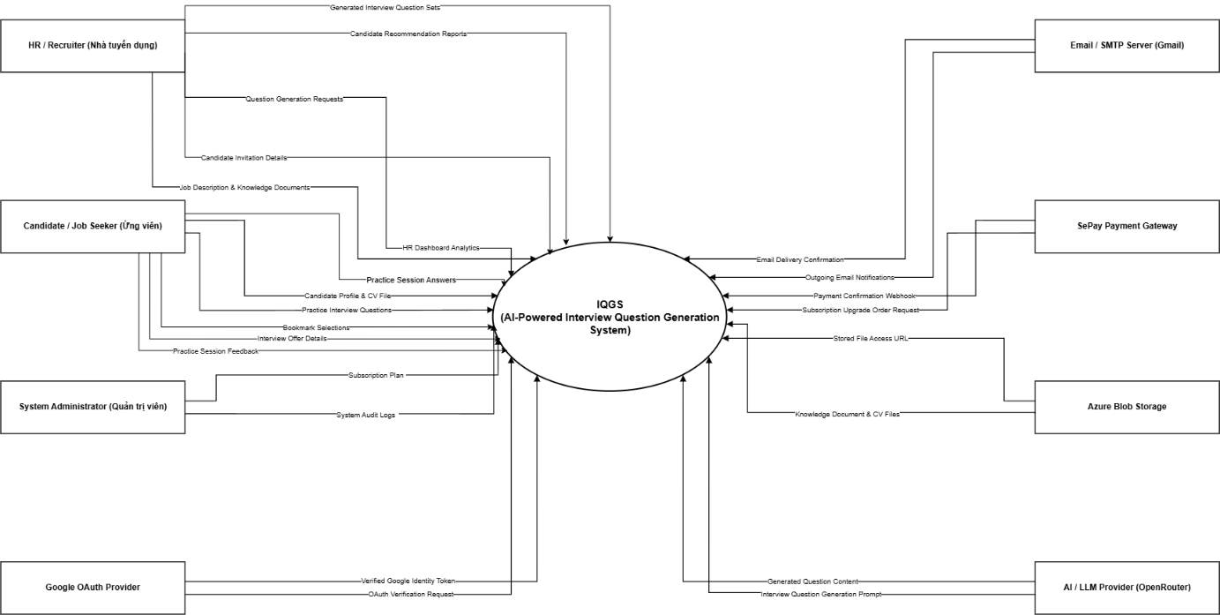

Figure 1: Context Diagram

2. User Requirements

2.1 Actors
The IQGS platform interacts with nine actors: four human actors and five external systems or services.
 | Actor | Description
1 | Guest | An unauthenticated visitor who can view the landing page, browse subscription plan pricing, register as Job Seeker or HR Manager, and initiate the login/forgot-password flow. Guests cannot access the marketplace, generate questions, or start practice sessions.
2 | Job Seeker / Candidate | An authenticated user with the Candidate role. Can browse and search the public question set marketplace, start timed practice sessions, submit answers, view AI-generated feedback, track practice history, send contact requests to HR Managers with practice scorecards, and manage their subscription plan.
3 | HR Manager / Recruiter | An authenticated user with the HR Manager role whose account has been approved by an Administrator (LI-02). Can input or upload job descriptions, configure and trigger AI question generation (RAG pipeline), review and edit generated questions, create and publish question sets, view recruitment analytics, manage candidate contact requests, and manage subscription plan.
4 | Administrator | An authenticated super-user with full platform access. Manages all user accounts, the Knowledge Base, subscription plan configurations, RAG baseline evaluation experiments (mandatory per project topic §3.3), and system configuration parameters.
5 | LLM Service (OpenAI GPT-4o) | External AI system, accessed via the official OpenAI .NET SDK, that generates interview questions from job-description context and evaluates candidate answers to produce AI Feedback scores. Invoked by the backend during question generation jobs and answer evaluation; not directly accessed by any human actor.
6 | Vector Database (pgvector) | PostgreSQL extension storing embedded Knowledge Base chunks. Provides semantic similarity search (RAG retrieval) that grounds AI question generation in the HR Manager's own knowledge-base documents and public reference material.
7 | Email Service (SMTP) | SMTP relay used by the backend to deliver transactional emails: account email verification, password reset, and candidate invitation notifications.
8 | Payment Service (SePay) | Third-party payment gateway. Generates VietQR bank-transfer orders for subscription upgrades and confirms payment via a signed (HMAC-SHA256) webhook callback.
9 | File Storage (Azure Blob Storage) | Cloud object storage used to persist uploaded files — candidate CVs, HR knowledge-base source documents, and question-attached images — and to issue time-limited SAS URLs for secure access.

2.2 Use Cases

2.2.1 Diagrams
The diagram below consolidates all actors and all 49 use cases into a single system boundary ("IQGS Platform"). Each actor is connected by a plain association line to the specific use case(s) it participates in, following standard UML use case diagram notation. Full use case descriptions follow in section 2.2.2.

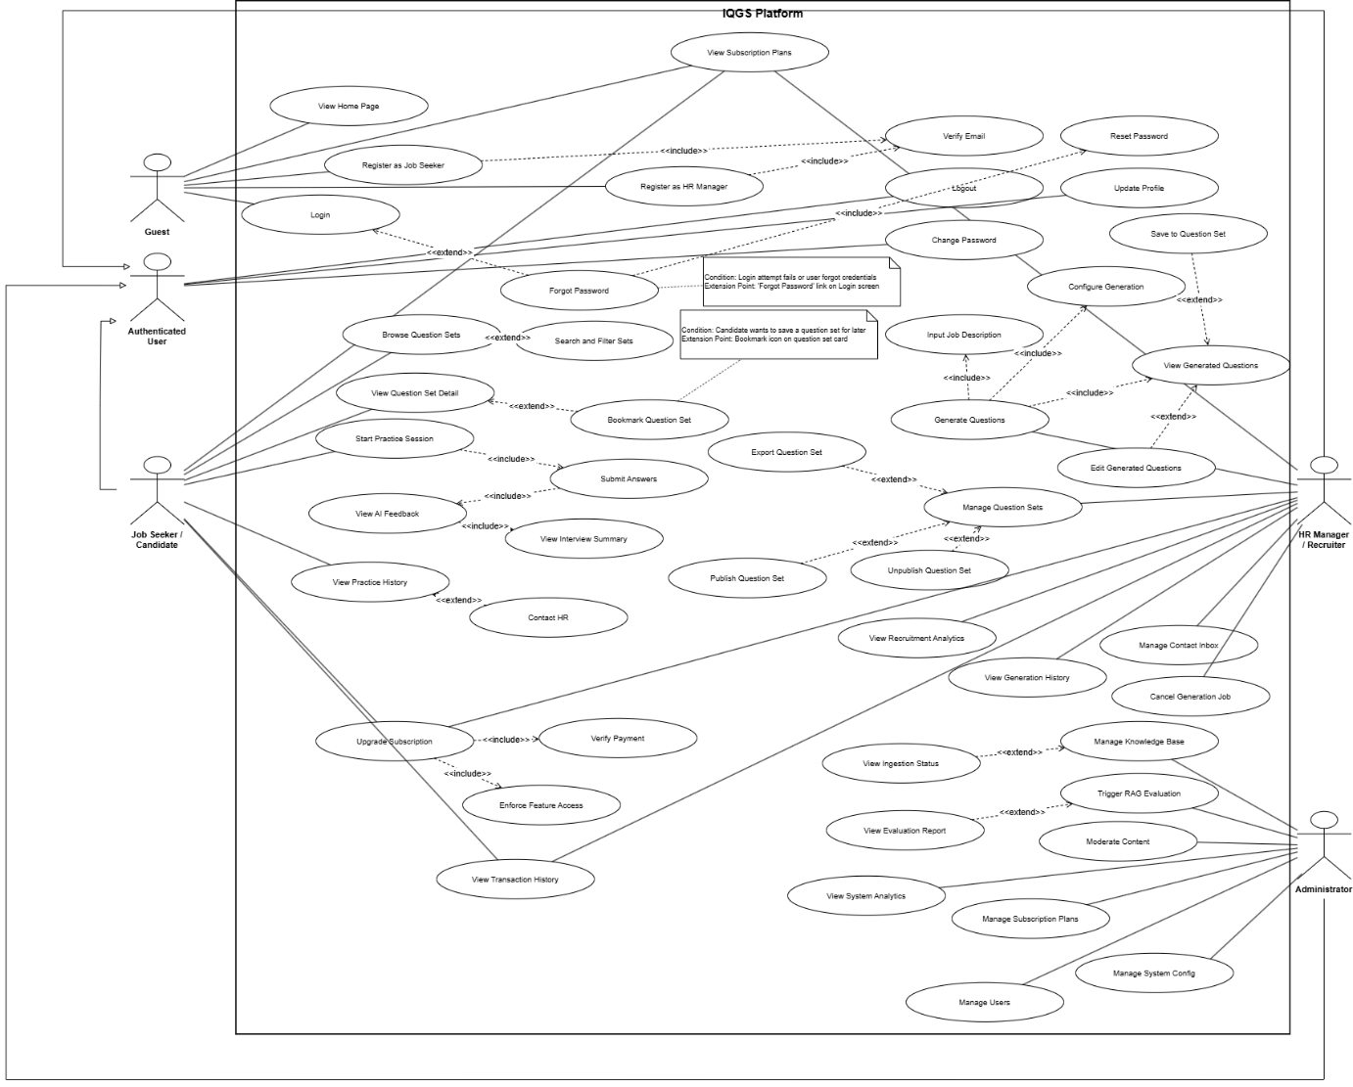

Figure 2.2.1: Use Case Diagram (All Actors)

2.2.2 Descriptions
UC ID | Use Case Name | Actors | Description
UC-G01 | View Home Page | Guest | Guest views the IQGS public landing page with platform description, features overview, and pricing tier summary.
UC-G02 | View Subscription Plans | Guest | Guest views all active subscription tiers, included features, and pricing before registering.
UC-G03 | Register as Job Seeker | Guest, Email Service | Guest creates a Job Seeker account; system sends email verification link.
UC-G04 | Register as HR Manager | Guest, Email Service | Guest creates an HR Manager account (Status = Pending until Admin approval per LI-02); system sends verification email.
UC-G05 | Login | Guest | Guest submits email and password credentials to authenticate and obtain a JWT access token.
UC-G06 | Forgot Password | Guest, Email Service | Guest requests a password reset link sent to their registered email (anti-enumeration: identical response regardless of email existence).
UC-A01 | Verify Email | All Roles, Email Service | User clicks verification link to activate account (IsEmailVerified = true).
UC-A02 | Reset Password | All Roles | User sets a new password using a valid, unexpired, single-use reset token.
UC-A03 | Logout | All Roles | User ends session; refresh token invalidated server-side.
UC-A04 | Update Profile | All Roles | User updates personal info and avatar; HR Manager updates company details.
UC-A05 | Change Password | All Roles | User changes password after verifying current password.
UC-HR01 | Input Job Description | HR Manager | HR Manager types or uploads a JD file (PDF/DOCX/TXT) for question generation.
UC-HR02 | Configure Generation | HR Manager | HR Manager sets seniority, question count, question types, and tech stack tags.
UC-HR03 | Generate Questions | HR Manager, LLM Service | HR Manager triggers async RAG pipeline; system generates structured questions.
UC-HR04 | View Generated Questions | HR Manager | HR Manager views the AI-generated question list after job completes.
UC-HR05 | Edit Generated Questions | HR Manager | HR Manager edits question text, difficulty, or sample answers inline.
UC-HR06 | Save to Question Set | HR Manager | HR Manager saves selected questions to a new or existing question set.
UC-HR07 | Manage Question Sets | HR Manager | HR Manager views, searches, edits, and deletes their own question sets.
UC-HR08 | Publish Question Set | HR Manager | HR Manager changes a set's visibility to Public for the marketplace.
UC-HR09 | Unpublish Question Set | HR Manager | HR Manager reverts a public set to Private/Draft status.
UC-HR10 | Export Question Set | HR Manager | HR Manager downloads a question set as PDF or DOCX.
UC-HR11 | View Recruitment Analytics | HR Manager | HR Manager views charts on question set usage: attempts, completion rates, and scores.
UC-HR12 | Manage Contact Inbox | HR Manager | HR Manager views, accepts, or declines candidate contact requests.
UC-HR13 | View Generation History | HR Manager | HR Manager reviews past generation jobs with status and output.
UC-HR14 | Cancel Generation Job | HR Manager | HR Manager cancels a queued or running generation job.
UC-JS01 | Browse Question Sets | Job Seeker | Job Seeker browses the paginated public marketplace of published question sets.
UC-JS02 | Search and Filter Sets | Job Seeker | Job Seeker filters sets by role, tech stack, company, seniority, or difficulty.
UC-JS03 | View Question Set Detail | Job Seeker | Job Seeker views set details: skills, difficulty, publisher, and aggregate statistics.
UC-JS04 | Bookmark Question Set | Job Seeker | Job Seeker toggles a bookmark on a question set for later access.
UC-JS05 | Start Practice Session | Job Seeker | Job Seeker initiates a timed practice session for a selected question set.
UC-JS06 | Submit Answers | Job Seeker, LLM Service | Job Seeker submits answers; LLM evaluates and generates AI feedback asynchronously.
UC-JS07 | View AI Feedback | Job Seeker | Job Seeker views per-answer feedback: score, strengths, and missing points.
UC-JS08 | View Interview Summary | Job Seeker | Job Seeker views the overall session performance summary with aggregated scores.
UC-JS09 | View Practice History | Job Seeker | Job Seeker views past sessions, scores, and progress over time.
UC-JS10 | Contact HR | Job Seeker, Email Service | Job Seeker sends a contact request to HR with a practice scorecard attached.
UC-P01 | View Subscription Plans | HR Manager, Job Seeker | User views all active plan tiers, pricing, and feature comparison.
UC-P02 | Upgrade Subscription | HR Manager, Job Seeker | User selects a higher plan and initiates the payment flow (Order + VietQR).
UC-P03 | Verify Payment | System, Payment Service | System receives payment callback, verifies transaction, and activates subscription.
UC-P04 | View Transaction History | HR Manager, Job Seeker | User views paginated past Orders with dates, amounts, and plan details.
UC-P05 | Enforce Feature Access | System (middleware) | System validates subscription tier and quota before granting access to premium features.
UC-AD01 | Manage Users | Administrator | Admin views, activates, suspends, or changes roles of user accounts.
UC-AD02 | Manage Knowledge Base | Administrator, File Storage | Admin uploads, re-ingests, or deletes knowledge base documents.
UC-AD03 | View Ingestion Status | Administrator | Admin monitors ingestion pipeline status per knowledge base document.
UC-AD04 | Trigger RAG Evaluation | Administrator, LLM Service | Admin triggers RAG vs. zero-shot vs. few-shot comparison experiment (mandatory per project topic §3.3).
UC-AD05 | View Evaluation Report | Administrator | Admin views and exports RAG baseline evaluation results.
UC-AD06 | Moderate Content | Administrator | Admin reviews and removes violating public question sets from the marketplace.
UC-AD07 | View System Analytics | Administrator | Admin views system metrics: users, generation jobs, token usage, and uptime.
UC-AD08 | Manage Subscription Plans | Administrator | Admin creates, updates, or deactivates subscription plan configurations.
UC-AD09 | Manage System Config | Administrator | Admin updates platform-wide configuration (API keys, Top-K value, similarity thresholds).

3. Functional Requirements

3.1 System Functional Overview

3.1.1 Screens Flow
The diagram below shows the primary screen-to-screen navigation for each of the four application workspaces described in section 3.2. Each workspace is entered from its role dashboard after login; screens below the dashboard are reachable from the dashboard's navigation menu.

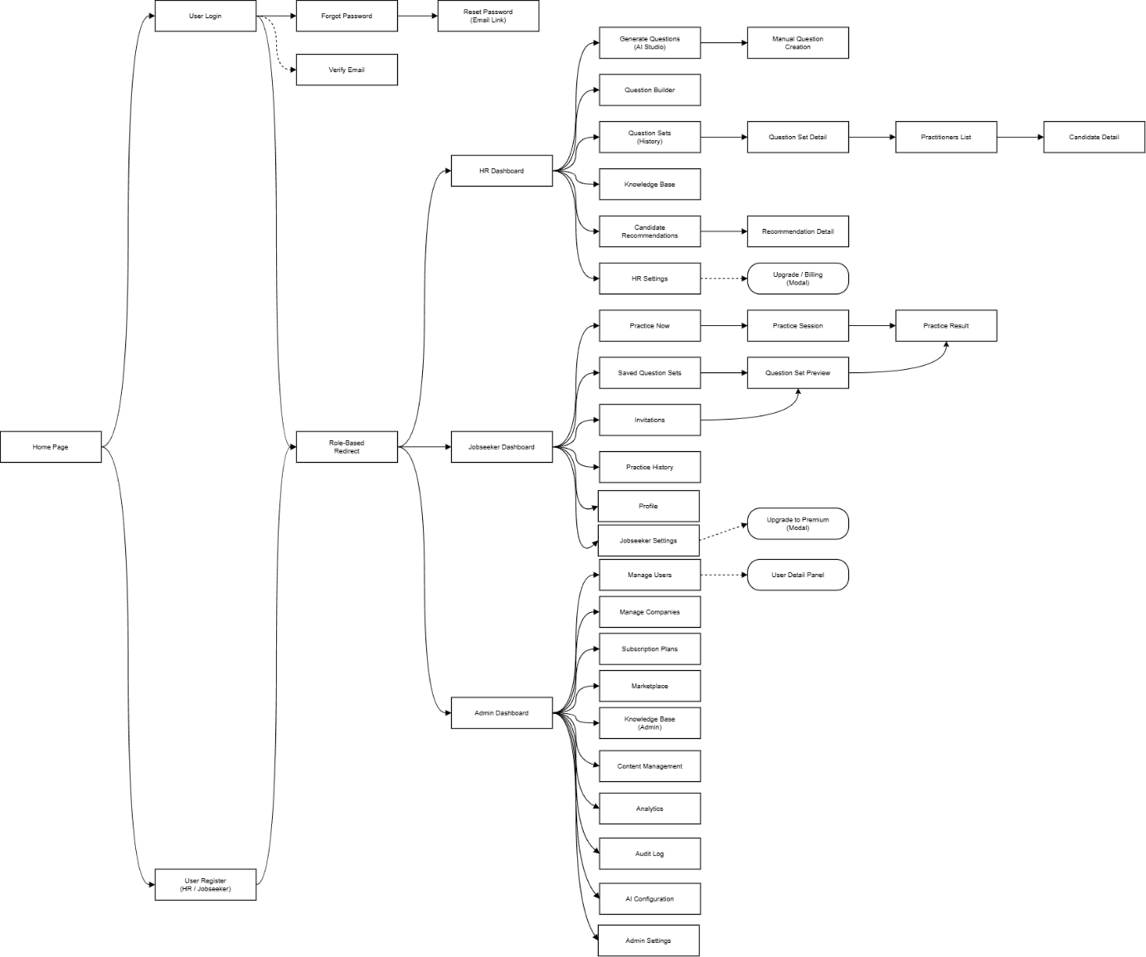
Figure 3.1.1: Screens Flow

3.1.2 Screen Descriptions
Detailed screen-by-screen descriptions (layout, key elements, and behavior) are provided per application area in section 3.2 Web Application below.

3.1.3 Screen Authorization
IQGS uses coarse-grained, role-based authorization enforced at the API-controller level (ASP.NET Core [Authorize(Roles=...)]); the frontend groups screens into one workspace per role under a matching route prefix.

No. | Application Area (Route Prefix) | Guest | Candidate | HR Manager | Administrator
1 | Public / Landing (/, /login, /register, /forgot-password, /pricing) | Yes | Yes | Yes | Yes
2 | Job Seeker / Candidate Workspace (/jobseeker/*) | No | Yes | No | No
3 | HR Manager Workspace (/hr/*, incl. Project Studio /hr/generate-v2) | No | No | Yes | No
4 | Administrator Workspace (/admin/*) | No | No | No | Yes
Table 3.1.3: Screen Authorization Matrix
Note: Company profile management is exposed to both HR Manager and Administrator (backend CompanyController allows Roles="HR,Admin"), surfaced within each role's own workspace.

3.1.4 Non-Screen Functions
The following backend functions run without a corresponding user screen, executed as Hangfire background jobs (on-demand or on a fixed recurring schedule).

No. | Function | Trigger | Description
1 | Knowledge Document Ingestion | On-demand — HR Manager uploads a knowledge-base document | Extracts text, chunks, and embeds the document into the Vector Database for RAG retrieval; updates document status (Processing to Ready/Failed).
2 | Question Generation Plan | On-demand — HR Manager submits a job description for AI generation | Calls the LLM Service to produce a structured, RAG-grounded question-generation plan; the plan awaits HR approval before questions are generated.
3 | Question Generation from Plan | On-demand — HR Manager approves a generation plan | Calls the LLM Service to generate the final interview questions per the approved plan; updates the QuestionGenerationJob status.
4 | Stuck Knowledge Document Watchdog | Recurring, every 15 minutes | Detects knowledge documents stuck in Processing beyond an expected window and marks them Failed so HR Managers are not left waiting indefinitely.
5 | Expired Practice Session Watchdog | Recurring, every 1 minute | Auto-submits and finalizes (score + AI insight) any practice session still In Progress past its time limit, covering candidates who lose connectivity or close the app before submitting.
6 | Expire Pending Upgrade Orders | Recurring, every 5 minutes | Marks SePay subscription-upgrade orders as Expired once their payment TTL has passed without a confirmed webhook.
Table 3.1.4: Non-Screen Functions (Background Jobs)

3.1.5 Entity Relationship Diagram
The diagram below covers the 26 core entities backing the functionality described in this specification (identity, HR/company profile, knowledge base, question generation, question sets, practice sessions, AI feedback, candidate recommendations, and subscriptions/payments). Foreign-key columns are marked [FK]; primary keys are marked [PK]. The separate Project Studio module (an advanced, in-progress HR generation workspace) has its own extended schema and is intentionally out of scope for this diagram.

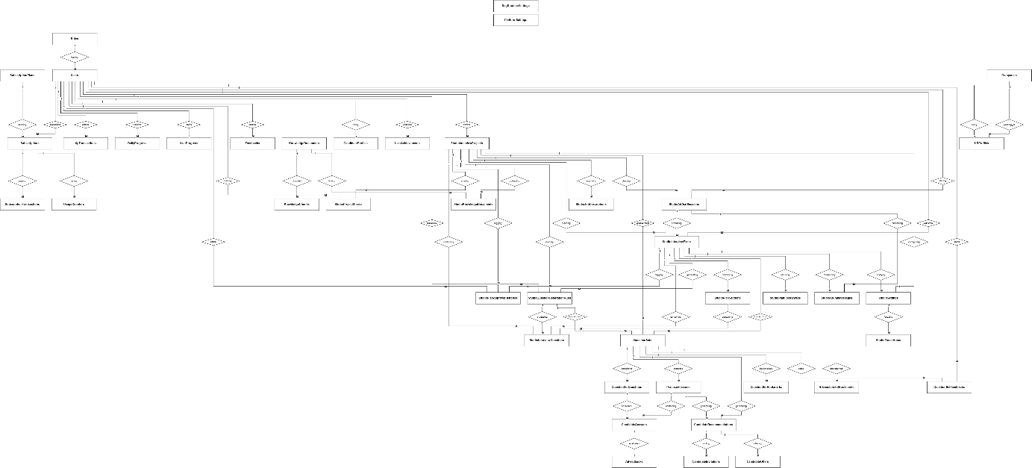
Figure 3.1.5: Entity Relationship Diagram (Core Schema)

3.2 Web Application

3.2.1 HR Manager Interface
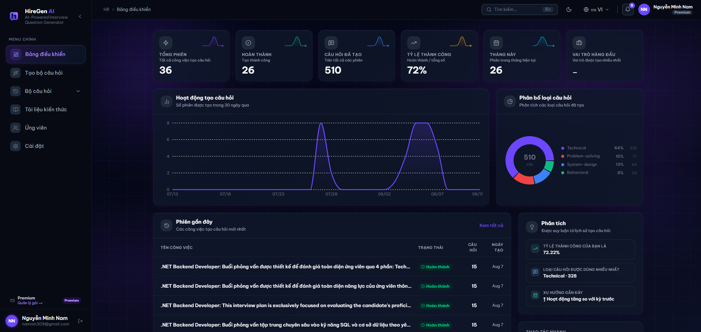
Figure 3.2.1.1. HR Manager Dashboard, loaded state with real account data.

3.2.1.1 HR Manager Dashboard

Function trigger: Shown right after an HR Manager logs in. HR Managers can also get back to it any time by clicking “Bảng điều khiển” (Dashboard) in the sidebar.
Function description: The HR Manager's home page — summarizes their question-generation activity (sessions run, completion rate, questions produced) and surfaces their most recent generation jobs so they can jump back into one.
Pre-condition:
- The HR Manager is logged in.
Function detail:
- KPI summary row shows six cards: Tổng phiên (Total sessions), Hoàn thành (Completed), Câu hỏi đã tạo (Questions generated), Tỷ lệ thành công (Success rate), Tháng này (sessions generated this month), and Vai trò hàng đầu (the role generated most often, shown as “–” when there isn't enough data yet).
- Hoạt động tạo câu hỏi (Question Generation Activity) chart a line chart plotting the number of generation sessions created per day over the last 30 days.
- Phân bố loại câu hỏi (Question Type Distribution) donut chart breaks the HR Manager's generated questions down by type — Technical, Problem-solving, System-design, Behavioral — each with a percentage and raw count, centered on the total question count.
- Phiên gần đây (Recent Sessions) table lists the most recent question-generation jobs with status, question count and creation date, with a “Xem tất cả” (View all) link to the full history.
- Phân tích (Analysis) panel on the right surfaces insights inferred from the HR Manager's generation history: overall success rate, the most-used question type, and a short recent-trend note.
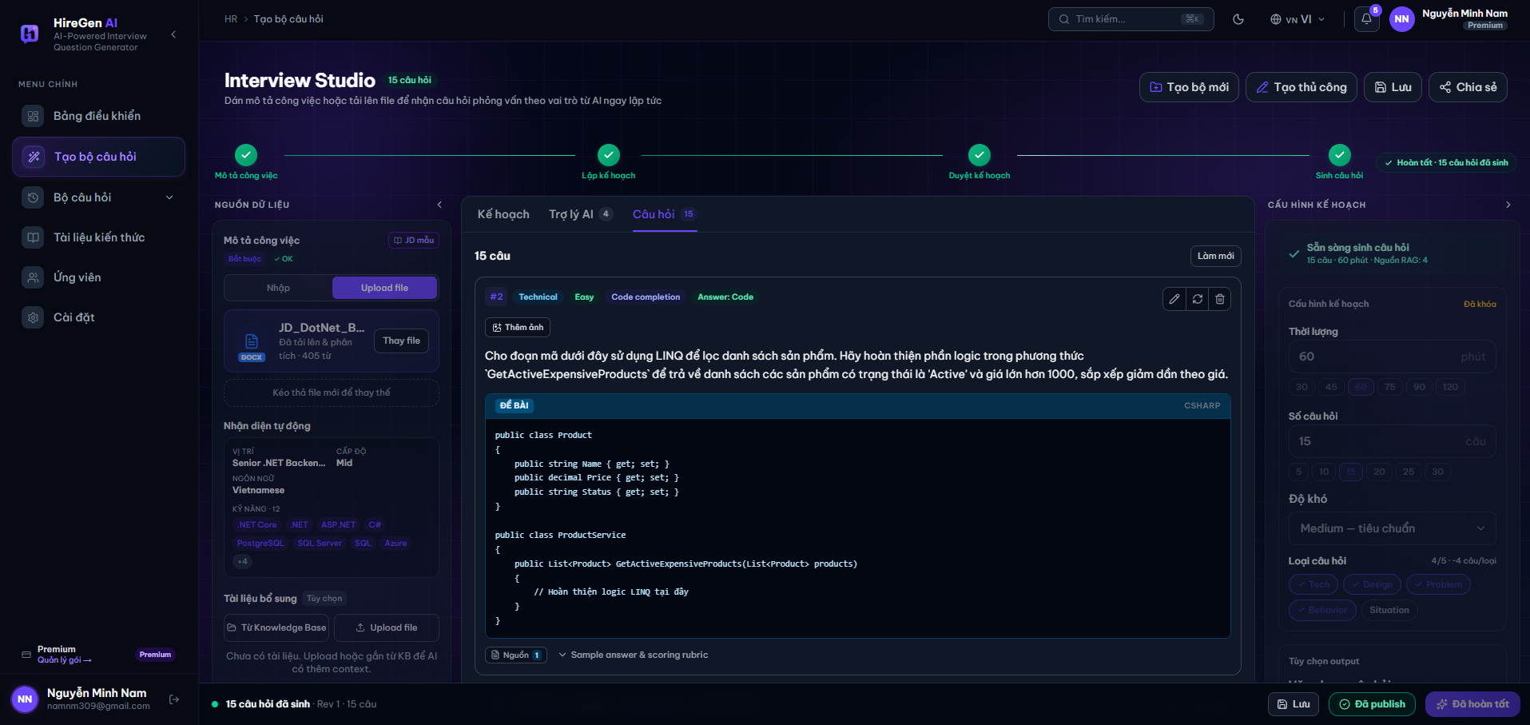
Figure 3.2.1.2. Interview Studio, plan approved and question set generated.

3.2.1.2 Interview Studio (Question Set Generation)
Function trigger: Opened from the sidebar (“Tạo bộ câu hỏi”) or via “Tạo bộ mới” on the Dashboard/question-set list.
Function description: The main question-generation workspace: the HR Manager provides a job description and optional reference material, AI drafts a generation plan, and once approved AI produces a full interview question set that can be edited, saved, published or shared.
Pre-condition:
- The HR Manager is logged in with the HR Manager role.
Function detail:
- Progress stepper at the top tracks the four stages of the flow — Mô tả công việc (Job description), Lập kế hoạch (Plan drafted), Duyệt kế hoạch (Plan approved) and Sinh câu hỏi (Questions generated) — each shown with a green check once complete.
- Nguồn dữ liệu panel (left) lets the HR Manager paste or upload a job description (marked Bắt buộc/Required); once uploaded, the system auto-detects position, level, language and up to 12 skill tags from the file. An optional “Tài liệu bổ sung” area lets the HR Manager attach extra reference documents from the Knowledge Base or by direct upload for extra AI context.
- Câu hỏi tab (center) lists every generated question as a card showing its index, category (e.g. Technical), difficulty (Easy), type (Code completion) and answer format; each card has edit, regenerate and delete actions, an “add image” option, the question prompt, and for coding questions a syntax-highlighted code block plus links to the source reference and the sample answer/scoring rubric. Kế hoạch and Trợ lý AI tabs (not shown expanded here) hold the drafted plan and an AI assistant chat respectively.
- Cấu hình kế hoạch panel (right) shows the locked plan configuration used to generate the set — duration (60 phút), number of questions (15 câu), difficulty level (Medium — tiêu chuẩn) and the mix of question categories (Tech, Design, Problem, Behavior, Situation) with a running count of how many categories are covered.
- Bottom action bar shows generation status (e.g. “15 câu hỏi đã sinh · Rev 1”) and the Tạo bộ mới, Tạo thủ công, Lưu, Chia sẻ, Publish and Hoàn tất actions for saving, publishing or finalizing the set.
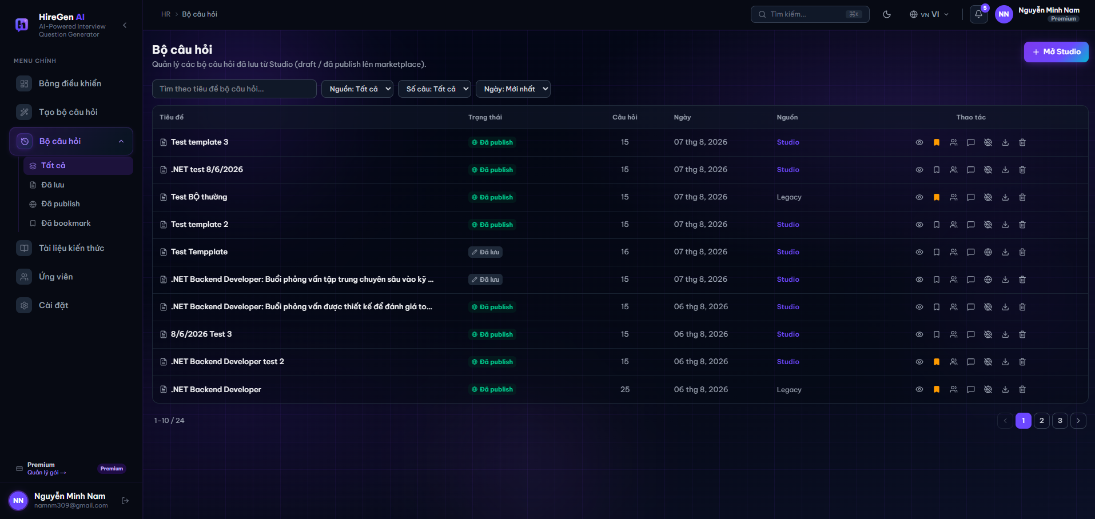
Figure 3.2.1.3. Question set list, “Tất cả” view.

3.2.1.3 Question Set List (Bộ câu hỏi)
Function trigger: Opened by clicking “Bộ câu hỏi” in the sidebar.
Function description: Lets the HR Manager browse, filter and manage every question set they have created or saved from Interview Studio, whether still a draft or already published to the Marketplace.
Pre-condition:
- The HR Manager is logged in.
Function detail:
- Sidebar sub-menu splits the list into Tất cả (All), Đã lưu (Saved/draft), Đã publish (Published) and Đã bookmark (Bookmarked).
- Filter bar lets the HR Manager search by title and filter by Nguồn (source: Studio/Legacy), Số câu (question count) and Ngày (date, newest first by default).
- Results table lists each set's Tiêu đề (title), Trạng thái (status badge — Đã publish or Đã lưu), Số câu hỏi (question count), Ngày (creation date) and Nguồn (Studio or Legacy), with per-row action icons to view, bookmark, share, comment, toggle publish visibility, download or delete the set.
- Header action “+ Mở Studio” opens Interview Studio to start a new set, and results are paginated at the bottom (e.g. “1–10 / 24”).
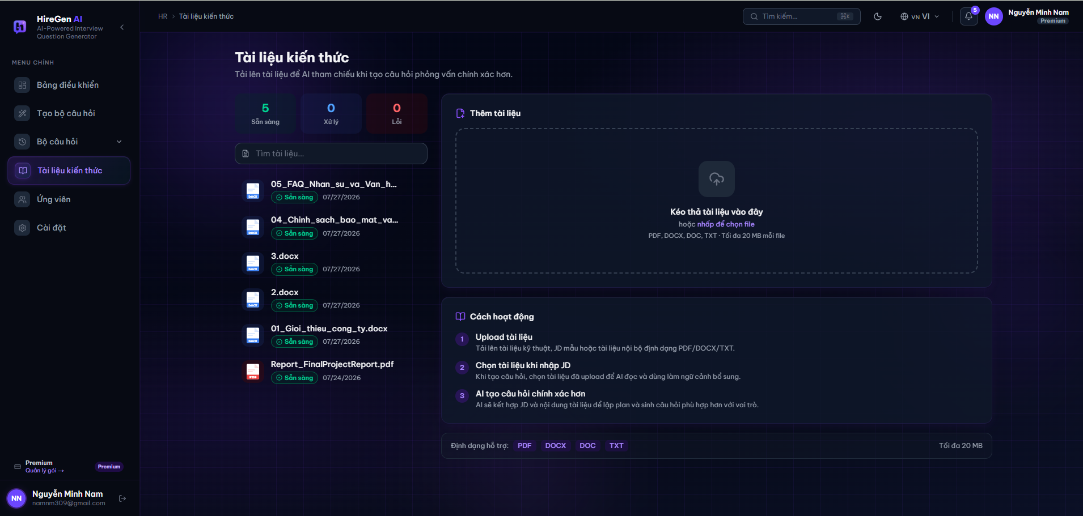
Figure 3.2.1.4. Knowledge documents library, personal scope.

3.2.1.4 Knowledge Documents (Tài liệu kiến thức)
Function trigger: Opened by clicking “Tài liệu kiến thức” in the sidebar.
Function description: Lets the HR Manager upload and manage reference documents (JD templates, internal policies, sample reports, etc.) that can be attached to a job description in Interview Studio so the AI can use them as extra context when generating questions.
Pre-condition:
- The HR Manager is logged in.
Function detail:
- Status summary shows counts of documents that are Sẵn sàng (Ready), Đang xử lý (Processing) and Lỗi (Failed).
- Document list shows each uploaded file's name, an icon for its type (DOCX/PDF), its processing status badge and the upload date; a search box filters the list by name.
- Thêm tài liệu panel (right) is a drag-and-drop / click-to-browse upload zone accepting PDF, DOCX, DOC and TXT files up to 20 MB each.
- Cách hoạt động panel explains the 3-step flow: (1) upload the document, (2) select it while entering a JD so the AI reads it as supplementary context, (3) AI combines the JD and the document content to plan and generate more accurate questions.
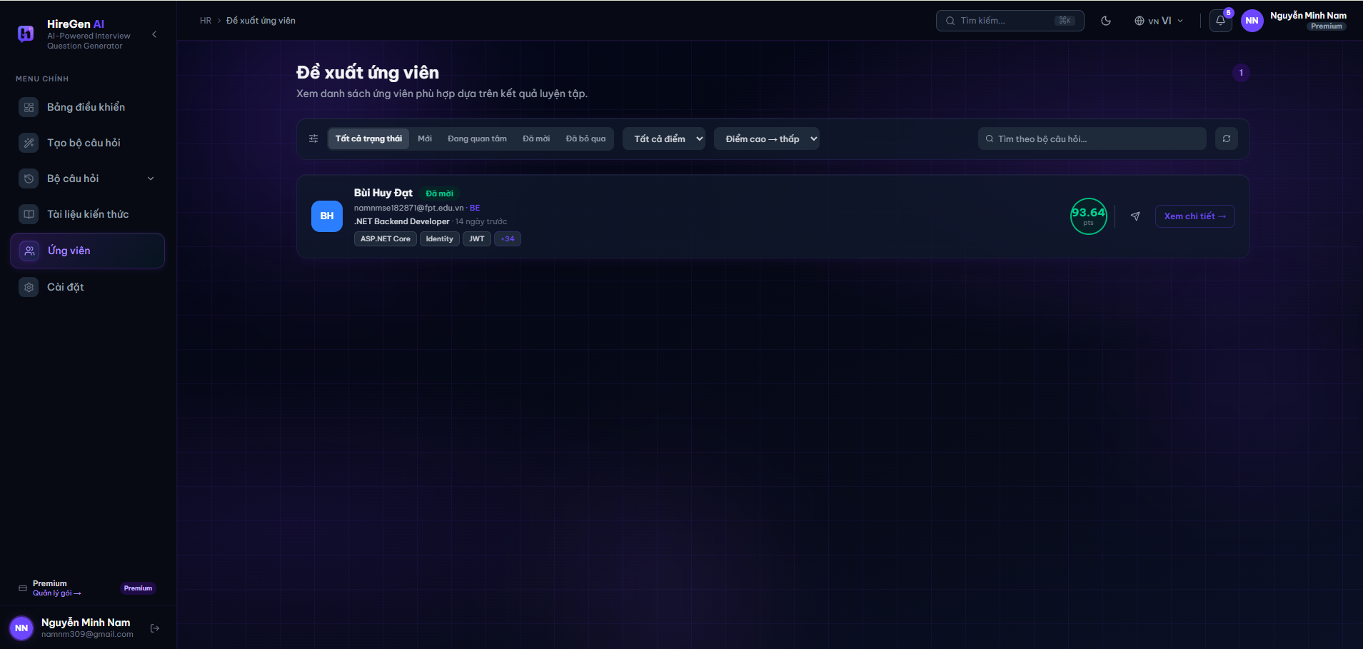
Figure 3.2.1.5. Candidate recommendations list.

3.2.1.5 Candidate Recommendations (Đề xuất ứng viên)
Function trigger: Opened by clicking “Ứng viên” in the sidebar.
Function description: Shows candidates whom the AI has matched against the HR Manager's question sets based on their practice results, so the HR Manager can review scores and reach out to promising candidates.
Pre-condition:
- The HR Manager is logged in.
- At least one candidate has practiced against one of the HR Manager's question sets.
Function detail:
- Filter bar offers status tabs (Tất cả trạng thái, Mới, Đang quan tâm, Đã mời, Đã bỏ qua), a score-range filter, a “Điểm cao → thấp” sort dropdown, a search box to filter by question set, and a refresh action.
- Candidate card shows the candidate's avatar and name, a status tag (e.g. Đã mời/Invited), their email and target role, how long ago they practiced, up to a few matched skill tags with a “+N” overflow count, a circular score badge (e.g. 93.64 pts), a message/invite icon, and a “Xem chi tiết →” (View details) link.
- Notification badge on the page header indicates new candidate matches since the HR Manager last viewed the page.
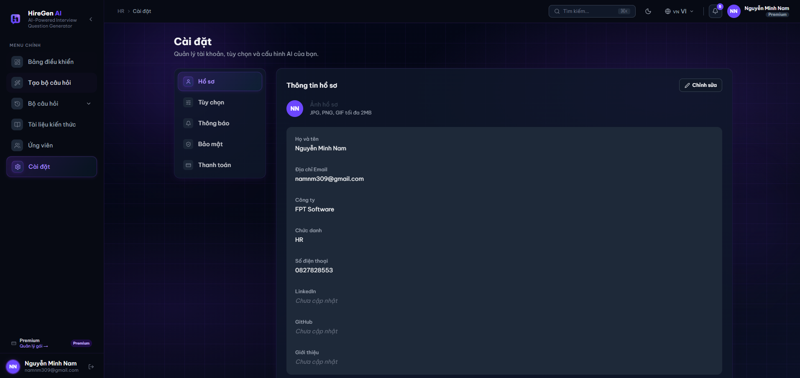
Figure 3.2.1.6. Settings, Hồ sơ (Profile) tab.

3.2.1.6 Settings — Profile (Cài đặt)
Function trigger: Opened by clicking “Cài đặt” in the sidebar.
Function description: Lets the HR Manager view and update their account profile and manage account-level preferences, notifications, security and billing.
Pre-condition:
- The HR Manager is logged in.
Function detail:
- Settings sub-navigation lists Hồ sơ (Profile, active), Tùy chọn (Preferences), Thông báo (Notifications), Bảo mật (Security) and Thanh toán (Billing).
- Profile information panel shows a profile picture uploader (JPG/PNG/GIF up to 2 MB) and the account fields Họ và tên (Full name), Địa chỉ Email, Công ty (Company), Chức danh (Job title), Số điện thoại (Phone number), LinkedIn and GitHub, plus a Giới thiệu (Bio) field, with fields left blank showing a “Chưa cập nhật” (Not yet updated) placeholder.
- Chỉnh sửa button at the top of the panel switches the profile fields into an editable state.

3.2.2 Candidate Interface
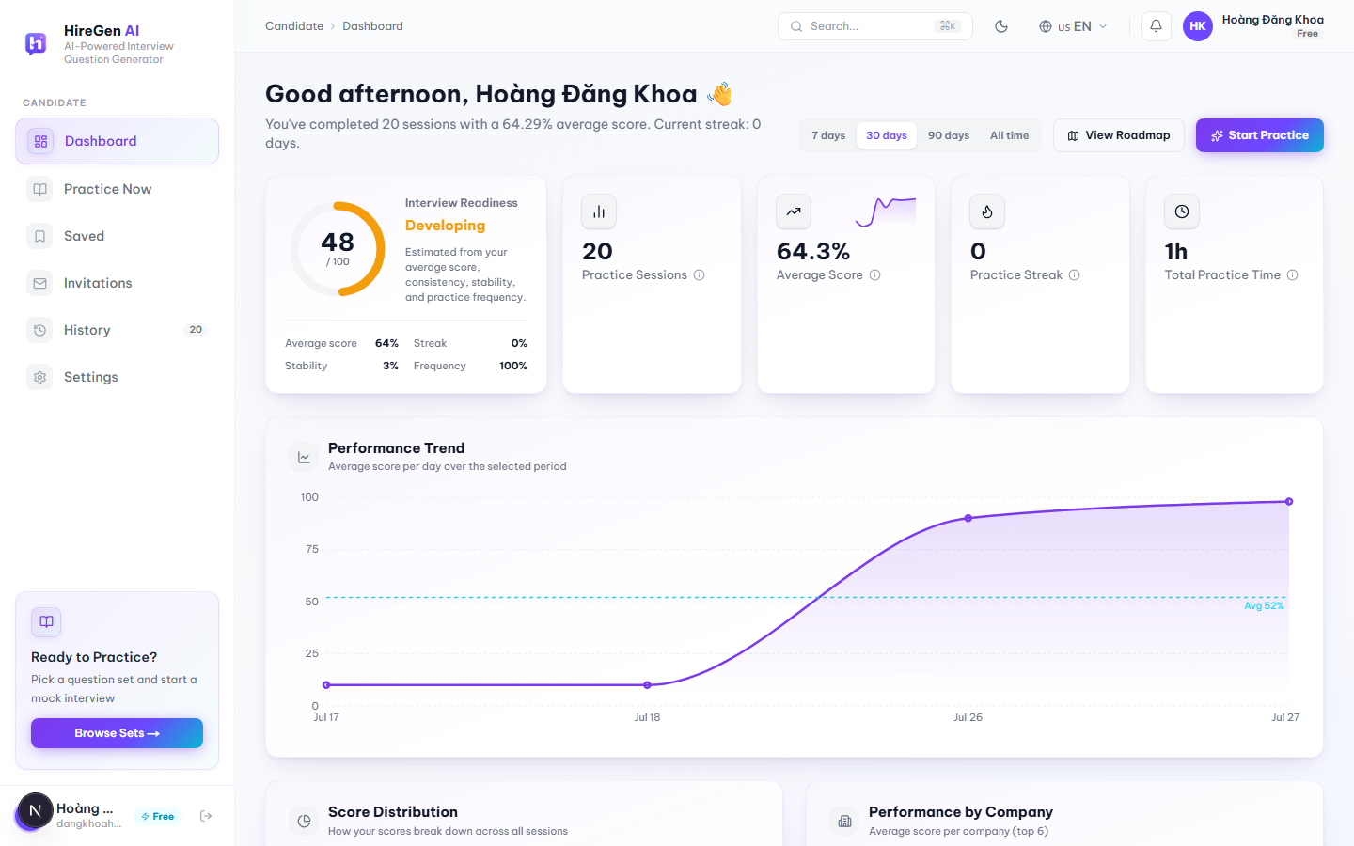
Figure 3.2.2.1. Candidate Dashboard, loaded state with real account data.

3.2.2.1 Candidate Dashboard

Function trigger:
Shown right after a Candidate logs in. Candidates can also get back to it any time by clicking “Dashboard” in the sidebar.
Function description:
This is the candidate's home page. It pulls together past practice sessions, AI scores and a few recommendations so the candidate has one place to check how their interview prep is going.
Pre-condition:
- The candidate is logged in.
- Each widget loads on its own and can be in a loading, error or empty state independently — for example the score-distribution or skill-radar charts stay empty until there is enough AI-scored practice data to draw them.
Function detail:
- Time range filter with options 7 days, 30 days, 90 days and All time. Switching it recalculates every KPI and chart below.
- KPI row shows Interview Readiness (a 0–100 score with a label like “Developing”), Practice Sessions, Average Score, Practice Streak and Total Practice Time.
- A Performance Trend chart plots average score per day for the selected range against the candidate's overall average.
- Score Distribution, Performance by Company, Skill Radar, Practice Heatmap, Weekly Goal and Role Readiness widgets only render once there is enough AI-scored data; before that they show a short guidance message instead of an empty chart.
- An AI Career Coach panel gives a short recommendation based on recent scores and weak skills, with a “View Roadmap” link.
- The Recent Practice list lets the candidate reopen a past session's feedback or retry the same set.
- Recommended Question Sets can be bookmarked straight from the dashboard card.
- The “Start Practice” button at the top of the page jumps straight to the marketplace.

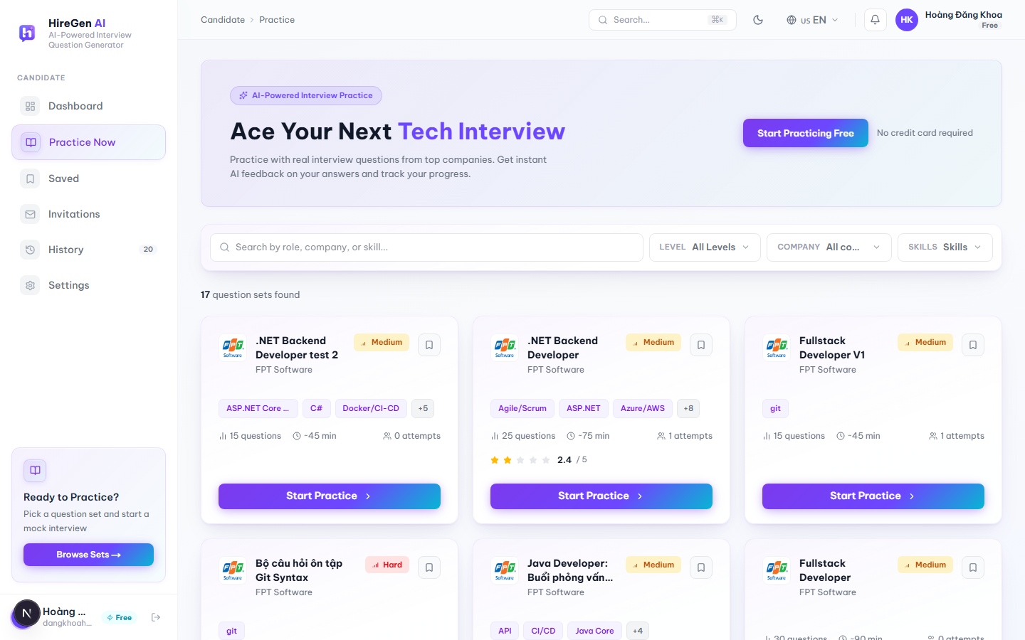
Figure 3.2.2.2. Practice Now / Question Set Marketplace, 17 published sets.

3.2.2.2 Question Set Marketplace (Practice Now)

Function trigger:
Candidate clicks “Practice Now” in the sidebar, or “Browse Sets” / “Start Practice” on the Dashboard.
Function description:
Where candidates browse and filter the published question sets to find one worth practicing with.
Pre-condition:
- Candidate is authenticated.
- At least one question set must already be published, otherwise the list has nothing to show.
Function detail:
- Search box (400 ms debounce) is meant to match role, company or skill. In practice the backend keyword filter only matches the set title, so the client pulls a larger page of results and also matches company name and skills locally — otherwise searching by company wouldn't work at all.
- Filters for Difficulty (single-select), Company (single-select with its own search box) and Skills (multi-select with search and a “Clear all” button) are available; changing any of them resets the list back to page 1.
- Each card shows the company logo/name, difficulty pill, question count, estimated time, how many attempts it's had, average rating if there is one, up to 3 skill tags plus a “+N” overflow, and a bookmark icon.
- Pagination is done with numbered page buttons (9 sets per page), not infinite scroll.
- Loading, error-with-retry and empty (no matching set) states are all handled.
- Clicking a card's title or its “Start Practice” button opens the Question Set Detail page.

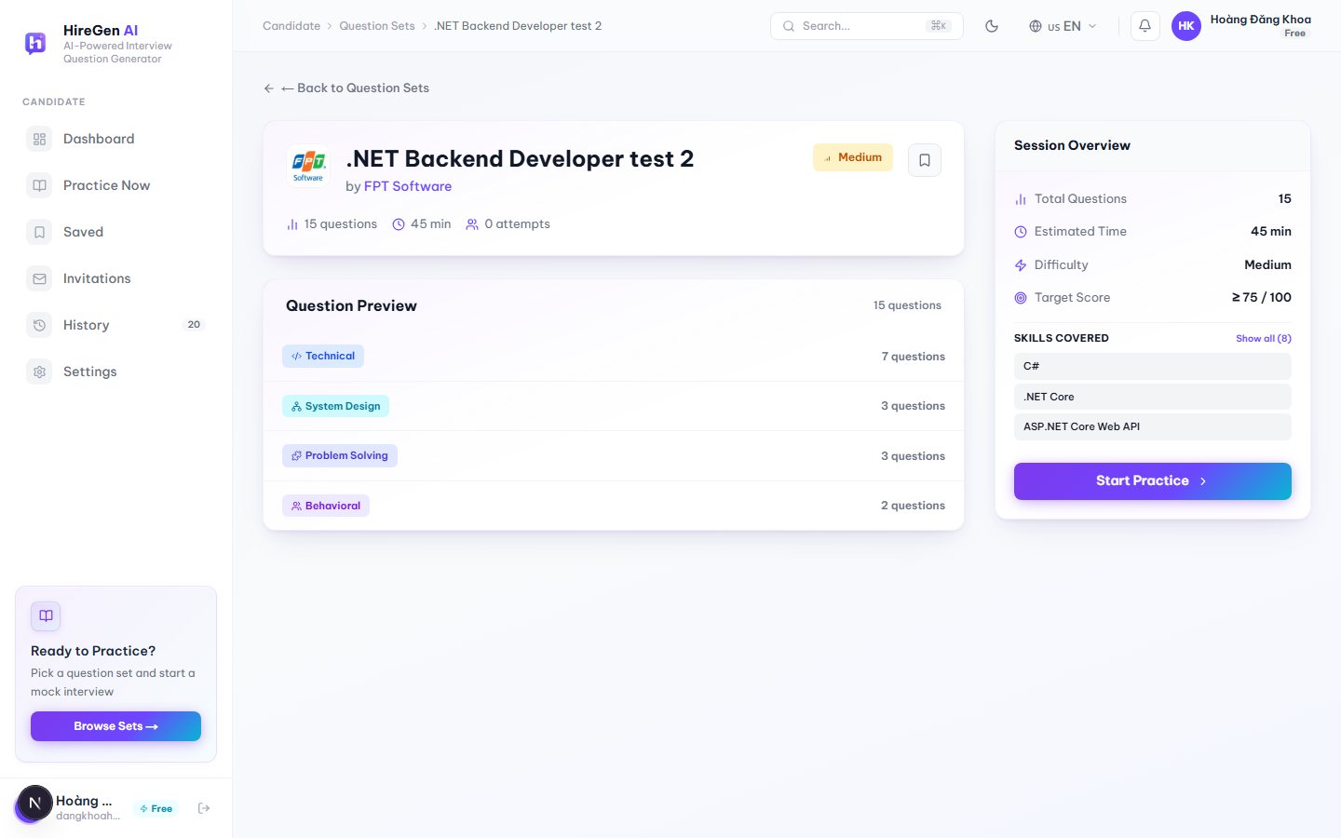
Figure 3.2.2.3. Question Set Detail page.

3.2.2.3 Question Set Detail

Function trigger:
Reached by opening a set from the Marketplace, the Dashboard, Saved Sets, an interview invitation, or “Retry” in History.
Function description:
Shows what a candidate needs before deciding to start the mock interview: difficulty, target score, question mix and so on.
Pre-condition:
- Candidate is authenticated.
- The set exists and is published.
Function detail:
- The header has the company logo, the set title, a “by [Company]” link that opens the Company Info Modal, a difficulty pill and a bookmark toggle.
- A Question Preview lists the question categories actually present in the set (Technical, System Design, Problem Solving, Behavioral, etc. — not a fixed 3-value list) with a count per category.
- The Session Overview card on the right shows Total Questions, Estimated Time, Difficulty and a fixed Target Score of “≥ 75 / 100”, plus the set's skills (first 3 shown, “Show all (N)” to expand).
- The main call-to-action reads “Start Practice” when there's no active attempt, or “Continue” once an IN_PROGRESS session already exists for this set.
- A “Start New” button only appears when there's an in-progress session; it asks for confirmation before it abandons that attempt and starts a fresh one.

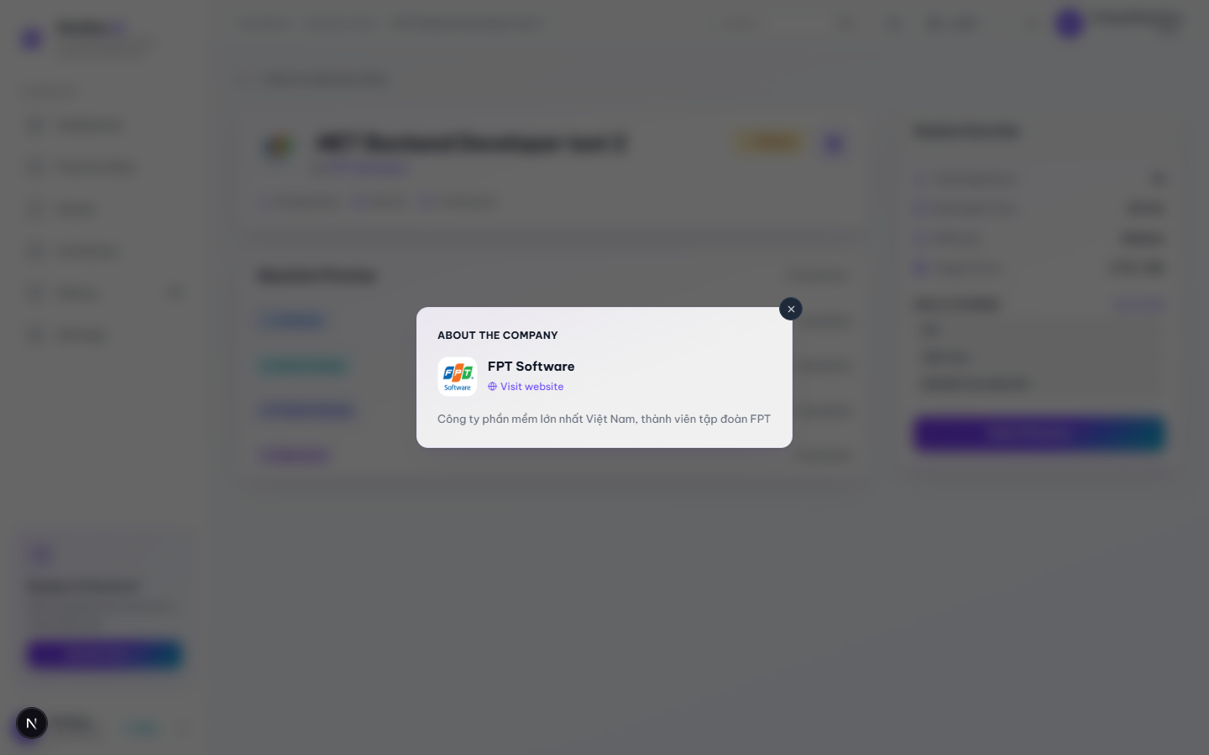
Figure 3.2.2.4. Company Info Modal opened from Question Set Detail.

3.2.2.4 Company Info Modal

Function trigger:
Candidate clicks the company name link on the Question Set Detail page.
Function description:
A quick look at the hiring company without leaving the set detail page.
Pre-condition:
- The selected question set has a company profile attached.
Function detail:
- Shows the company logo, name, a “Visit website” link if one exists, and a short description.
- Any field with no data (e.g. no description) is just left out — there's no empty placeholder text.
- Can be closed with the × button or by clicking the dark area outside the card. Note it does not close on Esc, unlike the Upgrade to Premium modal.

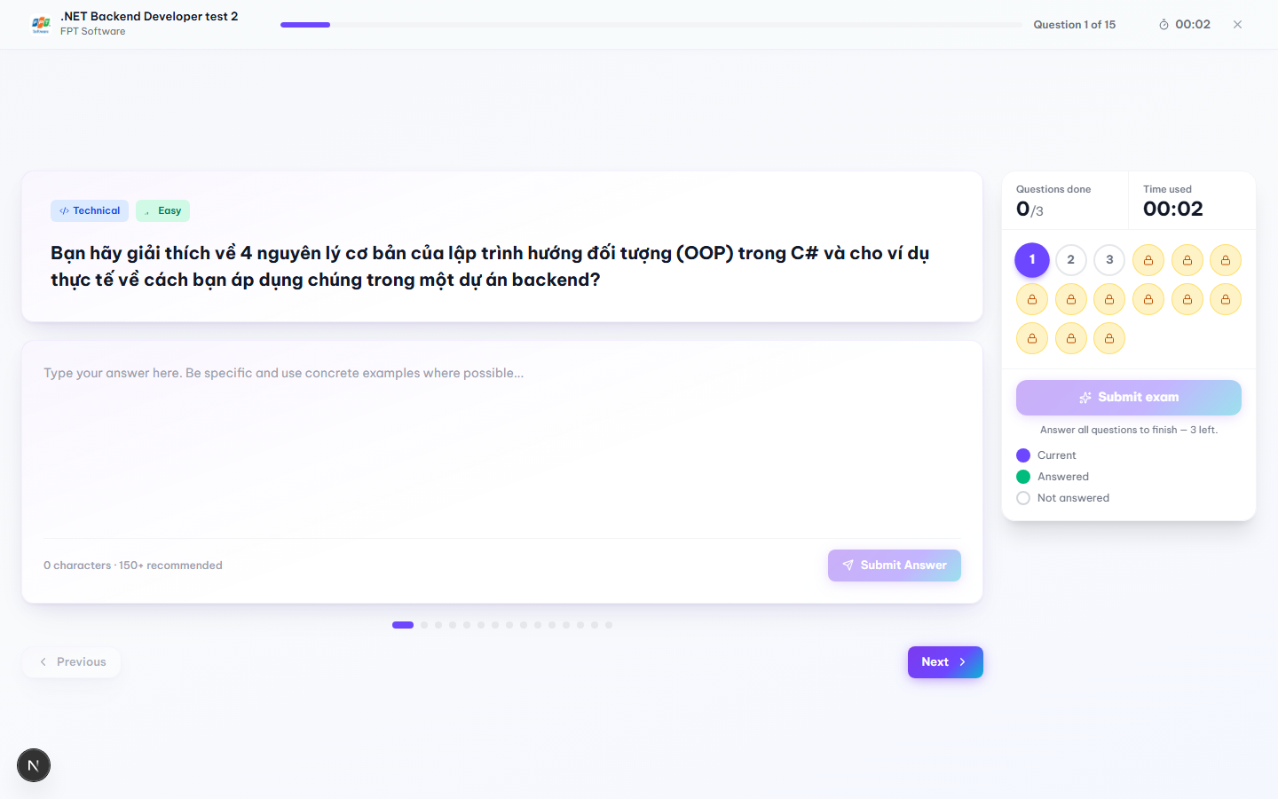
Figure 3.2.2.5a. Practice Session, answering an unlocked question.
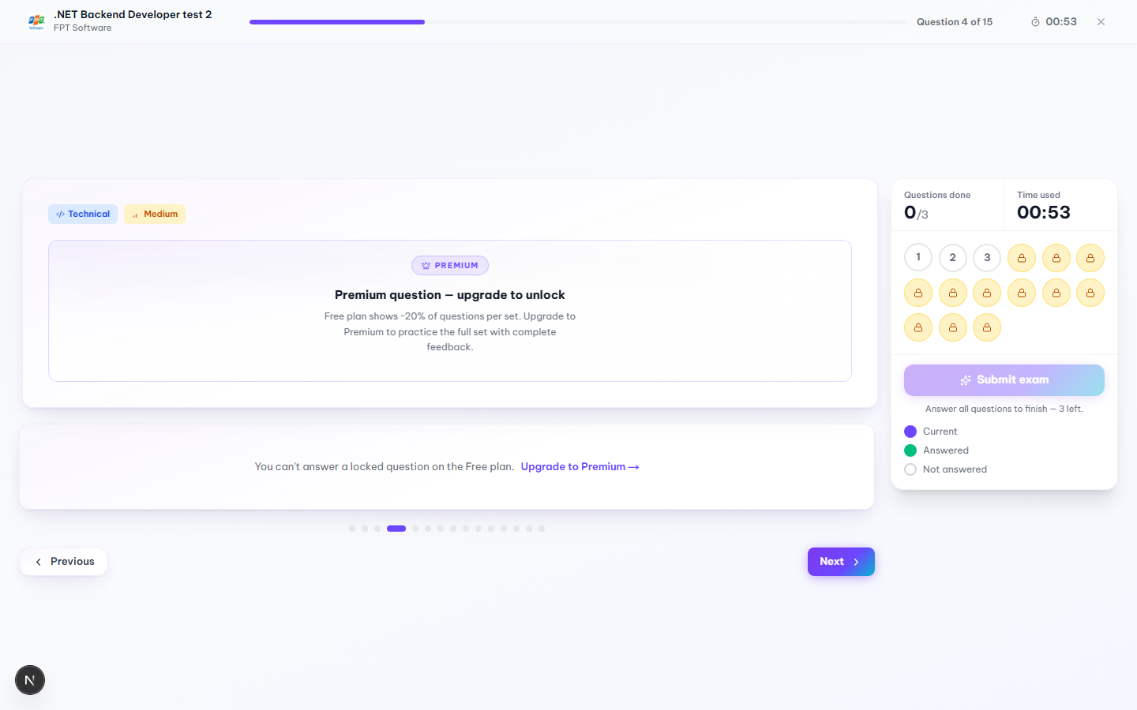
Figure 3.2.2.5b. Free-plan question locking inside an active session; the actual in-app text reads “Free plan shows ~20% of questions per set.”

3.2.2.5 Practice Session (Mock Interview)

Function trigger:
“Start Practice” / “Continue” on the Question Set Detail page, or “Retry” / “Practice Again” from Dashboard, History, Saved Sets or the Feedback page.
Function description:
This is where the actual mock interview happens — one question at a time, free-text answers, and each answer gets AI-scored right after it's submitted.
Pre-condition:
- Candidate is authenticated and allowed to access the selected set.
- The Free-plan practice-attempt quota hasn't been used up (if it has, the backend returns 403 and the candidate sees a “start forbidden” screen instead of the session).
- A new session is started, or an existing IN_PROGRESS one is resumed, successfully.
Function detail:
- Opening the page either starts a new session or silently resumes an unfinished one. When it resumes, a “Resumed” badge shows up, a toast confirms it, and previously submitted answers are already filled in.
- Free-plan accounts only get a portion of a set's questions unlocked — in the set tested, 3 out of 15 (about 20%), matching the real message shown in the app. Locked questions appear blurred with a “Premium” badge and an “Upgrade to Premium” button; clicking it opens the Upgrade modal without losing session progress. The answer box on a locked question is replaced with “You can't answer a locked question on the Free plan.”
- “Submit Answer” stays disabled while the box is empty. On submit, the answer needs at least 20 characters and 3 words — otherwise the message “Answer too short — please write at least 20 characters.” appears and the submission is blocked.
- Typed answers are auto-saved to the browser's session storage as the candidate types. The UI shows “Saving draft…” about 600 ms after the last keystroke, then “Draft saved” for roughly 2 seconds. If the page gets reloaded, an unsubmitted draft comes back automatically.
- After a valid submit the answer goes off for AI scoring and the box shows “AI is evaluating your answer…”. Once scored, the question turns green and the session moves to the next question after about 600 ms.
- A question grid on the right shows every question's state — current, answered, unanswered or locked — and the candidate can jump to any unlocked one directly. Previous/Next buttons step through in order.
- For timed sets there's a countdown based on the session's absolute expiry time from the backend; it turns red under 5 minutes left and stays accurate even if the tab loses focus, since it re-syncs when the tab becomes visible again. Untimed sets show elapsed time instead.
- If the countdown hits zero, the session is force-submitted right away and the candidate is sent to the result page — the review dialog is skipped in that case.
- “Finish & Get Feedback” only becomes clickable once every unlocked question has an answer. Confirming the dialog in §3.2.2.7 finishes the session and sends the candidate to the AI Feedback page.
- If there's unsaved typed text in the answer box, closing or refreshing the tab triggers the browser's native “leave site?” warning.

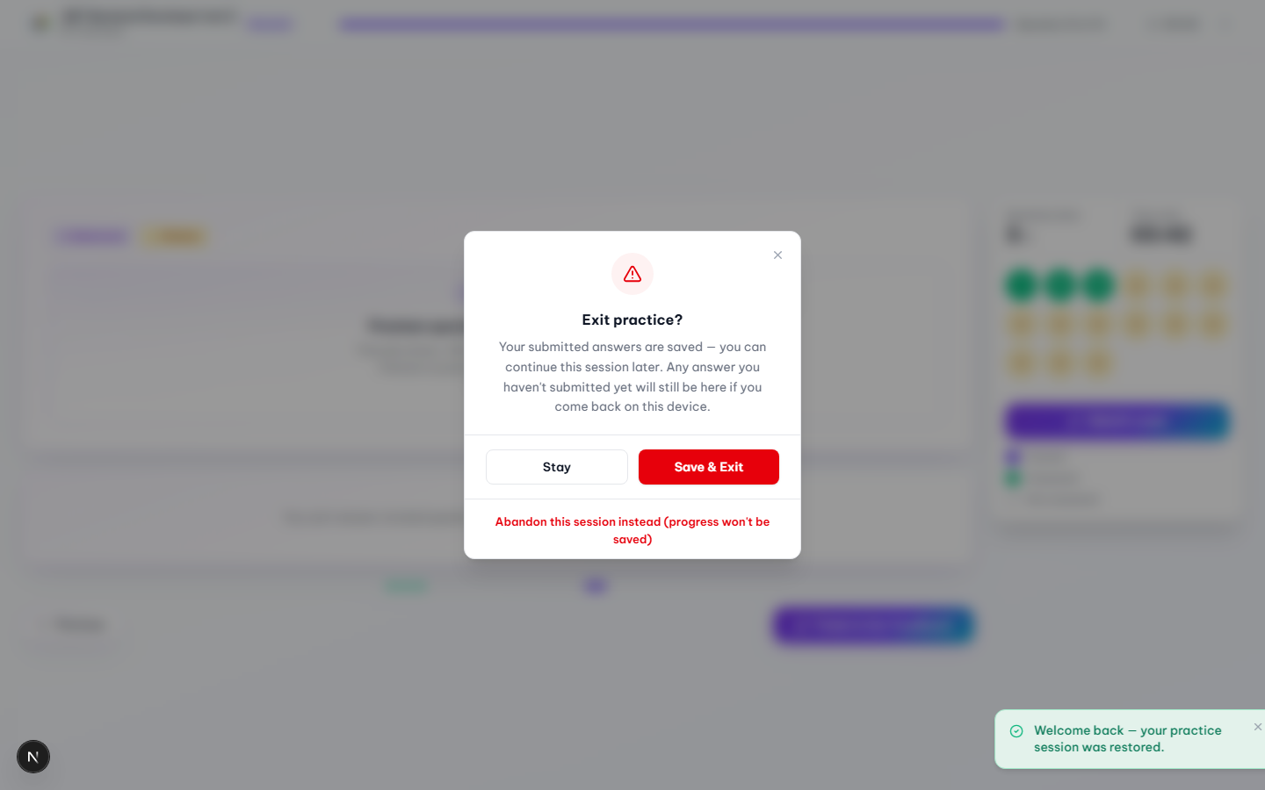
Figure 3.2.2.6. Exit practice confirmation dialog.

3.2.2.6 Exit Practice Confirmation Dialog

Function trigger:
Candidate clicks the × icon in the header of an active practice session.
Function description:
A safety step before leaving a mock interview midway, so the candidate doesn't accidentally lose an attempt.
Pre-condition:
- A practice session is currently in progress.
Function detail:
- Stay just closes the dialog and keeps the candidate on the current question. Nothing changes.
- Save & Exit leaves the page right away. Answers already submitted stay saved, so the candidate can pick the session back up later, either from this device or via “Continue” on the set detail page.
- Abandon this session instead is a smaller text link below the two main buttons. It permanently cancels the attempt — status becomes ABANDONED and unsaved progress is thrown away — so a fresh attempt can be started right after.

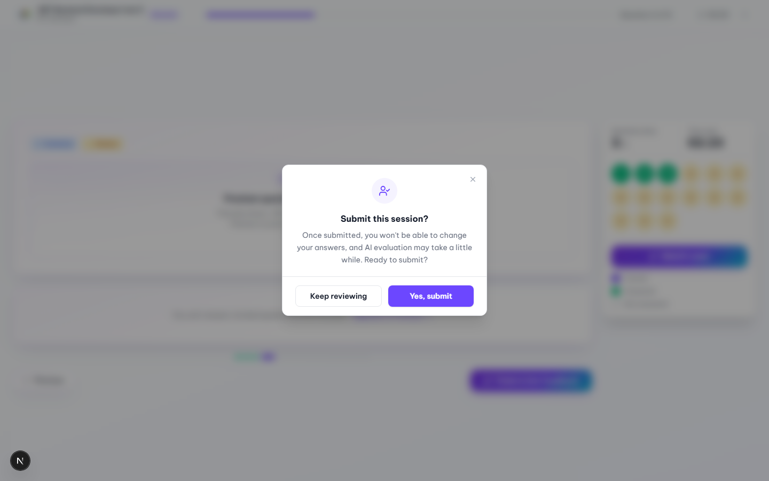
Figure 3.2.2.7. Submit-session confirmation dialog, shown once every unlocked question has an answer.

3.2.2.7 Submit Session Confirmation Dialog

Function trigger:
Candidate clicks “Finish & Get Feedback” (or “Submit exam” in the sidebar) after answering every unlocked question.
Function description:
One last check before answers are locked in, since nothing can be edited once the session is submitted.
Pre-condition:
- Every unlocked question in the session already has a submitted answer.
Function detail:
- The dialog text warns that answers can't be changed afterward and that AI evaluation may take a moment.
- Keep reviewing closes the dialog and leaves the session as it is.
- Yes, submit finishes the session and takes the candidate to the AI Feedback & Result page.

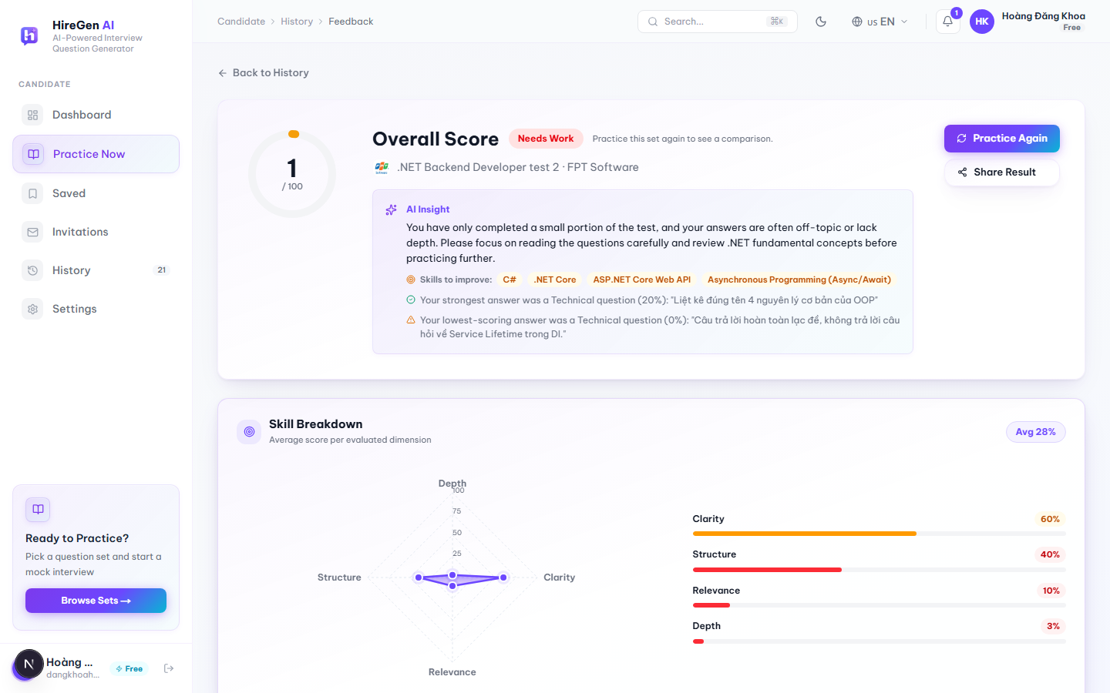
Figure 3.2.2.8a. AI Feedback & Result Report: overall score, AI Insight, Skill Breakdown.
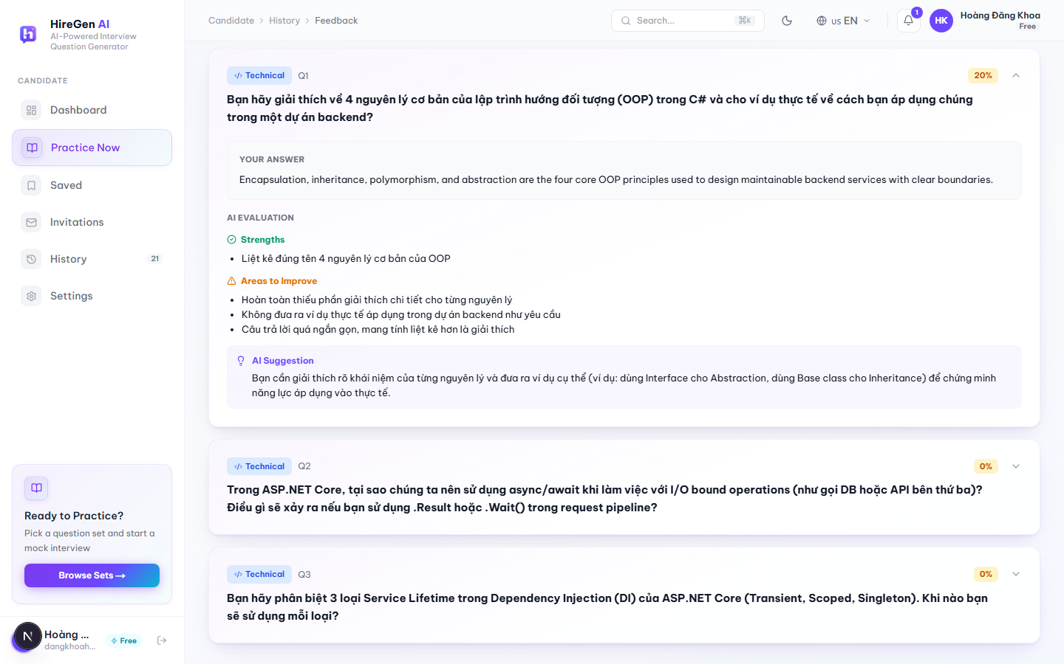
Figure 3.2.2.8b. Question-by-Question Review, with Strengths, Areas to Improve and an AI Suggestion.

3.2.2.8 AI Feedback & Result Report

Function trigger:
Opens automatically right after a session finishes (or auto-submits), or via “View” from the Dashboard, Practice History, or a shared result link.
Function description:
The full AI write-up for one completed mock interview.
Pre-condition:
- The session status is COMPLETED.
- Route: /jobseeker/practice/[sessionId]/result.
Function detail:
- An Overall Score (0–100) is shown with a label such as “Needs Work”. On a first attempt it says “Practice this set again to see a comparison”; on later attempts it compares the score against the previous one.
- AI Insight gives a short write-up plus “Skills to improve” tags, and calls out the single strongest and single weakest answer with a quoted excerpt from each.
- Skill Breakdown is a radar chart plus bars for Clarity, Structure, Relevance and Depth with an average badge; it only shows up once there's real scoring data — no numbers are made up to fill the chart.
- Action Plan lists up to 3 improvement suggestions, built from the weakest-scoring answers.
- Question-by-Question Review lets each question expand or collapse (the first one is open by default), showing the candidate's answer plus AI-identified strengths, areas to improve, and a suggestion.
- “Practice Again” starts a new session on the same set; “Share Result” copies the result link to the clipboard.
- If the score isn't ready yet, the rest of the page still shows normally while it quietly polls every 3 seconds, up to 8 tries, before giving up.
- A small celebration animation plays when the score is 80 or above.

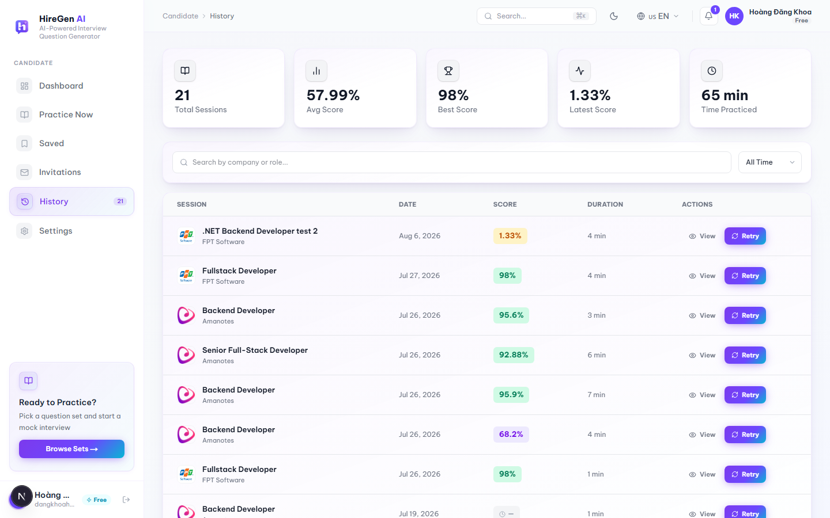
Figure 3.2.2.9. Practice History, 21 completed sessions.

3.2.2.9 Practice History

Function trigger:
Candidate clicks “History” in the sidebar.
Function description:
A record of every completed mock interview, with a way back into each one's AI feedback.
Pre-condition:
- Candidate is authenticated.
- An empty state is shown instead of the table if there are no completed sessions yet.
Function detail:
- Summary numbers at the top: Total Sessions, Average Score, Best Score, Latest Score, Total Time Practiced.
- There's a search box (350 ms debounce) by company or role, and a time filter — All Time, This Week, This Month.
- The table itself lists company/role, completion date, AI score (color-coded, or a pending indicator if scoring is still running), duration, and “View” / “Retry” actions per row.
- Sessions load 20 at a time; on mobile the table becomes a stack of cards instead.

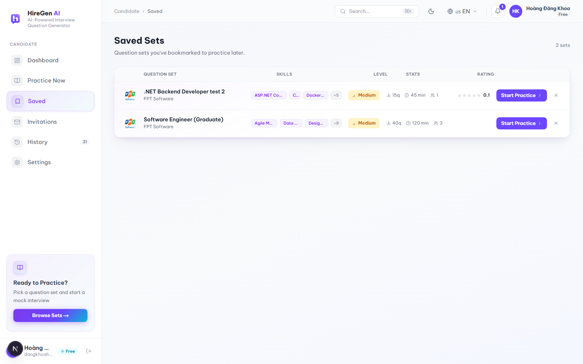
Figure 3.2.2.10. Saved Sets page.

3.2.2.10 Saved Sets (Bookmarks)

Function trigger:
Candidate clicks “Saved” in the sidebar, or the bookmark icon on any question-set card (Marketplace, Dashboard, Question Set Detail).
Function description:
A short list of question sets the candidate wants to come back to.
Pre-condition:
- Candidate is authenticated.
- If nothing has been bookmarked yet, an empty state with a hint is shown instead of the table.
Function detail:
- The table lists each saved set with its skills, difficulty, question count / estimated time / attempts, and rating.
- “Start Practice” launches that set's session right from the row.
- An × button removes the bookmark; the row disappears right away and a toast confirms it.
- Bookmark state is kept in sync everywhere — Marketplace, Dashboard, Question Set Detail and this page.

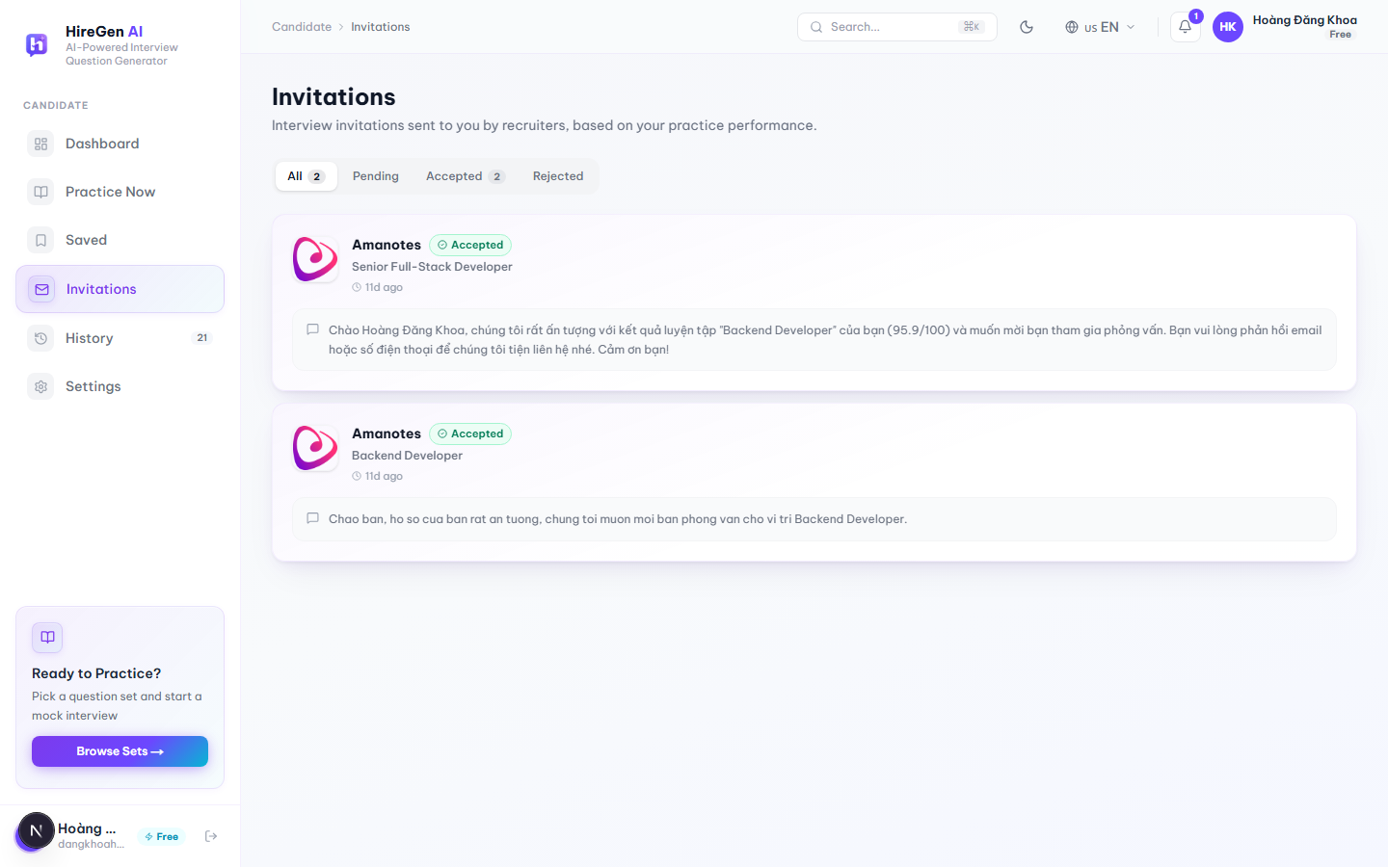
Figure 3.2.2.11. Interview Invitations page.

3.2.2.11 Interview Invitations

Function trigger:
Candidate clicks “Invitations” in the sidebar.
Function description:
Where recruiters' interview invitations show up, based on how the candidate has been performing in practice.
Pre-condition:
- Candidate is authenticated.
- An empty state is shown if there are no invitations.
Function detail:
- Status tabs — All, Pending, Accepted, Rejected — each with a live count.
- Each card shows the company logo/name, status, the recruiter's message, and how long ago it arrived.
- “Accept” isn't instant — it opens a small modal where the candidate can optionally add a message and a phone number (must be 10 digits, starting with 0) before confirming.
- “Decline” opens a confirmation dialog first (“Decline this invitation? … The recruiter will see that you declined.”) before the status flips to Rejected.
- If the invitation was already answered elsewhere — another tab or device, say — the app shows “You've already responded to this invitation.” instead of a generic error.

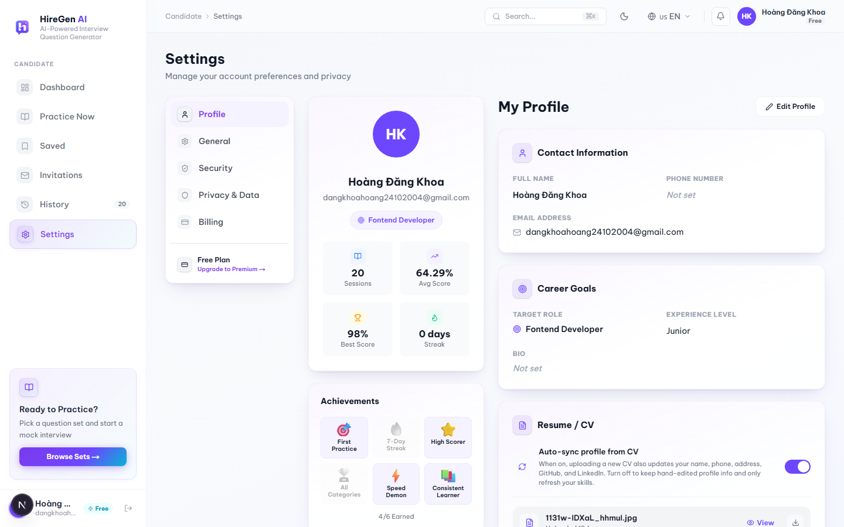
Figure 3.2.2.12a. Candidate Profile, view mode (Settings → Profile tab).
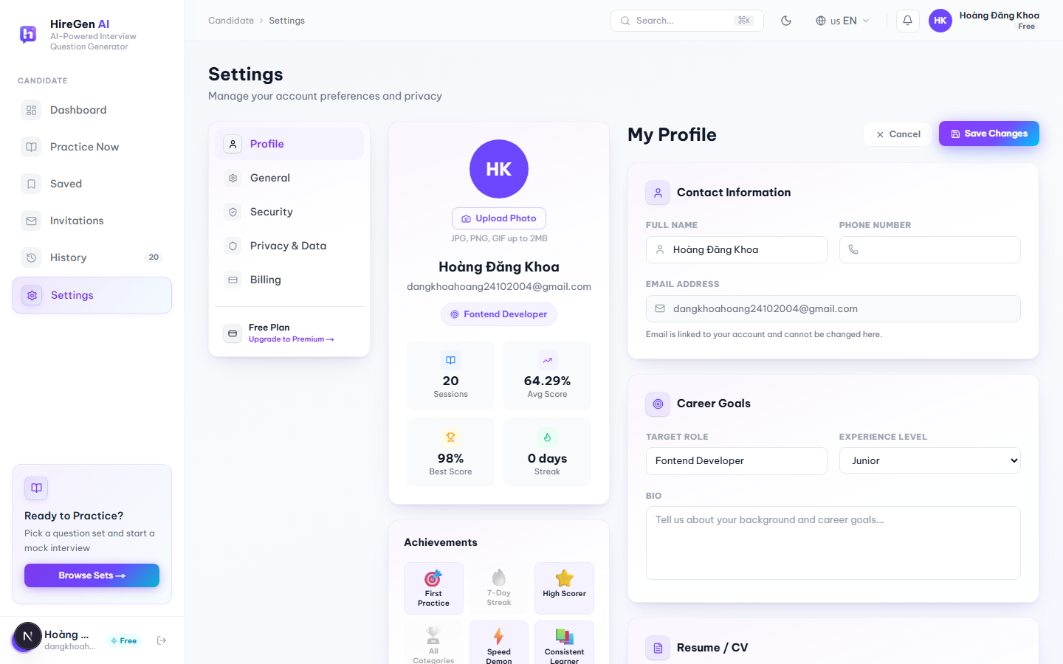
Figure 3.2.2.12b. Candidate Profile, edit mode.

3.2.2.12 Candidate Profile

Function trigger:
Candidate clicks “Settings” in the sidebar (Profile is the first tab, shown by default), or goes directly to /jobseeker/profile.
Function description:
Where a candidate keeps their personal info, career goals and CV up to date, including whatever the AI CV parser has picked up.
Pre-condition:
- Candidate is authenticated.
- Editing anything requires switching into Edit mode first.
Function detail:
- View mode shows an avatar, live stats (Sessions, Avg Score, Best Score, Streak), an Achievements strip (First Practice, 7-Day Streak, High Scorer, All Categories, Speed Demon, Consistent Learner — unlocked automatically from activity, shown as “x/6 earned”), Contact Information, Career Goals and Resume/CV.
- In Edit mode, Contact Information and Career Goals become editable inputs (email stays locked, since it's tied to the account); “Save Changes” saves and refreshes the profile, “Cancel” throws the edits away.
- Avatar photos can be JPG, PNG or GIF up to 2 MB, stored on Cloudinary.
- CV uploads accept PDF, DOCX, JPG or PNG. The backend runs an AI parser over it to pull out a summary and technical skills, which then overwrite “Skills & Expertise” automatically. An “Auto-sync profile from CV” toggle decides whether a new upload also overwrites name, phone, address, GitHub and LinkedIn. Each file can be viewed, downloaded, replaced or deleted.
- LinkedIn and GitHub links are validated before saving; a bad URL shows an inline error.

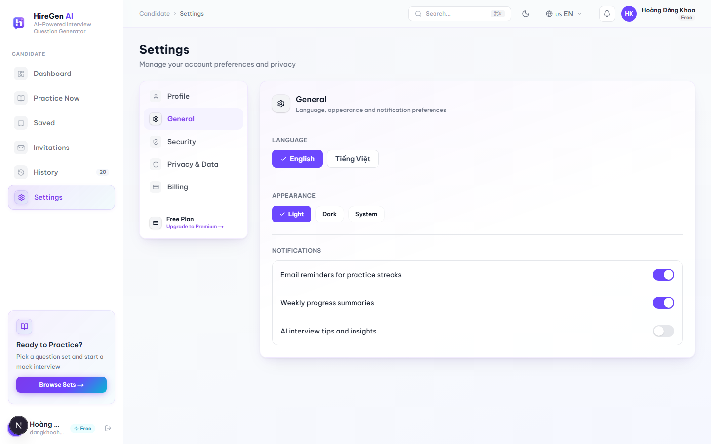
Figure 3.2.2.13. Settings, General tab.

3.2.2.13 Settings — General

Function trigger:
Settings → General tab (route: /jobseeker/settings?tab=general).
Function description:
General app preferences, not tied to any particular candidate data.
Pre-condition:
- Candidate is authenticated.
Function detail:
- Language can be switched between English and Tiếng Việt, and takes effect immediately across the app.
- Appearance can be set to Light, Dark or System.
- Notification toggles cover practice-reminder emails, weekly progress summaries, and AI interview tips.
- Which Settings tab is active is kept in the URL's `tab` query parameter, so a refresh or a shared link lands on the same tab.

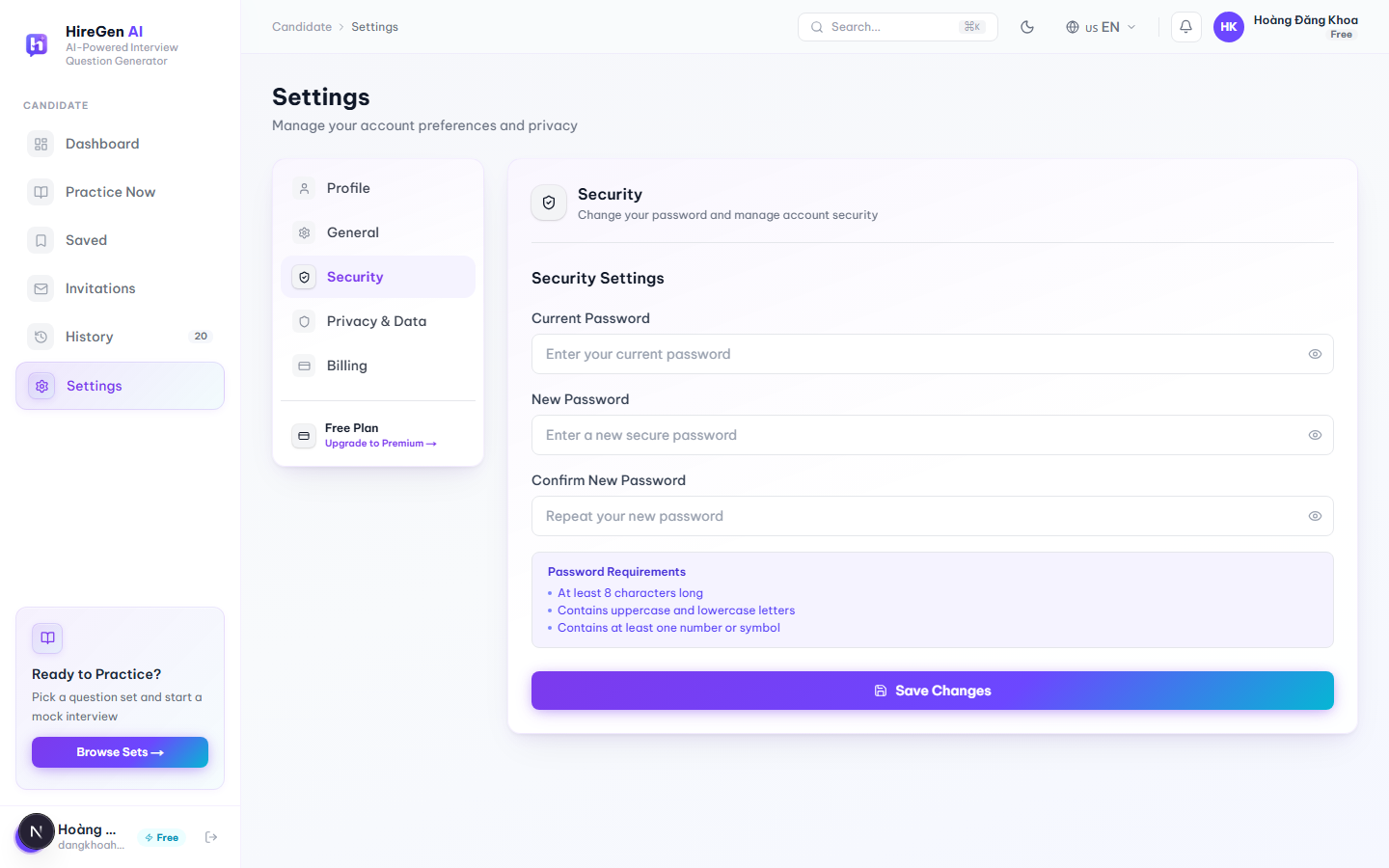
Figure 3.2.2.14. Settings, Security tab.

3.2.2.14 Settings — Security

Function trigger:
Settings → Security tab.
Function description:
Where a candidate changes their account password.
Pre-condition:
- Candidate is authenticated and knows their current password.
Function detail:
- The form has Current Password, New Password and Confirm New Password, each with a show/hide toggle.
- Password rules are shown right below the fields: at least 8 characters, upper- and lower-case letters, and at least one number or symbol.
- “Save Changes” sends the update to the backend.

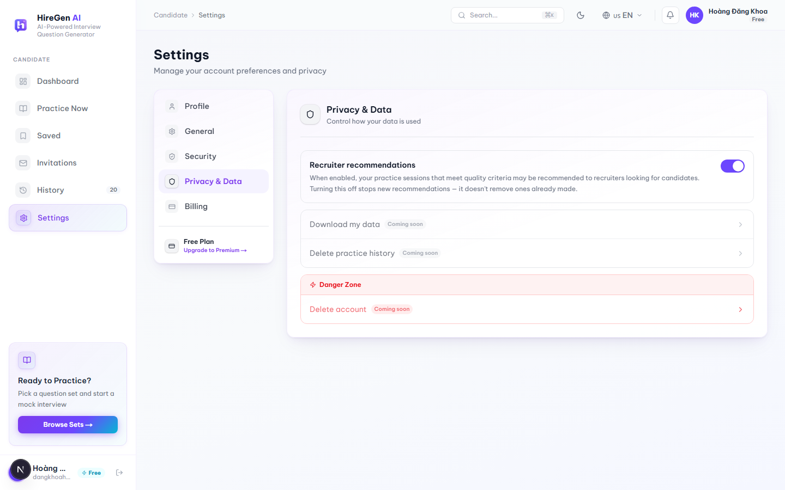
Figure 3.2.2.15. Settings, Privacy & Data tab.

3.2.2.15 Settings — Privacy & Data

Function trigger:
Settings → Privacy & Data tab.
Function description:
Controls what recruiters can see, plus a preview of some data-control tools that aren't live yet.
Pre-condition:
- Candidate is authenticated.
Function detail:
- A “Recruiter recommendations” toggle: while it's on, practice sessions that meet certain quality criteria may be recommended to recruiters. Turning it off only stops future recommendations — it doesn't undo anything already sent.
- “Download my data”, “Delete practice history” and “Delete account” (the last one sits in a red Danger Zone block) are all on the page but disabled, each labeled “Coming soon.”

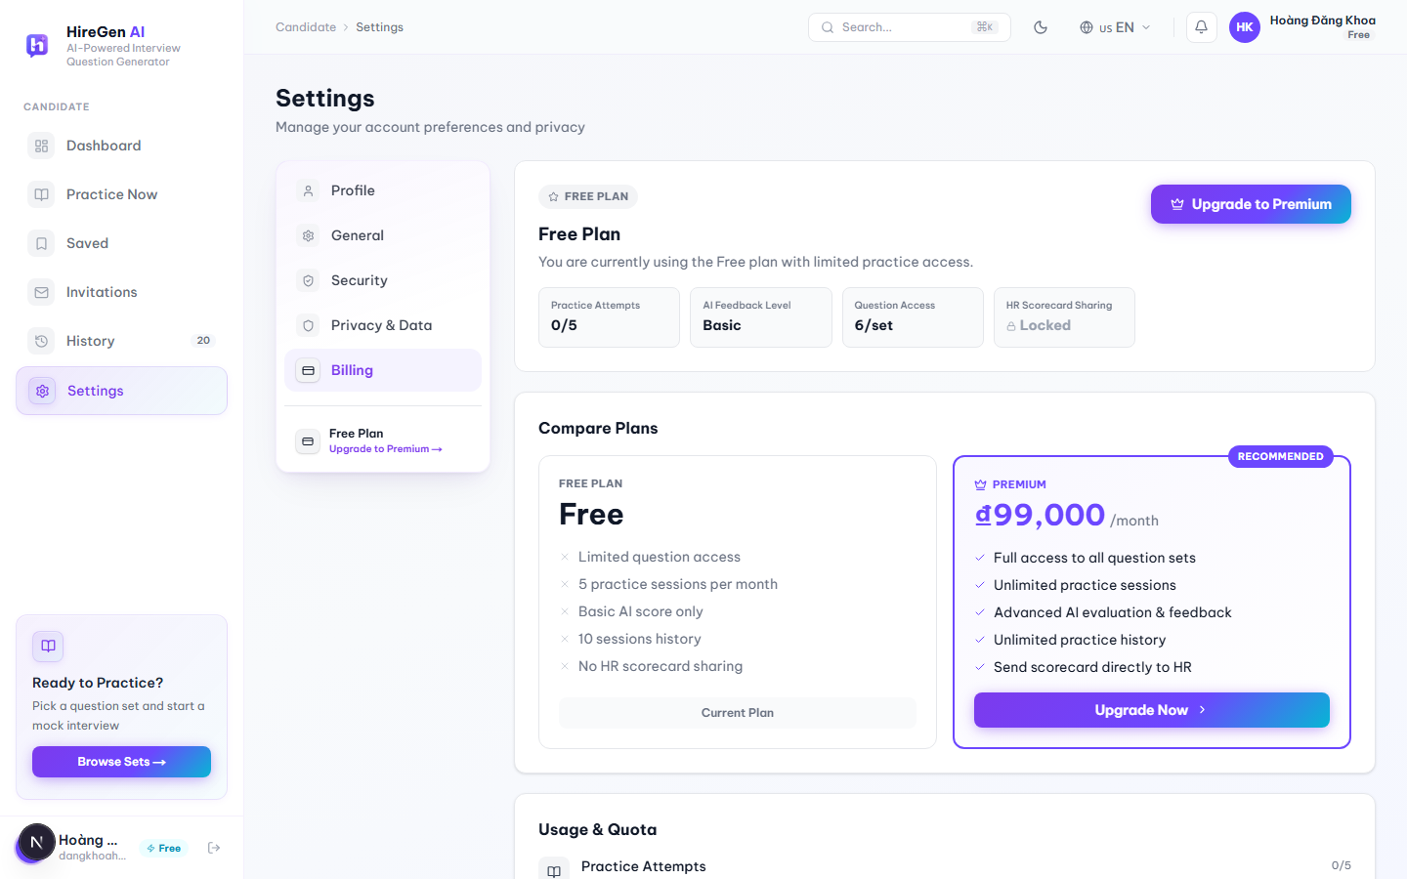
Figure 3.2.2.16. Settings, Billing tab, with real Free-plan quotas and the current Premium price.

3.2.2.16 Settings — Billing & Subscription

Function trigger:
Settings → Billing tab, or “Upgrade Premium” from the sidebar, Dashboard, or a locked practice question.
Function description:
Shows the candidate's current plan, how much of it they've used, and how it compares to Premium.
Pre-condition:
- Candidate is authenticated.
Function detail:
- The current-plan card shows a plan badge and four live numbers — on the Free plan these were Practice Attempts (0/5), AI Feedback Level (Basic), Question Access (6/set) and HR Scorecard Sharing (Locked).
- A Compare Plans section lines up Free (limited question access, 5 practice sessions a month, basic AI score only, 10 sessions of history, no HR scorecard sharing) against Premium (full access to all sets, unlimited sessions, advanced AI evaluation, unlimited history, scorecards can be sent to HR). Premium's price comes from the backend's live subscription plan rather than being hard-coded — 99,000 ₫/month at the time of testing.
- A Usage & Quota section repeats the same limits as progress bars, switching to a warning color once usage passes 80%.
- “Upgrade to Premium” / “Upgrade Now” opens the modal described in §3.2.2.17.

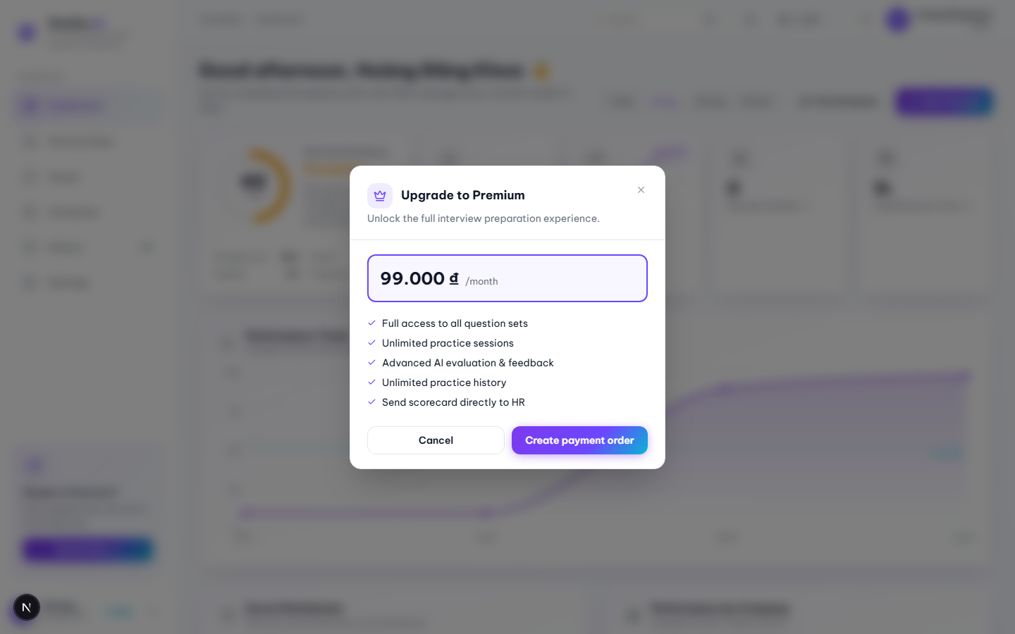
Figure 3.2.2.17. Upgrade to Premium modal, opened from the sidebar “Free” badge.

3.2.2.17 Upgrade to Premium Modal

Function trigger:
Candidate clicks the “Free” badge in the sidebar footer, “Upgrade to Premium” on the Billing tab, or the “Upgrade” button on a locked practice question.
Function description:
Lets a candidate start upgrading to Premium without leaving whatever page or session they were on.
Pre-condition:
- Candidate is currently on the Free plan.
Function detail:
- Shows the live monthly price pulled from the backend, plus a fixed list of Premium benefits: full access to all question sets, unlimited practice sessions, advanced AI evaluation, unlimited history, and sending scorecards directly to HR.
- “Create payment order” starts a QR-code payment flow and polls the order status until it's done; “Cancel” just closes the modal.
- Can be closed with the × button, the Esc key, or by clicking outside it.
- If it's opened from inside a practice session, a successful upgrade unlocks that session's locked questions right away — no reload needed — and a toast confirms it.

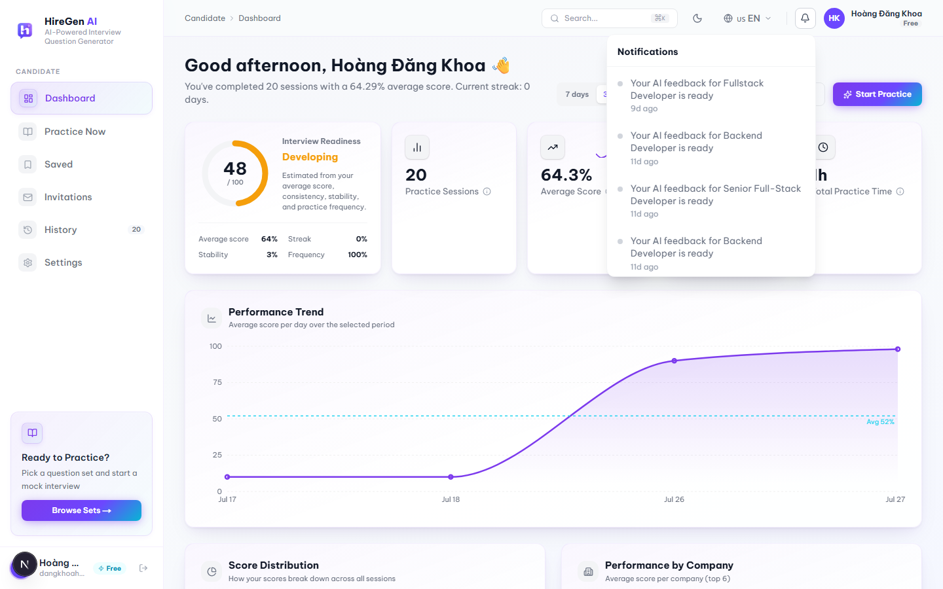
Figure 3.2.2.18. Notification bell dropdown.

3.2.2.18 Notification Bell

Function trigger:
Candidate clicks the bell icon in the top bar; it's available on every candidate page.
Function description:
A quick way to catch recent activity without going into History or Invitations directly.
Pre-condition:
- Candidate is authenticated.
Function detail:
- Notifications aren't a separate backend feed — they're put together on the client from two things: the 5 most recently completed practice sessions (“Your AI feedback for … is ready”) and any pending interview invitations.
- An unread-count badge sits on the bell icon; read/unread state is tracked per device in the browser and merged back in whenever the list loads.
- Clicking a notification jumps to the matching Feedback Result page or the Invitations page.
- The panel closes when the candidate clicks anywhere outside it.

3.2.3 Admin Interface
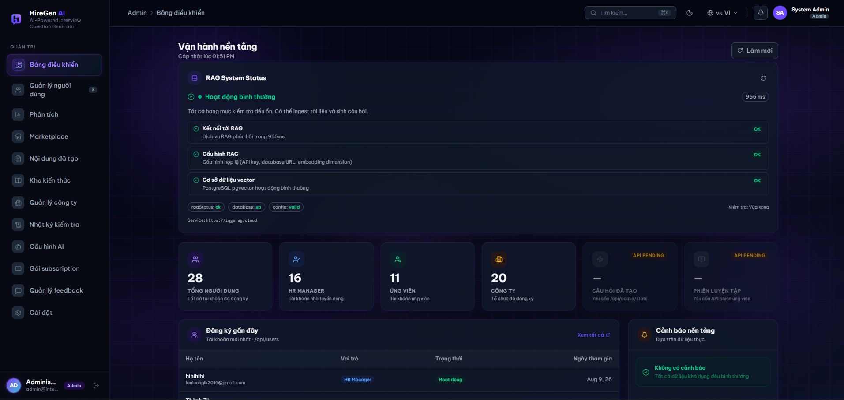
Figure 3.2.3.1. Admin Dashboard (Platform Operations), loaded state with real platform data.

3.2.3.1 Admin Dashboard (Platform Operations)

Function trigger: Shown right after a System Admin logs in. Admins can also get back to it any time by clicking “Bảng điều khiển” (Dashboard) in the sidebar.
Function description: Platform-wide operations overview for System Admins — surfaces RAG pipeline health alongside platform usage counters, recent account registrations, and system alerts.
Pre-condition:
- The user is logged in with the Administrator role.
Function detail:
- RAG System Status card reports overall health (“Hoạt động bình thường” / operating normally) with response time, plus three individual checks — RAG connectivity, RAG configuration, and the vector database — each shown as OK, along with raw status badges (ragStatus, database, config) and the RAG service endpoint URL. A “Làm mới” (Refresh) button re-runs the check.
- KPI summary row shows six cards: total users, HR Manager accounts, candidate accounts, and registered companies are live; questions-generated and practice-sessions counters are marked “API PENDING” — not yet wired to their backing endpoints.
- Đăng ký gần đây (Recent Registrations) table lists the newest accounts with name/email, role, status and join date, with a “Xem tất cả” link.
- Cảnh báo nền tảng (Platform Alerts) panel shows alerts derived from real platform data; displays “Không có cảnh báo” (no alerts) when nothing is flagged.

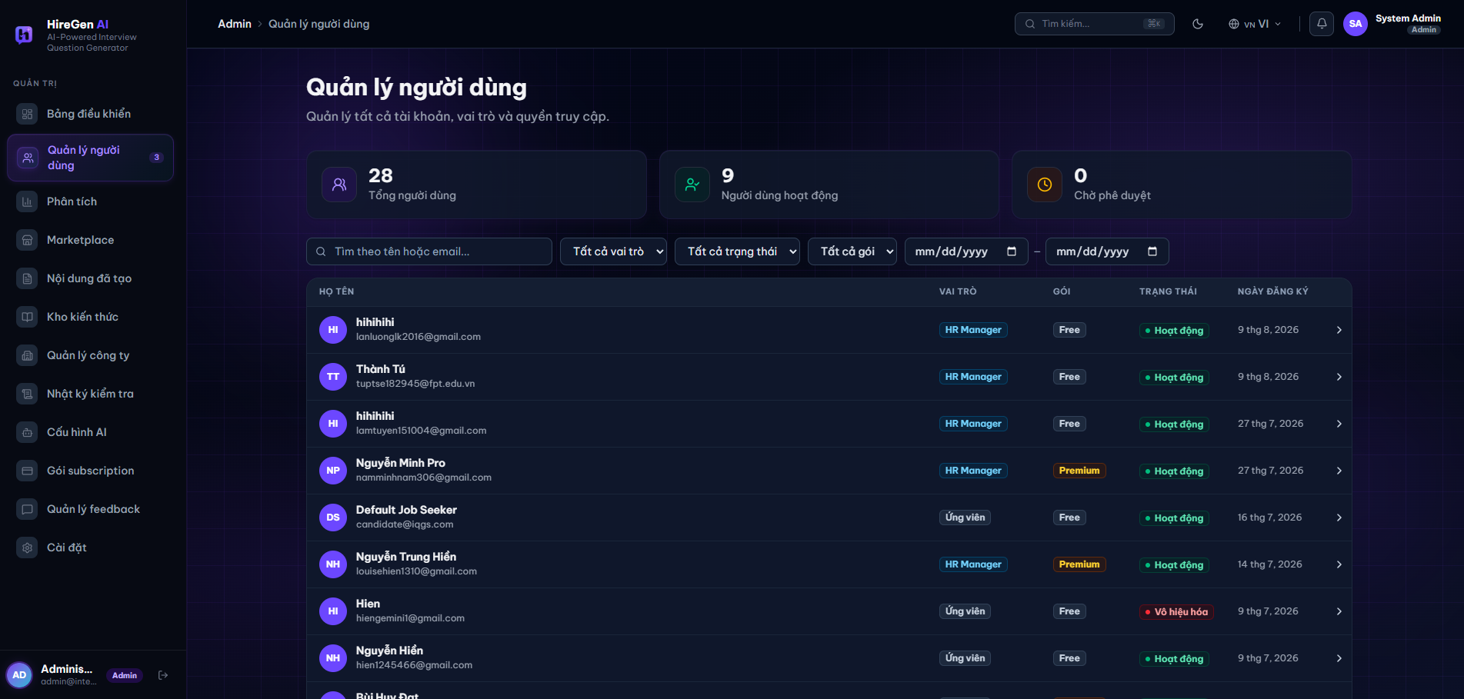
Figure 3.2.3.2. User management list.

3.2.3.2 User Management (Quản lý người dùng)
Function trigger: Opened by clicking “Quản lý người dùng” in the Admin sidebar.
Function description: Lets the Admin view and manage every account on the platform — role, subscription package and status — across both HR Managers and Candidates.
Pre-condition:
- The user is logged in with the Administrator role.
Function detail:
- Summary cards show Tổng người dùng (Total users), Người dùng hoạt động (Active users) and Chờ phê duyệt (Pending approval) counts.
- Filter bar lets the Admin search by name or email and filter by role, status, package and registration date range.
- Users table lists each account's Họ tên (name/avatar/email), Vai trò (role — e.g. HR Manager, Ứng viên), Gói (package — Free/Premium), Trạng thái (Hoạt động/Vô hiệu hóa) and Ngày đăng ký (registration date), with a chevron to open the account's details.
- Sidebar badge on “Quản lý người dùng” flags how many accounts are pending review.
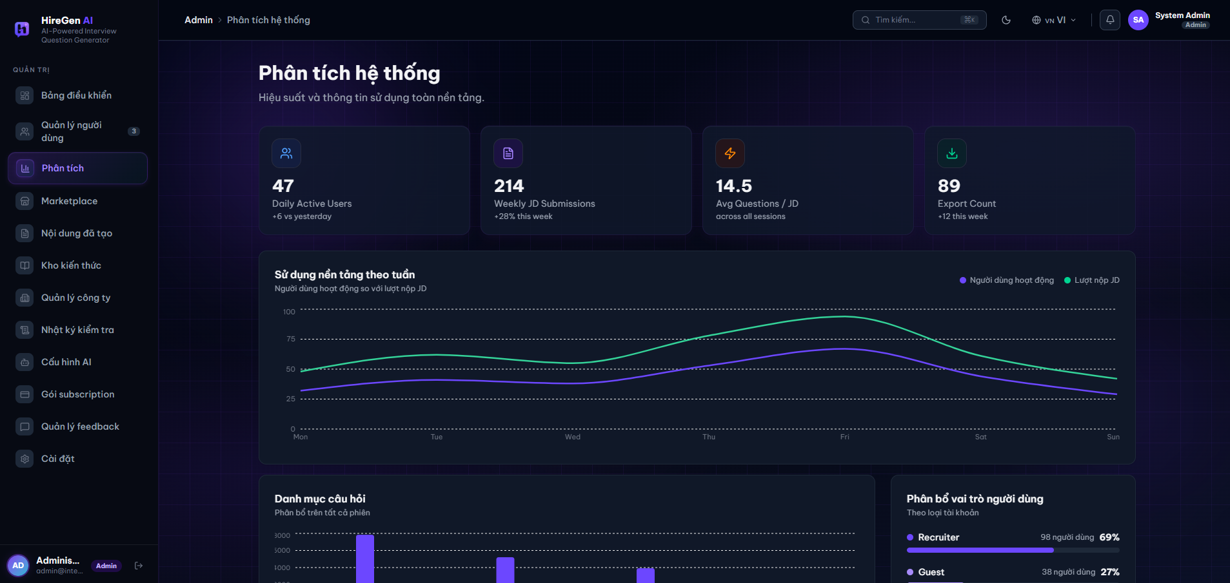
Figure 3.2.3.3. System analytics dashboard.

3.2.3.3 System Analytics (Phân tích hệ thống)
Function trigger: Opened by clicking “Phân tích” in the Admin sidebar.
Function description: Gives the Admin a platform-wide view of usage and performance so they can monitor adoption and spot trends across all HR Managers and Candidates.
Pre-condition:
- The user is logged in with the Administrator role.
Function detail:
- KPI summary row shows four cards: Daily Active Users, Weekly JD Submissions, Avg Questions / JD, and Export Count, each with a change indicator versus the previous period.
- Sử dụng nền tảng theo tuần chart is a line chart comparing Người dùng hoạt động (active users) against Lượt nộp JD (JD submissions) across the days of the week.
- Danh mục câu hỏi chart is a bar chart showing the distribution of generated questions across categories for all sessions.
- Phân bố vai trò người dùng panel breaks down the user base by account type (e.g. Recruiter, Guest) with counts and percentages.
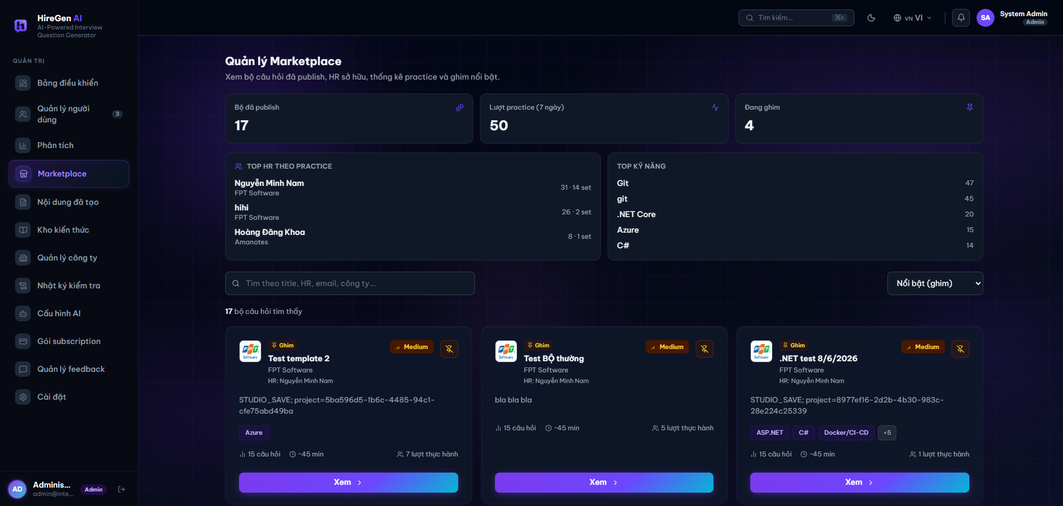
Figure 3.2.3.4. Marketplace management.

3.2.3.4 Marketplace Management (Quản lý Marketplace)
Function trigger: Opened by clicking “Marketplace” in the Admin sidebar.
Function description: Lets the Admin oversee every question set published to the Marketplace, see which sets are pinned as featured, and review practice/adoption statistics per HR Manager and skill.
Pre-condition:
- The user is logged in with the Administrator role.
Function detail:
- Summary cards show Bộ đã publish (Published sets), Lượt practice (7 ngày) (Practice attempts in the last 7 days) and Đang ghim (Currently pinned) counts.
- Top HR theo practice panel ranks HR Managers by total practice attempts and number of sets published.
- Top kỹ năng panel ranks the most common skill tags across published sets by frequency.
- Set grid lists each published set as a card with a Ghim (Pinned) badge when applicable, difficulty, owning company and HR Manager, description/tags, question count, estimated duration and practice-attempt count, a pin/unpin toggle, and a “Xem →” link to view it; results can be searched and sorted (e.g. “Nổi bật (ghim)” — Featured/pinned first).
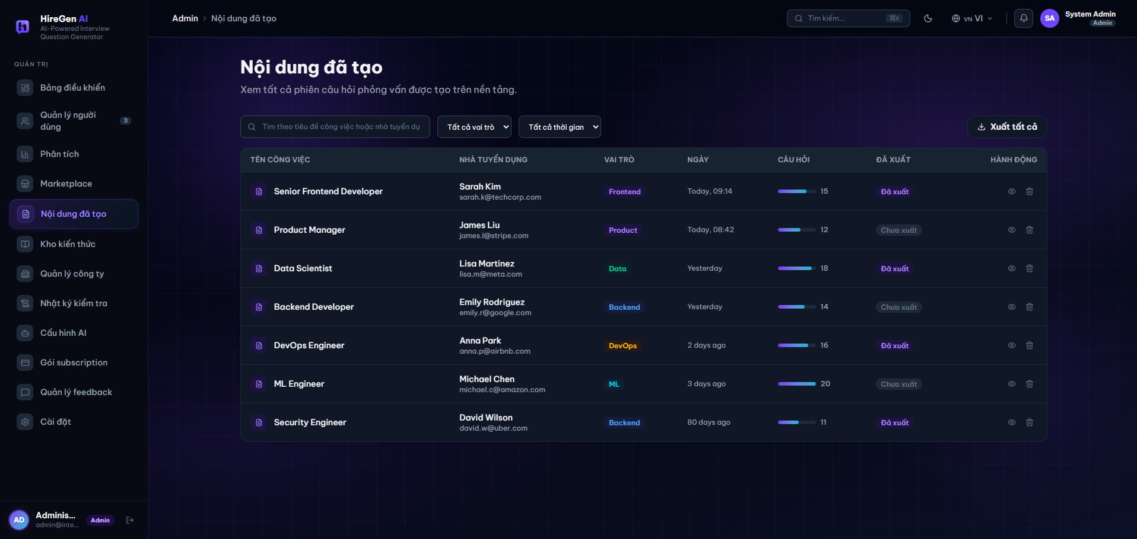
Figure 3.2.3.5. Generated content list.

3.2.3.5 Generated Content (Nội dung đã tạo)
Function trigger: Opened by clicking “Nội dung đã tạo” in the Admin sidebar.
Function description: Gives the Admin a global audit view of every interview-question session generated on the platform, regardless of which HR Manager created it.
Pre-condition:
- The user is logged in with the Administrator role.
Function detail:
- Filter bar lets the Admin search by job title or recruiter and filter by role and time range, plus a “Xuất tất cả” (Export all) action.
- Sessions table lists Tên công việc (job title), Nhà tuyển dụng (recruiter name/email), Vai trò (role tag), Ngày (date created), Câu hỏi (question count with progress indicator), Đã xuất (export status — Đã xuất/Chưa xuất) and row actions to view or delete the session.
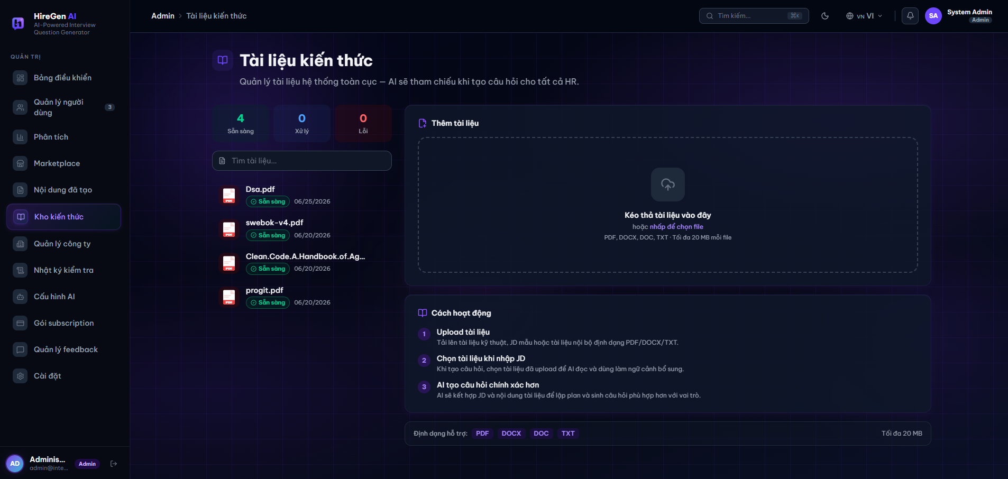
Figure 3.2.3.6. Global knowledge base.

3.2.3.6 Global Knowledge Base (Kho kiến thức)
Function trigger: Opened by clicking “Kho kiến thức” in the Admin sidebar.
Function description: The system-wide counterpart to the per-HR knowledge documents screen — documents uploaded here are available as AI context for question generation across all HR Managers, not just one account.
Pre-condition:
- The user is logged in with the Administrator role.
Function detail:
- Status summary shows counts of documents that are Sẵn sàng (Ready), Đang xử lý (Processing) and Lỗi (Failed) at the global scope.
- Document list shows each uploaded reference file (e.g. technical handbooks, standards documents) with its status badge and upload date, with a search box to filter.
- Thêm tài liệu panel is the same drag-and-drop / click-to-browse upload zone as the HR-level screen, accepting PDF, DOCX, DOC and TXT up to 20 MB, with the same 3-step “Cách hoạt động” explainer.
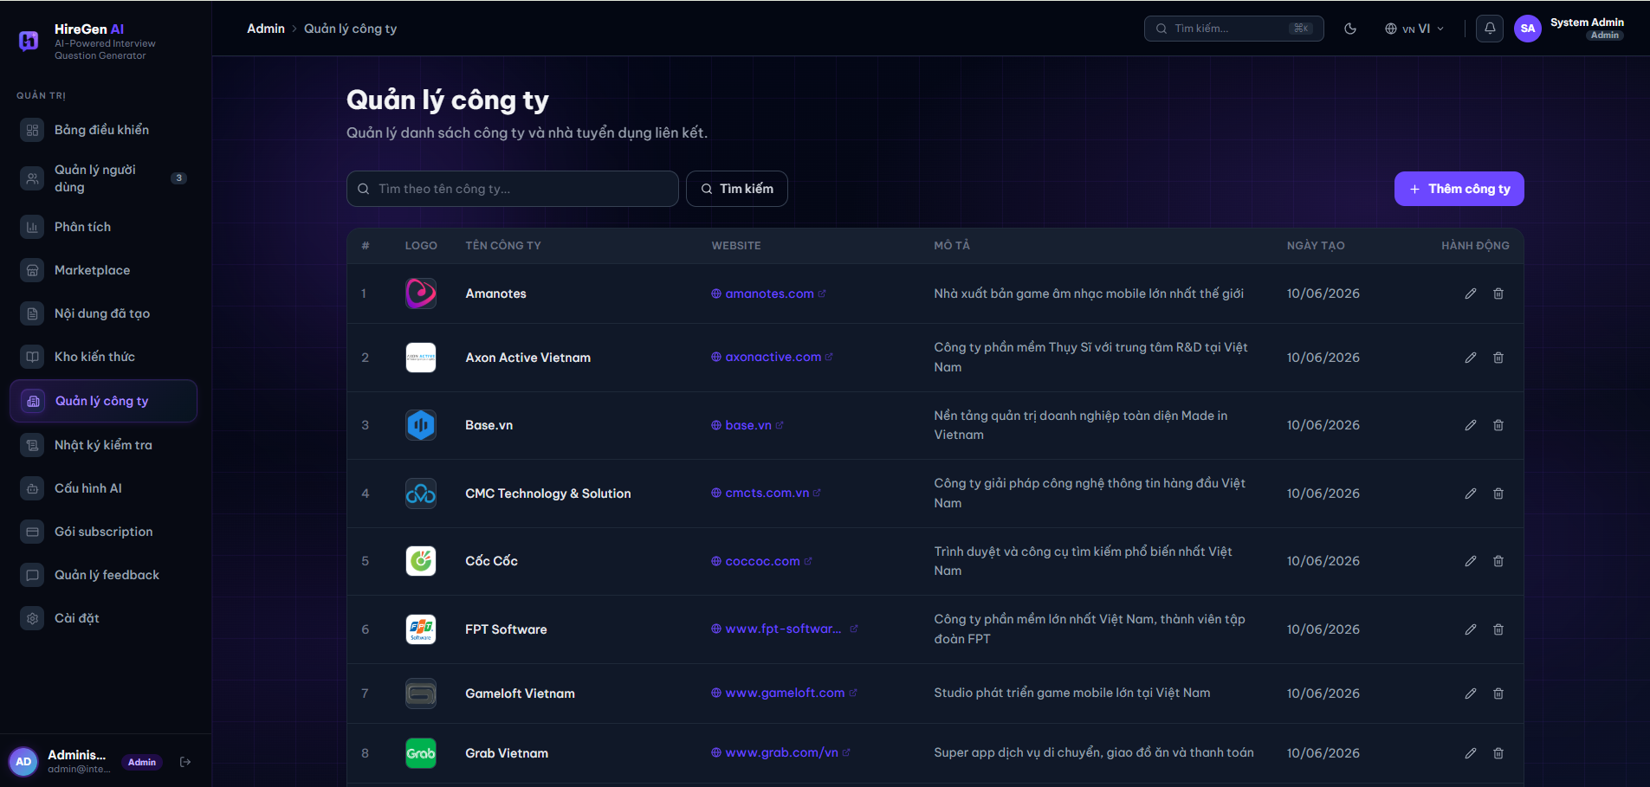
Figure 3.2.3.7. Company management list.

3.2.3.7 Company Management (Quản lý công ty)
Function trigger: Opened by clicking “Quản lý công ty” in the Admin sidebar.
Function description: Lets the Admin maintain the master list of companies that HR Managers and recruiters are associated with across the platform.
Pre-condition:
- The user is logged in with the Administrator role.
Function detail:
- Search bar and “Tìm kiếm” (Search) button filter the list by company name; a “+ Thêm công ty” (Add company) button creates a new entry.
- Companies table lists each company's index, Logo, Tên công ty (name), Website (as a clickable link), Mô tả (description), Ngày tạo (creation date) and row actions to edit or delete the entry.
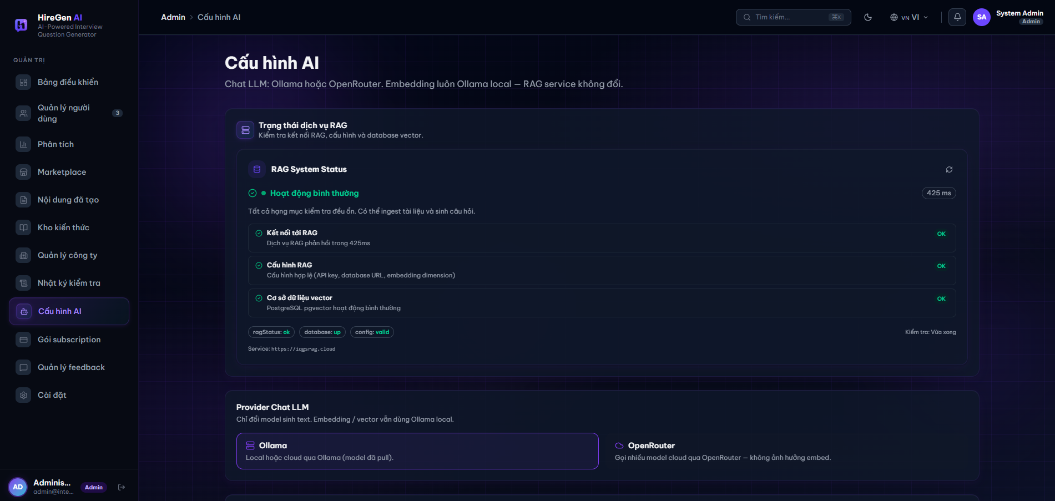
Figure 3.2.3.8. AI configuration and RAG status.

3.2.3.8 AI Configuration (Cấu hình AI)
Function trigger: Opened by clicking “Cấu hình AI” in the Admin sidebar.
Function description: Lets the Admin monitor the health of the platform's RAG (retrieval-augmented generation) service and choose which chat LLM provider is used for question generation; the embedding/vector pipeline always stays on the local Ollama service regardless of this choice.
Pre-condition:
- The user is logged in with the Administrator role.
Function detail:
- RAG System Status card shows an overall status (e.g. “Hoạt động bình thường” — Operating normally, with response time) plus three individual checks — Kết nối tới RAG (RAG connectivity), Cấu hình RAG (RAG configuration validity) and Cơ sở dữ liệu vector (vector database, PostgreSQL pgvector) — each with an OK/fail indicator, and a manual refresh action.
- Status chips (ragStatus, database, config) and the RAG service URL are shown for quick diagnostics, along with the timestamp of the last check.
- Provider Chat LLM panel lets the Admin select between Ollama (local or cloud-hosted via Ollama, using an already-pulled model) and OpenRouter (routes chat generation to cloud models via OpenRouter) as the text-generation provider, with a note that this choice only affects text generation — embedding and vector search always use the local Ollama service.
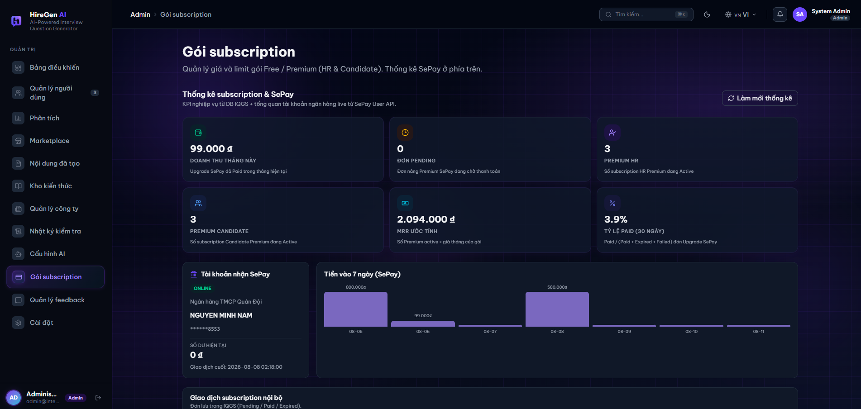
Figure 3.2.3.9. Subscription packages and SePay billing overview.

3.2.3.9 Subscription Packages (Gói subscription)
Function trigger: Opened by clicking “Gói subscription” in the Admin sidebar.
Function description: Lets the Admin monitor subscription revenue and billing health for the Free/Premium packages (for both HR Managers and Candidates) and review the linked SePay payment account.
Pre-condition:
- The user is logged in with the Administrator role.
Function detail:
- Summary cards show Doanh thu tháng này (revenue this month), Đơn pending (orders awaiting payment), active Premium HR and Premium Candidate subscription counts, ước tính MRR (estimated monthly recurring revenue) and Tỷ lệ paid trong 30 ngày (30-day paid conversion rate), with a “Làm mới thống kê” (Refresh stats) action.
- Tài khoản nhận SePay card shows the linked bank account's online status, bank name, account holder, masked account number, current balance and the timestamp of the last transaction.
- Tiền vào 7 ngày chart is a bar chart of daily SePay inflow over the last 7 days.
- Giao dịch subscription nội bộ table (below, partially shown) lists internal subscription orders stored in IQGS by status — Pending, Paid or Expired.
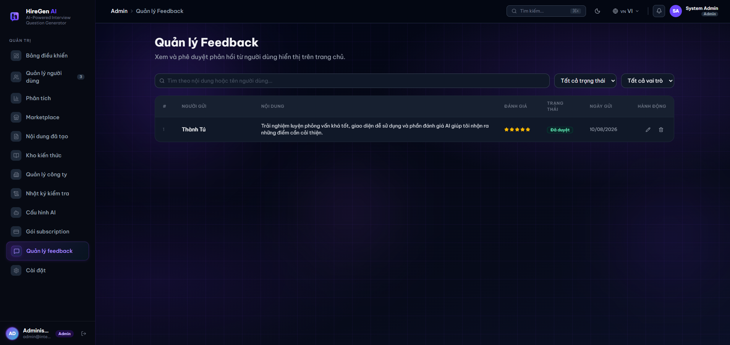
Figure 3.2.3.10. Feedback management list.

3.2.3.10 Feedback Management (Quản lý Feedback)
Function trigger: Opened by clicking “Quản lý feedback” in the Admin sidebar.
Function description: Lets the Admin review user-submitted feedback and approve which entries are shown publicly on the platform's homepage.
Pre-condition:
- The user is logged in with the Administrator role.
Function detail:
- Filter bar lets the Admin search feedback by content or sender name and filter by status and sender role.
- Feedback table lists each entry's index, Người gửi (sender), Nội dung (feedback text), Đánh giá (star rating), Trạng thái (approval status, e.g. Đã duyệt/Approved), Ngày gửi (submission date) and row actions to edit or delete the entry.
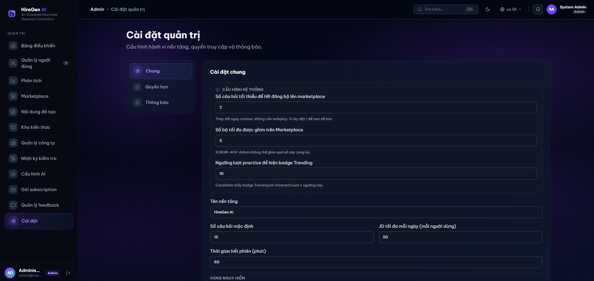
Figure 3.2.3.11. Admin settings, Chung (General) tab.

3.2.3.11 Admin Settings (Cài đặt quản trị)
Function trigger: Opened by clicking “Cài đặt” in the Admin sidebar.
Function description: Lets the Admin configure platform-wide behavior, access rules and notifications that apply to every HR Manager and Candidate.
Pre-condition:
- The user is logged in with the Administrator role.
Function detail:
- Settings sub-navigation lists Chung (General, active), Quyền hạn (Permissions) and Thông báo (Notifications).
- Cấu hình hệ thống group holds runtime-editable platform rules: the minimum number of questions an HR Manager needs before a set can be published to the Marketplace, the maximum number of sets that can be pinned on the Marketplace at once, and the practice-attempt threshold at which a set is shown with a “Trending” badge to candidates — each field applies immediately without a redeploy.
- General fields further down configure Tên nền tảng (platform name), Số câu hỏi mặc định (default question count), JD tối đa mỗi ngày mỗi người dùng (max JD submissions per user per day) and Thời gian hết phiên (session timeout in minutes).
- Vùng nguy hiểm section (below, partially shown) groups higher-risk administrative actions separately from the general settings.

4. Non-Functional Requirements

4.1 External Interfaces

4.1.1 User Interface

HR/Admin UI part
- Layout Structure: The HR and Admin workspaces must use a uniform dashboard layout. This includes a fixed left-side navigation sidebar for quick screen switching and a top bar displaying the current user profile, company logo, and system notifications.
- Data Presentation: All data lists, user lists, and question repositories must be presented in structured tables. These tables must support basic sorting (by name, date, or status), keyword filtering, and pagination with a default view of 10 or 20 records per page to keep the screen clean.
- Responsive Design: Since HR Managers and Administrators work primarily on computers, the UI must be highly optimized for desktop and laptop screens with standard resolutions such as 1920x1080 and 1366x768. UI components should auto-align correctly without text overlapping if the window size changes.
- Asynchronous Loading Indicators: Because the AI question generation process runs in the background and takes time, the UI must display a clear progress bar or loading spinner on the generation screen. This lets the user know the system is still working and prevents them from clicking the submit button multiple times.

Candidate UI part
- Layout Structure:The candidate-facing interface must use a clean, content-first layout without a sidebar. A fixed top navigation bar must be present on all authenticated candidate screens, containing links to Marketplace, Practice History, Bookmarks, and a User Profile dropdown with logout option. The top bar must remain visible at all times regardless of scroll position to ensure quick access to core navigation. When a Free-tier candidate has exhausted their monthly practice quota, a non-dismissible upgrade banner must be displayed directly below the top bar on all screens, prompting the candidate to upgrade their subscription plan with a direct link to the Subscription Plans screen.
- Marketplace and Card Design: The Marketplace screen must present published question sets as a responsive card grid (3 columns on desktop, 2 on tablet, 1 on mobile). Each card must clearly display the question set title, company name, difficulty badge (with text label: Intern / Junior / Senior), skill tag chips, question count, and a bookmark icon toggle. A search bar and filter panel (Company, Skill, Difficulty, Sort Order) must be visible above the card grid without requiring the candidate to scroll. The Sort Order dropdown must support at least three options: Newest, Most Attempted, and Highest Rated. The listing must support pagination with a default of 12 cards per page, and pagination controls must be displayed at the bottom of the grid. The active filter selections must be shown as removable chips above the grid so the candidate can clearly see and remove individual filters without resetting all criteria.
- Practice Session Interface: The Practice Session screen must present one question at a time in a distraction-free, full-content layout. A countdown timer must be displayed prominently at the top of the screen and must change visual weight (bold text) at 5 minutes remaining and show a warning banner at 1 minute remaining. A progress indicator (e.g. "Question 3 of 10") must always be visible. The answer input field must auto-expand to fit typed content and must have a minimum height of 120px. Previous and Next navigation buttons must allow the candidate to move between questions freely before final submission; previously typed answers must be preserved in the local session state when navigating between questions. If the candidate attempts to navigate away from the Practice Session screen (e.g. by clicking a navigation link or closing the tab), the system must display a confirmation dialog: "Your session is in progress. Leaving this page will not submit your answers. Are you sure?" to prevent accidental data loss. On mobile viewports, the Submit button must be sticky at the bottom of the screen and always visible without scrolling.
- Answer Submission Confirmation: After the candidate clicks "Submit All", the system must display a dedicated Answer Submission confirmation screen before triggering AI evaluation. This screen must show a clear summary of the session: the number of questions answered, the number of questions skipped, and the total question count. Two action buttons must be available: "Confirm Submit" to proceed and "Back to Review" to return to the practice session and revise answers. If the countdown timer reaches zero before the candidate manually submits, the system must auto-submit all currently entered answers without showing this confirmation screen and must immediately transition to the loading state.
- AI Feedback Result Display: The AI Feedback Result screen must display the overall session score prominently at the top using a large numeric format with a performance tier label (e.g. "7.4 / 10 — Good"). Per-question feedback must be presented as collapsible accordion components to avoid overwhelming the candidate with information at once. Each accordion item must show the question text, the candidate's submitted answer, AI score (0–10), a strengths list, a weaknesses list, and actionable improvement suggestions. A "Share with HR" button and a "View in History" button must be clearly accessible below the overall score card. While the AI evaluation is still processing after answer submission, this screen must display a full-page loading state with a spinner and the message "Generating your feedback…" until the evaluation result is ready. If AI evaluation fails, a clear error message must be shown with a retry option.
- Practice History Screen: The Practice History screen must display all of the candidate's past practice sessions in a paginated table with the following columns: Date, Question Set Name, Company, Overall Score, and Status (Submitted / Processing). The default sort order must be by date descending (most recent first). Each row must include a direct link to the corresponding AI Feedback Result screen for that session. The candidate must be able to filter the history list by date range, question set keyword, or score range using filter controls above the table. A "Processing…" badge must be shown in the Status column for sessions where AI evaluation is still in progress. Pagination must default to 10 sessions per page.
- Bookmark List Screen: The Bookmark List screen must display all question sets the candidate has saved, presented in the same card grid format as the Marketplace (3 columns on desktop, 2 on tablet, 1 on mobile) to maintain visual consistency. Each card must include a filled bookmark icon that the candidate can click to remove the bookmark immediately via optimistic UI update. Each card must link directly to the corresponding Question Set Detail screen. If the candidate has no bookmarks, an empty state must be shown with the message "No bookmarks yet. Browse the Marketplace to find question sets you like." and a direct link to the Marketplace screen.
- Responsive Design: Since candidates frequently access the platform on both desktop and mobile devices, all candidate-facing screens must be fully functional and usable across desktop (≥ 1280px), tablet (768px – 1024px), and mobile (375px – 767px) viewports. The Marketplace card grid, Practice Session layout, and AI Feedback accordion must each adapt gracefully to the available screen width without horizontal scrolling or text overflow. All interactive elements (buttons, bookmark icons, accordion toggles, navigation links) must have a minimum touch target size of 44×44px to ensure comfortable usability on touchscreen devices. The platform must be fully functional on the latest stable versions of Google Chrome, Mozilla Firefox, and Microsoft Edge on both desktop and mobile.
- Loading and Empty States: All candidate screens that depend on API data (Marketplace, Practice History, Bookmarks, AI Feedback Result) must display a skeleton loader during data fetch rather than a blank screen. The AI Feedback Result screen must show a dedicated loading state with the message "Generating your feedback…" and a spinner while awaiting the AI evaluation response. The Answer Submission confirmation screen must display a loading overlay after the candidate clicks "Confirm Submit", blocking interaction while the system saves answers and triggers the AI evaluation job. All list screens (Practice History, Bookmarks, Marketplace with no results) must show a descriptive empty state message with a clear call-to-action button rather than an empty area.

4.1.2 Email Service Interface
IQGS sends transactional email via SMTP (Gmail SMTP relay in the current environment). The backend email service is invoked synchronously from the relevant API request (registration, forgot-password, candidate invitation) and failures are logged rather than silently swallowed.

Interface Property | Specification
Provider | SMTP relay (smtp.gmail.com)
Port / Encryption | 587 (STARTTLS)
Authentication | Sender account credential stored in server configuration/environment variables, never hard-coded or committed to source control
Trigger Events | Account email verification, password-reset request, candidate invitation notification
Delivery Mode | Synchronous send on the originating API request thread; failures are logged and surfaced as an API error, not silently retried
Table 4.1.2: Email Service Interface Specification

4.1.3 Payment Service Interface
IQGS integrates with SePay, a third-party VietQR bank-transfer payment gateway, to process subscription-plan upgrades for HR Managers and Candidates. Payment confirmation is asynchronous: the client polls order status while SePay confirms the transfer out-of-band via webhook.

Interface Property | Specification
Provider | SePay (VietQR bank-transfer gateway)
Order Creation | Backend generates an order code, transfer content, and VietQR image URL for the upgrade amount; the order expires after a configurable TTL
Confirmation | SePay posts a webhook callback to the backend once the bank transfer is detected
Webhook Verification | HMAC-SHA256 signature computed over timestamp + "." + raw request body, verified server-side before a transaction is marked Paid
Data Persisted | SubscriptionTransaction record (order code, amount, currency, provider, status, raw webhook payload) linked to the user's Subscription
Table 4.1.3: Payment Service Interface Specification

4.1.4 LLM Service Interface
IQGS integrates with the OpenAI GPT-4o model via the official OpenAI .NET SDK (runtime) and the OpenAI Python SDK (offline KB preparation). All API calls are authenticated using an API key stored in environment variables (never hard-coded).

Interface Property | Specification
Provider | OpenAI (api.openai.com)
Model | gpt-4o (Chat Completions API)
SDK – Runtime (.NET) | OpenAI .NET SDK (official) — used in ASP.NET Core service layer for online question generation and AI feedback
SDK – Offline (Python) | openai Python package — used in offline KB embedding scripts
Embedding Model | text-embedding-3-small (1536 dimensions) — used for both offline KB chunks and online JD query vectors
Authentication | OPENAI_API_KEY environment variable. Key must not be committed to source control.
Timeout | 60 seconds per API call. Hangfire job configured with 3 retries on timeout.
Rate Limiting | Batch embedding calls limited to 100 chunks/request. Exponential back-off on 429 (rate limit exceeded) errors.
Output Format | response_format: json_object enforced for all question generation and evaluation calls to guarantee structured JSON output.
Table 4.1.4: LLM Service Interface Specification

4.1.5 Vector Database Interface
IQGS uses pgvector — a PostgreSQL extension — as its vector store. Online retrieval is performed by the ASP.NET Core backend using Npgsql (PostgreSQL .NET driver). Offline ingestion uses psycopg2 (Python).

Interface Property | Specification
Database | PostgreSQL 15+ with pgvector extension enabled
Vector Column Type | vector(1536) — stores 1536-dimensional float32 embedding vectors
Index Type | HNSW index on the embedding column for approximate nearest-neighbour search (supports cosine distance)
Similarity Metric | Cosine distance (<=> operator). Query: SELECT *, 1 - (embedding <=> $queryVec) AS score FROM knowledge_base_chunks ORDER BY score DESC LIMIT $k;
Runtime Driver (.NET) | Npgsql 8.x with Npgsql.EntityFrameworkCore.PostgreSQL for ORM-level access; raw SQL for vector queries
Offline Driver (Python) | psycopg2 — used for bulk INSERT of chunk vectors during KB ingestion
Connection | Connection string from environment variable (DB_CONNECTION_STRING). TLS required for production.
Top-k Default | k=5, configurable via SystemConfig table
Table 4.1.5: Vector Database Interface Specification

4.1.6 File Storage Interface
IQGS uses Azure Blob Storage as its object store for all user-uploaded and system-generated binary files. A single container per environment holds the content, auto-created on first use.

Interface Property | Specification
Provider | Azure Blob Storage
SDK | Azure.Storage.Blobs (.NET SDK)
Stored Content | Candidate CV files, HR knowledge-base source documents, question-attached images
Access Pattern | Upload/Delete via BlobContainerClient on the backend; time-limited SAS URLs issued for direct client-side read access
Container Configuration | One container per environment (dev/prod), created automatically if it does not already exist
Table 4.1.6: File Storage Interface Specification

4.2 Quality Attributes

4.2.1 Usability
- Required Training Time: * Normal Users (Candidates / Job Seekers): The client-side interface must be intuitive enough that a normal user can successfully browse question sets, start a mock practice session, and view their AI evaluation report within 5 minutes of their first access without any formal training.
  - Power Users (HR Managers / Administrators): An HR Recruiter or Admin must be able to master advanced operations (such as configuring RAG parameters, triggering background AI generations, uploading reference documents, or managing user accounts) within 20 minutes of reading a quick start guide or watching a short video walkthrough.
- Measurable Task Times: * A recruiter must be able to complete the setup form and trigger a new question generation session from a raw Job Description in less than 3 steps (clicks).
  - An administrator must be able to lookup any specific user profile or change account access roles within 10 seconds through the global user dashboard.
- Usability Standards: The layout structure, response alignments, form validation UI, and icon mappings across both the candidate portal and the administrative workspaces must strictly follow current Microsoft Fluent Design and Web GUI standards. This guarantees comfortable color contrasts, clear visual hierarchies, and a predictable user experience across all modern desktop web browsers.

4.2.2 Reliability
- Fault Tolerance / Job Retries: Background jobs (AI question generation, knowledge-base ingestion) run via Hangfire and must automatically retry up to 3 times on transient failures (LLM timeout, network error) before being marked Failed and surfaced to the HR Manager.
- Data Durability: Once a Question Set is Published or a subscription payment is confirmed, the corresponding database write must be committed atomically; partial writes must never leave a Question Set or Subscription in an inconsistent state.
- Idempotent Payment Webhook: The SePay payment webhook handler must be idempotent — a duplicate webhook delivery for an already-confirmed transaction must not create a second payment record or grant duplicate subscription credit.
- Graceful Degradation: If the LLM Service or Vector Database is temporarily unavailable, the affected generation job must fail with a clear error status rather than hang indefinitely, and previously generated or published content must remain accessible.

4.2.3 Performance
- Interactive Response Time: Marketplace browse/search and dashboard pages must return results within 2 seconds under normal load.
- Question Generation Throughput: An AI question-generation job (10-20 questions) is expected to complete end-to-end within the OpenAI request timeout and retry budget (60 seconds per call, up to 3 retries).
- Concurrent Practice Sessions: The system must support multiple candidates taking practice sessions concurrently without noticeable latency degradation on answer submission.
- Vector Search Latency: Semantic retrieval from the pgvector store must return the top-k matching knowledge chunks quickly enough that it does not dominate overall generation-job time.
- Workload Isolation: AI generation and knowledge-ingestion workloads run as Hangfire background jobs, decoupled from the request/response cycle, so spikes in AI workload do not block interactive API endpoints.

5. Requirement Appendix

5.1 Business Rules

ID | Rule Definition
BR-01 | Each email address must be unique across the entire system. A user cannot register with an email that already exists in the User table, regardless of role. Duplicate email triggers MSG_AUTH_REG_002.
BR-02 | A user must verify their email address before they can log in. Accounts with IsEmailVerified = false cannot obtain a JWT access token.
BR-03 | An HR Manager account is set to Pending status upon registration and requires explicit Administrator approval before login is permitted (mandatory per LI-02, Report 1).
BR-04 | Role-Based Access Control (RBAC) is enforced at the API level for all protected endpoints. A user can only access features permitted by their assigned role. Unauthorized access returns HTTP 403 Forbidden.
BR-05 | A password reset token is single-use and expires 15 minutes after generation. An email verification token is single-use and expires 24 hours after generation. Expired or used tokens are rejected.
BR-06 | An HR Manager may only trigger AI question generation if their active UserSubscription has RemainingGenerationQuota > 0. Each successful generation decrements quota by 1. Quota resets at each billing cycle renewal (CR-10).
BR-07 | A question set can only be published to the public marketplace if it contains at least 1 question. Empty sets cannot be published.
BR-08 | A question set's ownership is tied to the HR Manager account that created it. HR Managers may only view, edit, publish, or delete their own question sets. Administrators can moderate all question sets.
BR-09 | A Job Seeker on the Free tier can only view a limited subset of questions from any public question set (FullMarketplaceAccess = false). Full question access requires a premium subscription.
BR-10 | A Job Seeker may have at most one active (InProgress) PracticeSession per question set at any given time. A new session can only start after the previous is Submitted or its time limit has expired.
BR-11 | Practice session answers and AI feedback are stored for 90 days from the session submission date. After 90 days, raw AnswerText is archived by the Scheduled Cleanup Job. Session score and summary are retained permanently.
BR-12 | A Contact Request from a Job Seeker to an HR Manager is rate-limited to a maximum of 1 contact per (Candidate, Company) pair per 24-hour window.
BR-13 | A subscription upgrade payment Order expires 15 minutes after creation if payment is not confirmed. Only one PENDING Order is allowed per user at a time.
BR-14 | Subscription plans can only be upgraded to a higher tier. Plan downgrading takes effect at the end of the current billing cycle; user retains premium features until ExpiryDate.
BR-15 | Knowledge base documents must retain complete source metadata (Title, SourceType, Year, Source URL) as required by academic integrity policy per project topic section 3.3.
BR-16 | A Hangfire background job that fails is automatically retried up to 3 times with exponential backoff. After 3 failures, the job is marked FAILED, the failure is logged, and the user is notified.
BR-17 | All financial amounts in Orders are stored in Vietnamese Dong (VND). Per LI-06 (Report 1): only Payment Reference, Date, and tier are recorded; detailed billing breakdowns are out of scope.
BR-18 | The RAG Baseline Experiment (RAG vs. zero-shot vs. few-shot) is a mandatory research deliverable per project topic section 3.3. Must be triggered by an Administrator and produce an exportable evaluation report.

5.2 Common Requirements

ID | Category | Requirement
CR-01 | Pagination | All list-type API endpoints (question sets, users, orders, practice history, contact requests) must support pagination. Default page size: 20 items. Maximum: 100 items. Response must include total count, current page, and total pages.
CR-02 | Date / Time | All dates stored in DB must use UTC timezone. All dates returned by the API must use ISO 8601 format (YYYY-MM-DDTHH:mm:ssZ). Frontend converts to ICT (UTC+7) for display.
CR-03 | Soft Delete | User accounts, question sets, knowledge base documents, and subscription plans are soft-deleted (Status = Deleted/Inactive) rather than physically removed. Physical deletion is not performed during the project lifecycle.
CR-04 | Audit Logging | All user actions that modify data (create, update, delete, publish, approve, ban) must be logged with: UserId, action type, target entity ID, and timestamp. Logs retained for at least 90 days.
CR-05 | Error Response Format | All API error responses must follow the standard format: { errorCode, message, timestamp, path }. HTTP status codes used correctly: 400, 401, 403, 404, 429, 500.
CR-06 | Language Support | Per LI-03 (Report 1): system supports Vietnamese and English for JD input, question generation, and AI evaluation. JDs submitted in Vietnamese must be processed correctly through the RAG pipeline.
CR-07 | File Upload Validation | All uploaded files must be validated for: (a) file extension whitelist (PDF, DOCX, TXT for documents; PNG, JPG for images), (b) MIME type matching declared extension, (c) file size per-type limits. Files failing validation are rejected before any storage operation.
CR-08 | Data Export Format | Question sets exported by HR Managers must be available in both PDF and DOCX formats, including: question text, type, difficulty, skill tags, and sample answer per question.
CR-09 | API Versioning | The IQGS REST API must use URL path versioning (e.g., /api/v1/...). Current version is v1. Adding a new version must not break existing v1 clients.
CR-10 | Subscription Quota Reset | At the start of each new billing cycle, the Scheduled Cleanup Job automatically resets RemainingGenerationQuota to the plan's full GenerationQuota for all active UserSubscription records.

5.3 System Messages List

# | Message Code | Message Type | Context (Trigger Condition) | Content (Display Text)
I | Authentication
1 | MSG_AUTH_01 | Toast Message | User successfully logs in with valid credentials. | "Login successful. Welcome back!"
2 | MSG_AUTH_02 | Inline (Red) | User submits incorrect email or password. | "Invalid email or password. Please try again."
3 | MSG_AUTH_03 | Toast Message | JWT signature expires during an active session. | "Session expired. Please log in again to continue."
4 | MSG_AUTH_04 | Toast Message | User successfully logs out of the platform. | "You have been successfully logged out."
II | Validation
5 | MSG_VAL_01 | Inline (Red) | A required input field is left empty upon submission. | "This field is required and cannot be left blank."
6 | MSG_VAL_02 | Inline (Red) | Input string exceeds the database character limit. | "Input exceeds the maximum allowed length."
7 | MSG_VAL_03 | Inline (Red) | Password fails complexity policies (length/characters). | "Password must contain at least 8 characters, including a number and a special character."
III | AI Generation
8 | MSG_GEN_01 | Toast Message | User triggers the AI question generation pipeline. | "AI generation started. Processing in the background..."
9 | MSG_GEN_02 | Toast Message | Hangfire async job completes successfully. | "Interview questions generated successfully!"
10 | MSG_GEN_03 | Toast Message | LLM API times out or fails to return a valid schema. | "AI generation failed or timed out. Please try again."
11 | MSG_GEN_04 | Toast Message | User quota for AI generation is depleted. | "AI generation quota exceeded. Please upgrade your plan."
IV | Question Set Management
12 | MSG_SET_01 | Toast Message | User successfully saves a new question set. | "Question set saved successfully."
13 | MSG_SET_02 | Toast Message | User deletes an existing question set. | "Question set deleted successfully."
14 | MSG_SET_03 | Toast Message | Set visibility is toggled to 'Published' (Marketplace). | "Question set is now published to the Marketplace."
V | Payment & Subscription
15 | MSG_PAY_01 | Toast Message | Financial gateway confirms successful transaction. | "Payment successful. Your subscription has been upgraded!"
16 | MSG_PAY_02 | Toast Message | Payment gateway rejects the transaction. | "Payment failed. Please check your billing information."
VI | File Uploads
17 | MSG_FILE_01 | Inline (Red) | User uploads an unsupported file extension. | "Unsupported format. Please upload PDF, DOCX, or TXT."
18 | MSG_FILE_02 | Inline (Red) | Uploaded file size exceeds the system payload limit. | "File size exceeds the 10MB maximum limit."
19 | MSG_FILE_03 | Toast Message | Document chunking and vectorization succeeds (RAG). | "File processed and indexed successfully."
VII | Practice Session (Candidate)
20 | MSG_PRAC_01 | Inline (Info) | Candidate starts the mock practice environment. | "Practice session started. The timer is now active."
21 | MSG_PRAC_02 | Toast Message | Candidate submits answers for AI evaluation. | "Answers submitted. Generating AI feedback..."
22 | MSG_PRAC_03 | Toast Message | AI feedback generation completes. | "Your AI evaluation report is ready to view!"
VIII | Admin Actions
23 | MSG_ADM_01 | Toast Message | Admin successfully updates a user's role. | "User role updated successfully."
24 | MSG_ADM_02 | Toast Message | Admin bans or suspends a user account. | "User account has been suspended."
25 | MSG_ADM_03 | Toast Message | Admin removes a violating public question set. | "Content flagged and removed from the marketplace."
26 | MSG_ADM_04 | Toast Message | Admin successfully saves new system configurations. | "System configurations updated successfully."

IV. Software Design Description

1. System Design

1.1 System Architecture

The system's Software Architecture uses a Client-Server model including a Frontend (React/Next.js SPA deployed on Cloudflare Workers) and a Backend (ASP.NET Core 8 Web API), integrated with a Python RAG microservice (FastAPI), an Azure PostgreSQL database with pgvector, Hangfire background workers, and external services including Google OAuth, Gmail SMTP, Ollama (LLM and embeddings), and Azure Blob Storage.
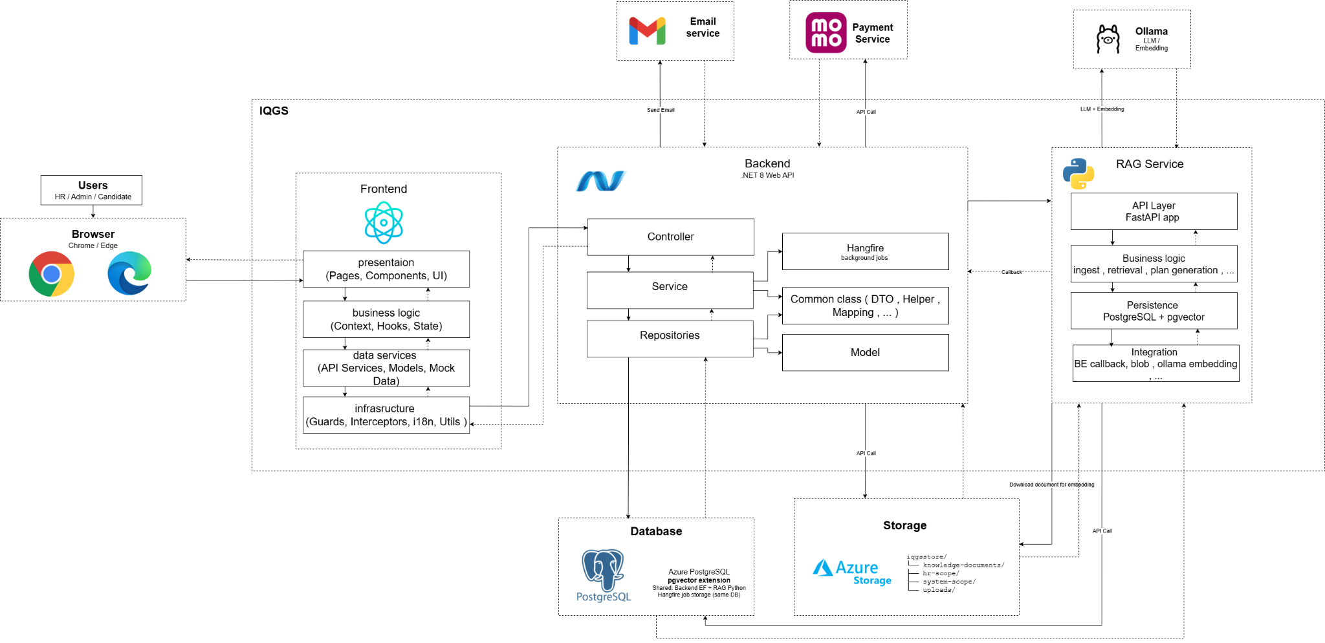
Figure 1: Software Architecture (Link)

1.2 Package Diagram
1.2.1 Front-end Package Diagram

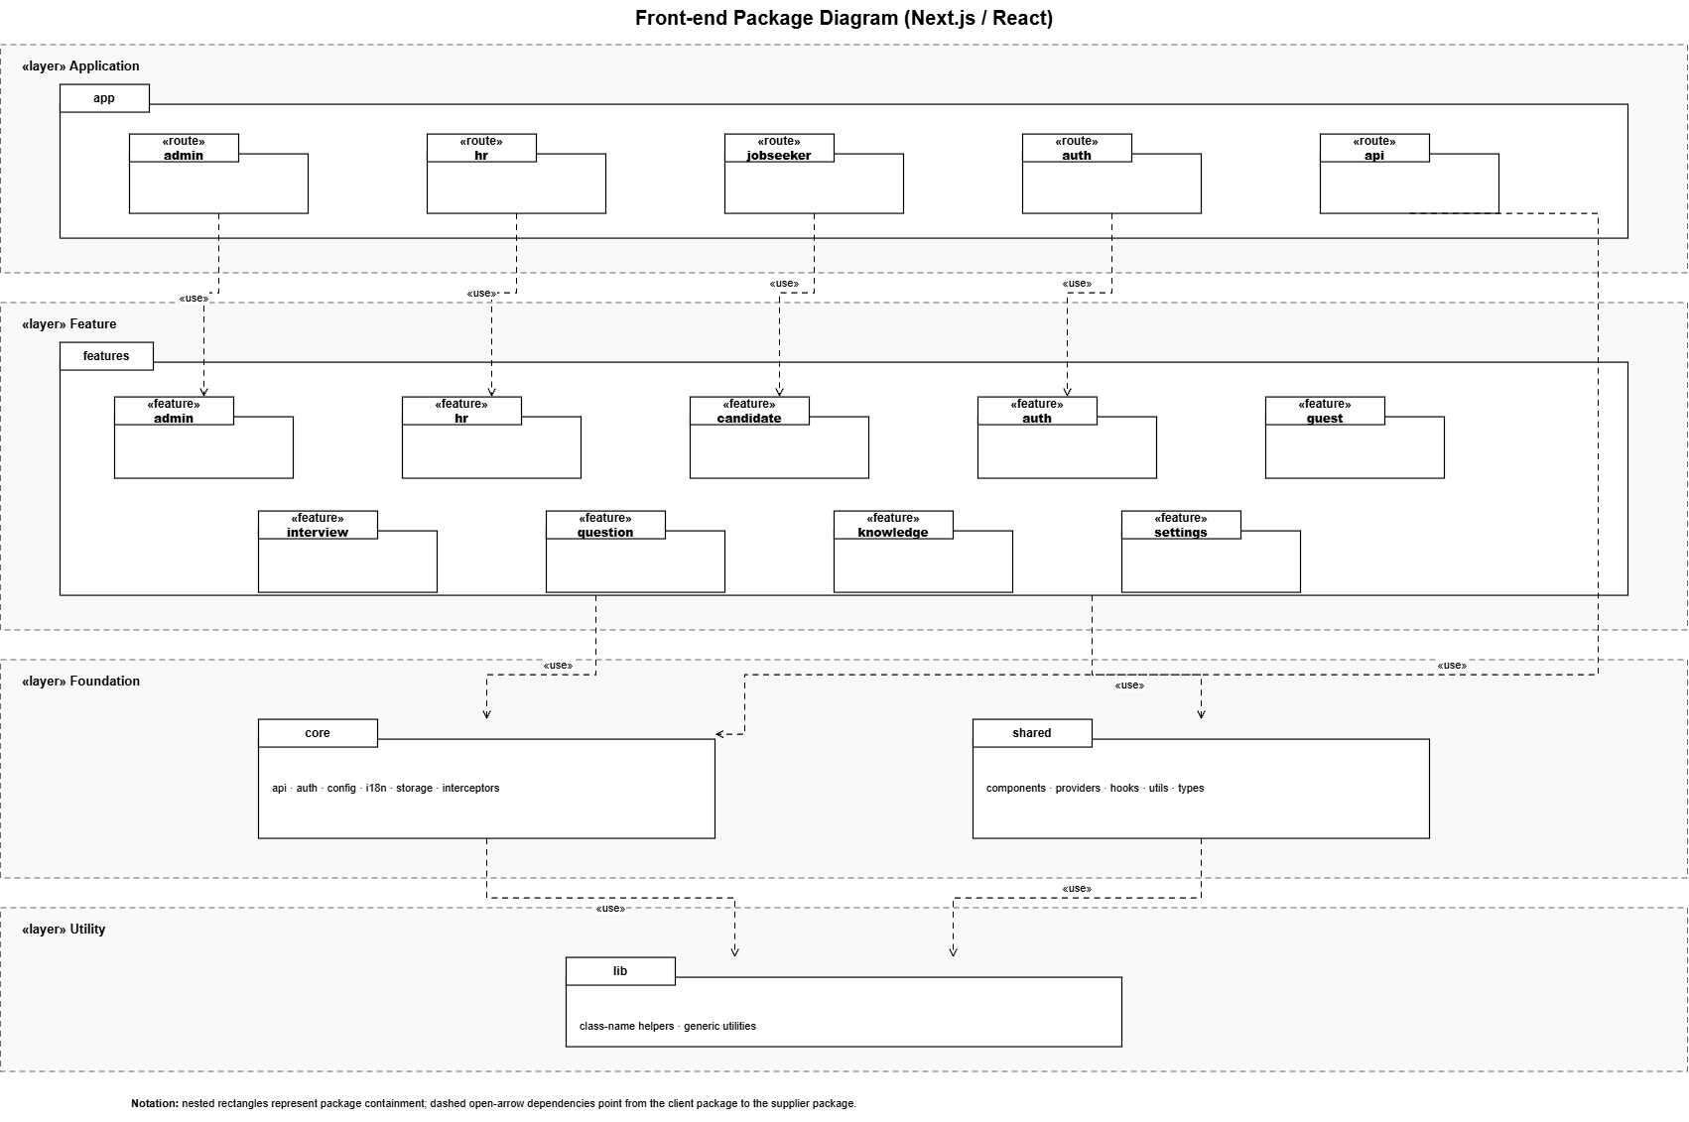

Figure 1.2.1: Front-end Package Diagram diagram (Link)
1.2.2 Back-end Package Diagram
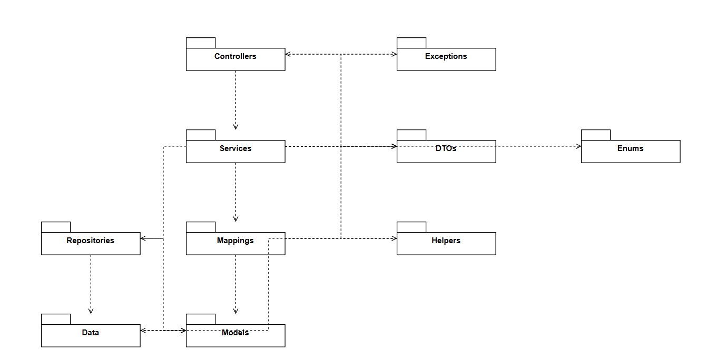

Figure 1.2.2: Back-end Package Diagram (Link)
1.2.3 AI/RAG Service Package Diagram
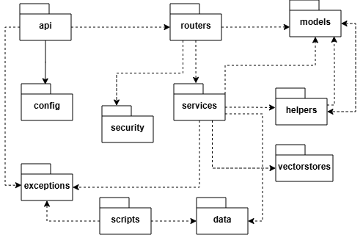
Figure 4: RAG services package diagram (Link)

Package Descriptions

No | Package | Description
1 | api | Starts the FastAPI app and sets up the RAG service.
2 | routers | Defines internal APIs for the Backend to call.
3 | services | Handles core logic: ingest, retrieval, plan and question generation.
4 | models | Defines API request and response data structures.
5 | vectorstores | Stores and searches embeddings in PostgreSQL pgvector.
6 | config | Manages environment settings such as DB, Ollama, and API key.
7 | security | Validates the Internal API Key before processing requests.
8 | helpers | Helper functions for JD validation, text chunking, and file parsing.
9 | exceptions | Defines common errors used in the ingest flow.
10 | data | Sample data for testing (system, hr).
11 | scripts | Scripts for DB checks and manual testing.

1.3 Database Design
The following figure illustrates the database design of the system and provides a detailed description of each table.
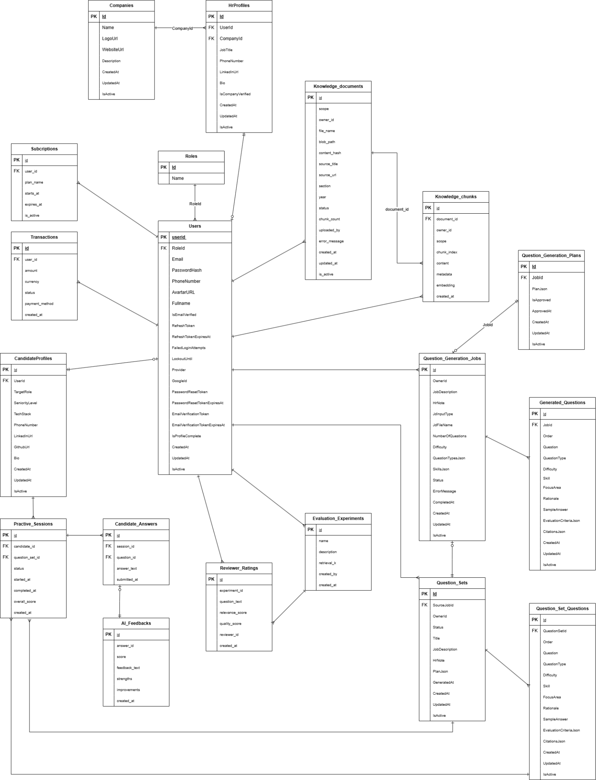

Figure 5: Database design diagram ( Link )
1.3.1 Roles

No | Field | Type | PK | FK | UN | NN | Description
1 | Id | int | x |  |  | x | Primary key — seed: 1=Admin, 2=HR, 3=Candidate
2 | Name | varchar |  |  | x | x | Role name (unique)

Table 1.3.1: Roles table
1.3.2 Users

No | Field | Type | PK | FK | UN | NN | Description
1 | Id | uuid | x |  |  | x | Primary key
2 | FullName | varchar |  |  |  | x | Full name
3 | Email | varchar |  |  | x | x | Login email (unique)
4 | PasswordHash | varchar |  |  |  |  | BCrypt hash. Null nếu Google OAuth
5 | PhoneNumber | varchar |  |  |  |  | Optional phone number
6 | AvatarUrl | varchar |  |  |  |  | Avatar image URL
7 | RoleId | int |  | x |  | x | FK → Roles.Id. Restrict delete
8 | IsEmailVerified | bool |  |  |  | x | Whether email is verified
9 | RefreshToken | varchar |  |  |  |  | Current JWT refresh token
10 | RefreshTokenExpiresAt | timestamptz |  |  |  |  | Refresh token expiry time
11 | FailedLoginAttempts | int |  |  |  | x | Consecutive failed login attempts
12 | LockoutUntil | timestamptz |  |  |  |  | Account unlock time
13 | Provider | varchar |  |  |  | x | 'local' | 'google'
14 | GoogleId | varchar |  |  | x |  | Google subject ID (unique, nullable)
15 | PasswordResetToken | varchar |  |  |  |  | SHA-256 hash token reset password
16 | PasswordResetTokenExpiresAt | timestamptz |  |  |  |  | Hạn sử dụng reset token
17 | EmailVerificationToken | varchar |  |  |  |  | SHA-256 hash token verify email
18 | EmailVerificationTokenExpiresAt | timestamptz |  |  |  |  | Hạn sử dụng verify token
19 | IsProfileComplete | bool |  |  |  | x | Profile đã điền đủ thông tin chưa
20 | CreatedAt | timestamptz |  |  |  | x | Created timestamp
21 | UpdatedAt | timestamptz |  |  |  |  | Last updated timestamp
22 | IsActive | bool |  |  |  | x | Whether account is active

Table 1.3.2: Users table
1.3.3 Companies

No | Field | Type | PK | FK | UN | NN | Description
1 | Id | uuid | x |  |  | x | Primary key
2 | Name | varchar |  |  |  | x | Company name
3 | LogoUrl | varchar |  |  |  |  | Company logo URL
4 | WebsiteUrl | varchar |  |  |  |  | Official website URL
5 | Description | text |  |  |  |  | Company description
6 | CreatedAt | timestamptz |  |  |  | x | Created timestamp
7 | UpdatedAt | timestamptz |  |  |  |  | Updated timestamp
8 | IsActive | bool |  |  |  | x | Whether record is active

Table 1.3.3: Companies table
1.3.4 HRProfiles

No | Field | Type | PK | FK | UN | NN | Description
1 | Id | uuid | x |  |  | x | Primary key
2 | UserId | uuid |  | x | x | x | FK → Users.Id (unique, cascade delete)
3 | CompanyId | uuid |  | x |  | x | FK → Companies.Id (restrict delete)
4 | JobTitle | varchar |  |  |  |  | Job title: Recruiter, HR Manager, etc.
5 | PhoneNumber | varchar |  |  |  |  | HR phone number
6 | LinkedInUrl | varchar |  |  |  |  | LinkedIn profile URL
7 | Bio | text |  |  |  |  | Short biography
8 | IsCompanyVerified | bool |  |  |  | x | Whether admin verified company membership
9 | CreatedAt | timestamptz |  |  |  | x | Created timestamp
10 | UpdatedAt | timestamptz |  |  |  |  | Updated timestamp
11 | IsActive | bool |  |  |  | x | Whether record is active

Table 1.3.4: HRProfiles table
1.3.5 CandidateProfiles

No | Field | Type | PK | FK | UN | NN | Description
1 | Id | uuid | x |  |  | x | Primary key
2 | UserId | uuid |  | x | x | x | FK → Users.Id (unique, cascade delete)
3 | TargetRole | varchar |  |  |  |  | Target role: Backend Dev, Frontend Dev, etc.
4 | SeniorityLevel | varchar |  |  |  |  | Intern|Fresher|Junior|Middle|Senior
5 | TechStack | text[] |  |  |  | x | Mảng kỹ thuật: ['React','TypeScript',...]
6 | PhoneNumber | varchar |  |  |  |  | Phone number
7 | LinkedInUrl | varchar |  |  |  |  | LinkedIn profile
8 | GithubUrl | varchar |  |  |  |  | GitHub profile
9 | Bio | text |  |  |  |  | Self introduction
10 | CreatedAt | timestamptz |  |  |  | x | Created timestamp
11 | UpdatedAt | timestamptz |  |  |  |  | Updated timestamp
12 | IsActive | bool |  |  |  | x | Whether record is active

Table 1.3.5: CandidateProfiles table
1.3.6 knowledge_documents

No | Field | Type | PK | FK | UN | NN | Description
1 | id | uuid | x |  |  | x | Primary key
2 | scope | varchar |  |  |  | x | 'SYSTEM' | 'HR'
3 | owner_id | uuid |  |  |  |  | NULL nếu SYSTEM; HR userId nếu scope=HR
4 | file_name | varchar |  |  |  | x | Original file name
5 | blob_path | varchar |  |  |  | x | Path on Azure Blob Storage
6 | content_hash | varchar |  |  |  |  | SHA-256 content hash for deduplication
7 | source_title | varchar |  |  |  |  | Academic document title
8 | source_url | varchar |  |  |  |  | Source document URL
9 | section | varchar |  |  |  |  | Chapter/section in document
10 | year | int |  |  |  |  | Publication year
11 | status | varchar |  |  |  | x | QUEUED|PROCESSING|COMPLETED|FAILED
12 | chunk_count | int |  |  |  |  | Number of ingested chunks
13 | uploaded_by | uuid |  |  |  | x | Soft FK → Users.Id (ai upload)
14 | error_message | text |  |  |  |  | Error message when status is FAILED
15 | created_at | timestamptz |  |  |  | x | Created timestamp
16 | updated_at | timestamptz |  |  |  |  | Updated timestamp
17 | is_active | bool |  |  |  | x | Whether record is active

Table 1.3.6: knowledge_documents table
1.3.7 knowledge_chunks

No | Field | Type | PK | FK | UN | NN | Description
1 | id | uuid | x |  |  | x | Primary key
2 | document_id | uuid |  | x |  | x | FK → knowledge_documents.id (cascade delete)
3 | owner_id | uuid |  |  |  |  | Soft FK → Users.Id (tối ưu filter theo HR)
4 | scope | varchar |  |  |  | x | 'SYSTEM' | 'HR'
5 | chunk_index | int |  |  |  | x | Chunk order within document
6 | content | text |  |  |  | x | Text chunk content
7 | metadata | jsonb |  |  |  |  | Metadata: source, page, section...
8 | embedding | vector(768) |  |  |  |  | 768-dim embedding (nomic-embed-text). HNSW index cosine
9 | created_at | timestamptz |  |  |  | x | Created timestamp

Table 1.3.7: knowledge_chunks table
1.3.8 question_generation_jobs

No | Field | Type | PK | FK | UN | NN | Description
1 | Id | uuid | x |  |  | x | Primary key
2 | OwnerId | uuid |  |  |  | x | Soft FK → Users.Id (HR owner)
3 | JobDescription | text |  |  |  | x | Job description content
4 | HrNote | text |  |  |  |  | Additional HR note
5 | JdInputType | varchar |  |  |  | x | 'text' | 'file'
6 | JdFileName | varchar |  |  |  |  | JD file name when uploaded
7 | NumberOfQuestions | int |  |  |  | x | Number of questions to generate
8 | Difficulty | varchar |  |  |  | x | 'easy' | 'medium' | 'hard'
9 | QuestionTypesJson | jsonb |  |  |  | x | Mảng loại câu hỏi: ['technical','behavioral']
10 | SkillsJson | jsonb |  |  |  | x | JSON array of focus skills
11 | Status | varchar |  |  |  | x | PLAN_QUEUED|PLAN_PROCESSING|WAITING_HR_APPROVAL|QUESTION_QUEUED|QUESTION_PROCESSING|COMPLETED|FAILED|CANCELLED
12 | ErrorMessage | text |  |  |  |  | Error message when status is FAILED
13 | CompletedAt | timestamptz |  |  |  |  | Completion timestamp
14 | CreatedAt | timestamptz |  |  |  | x | Created timestamp
15 | UpdatedAt | timestamptz |  |  |  |  | Updated timestamp
16 | IsActive | bool |  |  |  | x | Whether record is active

Table 1.3.8: question_generation_jobs table
1.3.9 question_generation_plans

No | Field | Type | PK | FK | UN | NN | Description
1 | Id | uuid | x |  |  | x | Primary key
2 | JobId | uuid |  | x | x | x | FK → question_generation_jobs.Id (unique, cascade)
3 | PlanJson | jsonb |  |  |  | x | Interview plan JSON: topics, skills, distribution
4 | IsApproved | bool |  |  |  | x | Whether HR approved the plan
5 | ApprovedAt | timestamptz |  |  |  |  | Approval timestamp
6 | CreatedAt | timestamptz |  |  |  | x | Created timestamp
7 | UpdatedAt | timestamptz |  |  |  |  | Updated timestamp
8 | IsActive | bool |  |  |  | x | Whether record is active

Table 1.3.9: question_generation_plans table
1.3.10 generated_questions

No | Field | Type | PK | FK | UN | NN | Description
1 | Id | uuid | x |  |  | x | Primary key
2 | JobId | uuid |  | x |  | x | FK → question_generation_jobs.Id (cascade)
3 | Order | int |  |  |  | x | Question order in the set
4 | Question | text |  |  |  | x | Question text
5 | QuestionType | varchar |  |  |  | x | 'technical' | 'behavioral' | 'situational'
6 | Difficulty | varchar |  |  |  | x | 'easy' | 'medium' | 'hard'
7 | Skill | varchar |  |  |  |  | Related skill
8 | FocusArea | varchar |  |  |  |  | Focus area
9 | Rationale | text |  |  |  |  | Rationale for selecting this question
10 | SampleAnswer | text |  |  |  |  | Sample answer hint
11 | EvaluationCriteriaJson | jsonb |  |  |  | x | Tiêu chí đánh giá câu trả lời
12 | CitationsJson | jsonb |  |  |  | x | Nguồn knowledge base tham chiếu
13 | CreatedAt | timestamptz |  |  |  | x | Created timestamp
14 | UpdatedAt | timestamptz |  |  |  |  | Updated timestamp
15 | IsActive | bool |  |  |  | x | Whether record is active

Table 1.3.10: generated_questions table
1.3.11 question_sets

No | Field | Type | PK | FK | UN | NN | Description
1 | Id | uuid | x |  |  | x | Primary key
2 | OwnerId | uuid |  |  |  | x | Soft FK → Users.Id (HR owner)
3 | SourceJobId | uuid |  | x | x | x | FK → question_generation_jobs.Id (unique, restrict)
4 | Status | varchar |  |  |  | x | DRAFT (planned: PUBLISHED, ARCHIVED)
5 | Title | varchar |  |  |  |  | Question set title
6 | JobDescription | text |  |  |  | x | Reference job description
7 | HrNote | text |  |  |  |  | HR note when saving draft
8 | PlanJson | jsonb |  |  |  | x | Reference interview plan JSON
9 | GeneratedAt | timestamptz |  |  |  |  | Timestamp when AI generation completed
10 | CreatedAt | timestamptz |  |  |  | x | Draft saved timestamp
11 | UpdatedAt | timestamptz |  |  |  |  | Updated timestamp
12 | IsActive | bool |  |  |  | x | Whether record is active

Table 1.3.11: question_sets table
1.3.12 question_set_questions

No | Field | Type | PK | FK | UN | NN | Description
1 | Id | uuid | x |  |  | x | Primary key
2 | QuestionSetId | uuid |  | x |  | x | FK → question_sets.Id (cascade delete)
3 | Order | int |  |  |  | x | Thứ tự câu hỏi
4 | Question | text |  |  |  | x | Question text (editable by HR)
5 | QuestionType | varchar |  |  |  | x | 'technical' | 'behavioral' | 'situational'
6 | Difficulty | varchar |  |  |  | x | 'easy' | 'medium' | 'hard'
7 | Skill | varchar |  |  |  |  | Related skill
8 | FocusArea | varchar |  |  |  |  | Focus area
9 | Rationale | text |  |  |  |  | Rationale for the question
10 | SampleAnswer | text |  |  |  |  | Sample answer hint
11 | EvaluationCriteriaJson | jsonb |  |  |  | x | Evaluation criteria JSON
12 | CitationsJson | jsonb |  |  |  | x | Referenced knowledge sources JSON
13 | CreatedAt | timestamptz |  |  |  | x | Created timestamp
14 | UpdatedAt | timestamptz |  |  |  |  | Updated timestamp
15 | IsActive | bool |  |  |  | x | Whether record is active

Table 1.3.12: question_set_questions table
1.3.13 practice_sessions

No | Field | Type | PK | FK | UN | NN | Description
1 | id | uuid | x |  |  | x | Primary key
2 | candidate_id | uuid |  | x |  | x | FK → Users.Id
3 | question_set_id | uuid |  | x |  | x | FK → question_sets.Id
4 | status | varchar |  |  |  | x | IN_PROGRESS | COMPLETED | ABANDONED
5 | started_at | timestamptz |  |  |  | x | Start timestamp
6 | completed_at | timestamptz |  |  |  |  | End timestamp
7 | overall_score | float |  |  |  |  | Overall score
8 | created_at | timestamptz |  |  |  | x | Created timestamp

Table 1.3.13: practice_sessions table
1.3.14 candidate_answers

No | Field | Type | PK | FK | UN | NN | Description
1 | id | uuid | x |  |  | x | Primary key
2 | session_id | uuid |  | x |  | x | FK → practice_sessions.id
3 | question_id | uuid |  | x |  | x | FK → question_set_questions.Id
4 | answer_text | text |  |  |  |  | Free-text answer
5 | submitted_at | timestamptz |  |  |  | x | Submission timestamp

Table 1.3.14: candidate_answers table
1.3.15 ai_feedbacks

No | Field | Type | PK | FK | UN | NN | Description
1 | id | uuid | x |  |  | x | Primary key
2 | answer_id | uuid |  | x |  | x | FK → candidate_answers.id
3 | score | float |  |  |  |  | Điểm AI chấm (0–10)
4 | feedback_text | text |  |  |  |  | Detailed AI feedback text
5 | strengths | jsonb |  |  |  |  | Strengths JSON
6 | improvements | jsonb |  |  |  |  | Improvements JSON
7 | created_at | timestamptz |  |  |  | x | Created timestamp

Table 1.3.15: ai_feedbacks table
1.3.16 subscriptions

No | Field | Type | PK | FK | UN | NN | Description
1 | id | uuid | x |  |  | x | Primary key
2 | user_id | uuid |  | x |  | x | FK → Users.Id
3 | plan_name | varchar |  |  |  | x | FREE | PRO | ENTERPRISE
4 | starts_at | timestamptz |  |  |  | x | Subscription start date
5 | expires_at | timestamptz |  |  |  |  | Subscription expiry date
6 | is_active | bool |  |  |  | x | Whether record is active

Table 1.3.16: subscriptions table
1.3.17 transactions

No | Field | Type | PK | FK | UN | NN | Description
1 | id | uuid | x |  |  | x | Primary key
2 | user_id | uuid |  | x |  | x | FK → Users.Id
3 | amount | decimal |  |  |  | x | Transaction amount
4 | currency | varchar |  |  |  | x | 'VND' | 'USD'
5 | status | varchar |  |  |  | x | PENDING|COMPLETED|FAILED|REFUNDED
6 | payment_method | varchar |  |  |  |  | 'momo' | 'vnpay' | 'stripe'
7 | created_at | timestamptz |  |  |  | x | Created timestamp

Table 1.3.17: transactions table
1.3.18 evaluation_experiments

No | Field | Type | PK | FK | UN | NN | Description
1 | id | uuid | x |  |  | x | Primary key
2 | name | varchar |  |  |  | x | Experiment name
3 | description | text |  |  |  |  | Description
4 | retrieval_k | int |  |  |  |  | Top-K retrieval
5 | created_by | uuid |  |  |  | x | Soft FK → Users.Id (Admin)
6 | created_at | timestamptz |  |  |  | x | Created timestamp

Table 1.3.18: evaluation_experiments table
1.3.19 reviewer_ratings

No | Field | Type | PK | FK | UN | NN | Description
1 | id | uuid | x |  |  | x | Primary key
2 | experiment_id | uuid |  | x |  | x | FK → evaluation_experiments.id
3 | question_text | text |  |  |  | x | Question text being rated
4 | relevance_score | int |  |  |  |  | Relevance score (1–5)
5 | quality_score | int |  |  |  |  | Quality score (1–5)
6 | reviewer_id | uuid |  |  |  |  | Soft FK → Users.Id
7 | created_at | timestamptz |  |  |  | x | Created timestamp

Table 1.3.19: reviewer_ratings table

3. Detailed Design

3.1 Authentication Management / Quản lý xác thực
3.1.1 Authentication Class Diagram
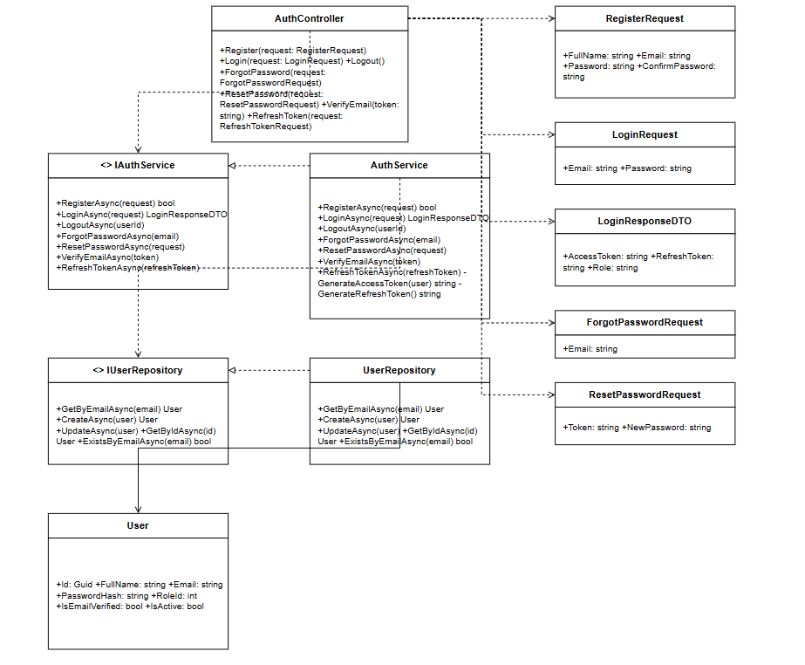
Figure 3.1.1: Authentication Class Diagram

3.1.2: Register Account
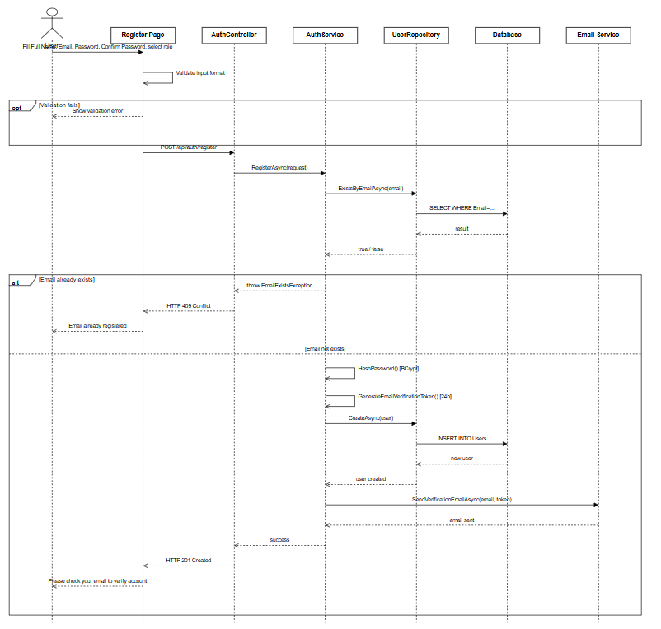
Figure: Register Account Sequence Diagram (Link)

3.1.3 Login
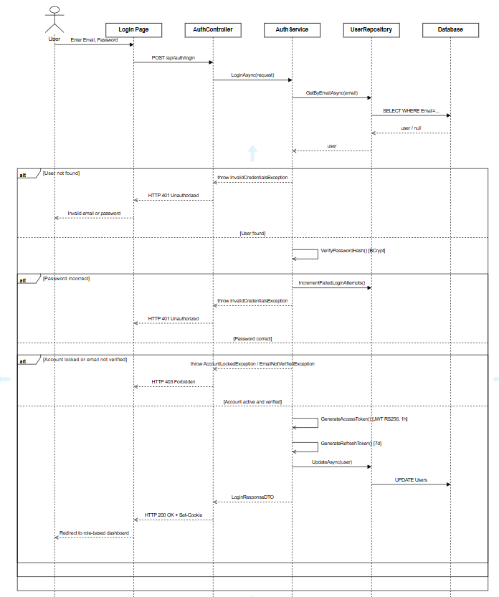

Figure 3.1.3 Login Sequence Diagram
3.1.4 Logout
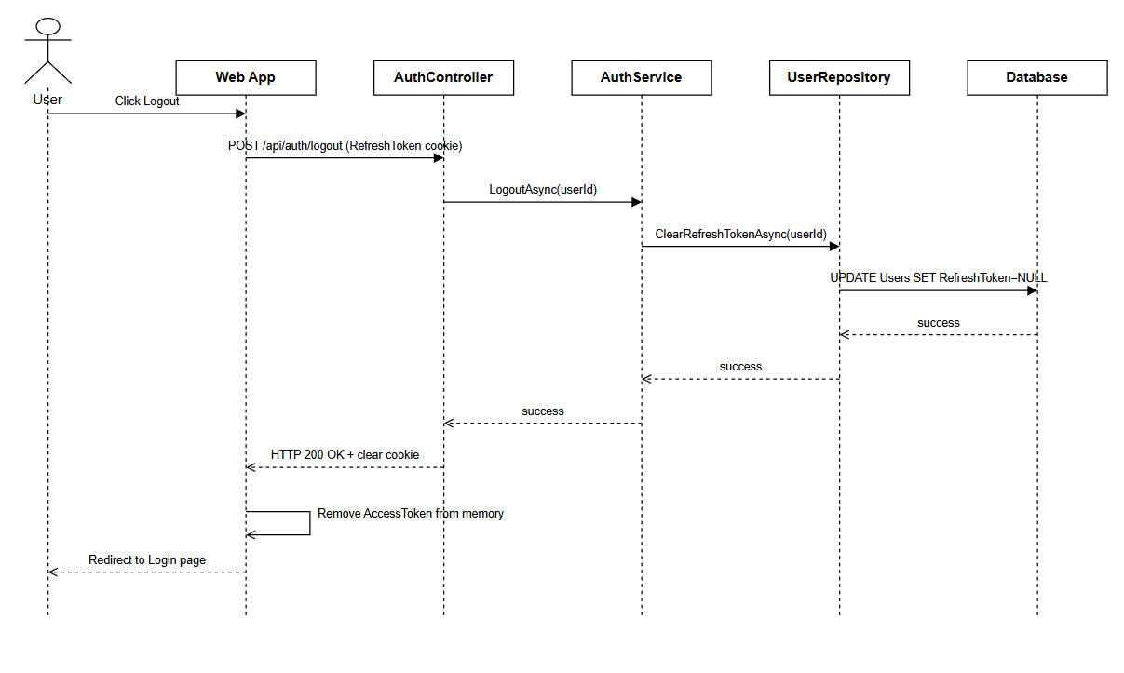
Figure: Logout Sequence Diagram (Link)
3.1.5 Forgot Password
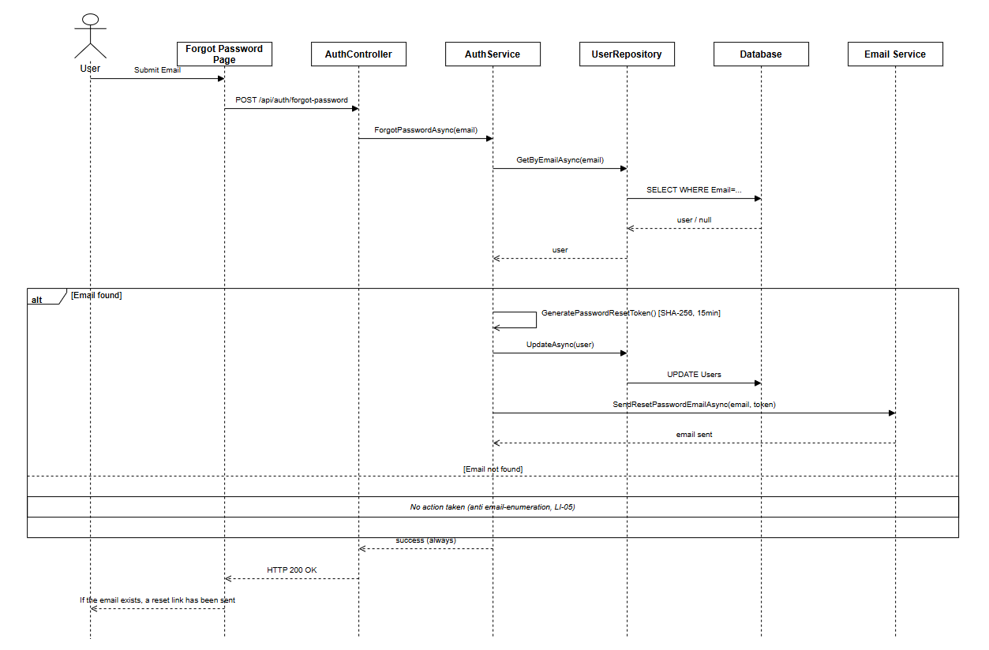
Figure: Forgot Password Sequence Diagram (Link)
3.1.6 Reset Password
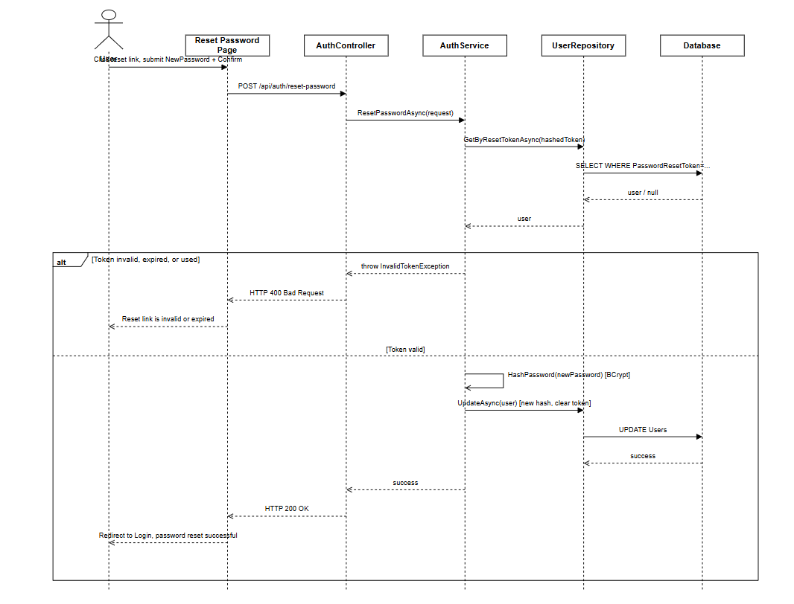
Figure: Reset Password Diagram (Link)
3.1.7 Email Verification
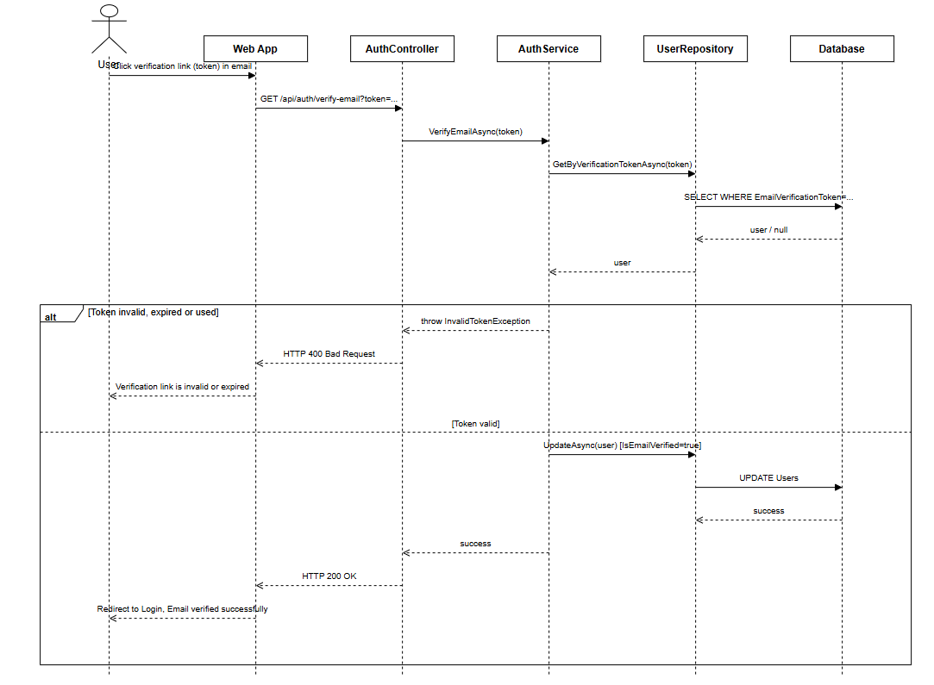
Figure: Email Verification Sequence Diagram (Link)

3.2 Profile Management / Quản lý hồ sơ cá nhân
3.2.1 View Profile
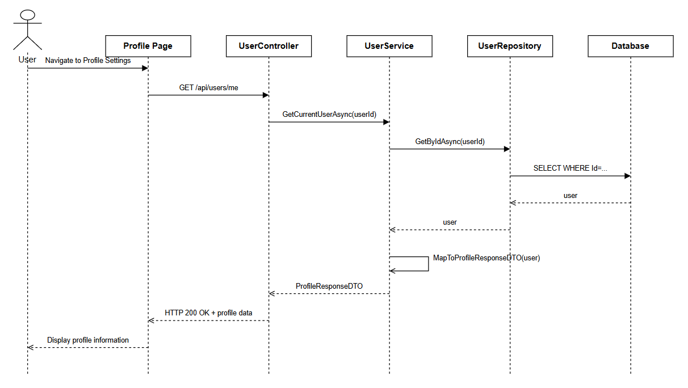
Figure: View Profile Sequence Diagram (Link)
3.2.2 Update Profile
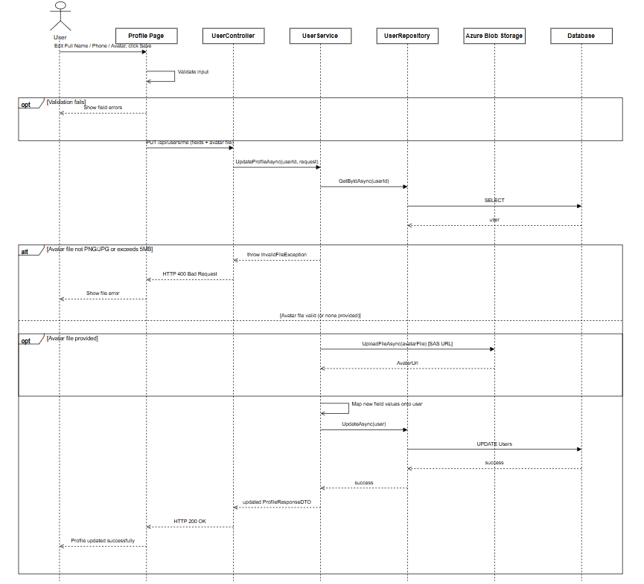
Figure: Update Profile Sequence Diagram (Link)
3.2.3 Change Password
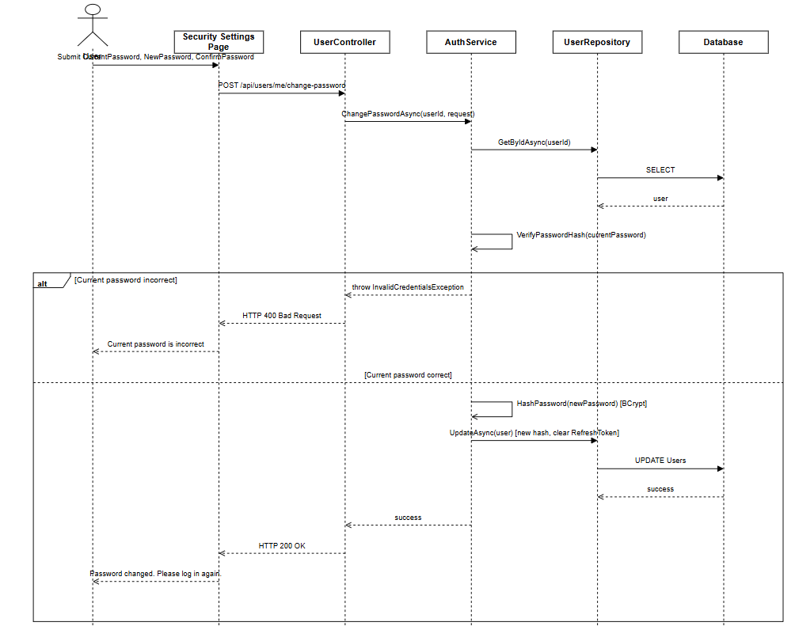
Figure: Change Password Sequence Diagram (Link)

3.3 User and Role Management / Quản lý người dùng và vai trò
3.3.1 User & Role Management
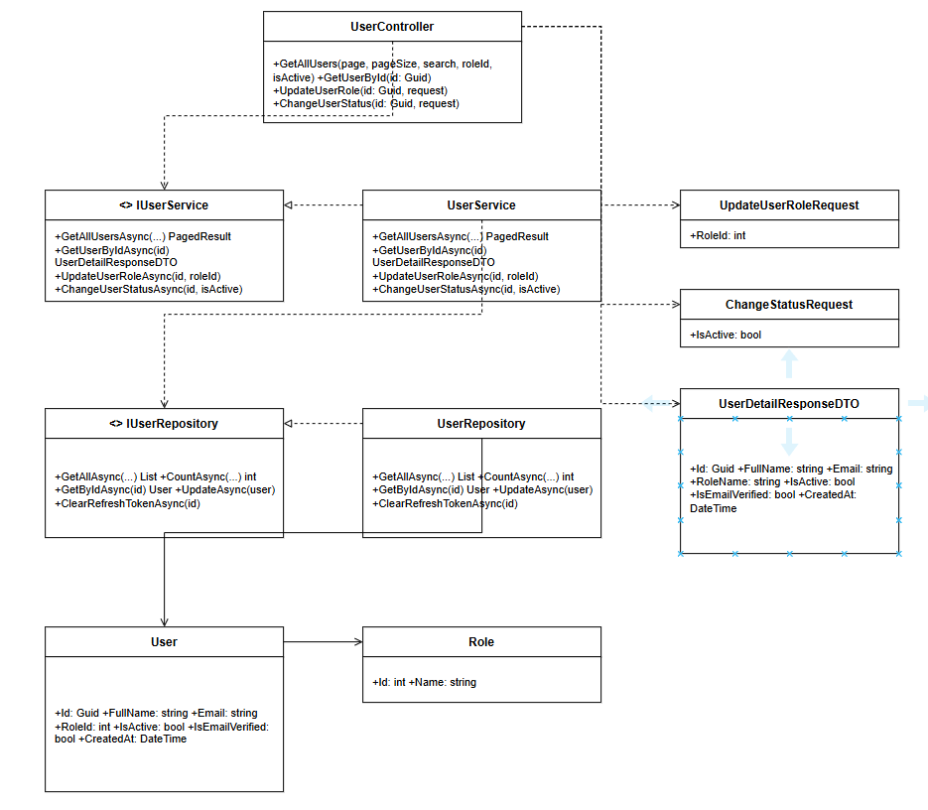
Figure: User & Role Management Class Diagram (Link)

3.3.2 View List User
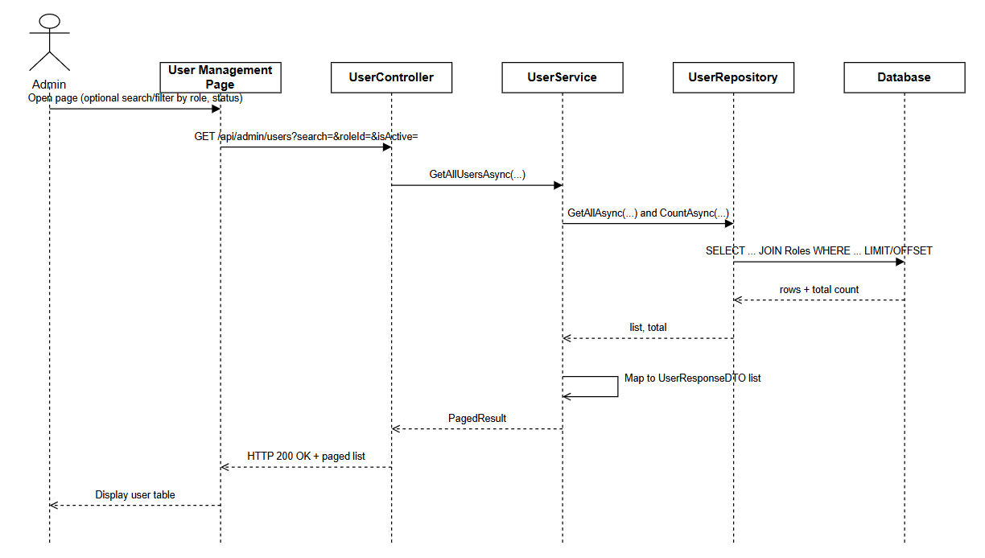
Figure: View List User Sequence Diagram (Link)
3.3.3 Update User Role
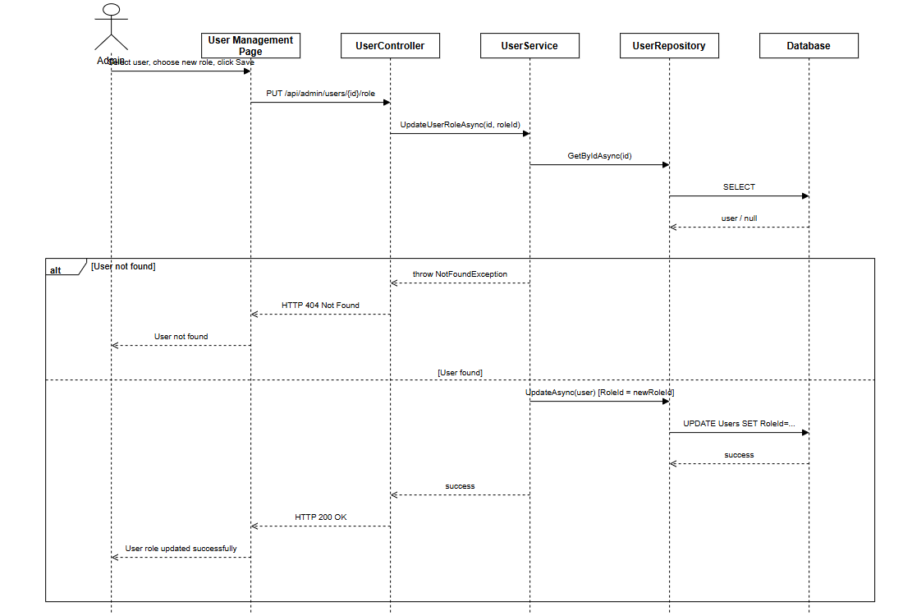
Figure: Update User Role Sequence Diagram (Link)
3.3.4 Suspend Activate Account
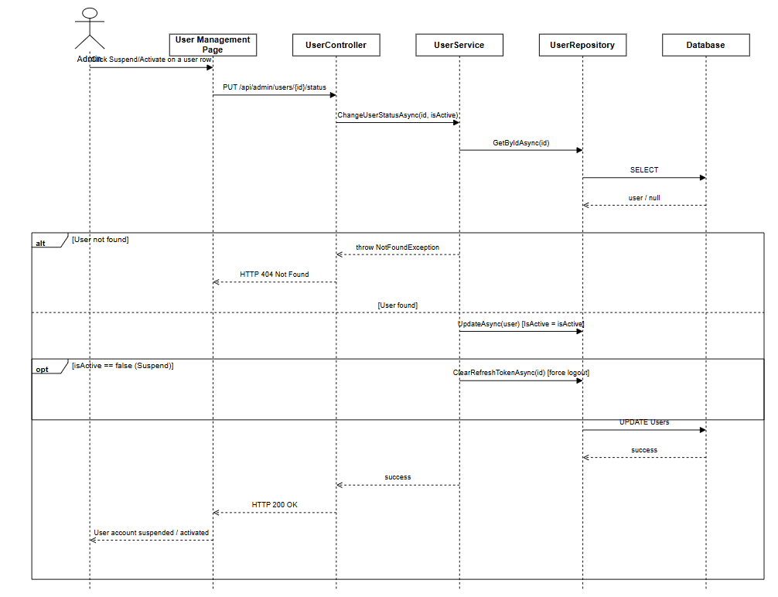
Figure: Suspend Activate Account Diagram (Link)
3.3.5 View User Detail
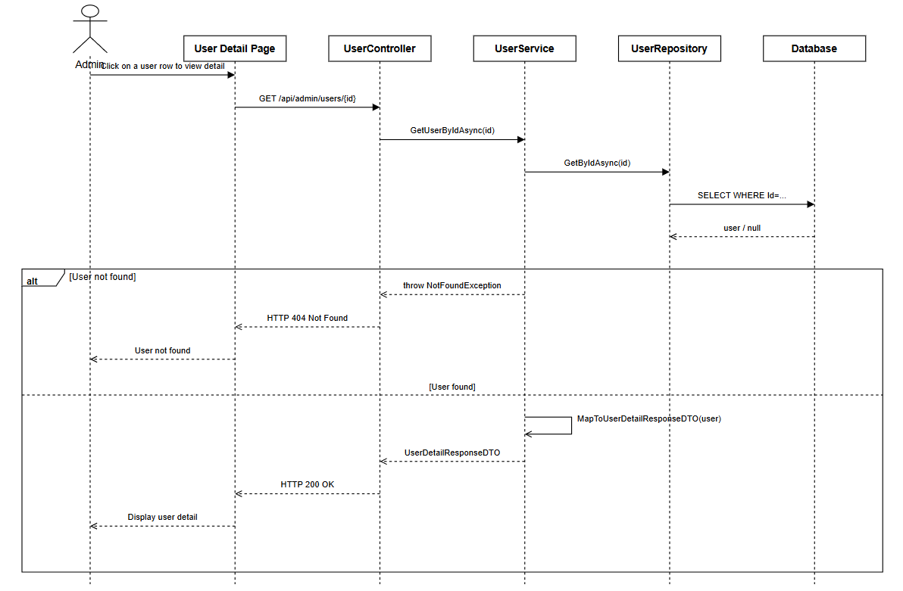
Figure: View User Detail Sequence Diagram (Link)

3.4 HR Company Management / Quản lý công ty của HR
3.4.1 HR Company Management
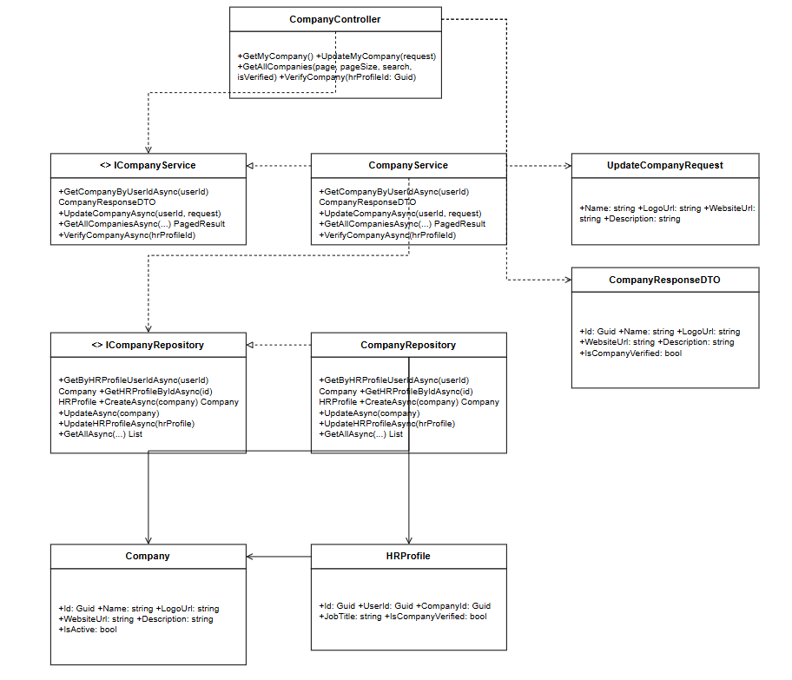

Figure: HR Company Management Class Diagram (Link)
3.4.2 View Company Profile
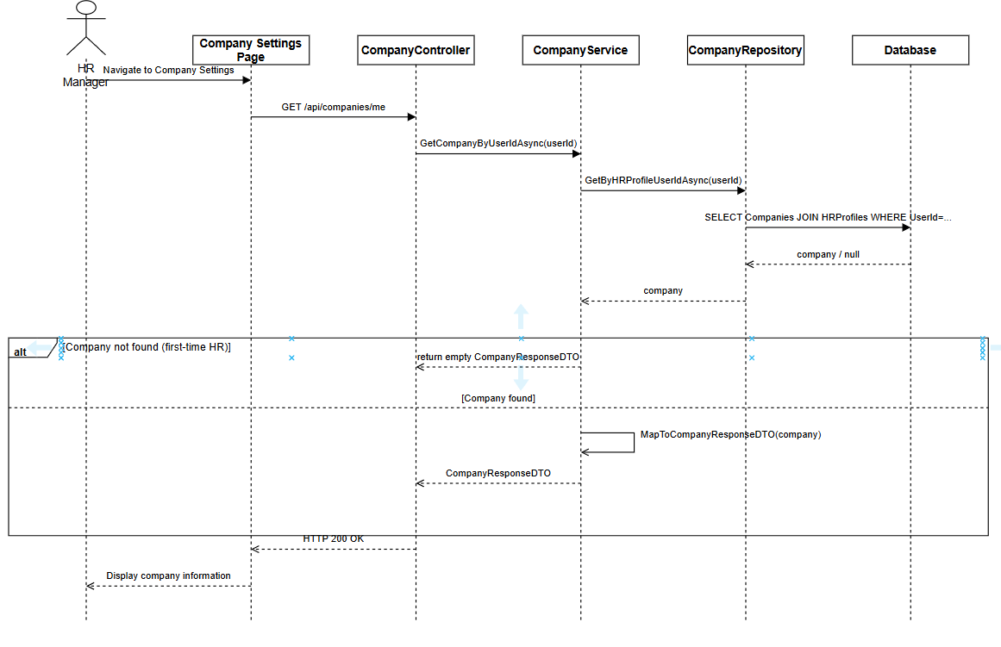
Figure: View Company Profile Sequence Diagram (Link)
3.4.3 Update Company Information
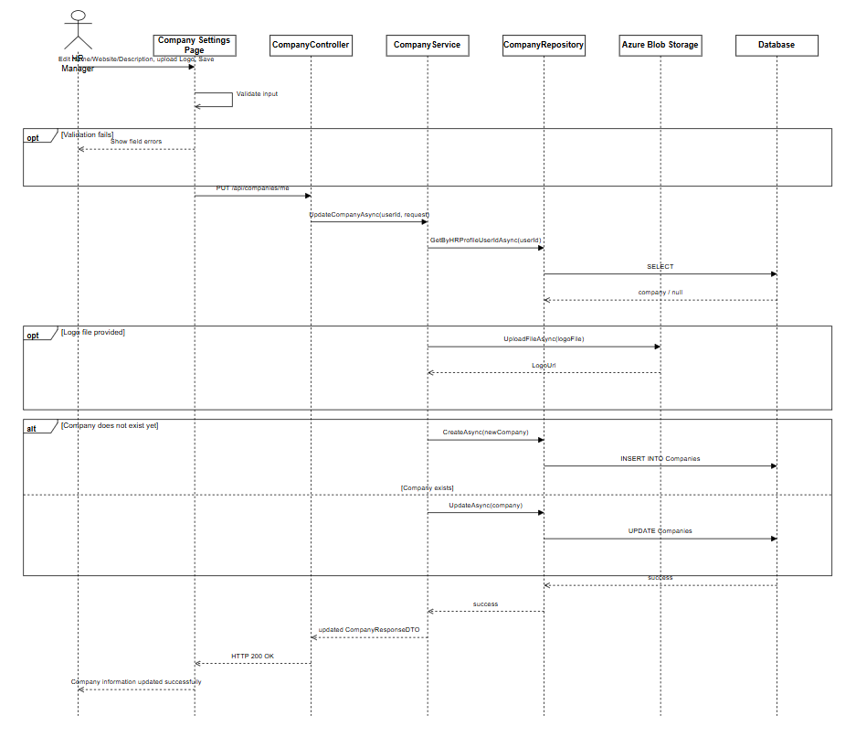
Figure: Update Company Information Sequence Diagram (Link)
3.4.4 VIew Company List
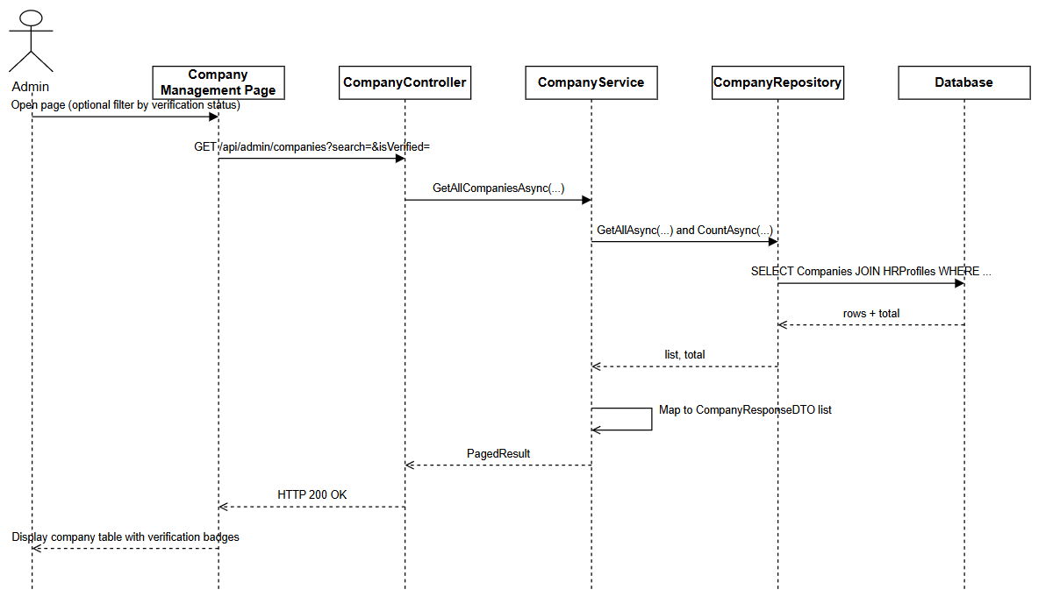
Figure: View Company List Sequence Diagram (Link)
3.4.5 Verify Company
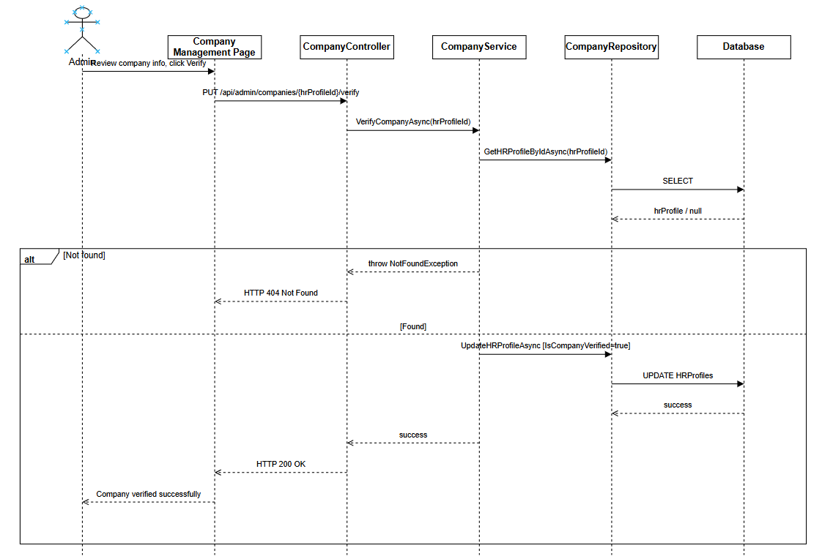
Figure: Verify Company Sequence Diagram (Link)

3.5 Job Description Management
3.5.1 Create JD ( Text )
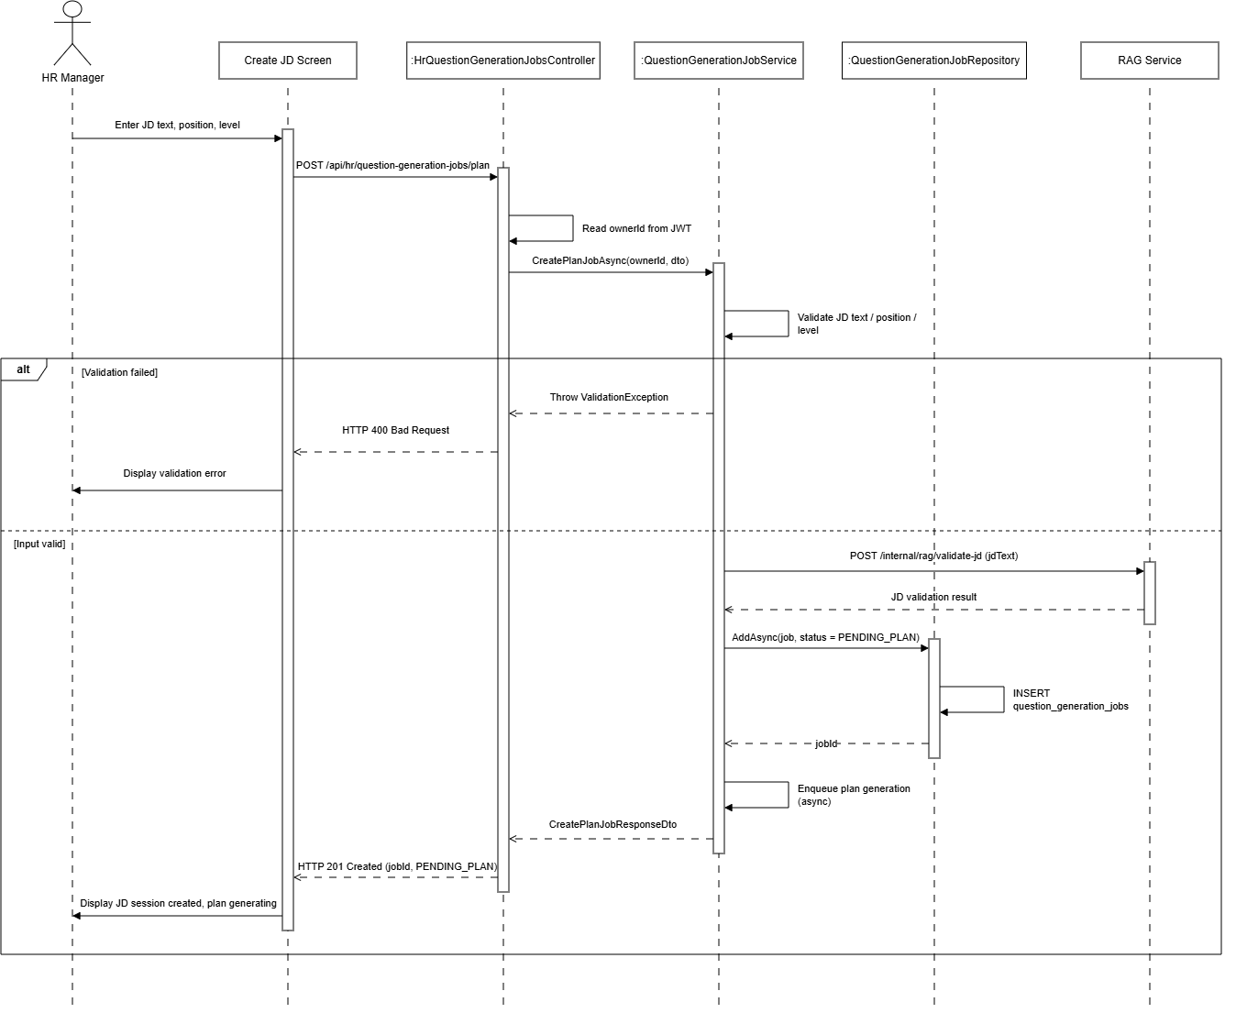
Figure : Create JD ( Text ) sequence diagram (Link)
3.5.2 Create JD (Upload File)
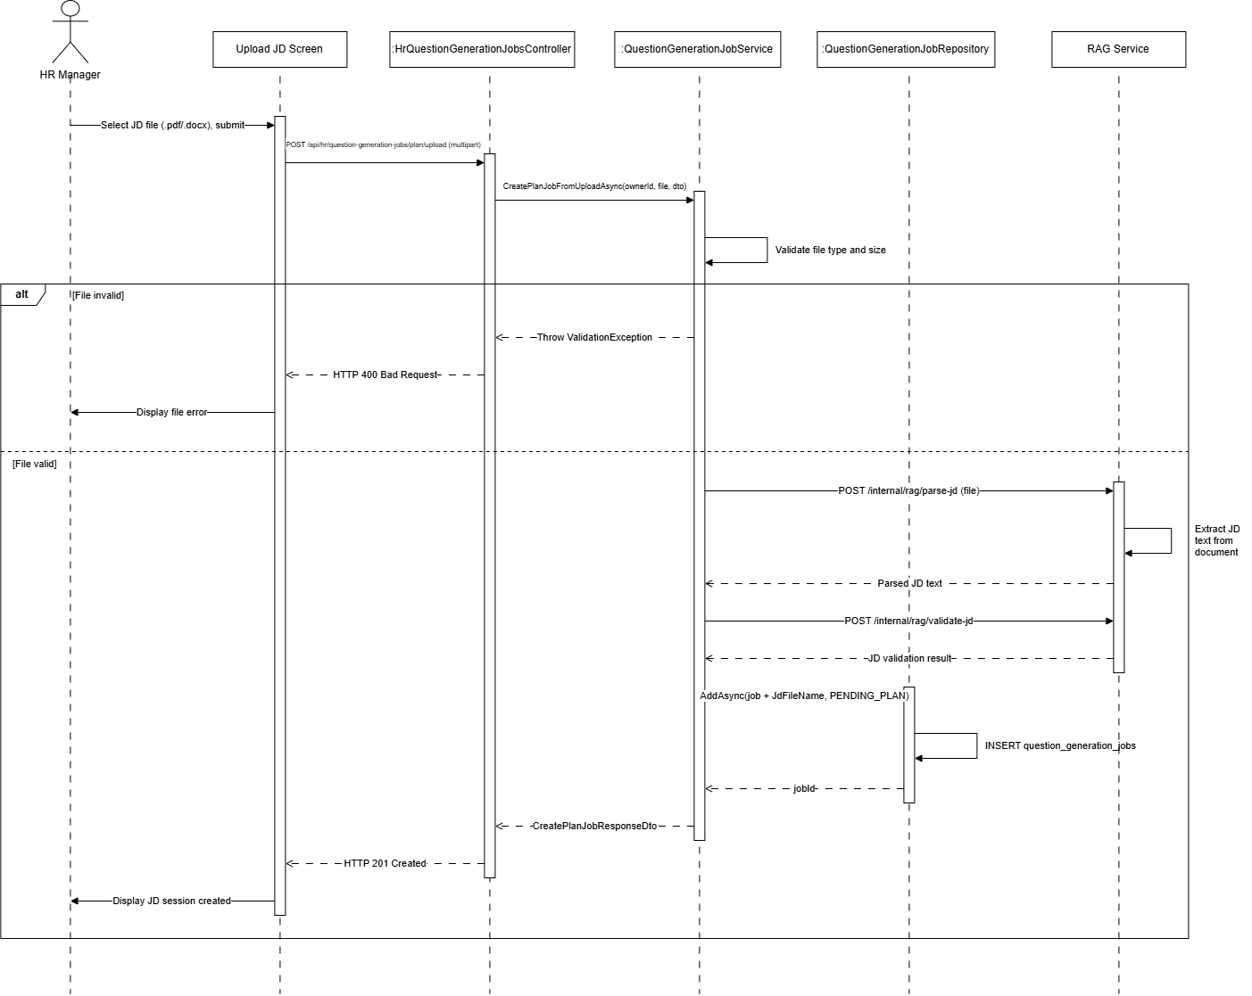
Figure : Create JD ( Upload File) sequence diagram (Link)
3.5.3 Update jd when failed
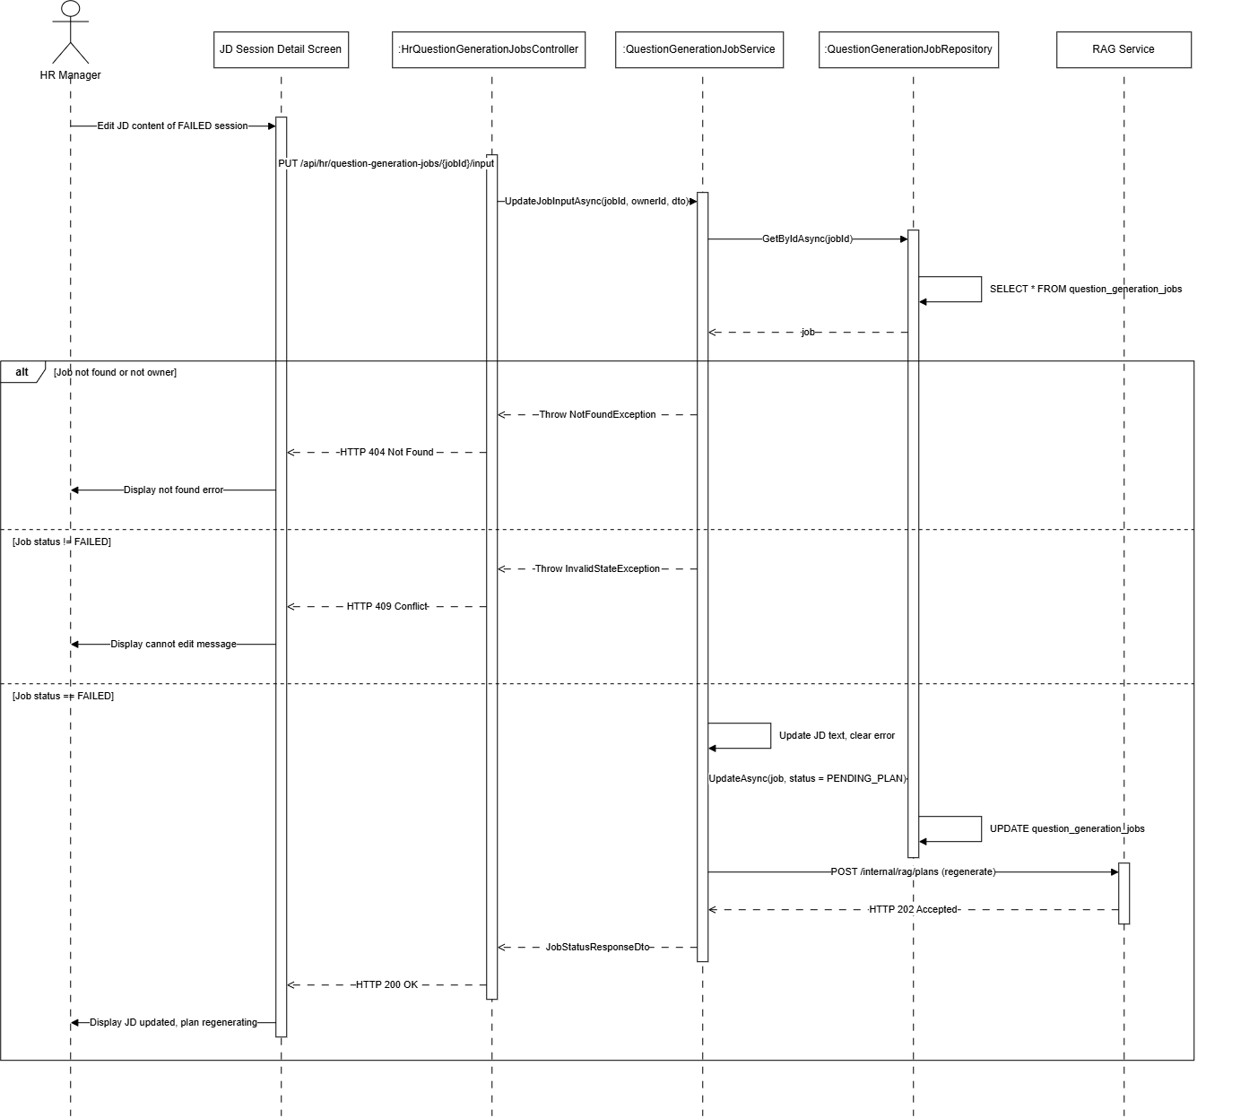
Figure : Update JD when failed sequence diagram (Link)
3.5.4 List view JD session

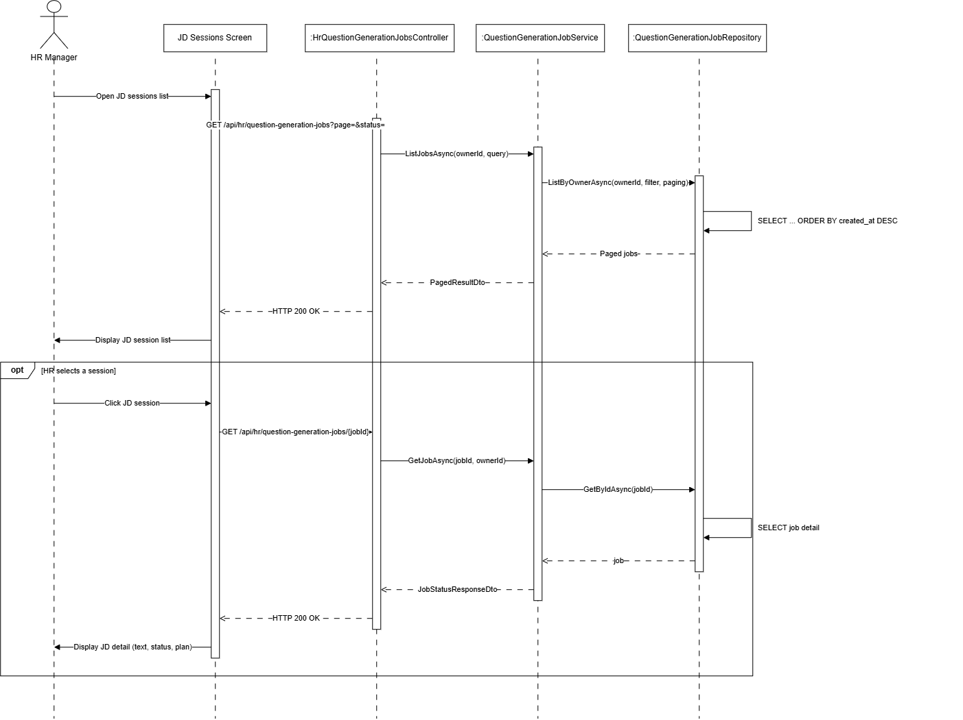

Figure : List view JS sequence diagram (Link)
3.5.5 Delete JD session
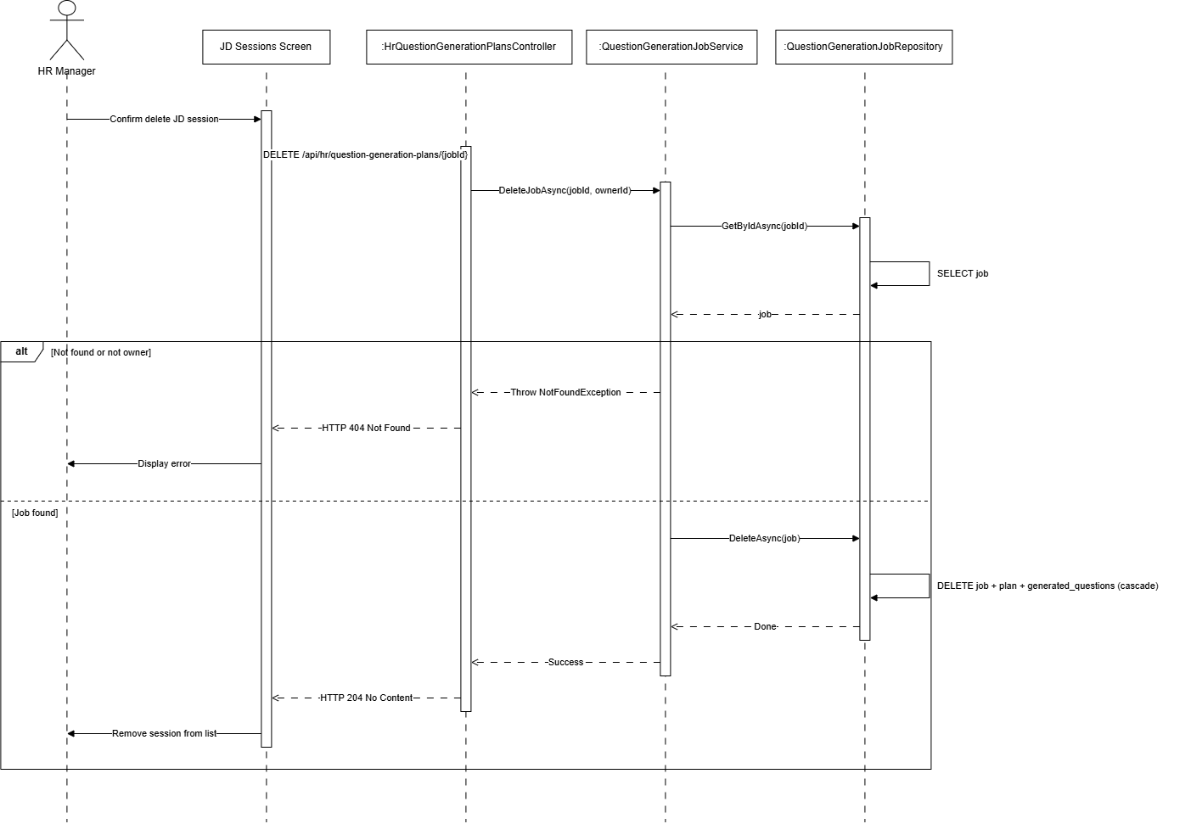

Figure : Delete JD session sequence diagram (Link)

3.6 Knowledge Base Management / Quản lý kho tri thức
3.6.1 Upload ingest HR
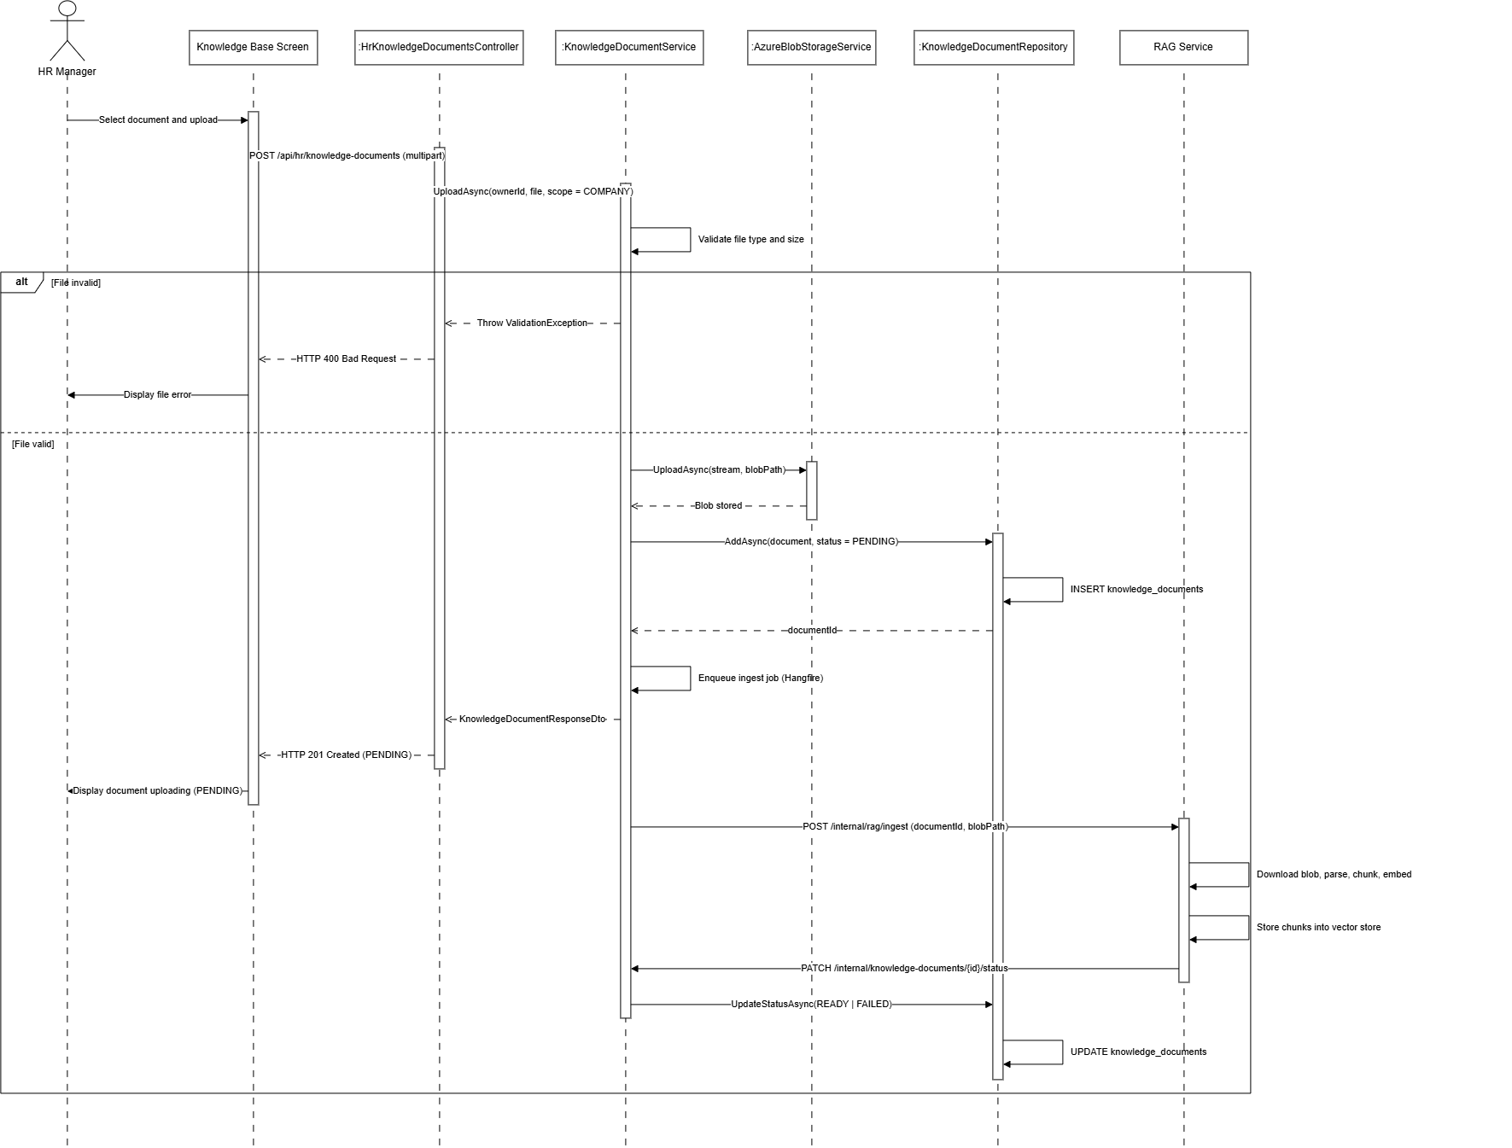
Figure : Upload ingest hr sequence diagram (Link)
3.6.2 Upload ingest Admin
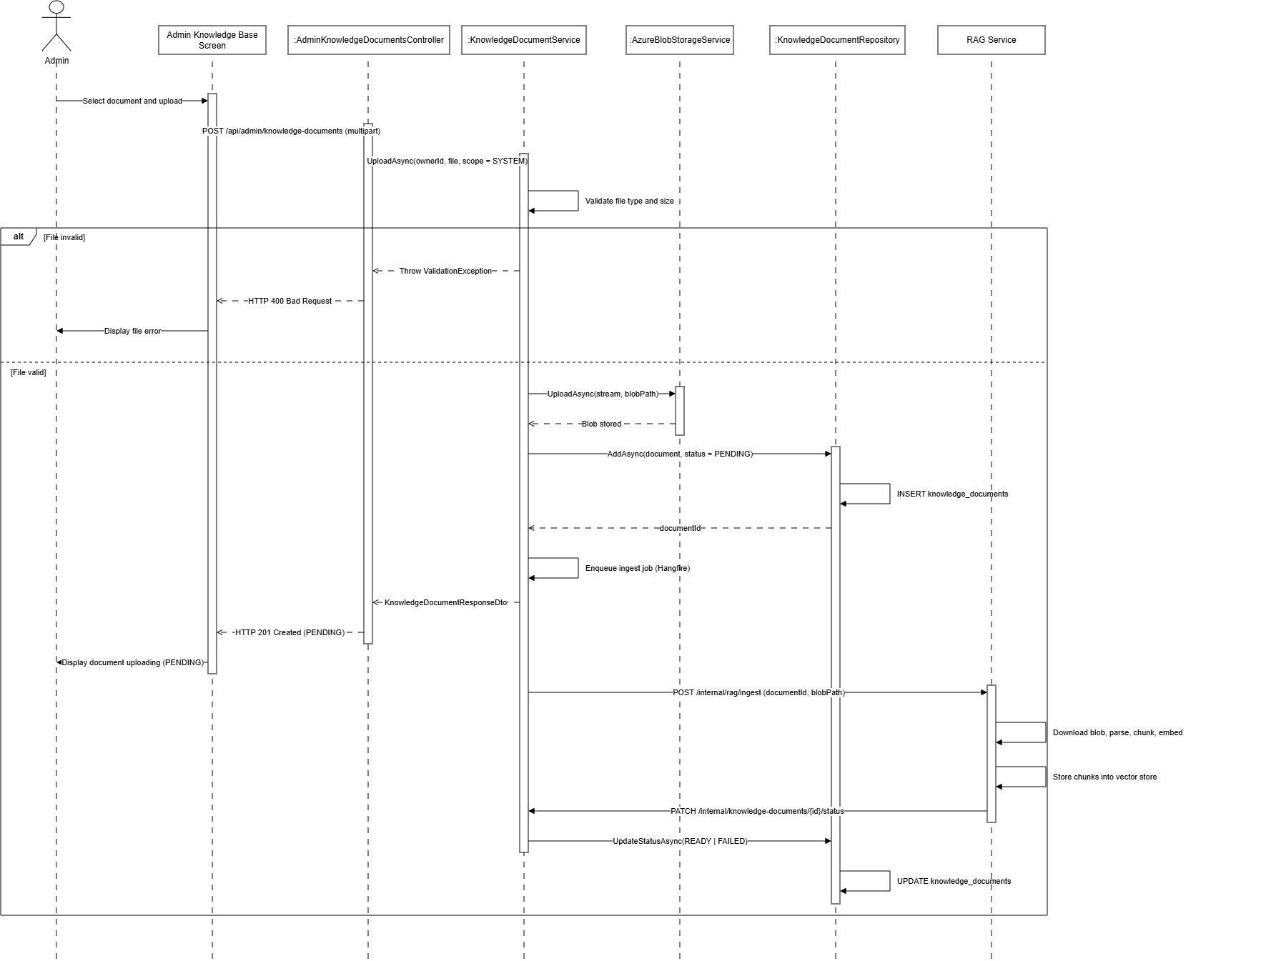
Figure : Upload ingest admin sequence diagram (Link)
3.6.3 Reingest document
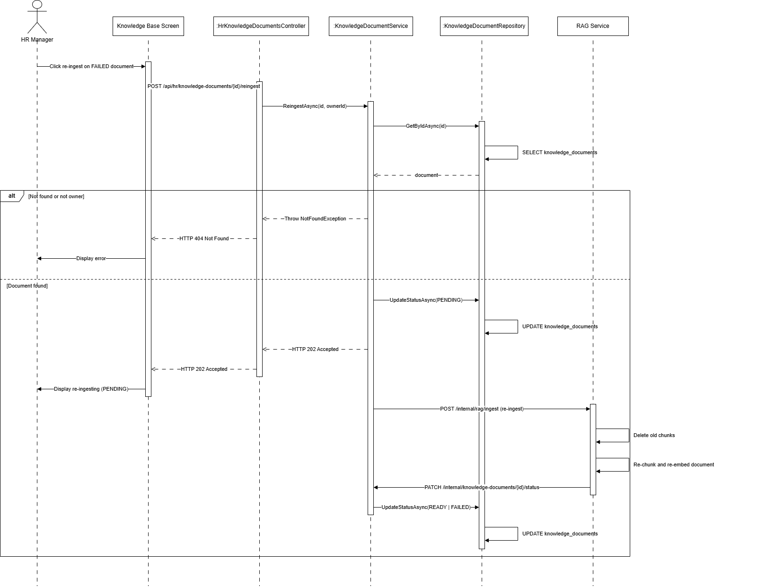
Figure : Reingest document sequence diagram (Link)
3.6.4 List get document
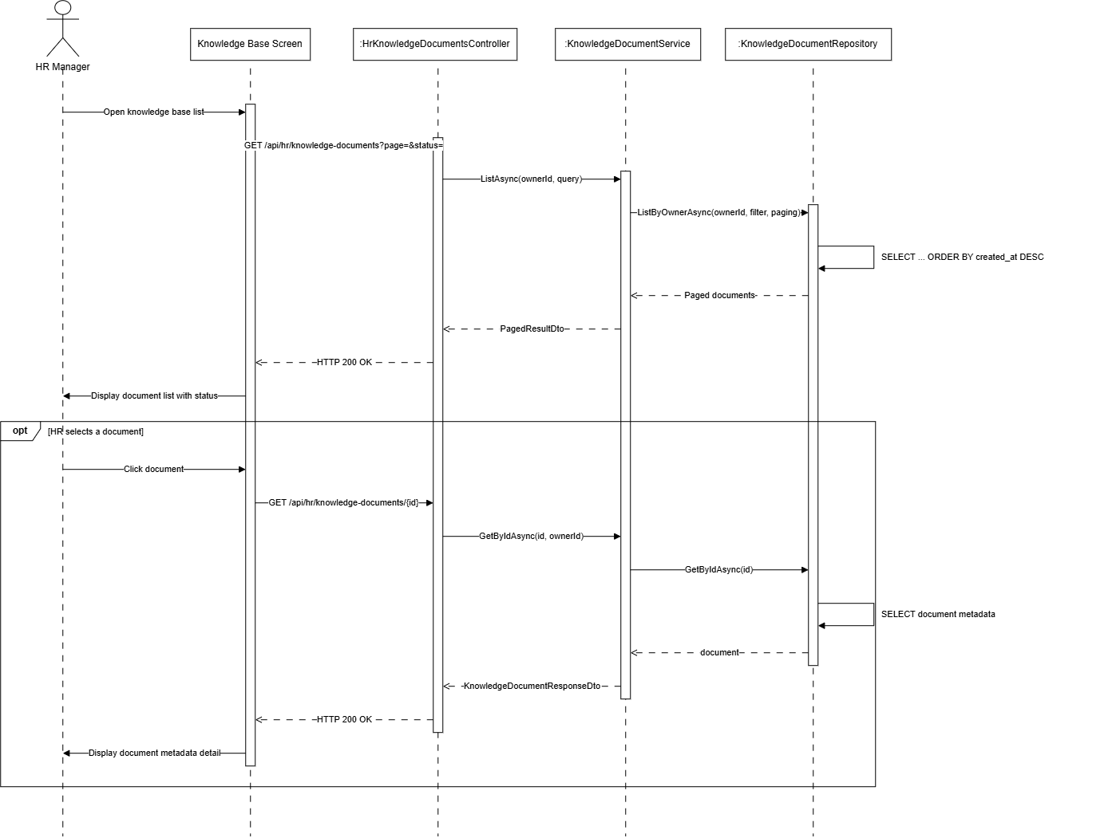
Figure : List get document sequence diagram (Link)
3.6.5 Delete document
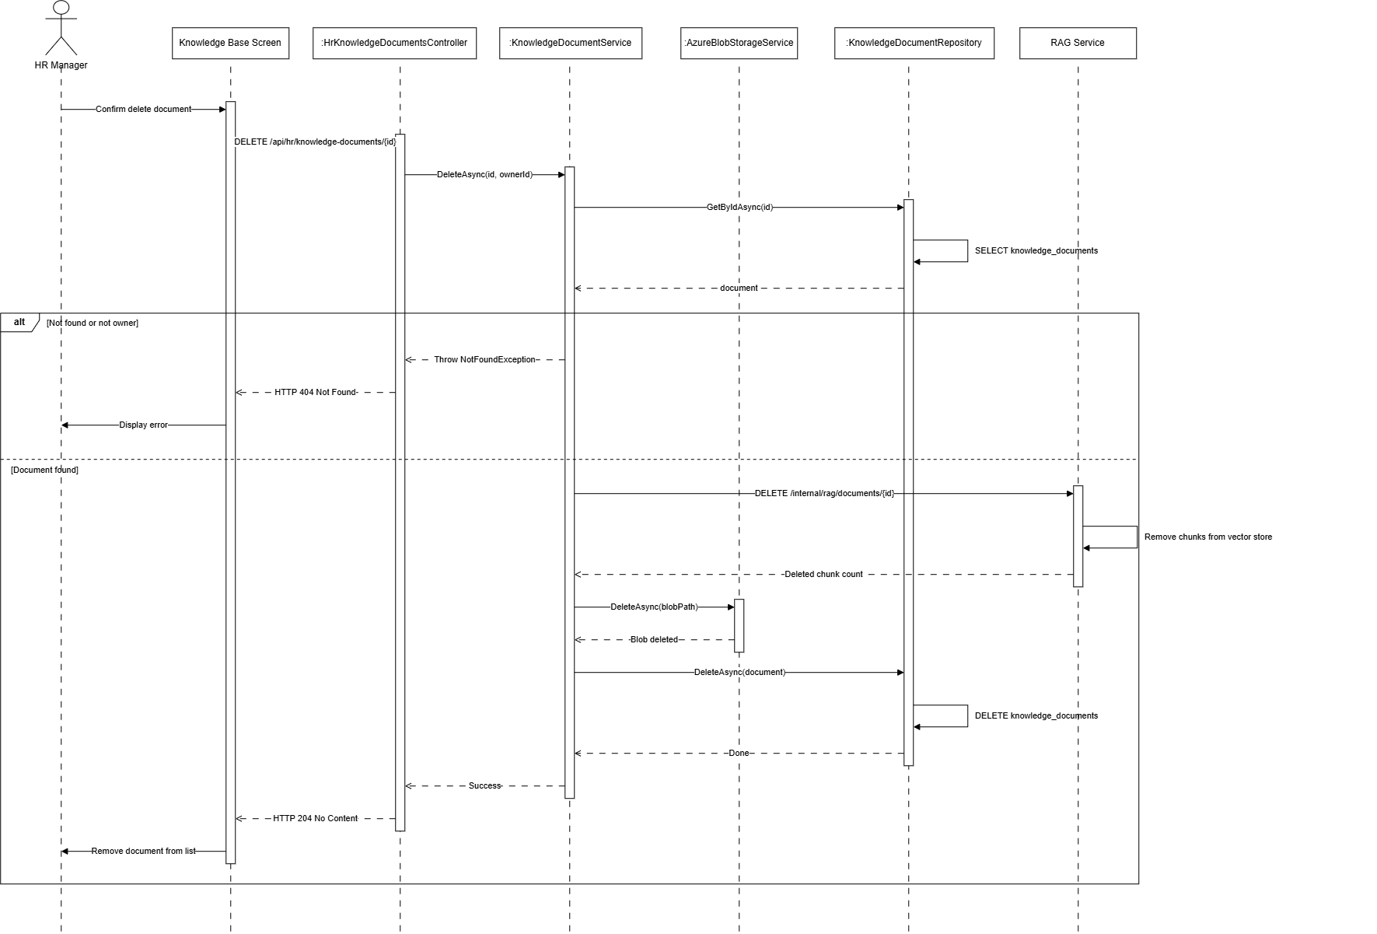
Figure : Delete document sequence diagram (Link)

3.7 AI Question Generation Management / Quản lý sinh câu hỏi bằng AI
3.7.1 Generate plan
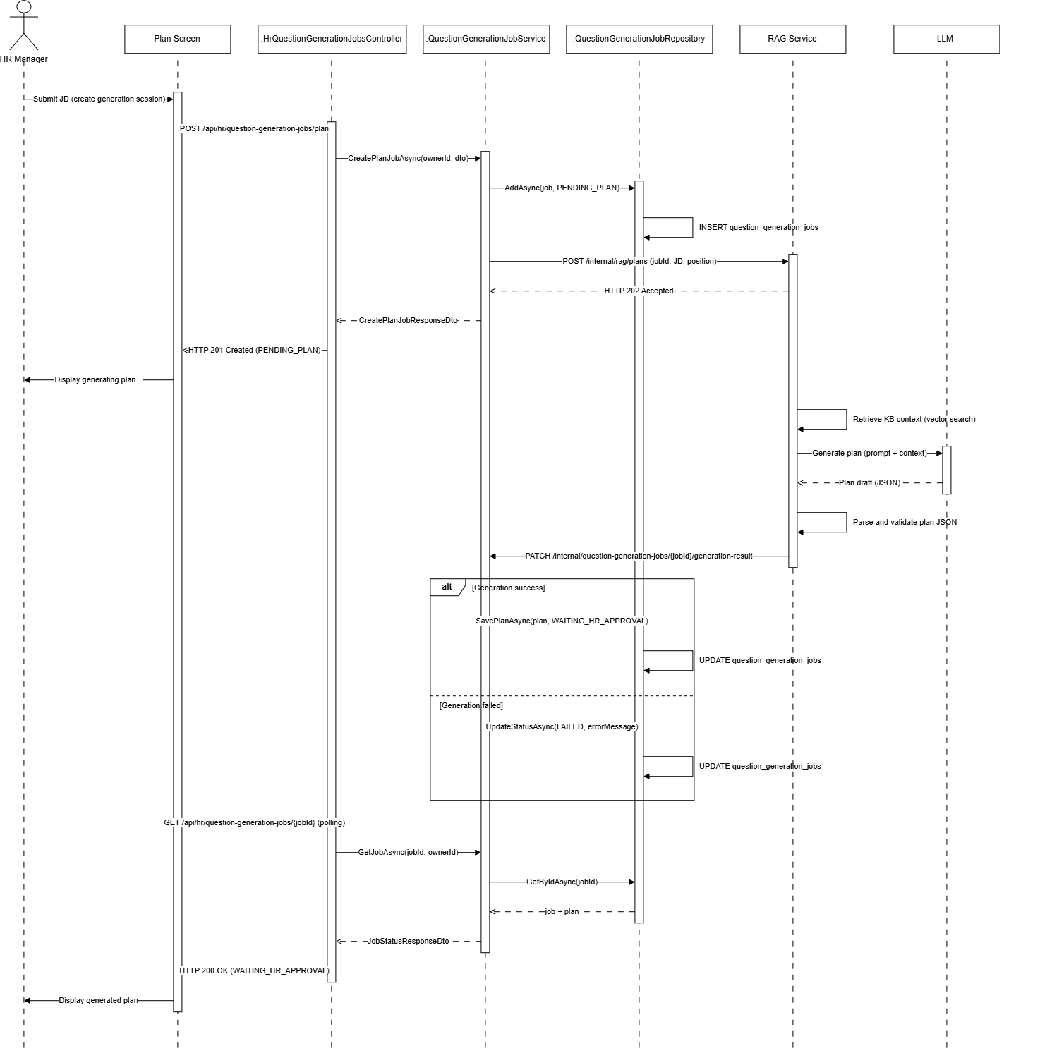
Figure : Generate plan sequence diagram (Link)
3.7.2 Review edit plan
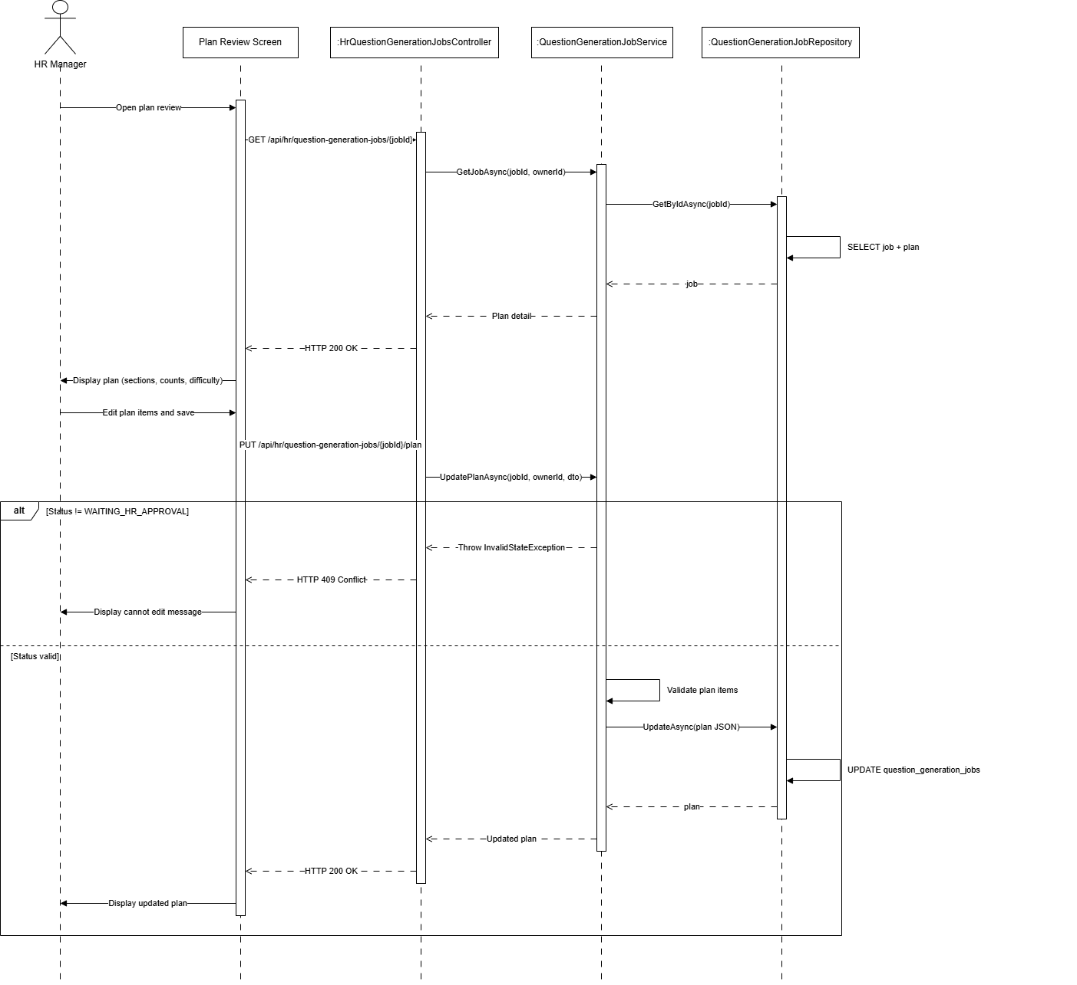
Figure : Review edit plan sequence diagram (Link)
3.7.3 Approve and generate questions
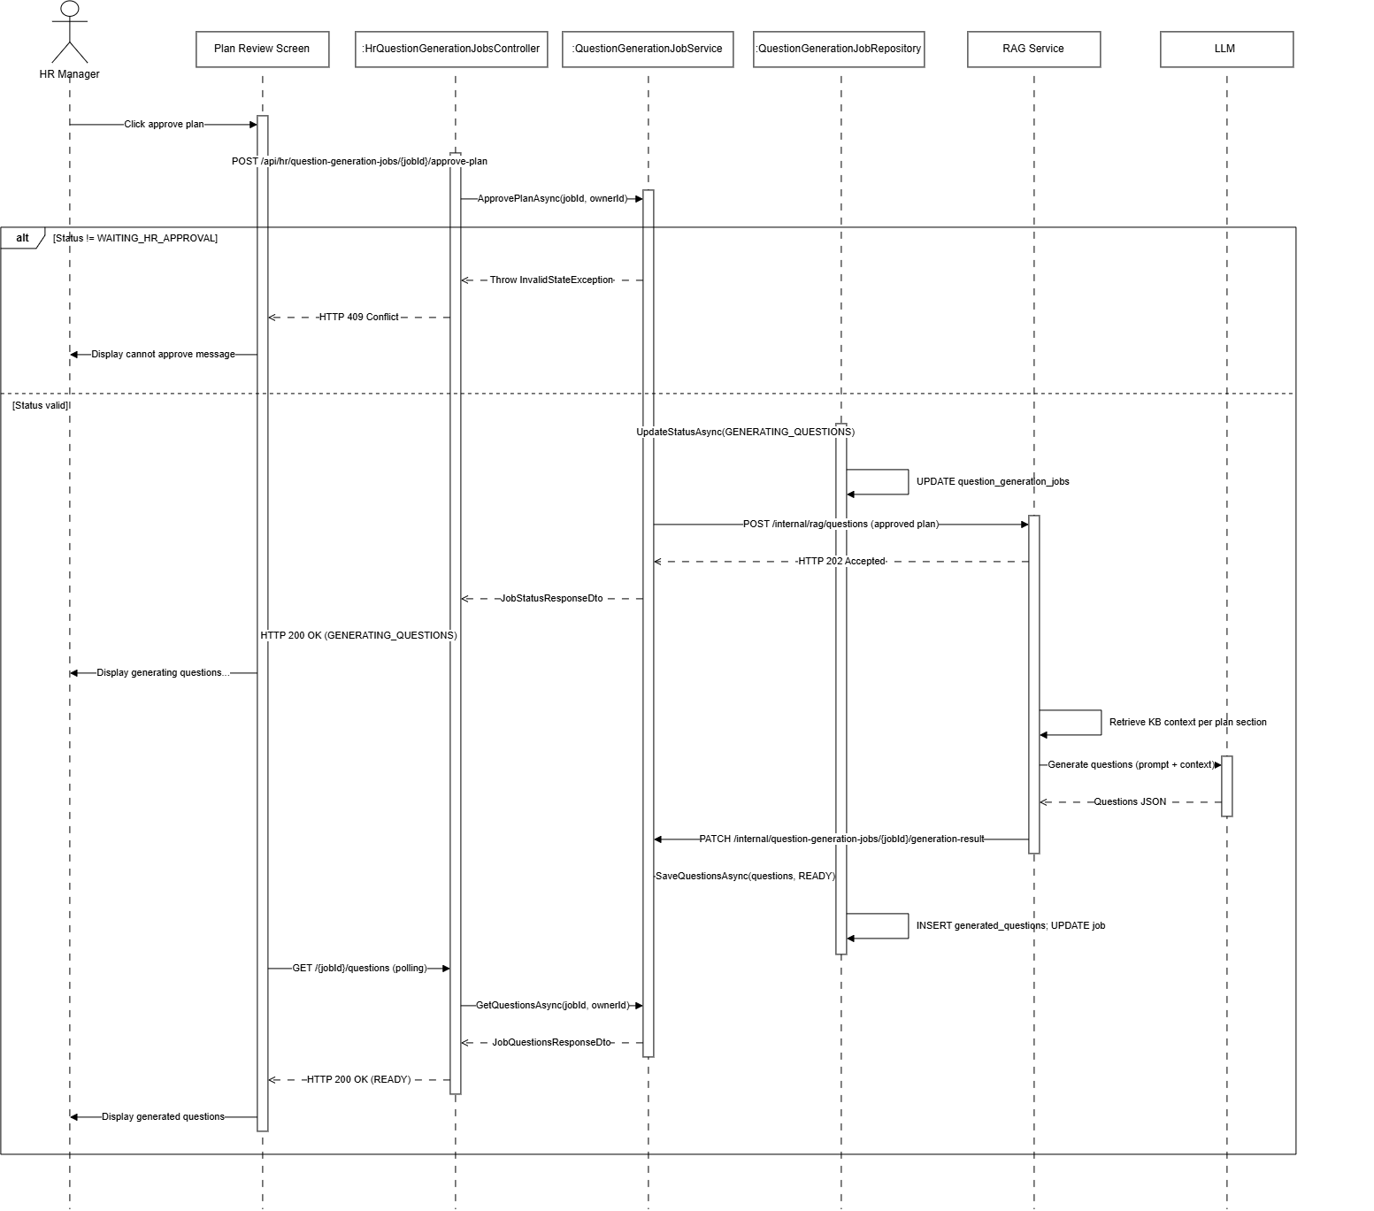
Figure : Approve and generate questions sequence diagram (Link)
3.7.4 Edit questions
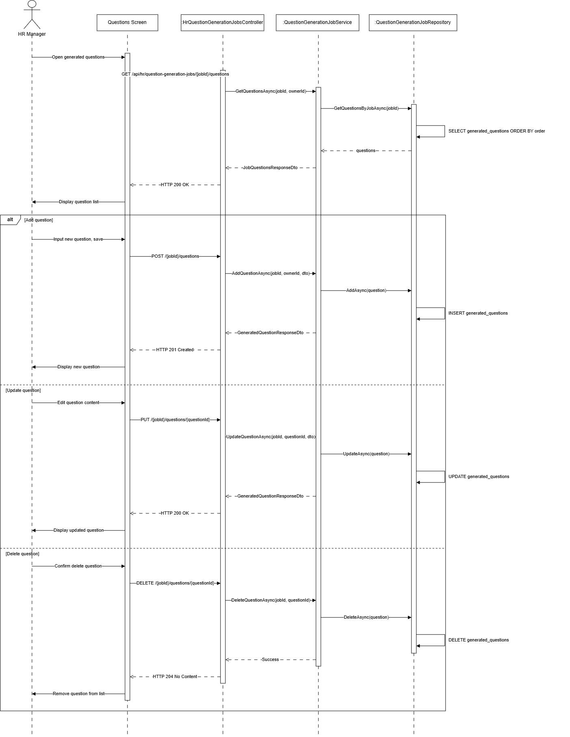
Figure : Edit questions sequence diagram (Link)
3.7.5 Retry plan or questions
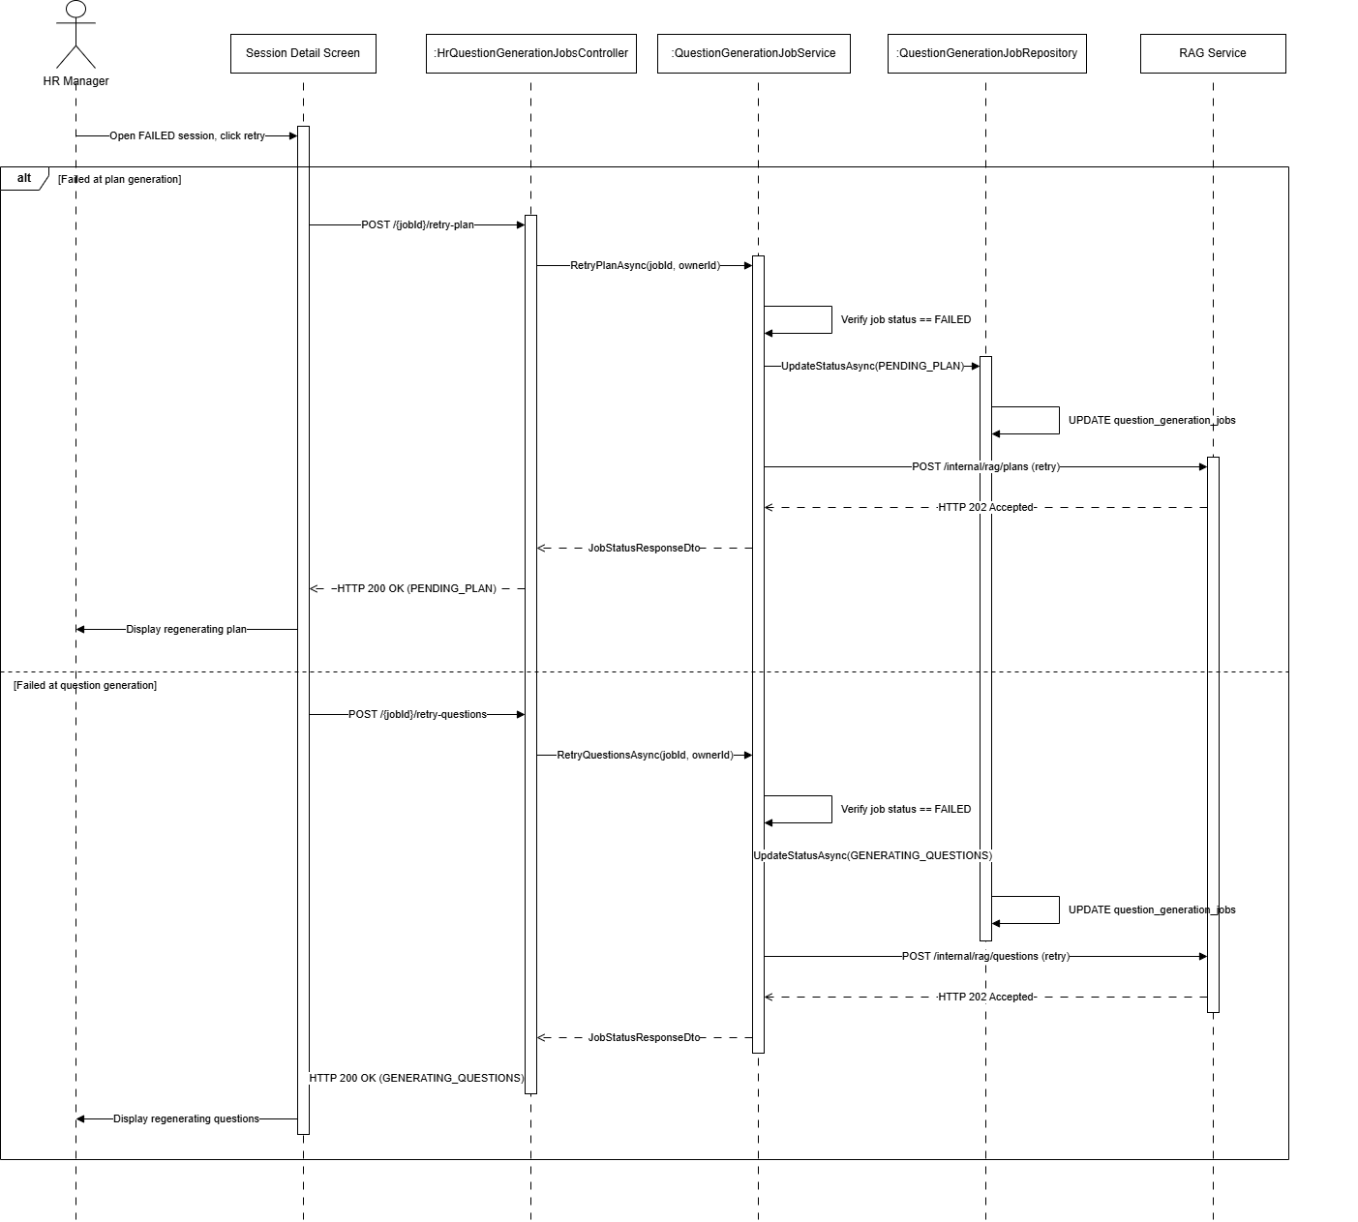
Figure : Retry plan or questions sequence diagram (Link)

3.8 Question Set Management / Quản lý bộ câu hỏi
3.8.1 Save draft
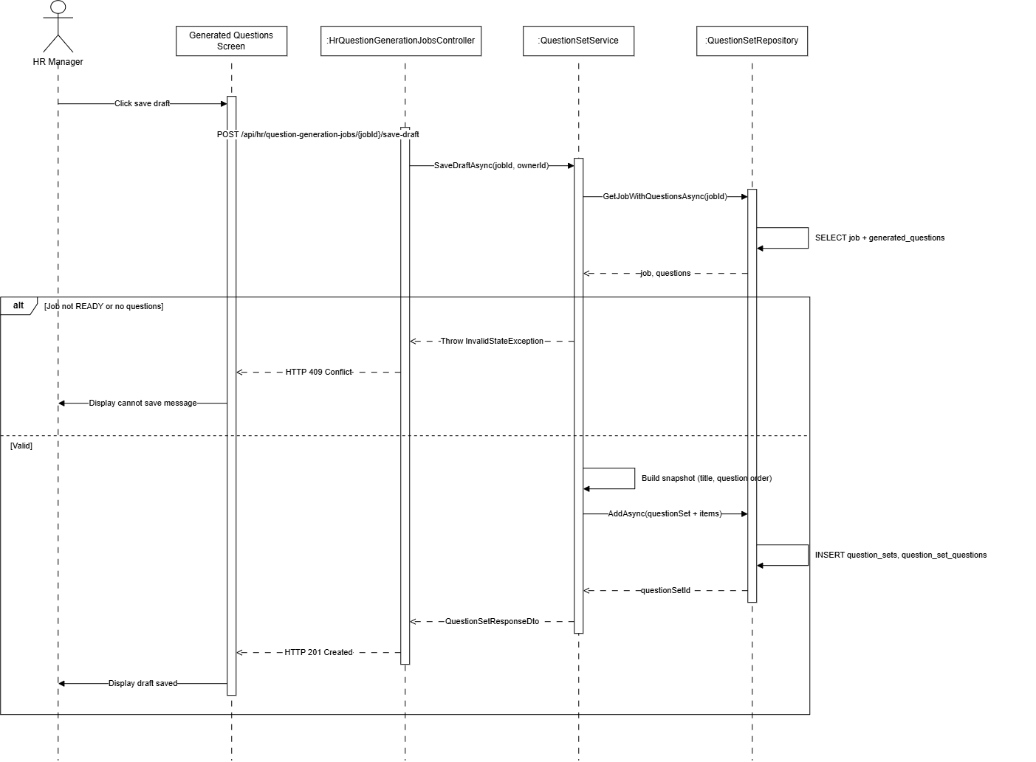
Figure : Save draft sequence diagram (Link)
3.8.2 List question sets
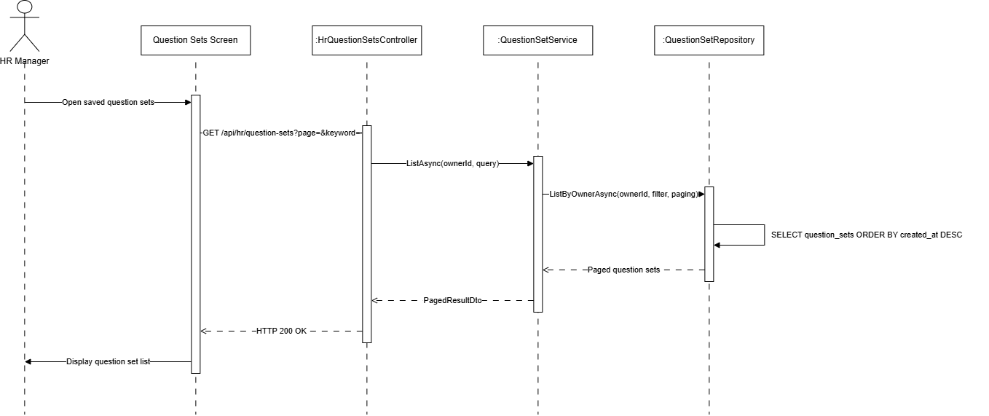
Figure : List question sets sequence diagram (Link)
3.8.3 View questions set detail
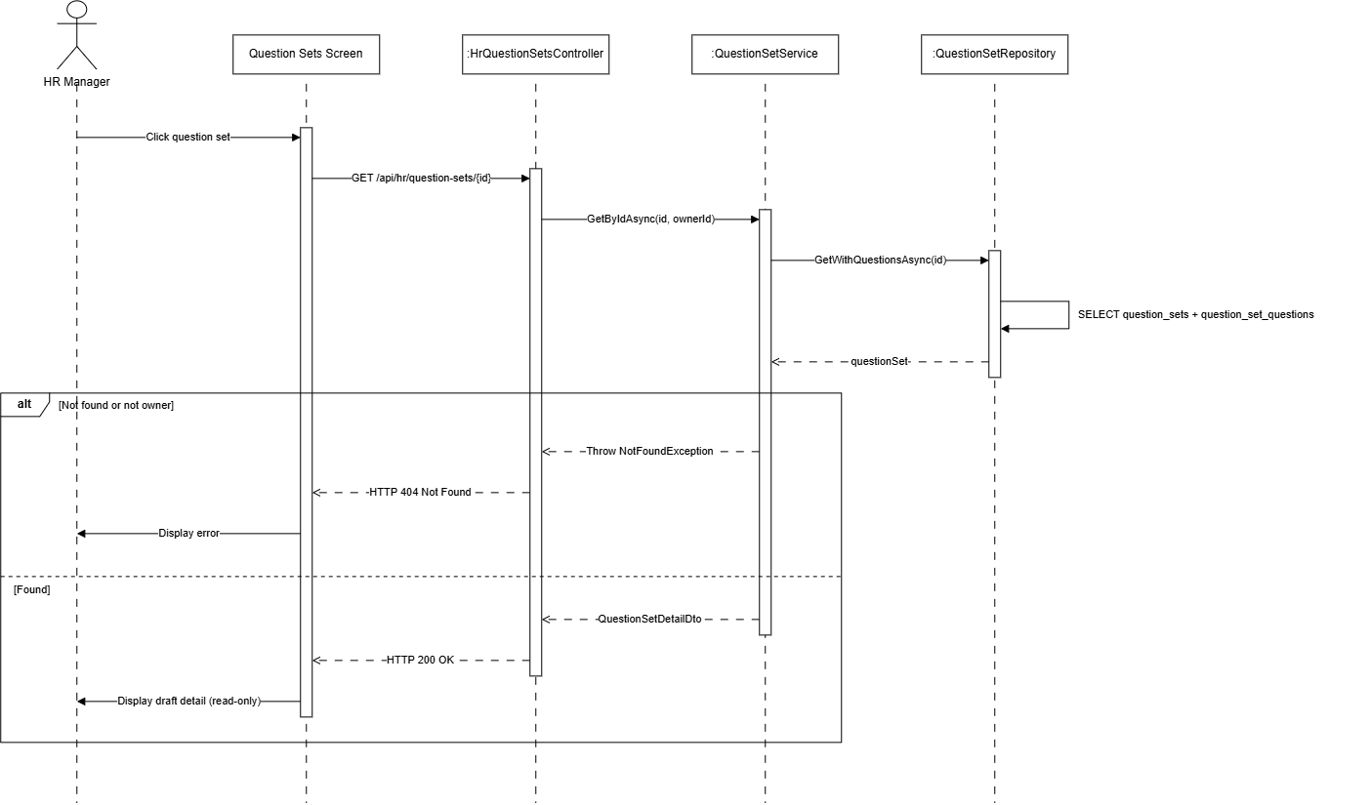
Figure : View questions set sequence diagram (Link)

3.9 Marketplace Management / Quản lý chợ bộ câu hỏi
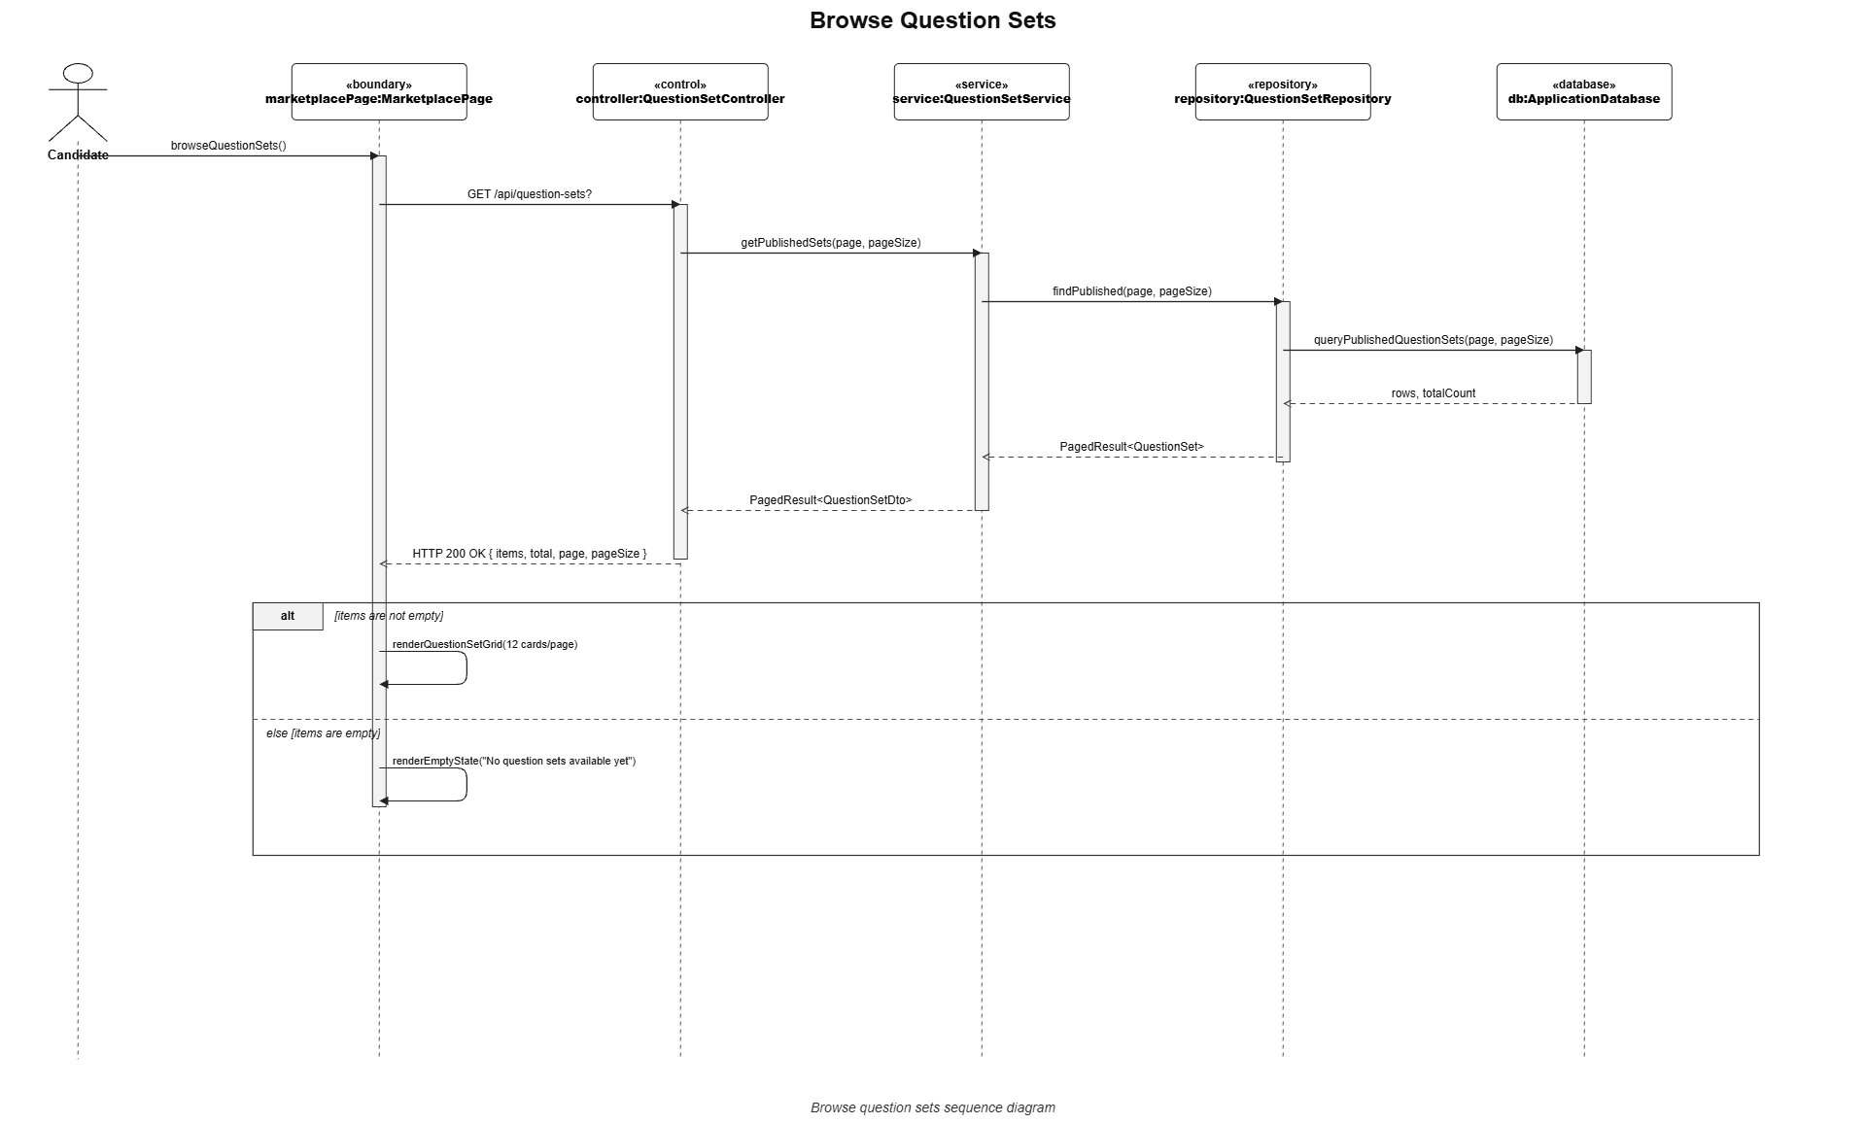
3.9.1. Browse Question Sets

Figure : Browse question sets sequence diagram (Link)
3.9.2. Search & Filter Question Sets
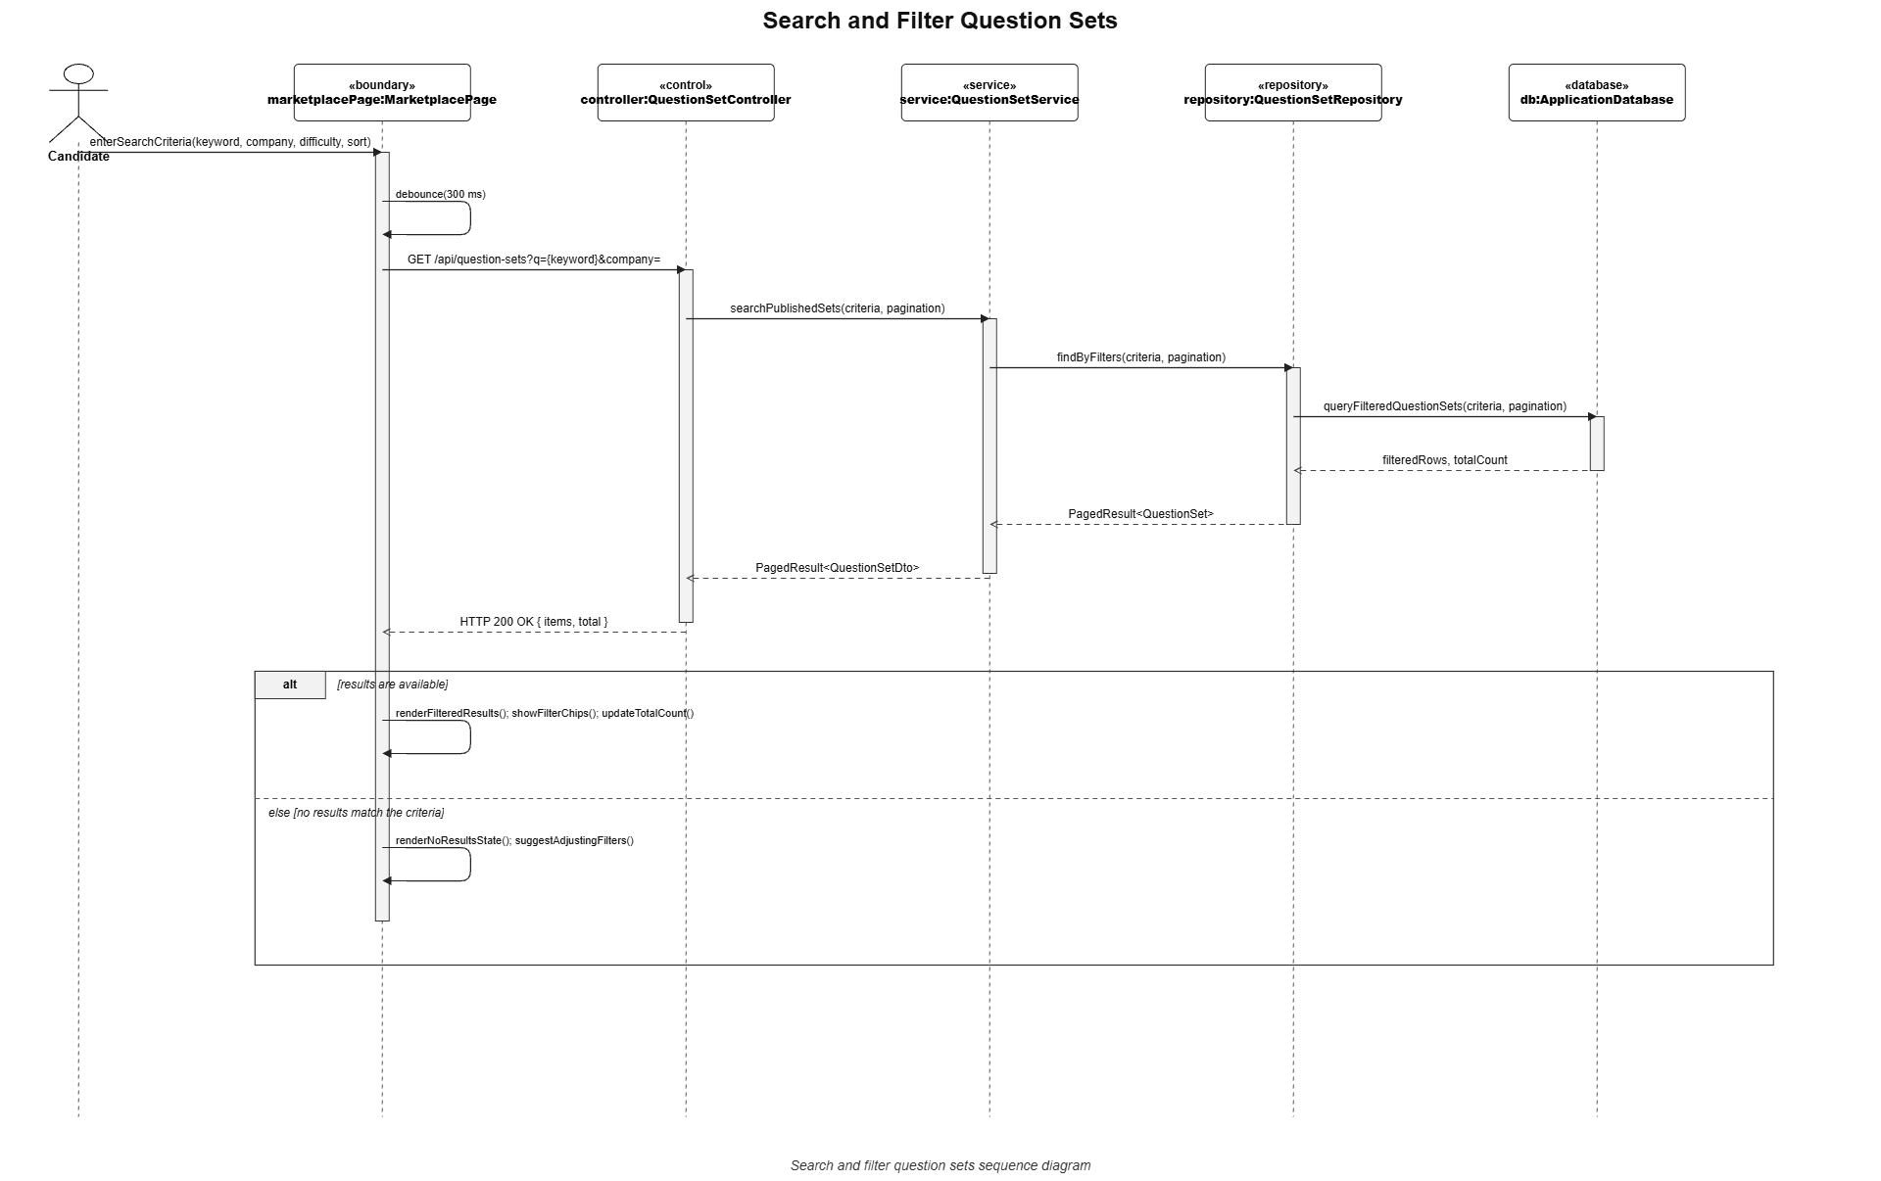

Figure : Search & filter question sets sequence diagram (Link)
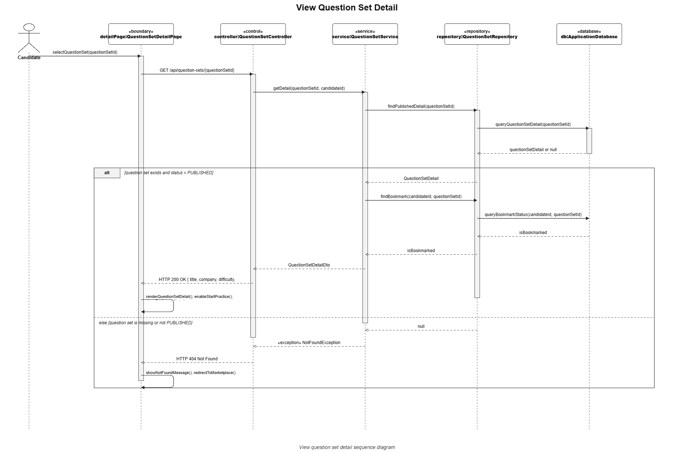
3.9.3. View Question Sets

Figure : View question sets sequence diagram (Link)
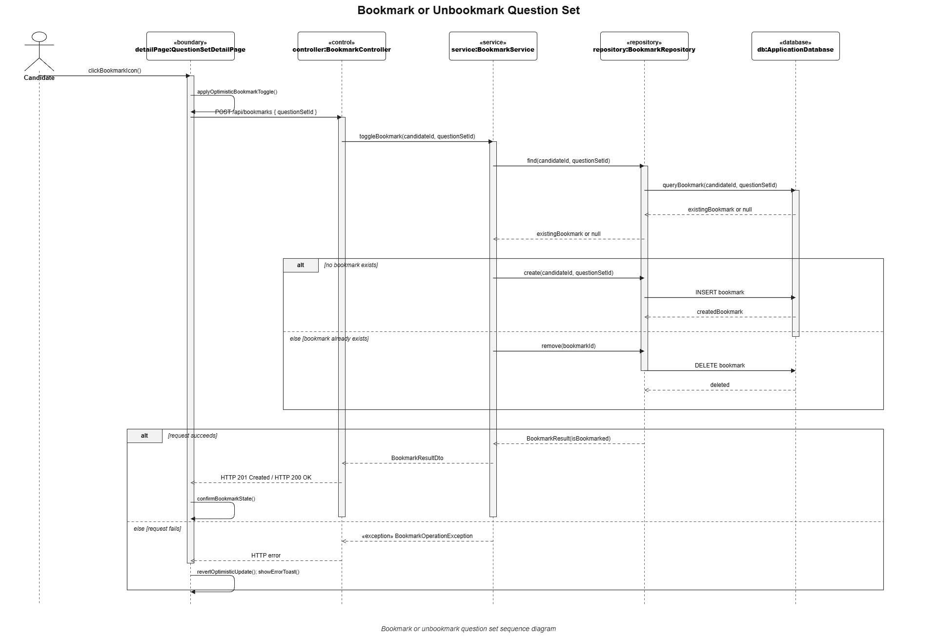
3.9.4. Bookmark/Unbookmark Question Sets

Figure : Bookmark/unbookmark question sets sequence diagram (Link)

3.10 Practice Session Management / Quản lý phiên luyện tập
3.10.1. Start Practice Sessions

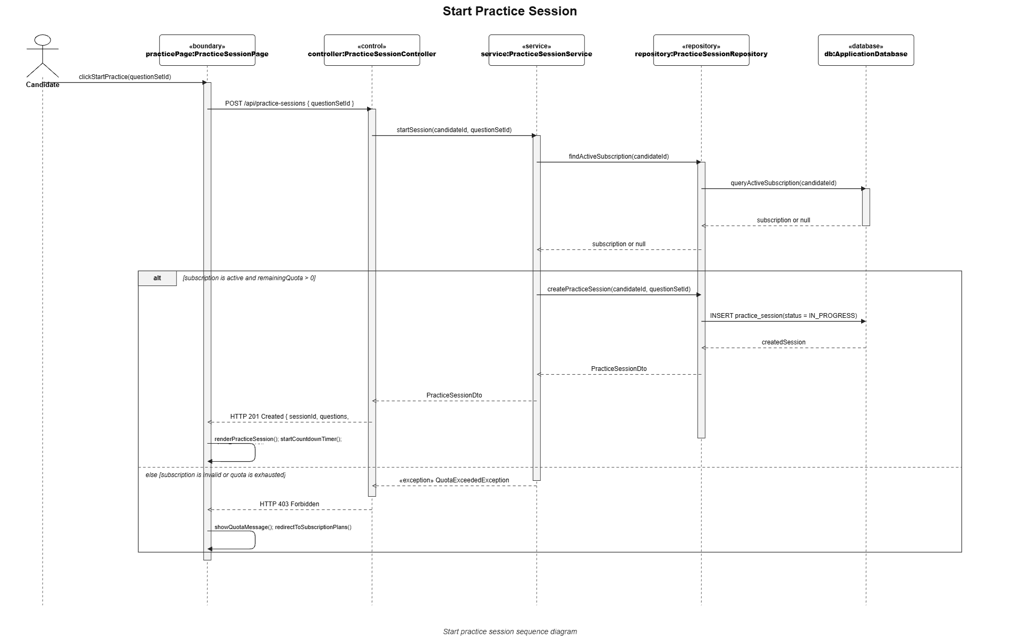

\

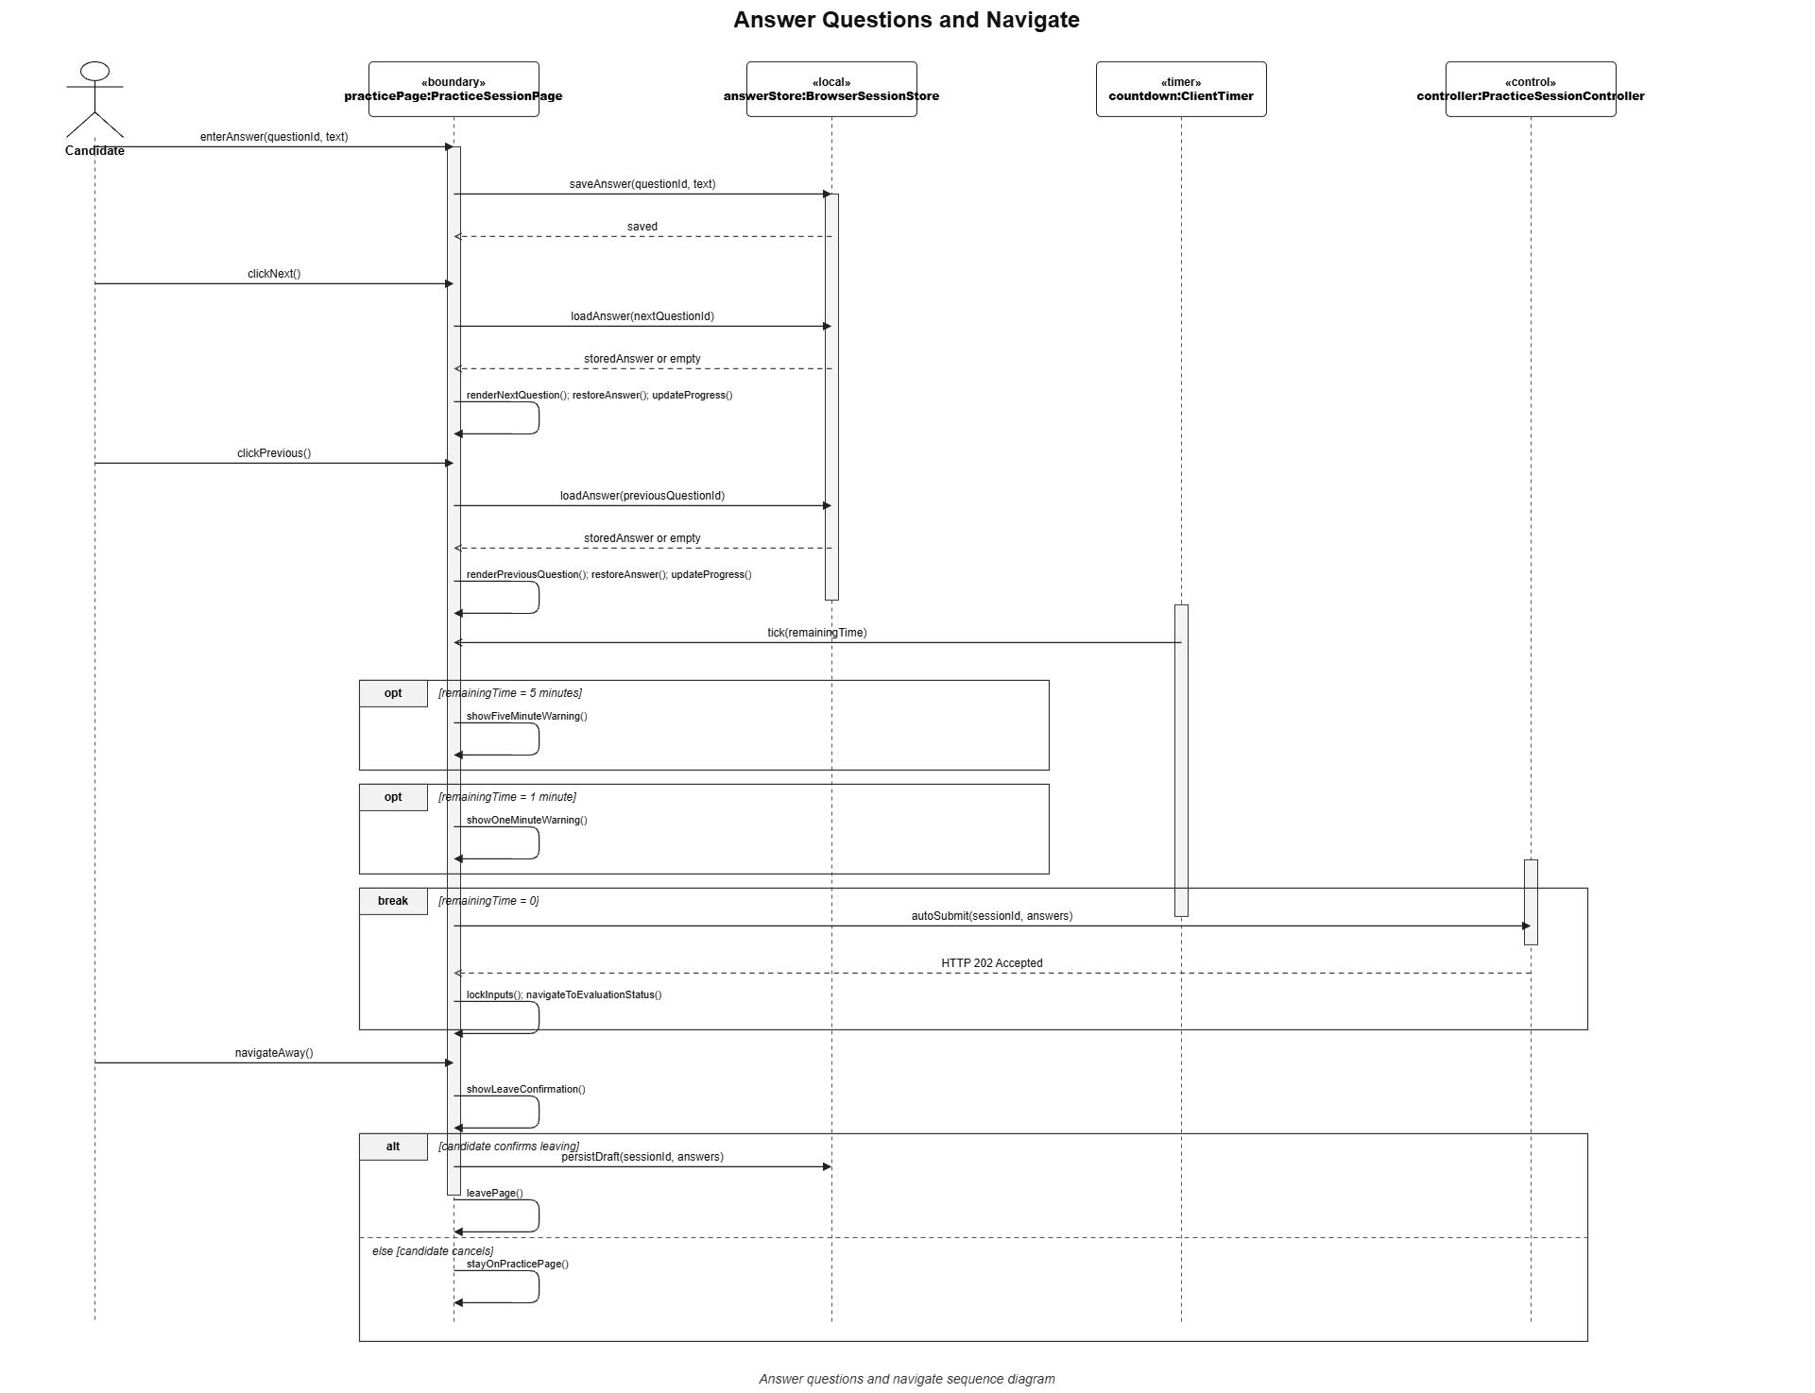
Figure : Start practice sessions sequence diagram (Link)

3.10.2. Answer Question & Navigate

Figure : Answer question & navigate sequence diagram (Link)

3.10.3. Submit Answers

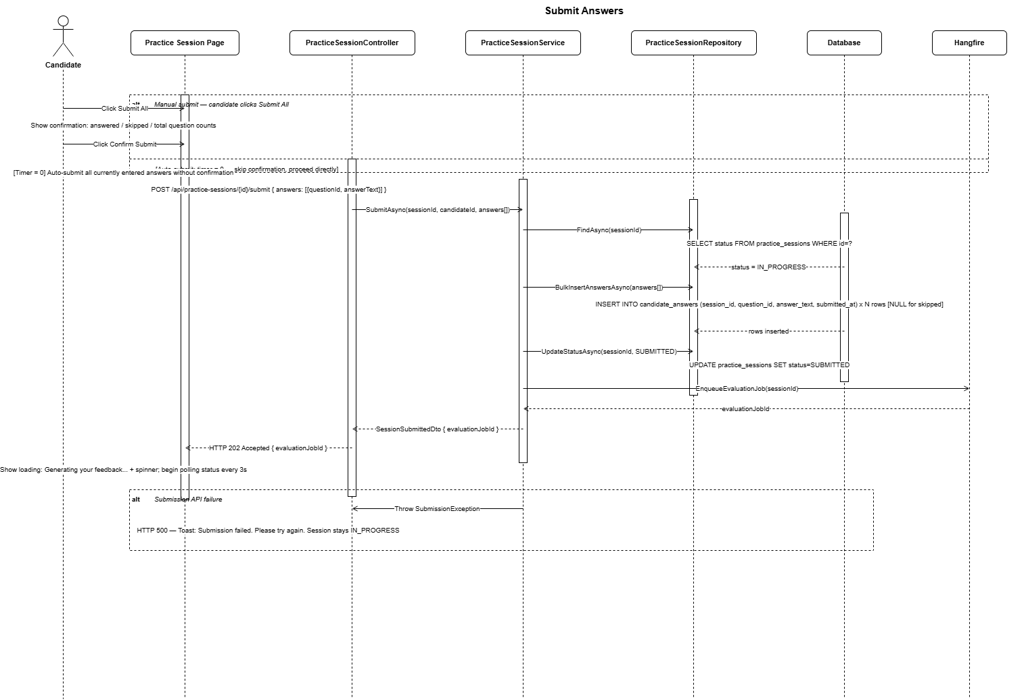
Figure : Start practice sessions sequence diagram (Link)

3.10.4. View Practice History
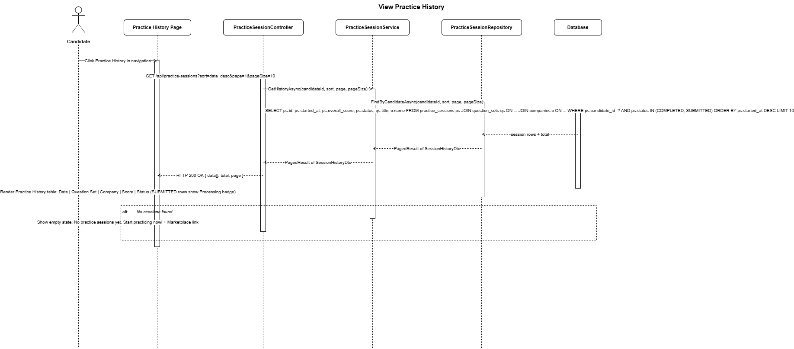

Figure : View practice history sequence diagram (Link)

3.11 AI Answer Evaluation and Feedback Management / Quản lý đánh giá và phản hồi AI
3.11.1 Evalute Candidate Answer

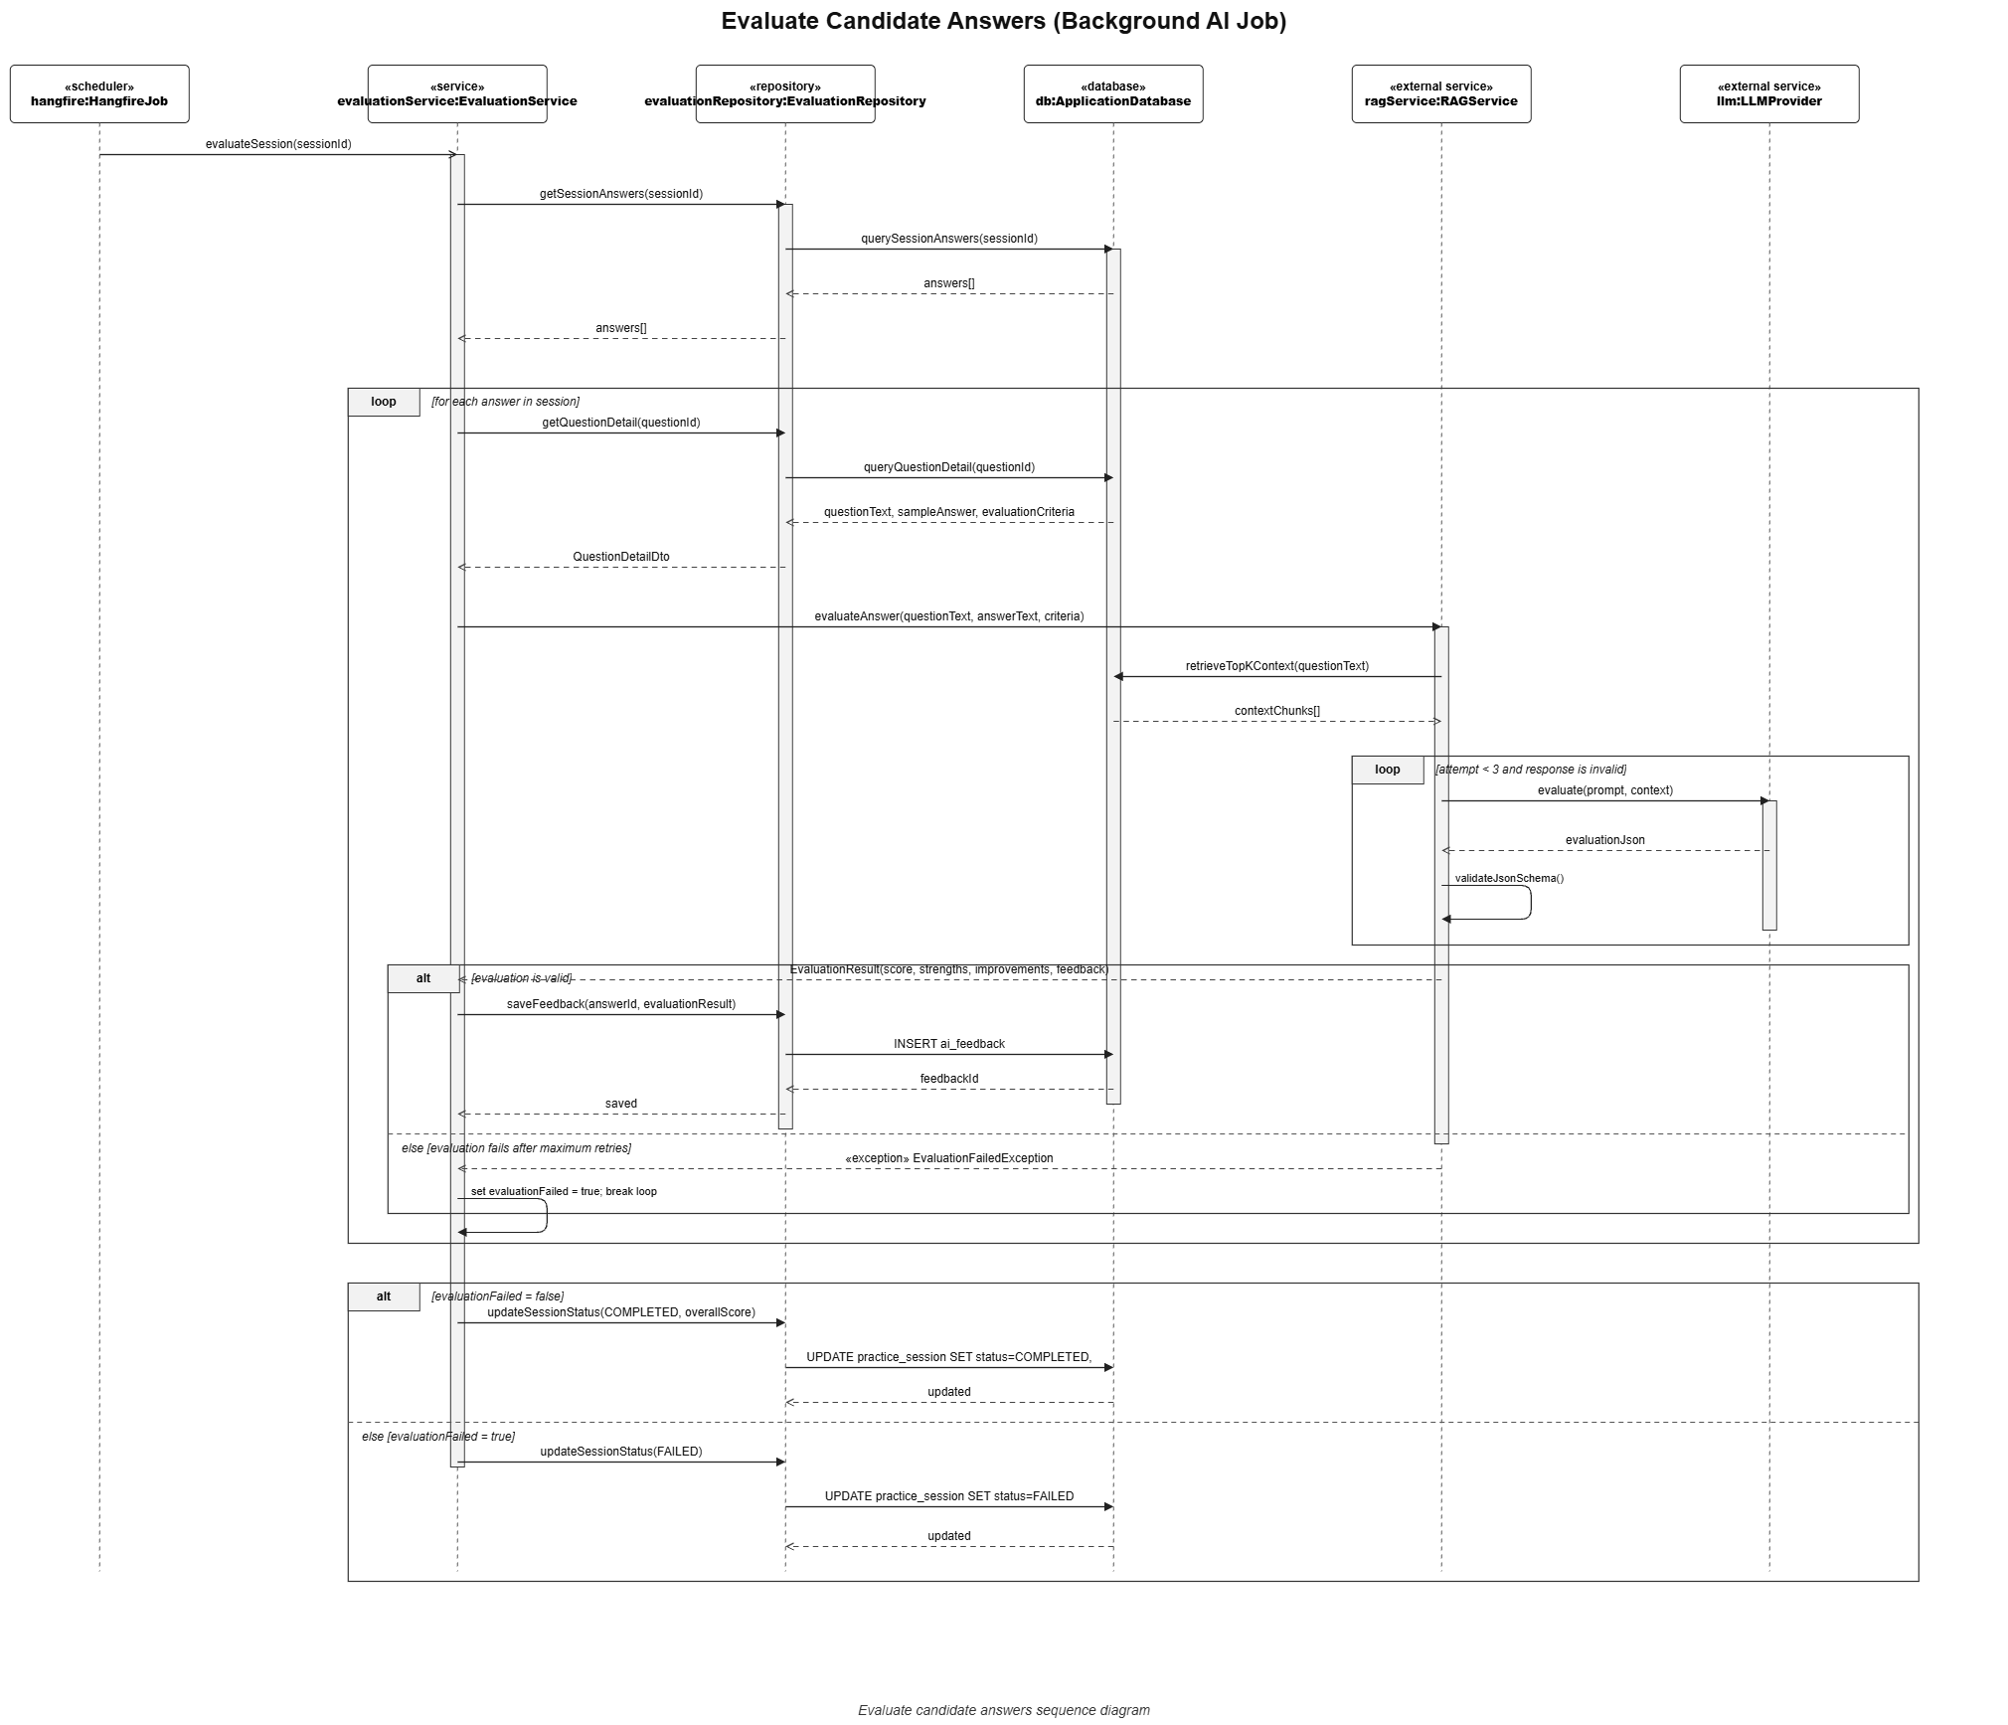

Figure : Evalute Candidate Answer sequence diagram (Link)
3.11.2 View AI Feedback Result
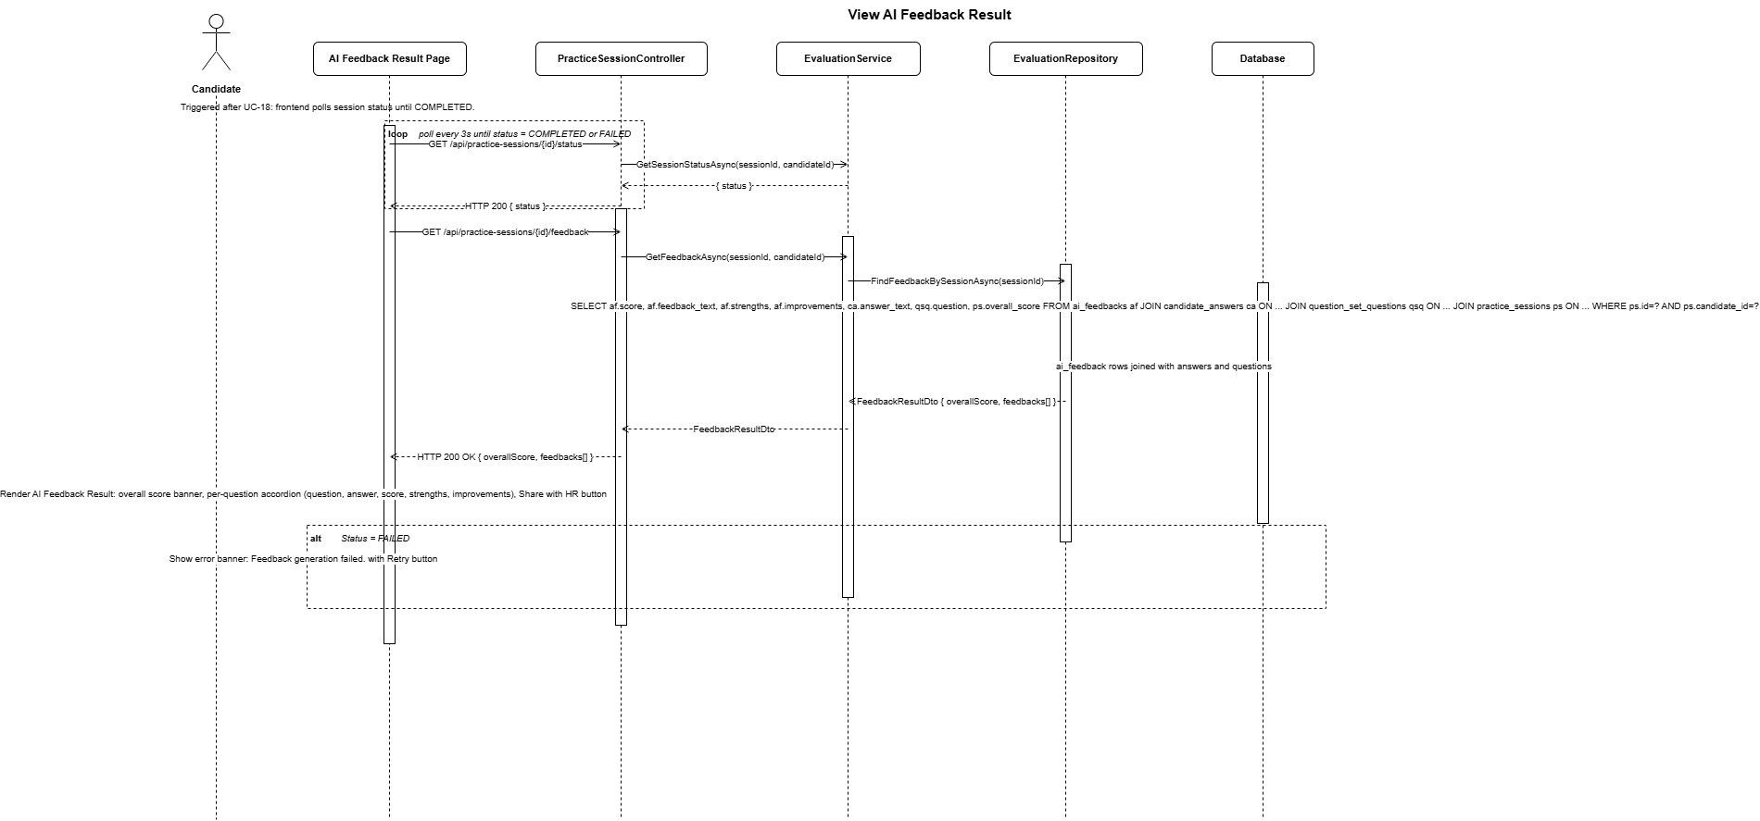

Figure : View AI feedback result sequence diagram (Link)
3.11.3 View Interview Summary

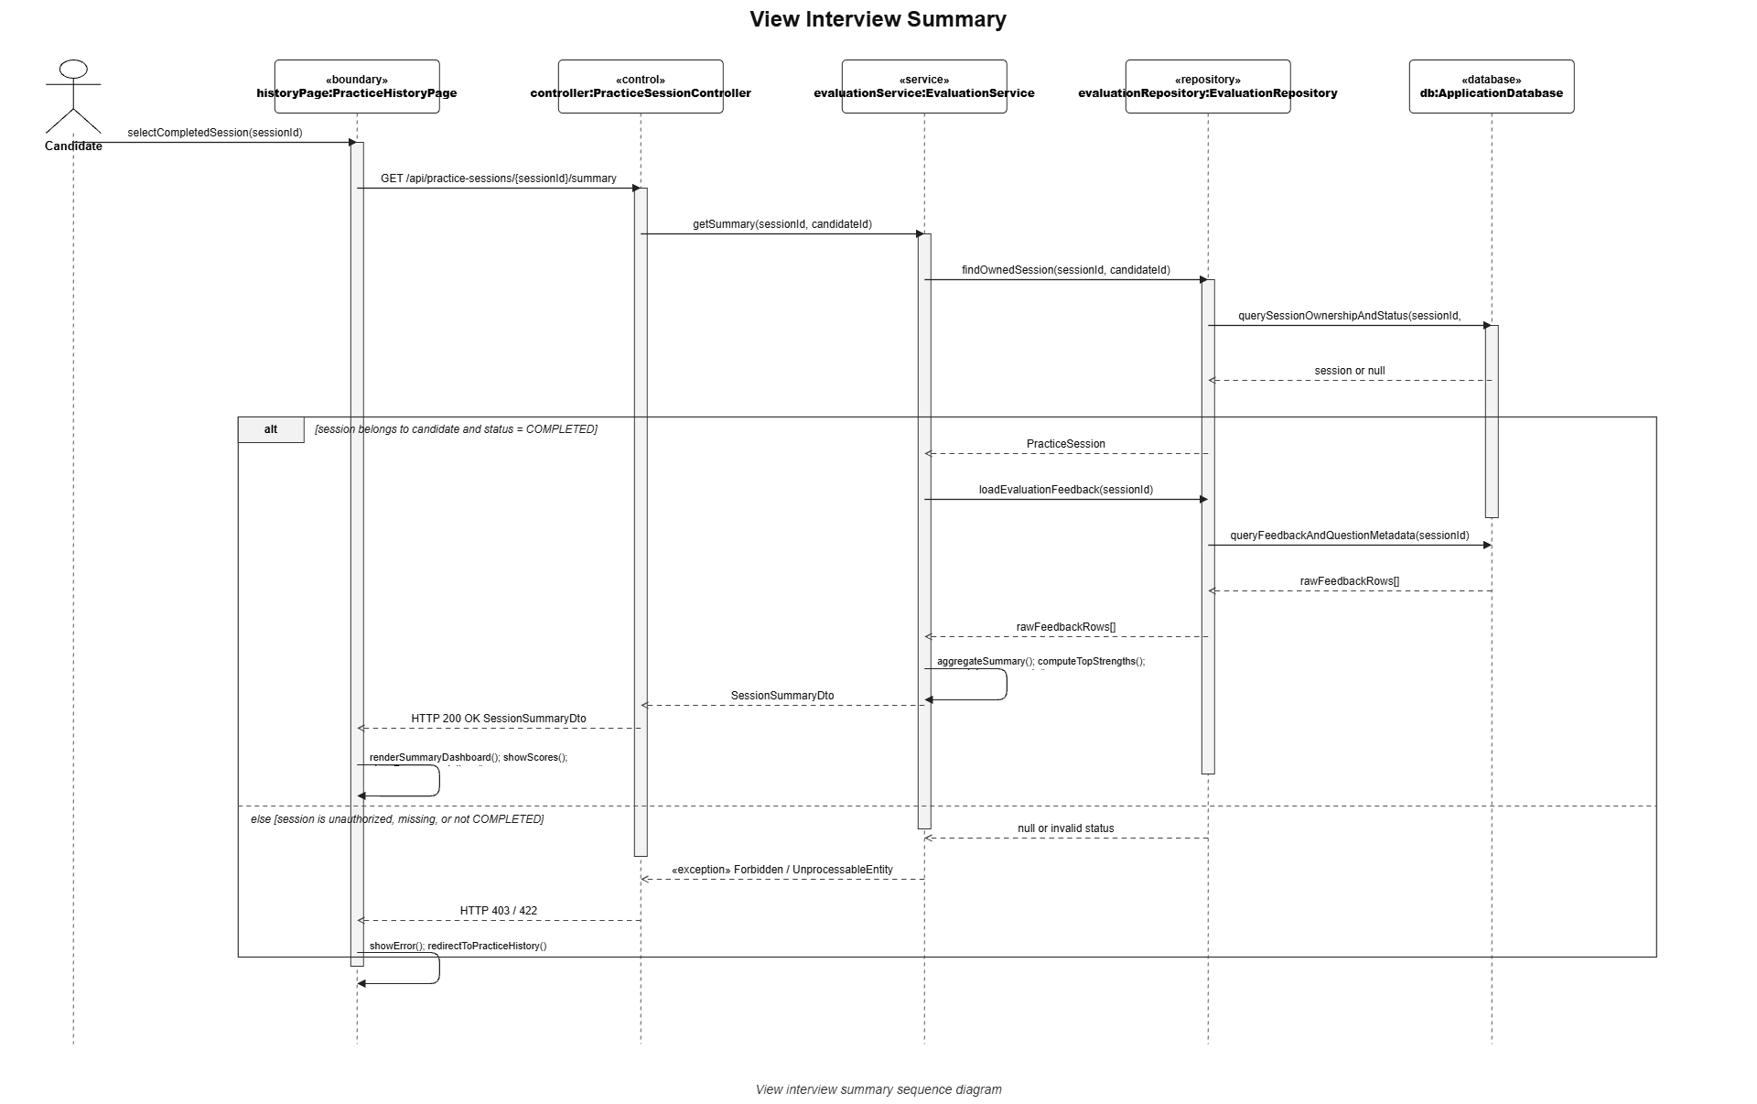Figure : View interview summary sequence diagram (Link)

3.12 Candidate–HR Contact Management / Quản lý liên hệ giữa ứng viên và HR

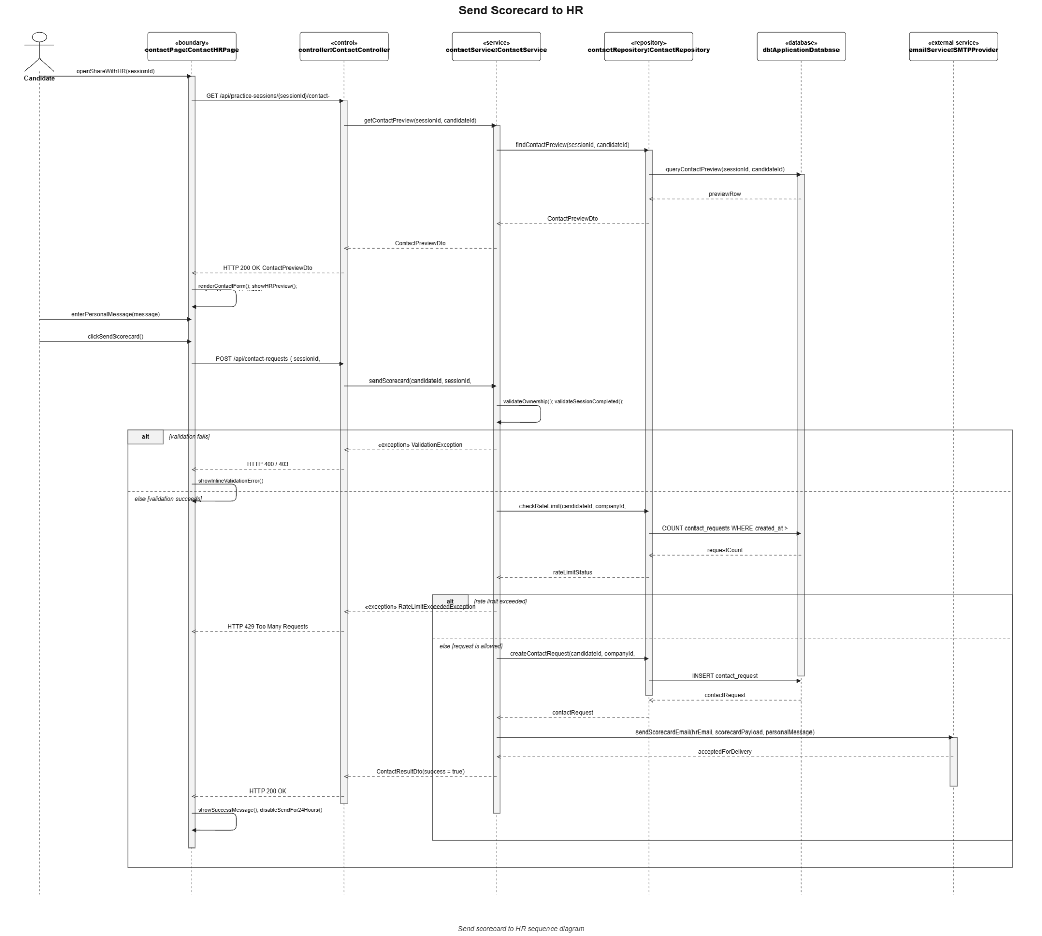
Figure :Candidate–HR contact management sequence diagram (Link)

3.13 HR Analytics Management / Quản lý phân tích dữ liệu cho HR
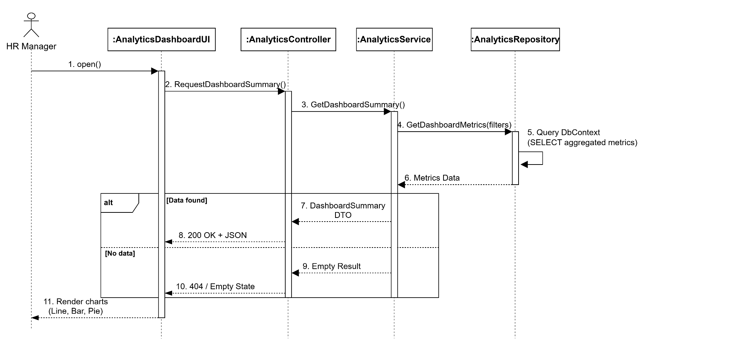
Figure : HR Analytics Management sequence diagram (Link)

3.14 RAG Quality Evaluation Management / Quản lý đánh giá chất lượng RAG
3.14.1 Create evaluation experiment
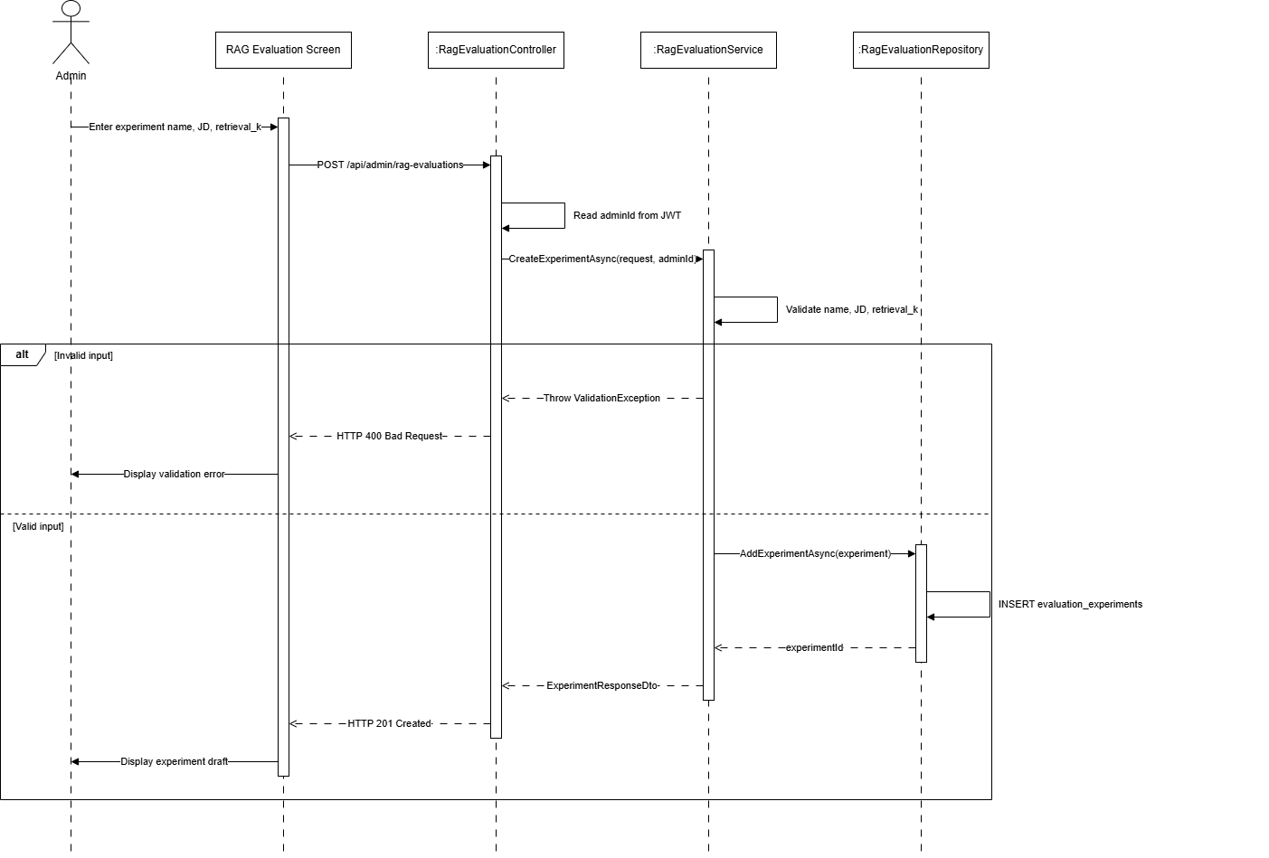
Figure : Create evaluation experiment sequence diagram (Link)
3.14.2 Run comparison generation
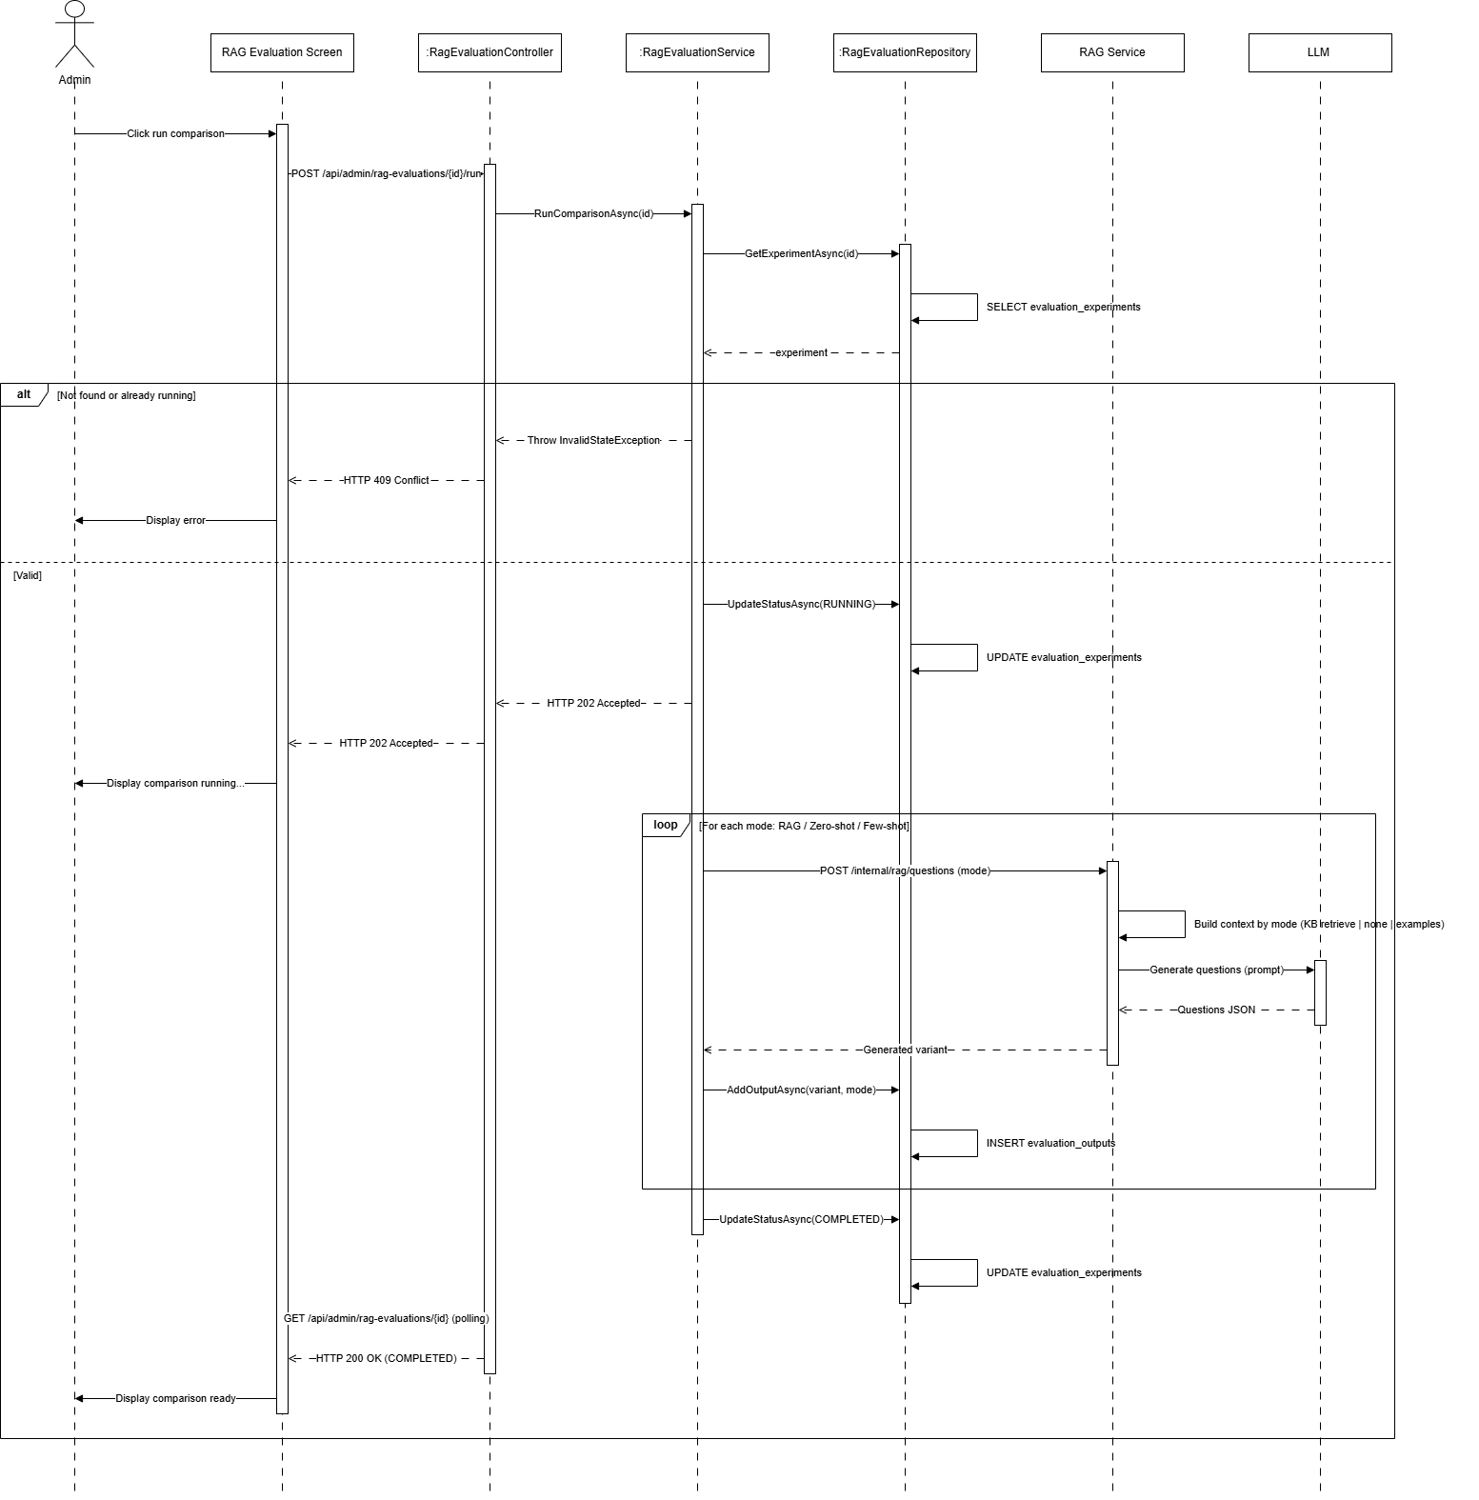
Figure : Run comparison generation sequence diagram (Link)
3.14.3 Assign blinded review
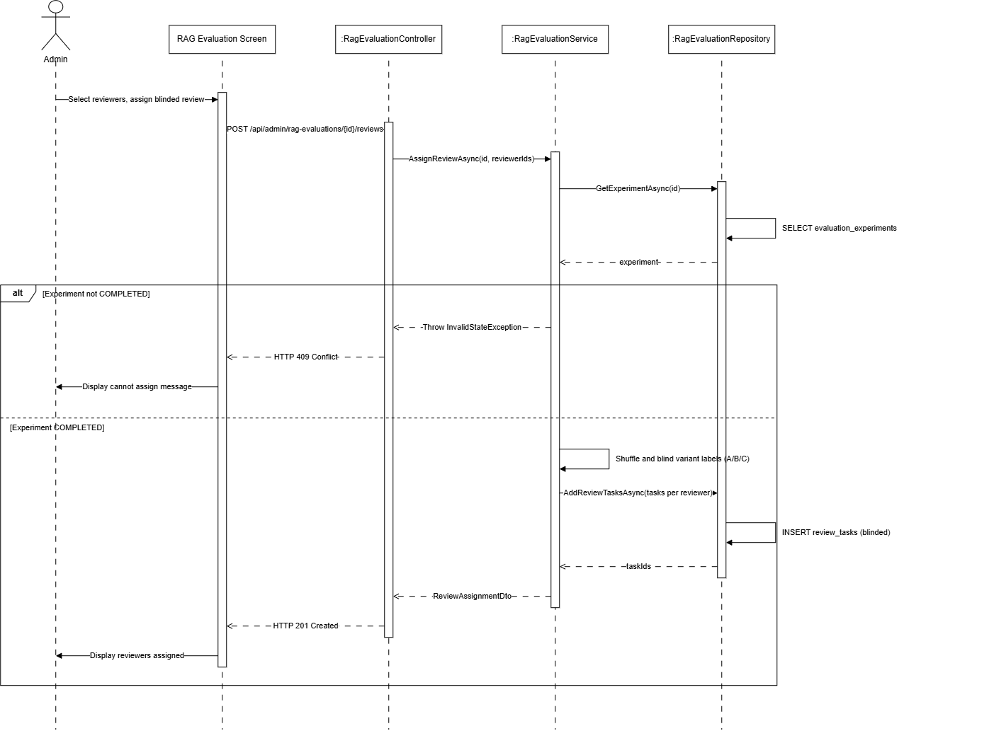
Figure : Assign blinded review sequence diagram (Link)
3.14.4 Submit reviewer rating
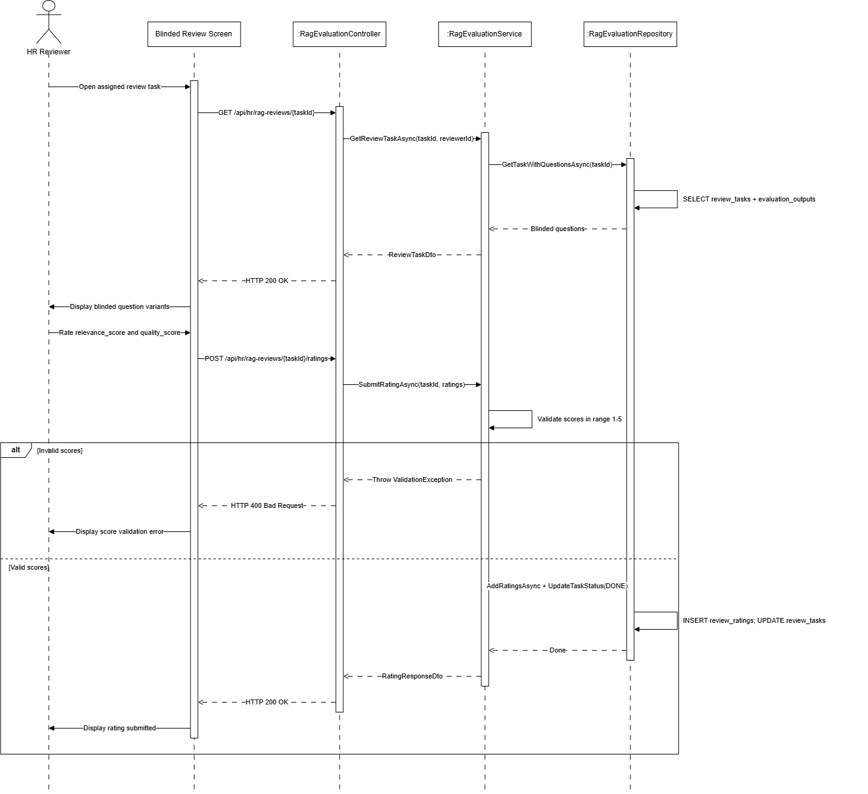
Figure : Submit reviewer rating sequence diagram (Link)
3.14.5 View export evaluation
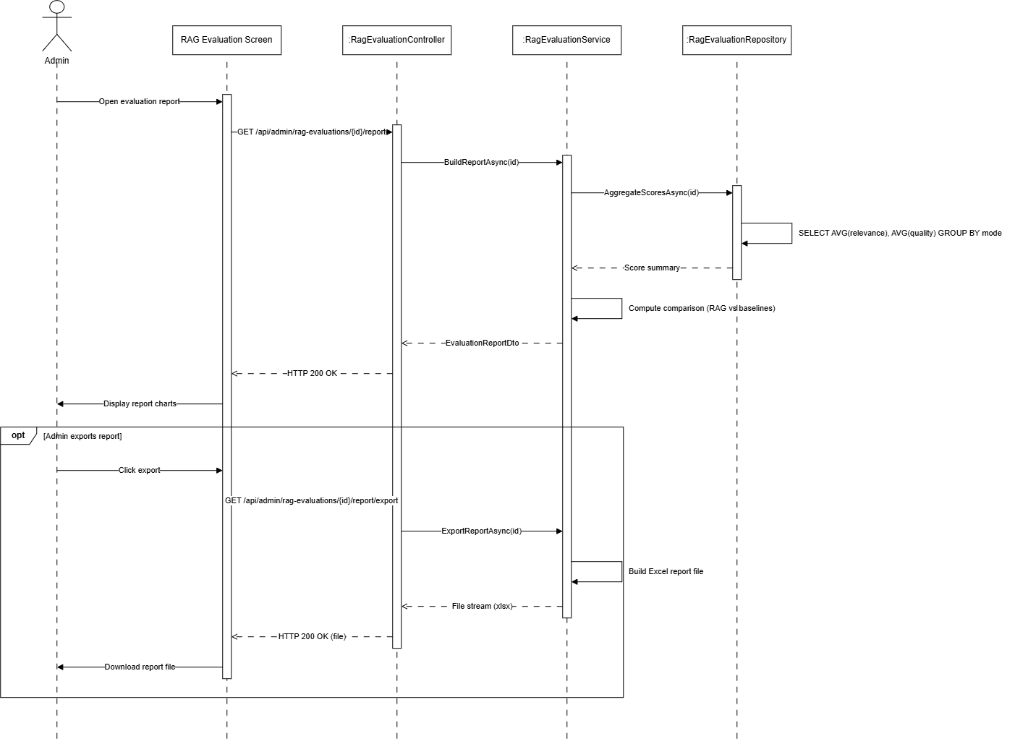
Figure : View export evaluation sequence diagram (Link)

3.15 Subscription and Payment Management / Quản lý gói đăng ký và thanh toán
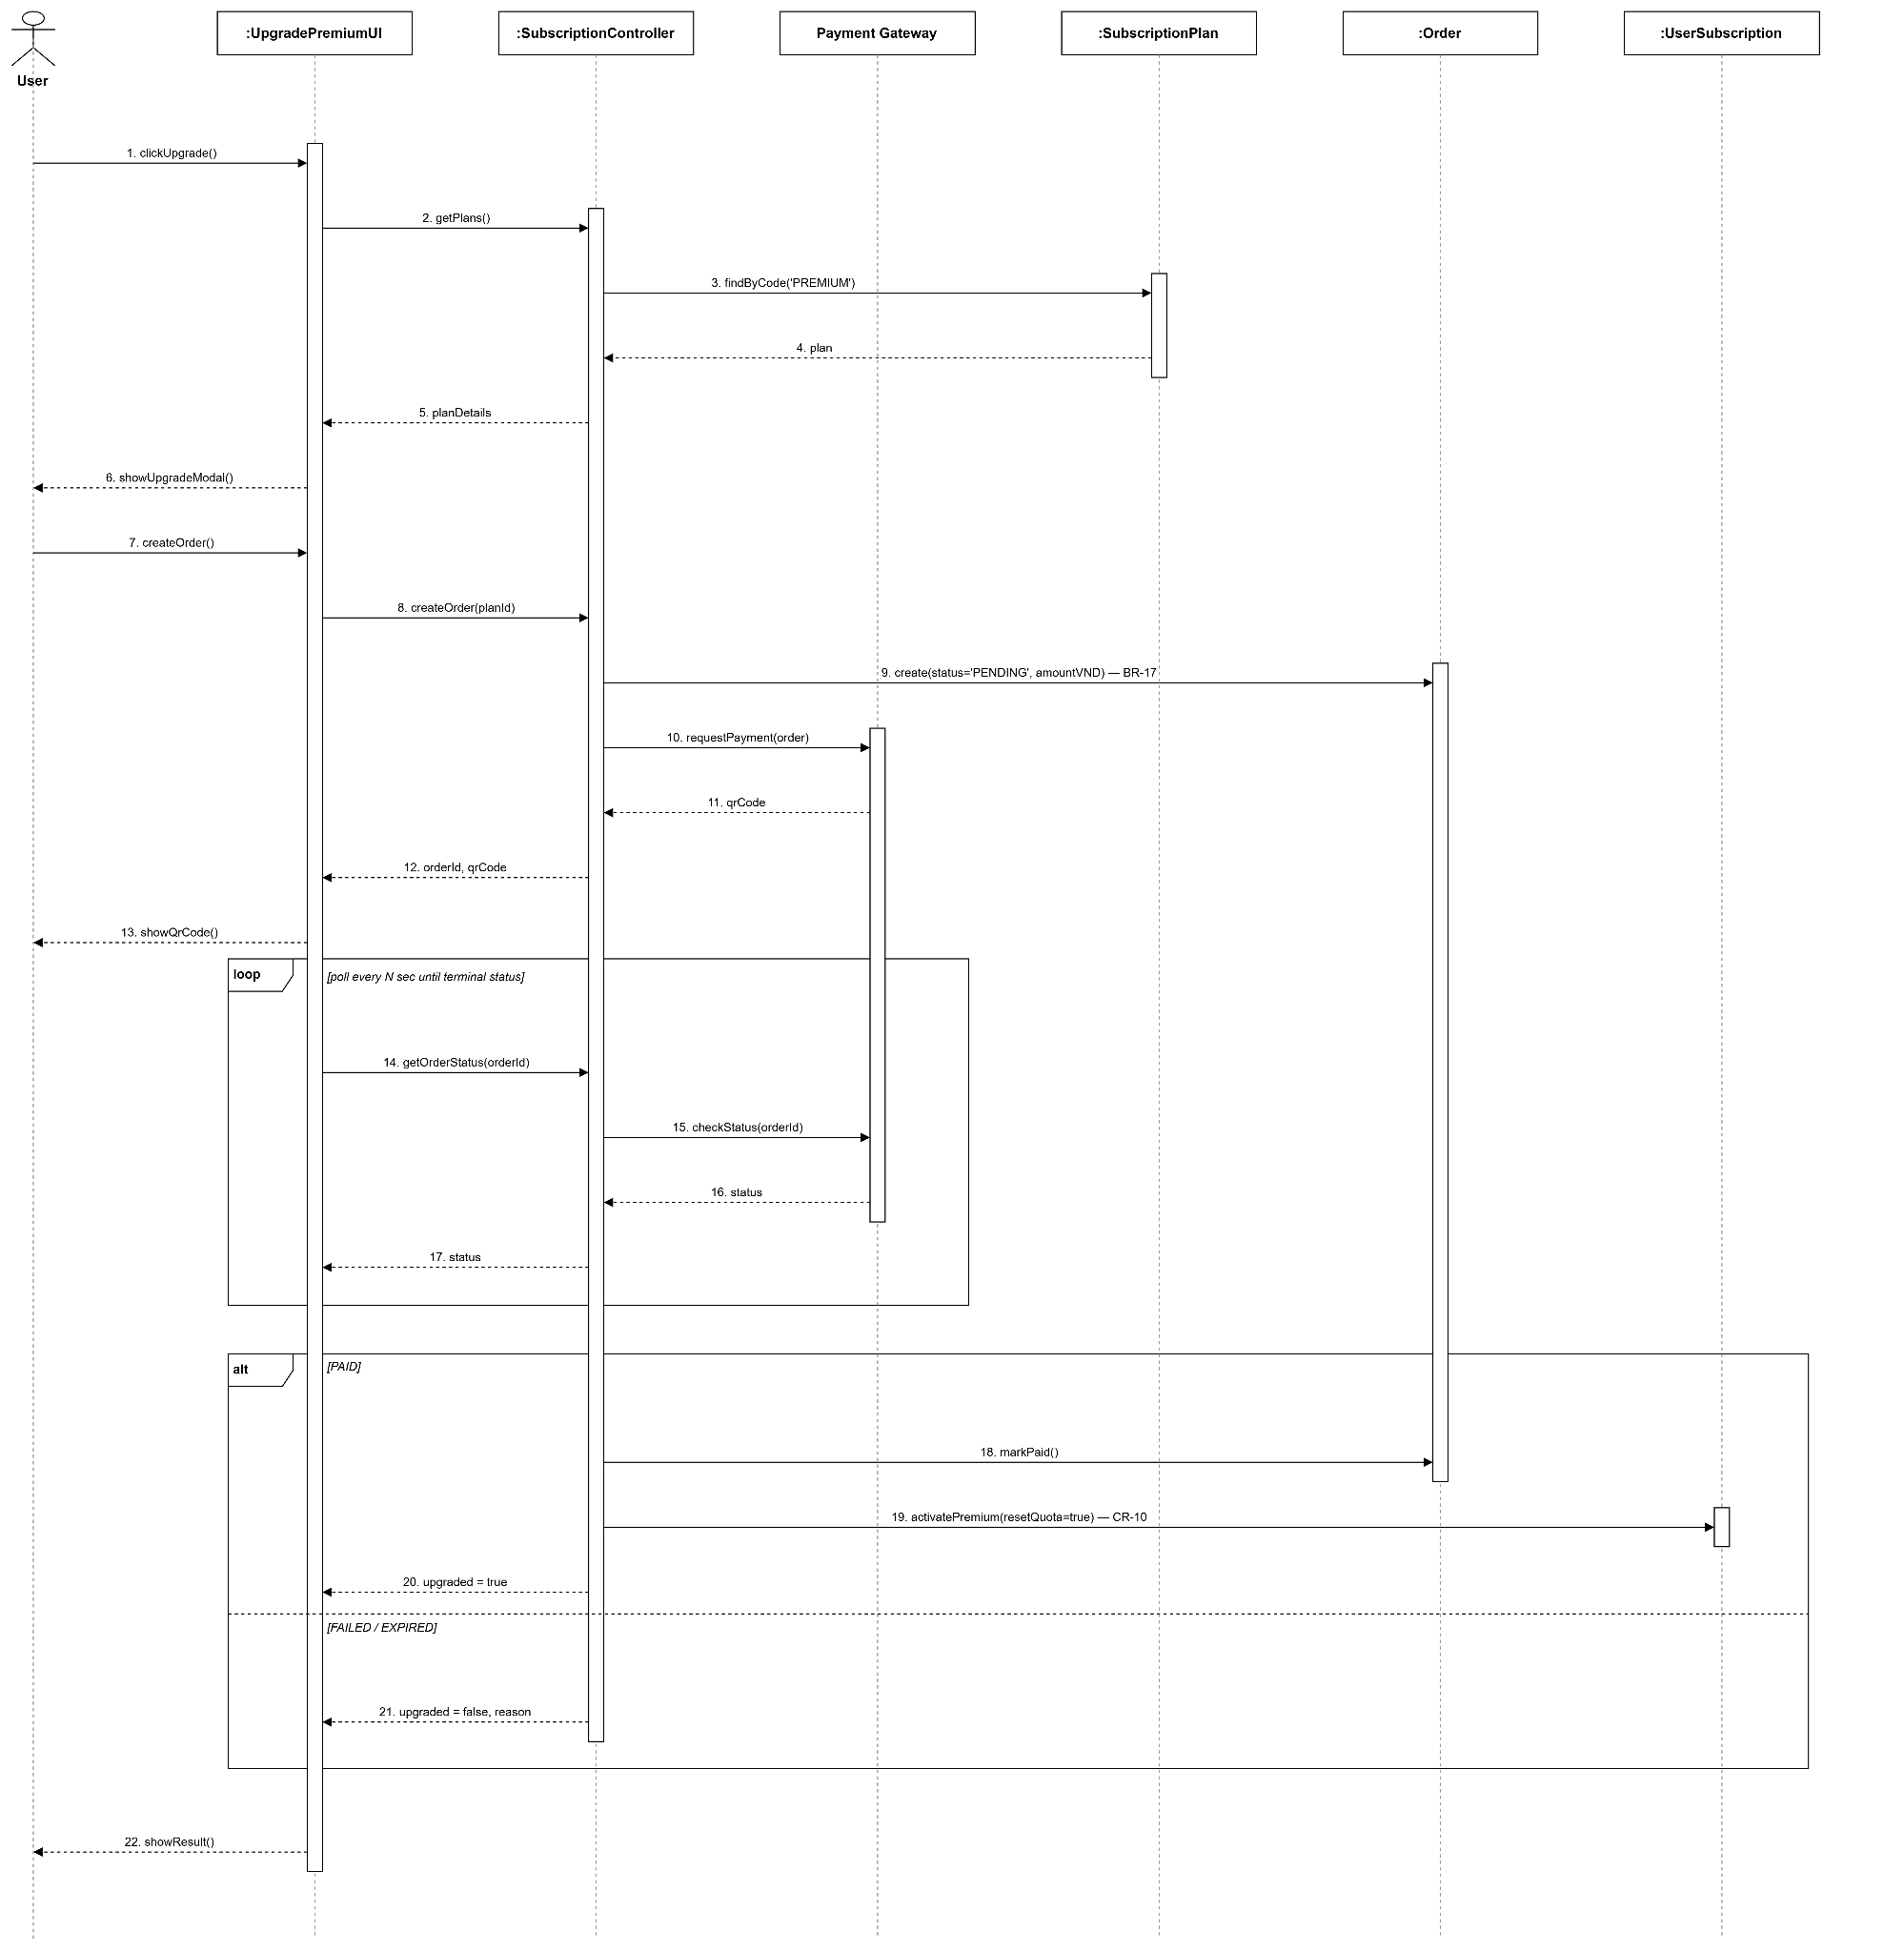
Figure : Subscription and Payment Management sequence diagram (Link)

3.16 Notification Management / Quản lý thông báo
3.16.1 HR Manager - Publish Questions & Notifications
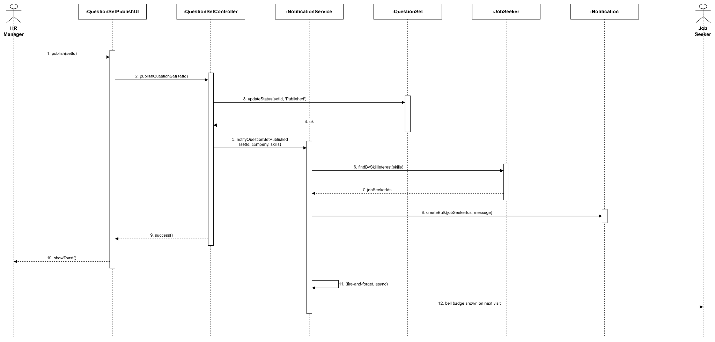
Figure : HR Manager - Publish Questions & Notifications sequence diagram (Link)

3.16.2 Job Seeker - Exam & Batch Digest Notifications
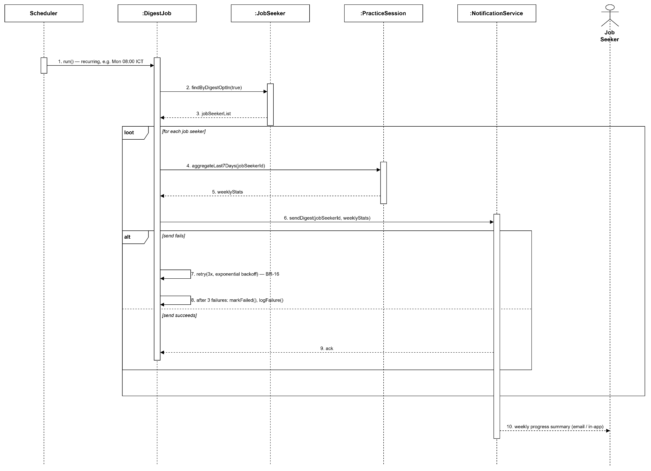
Figure : Job Seeker - Exam & Batch Digest Notifications sequence diagram (Link)

3.17 Audit Log and Error Handling Management / Quản lý nhật ký và xử lý lỗi
3.17.1 HR Manager - Audit Logging
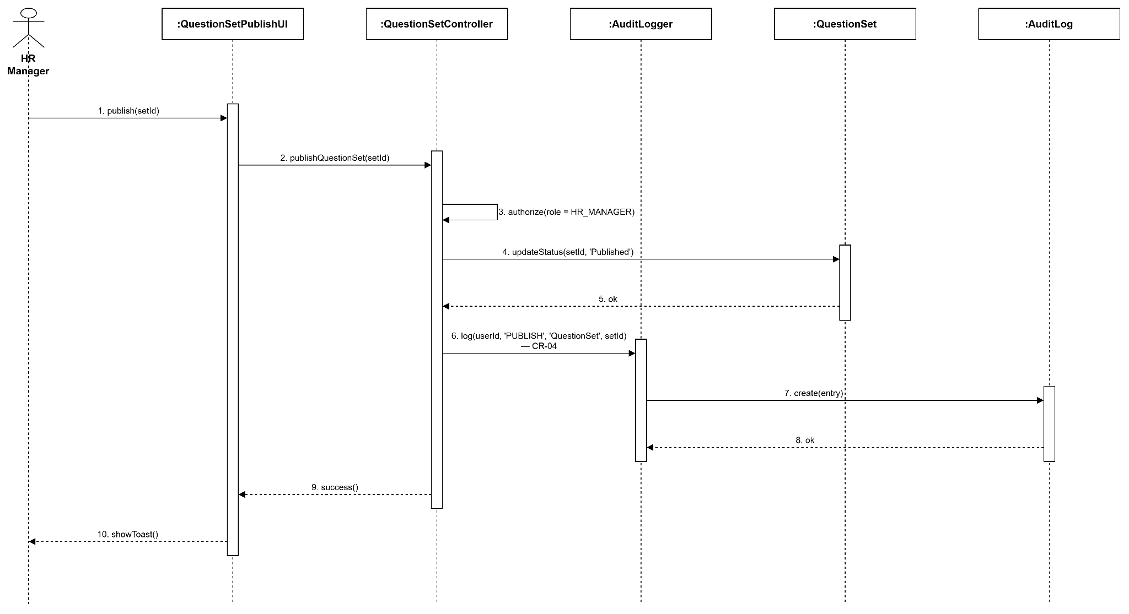
Figure : HR Manager - Audit Logging sequence diagram (Link)
3.17.2 JobSeeker - AuditLogAndErrorHandling
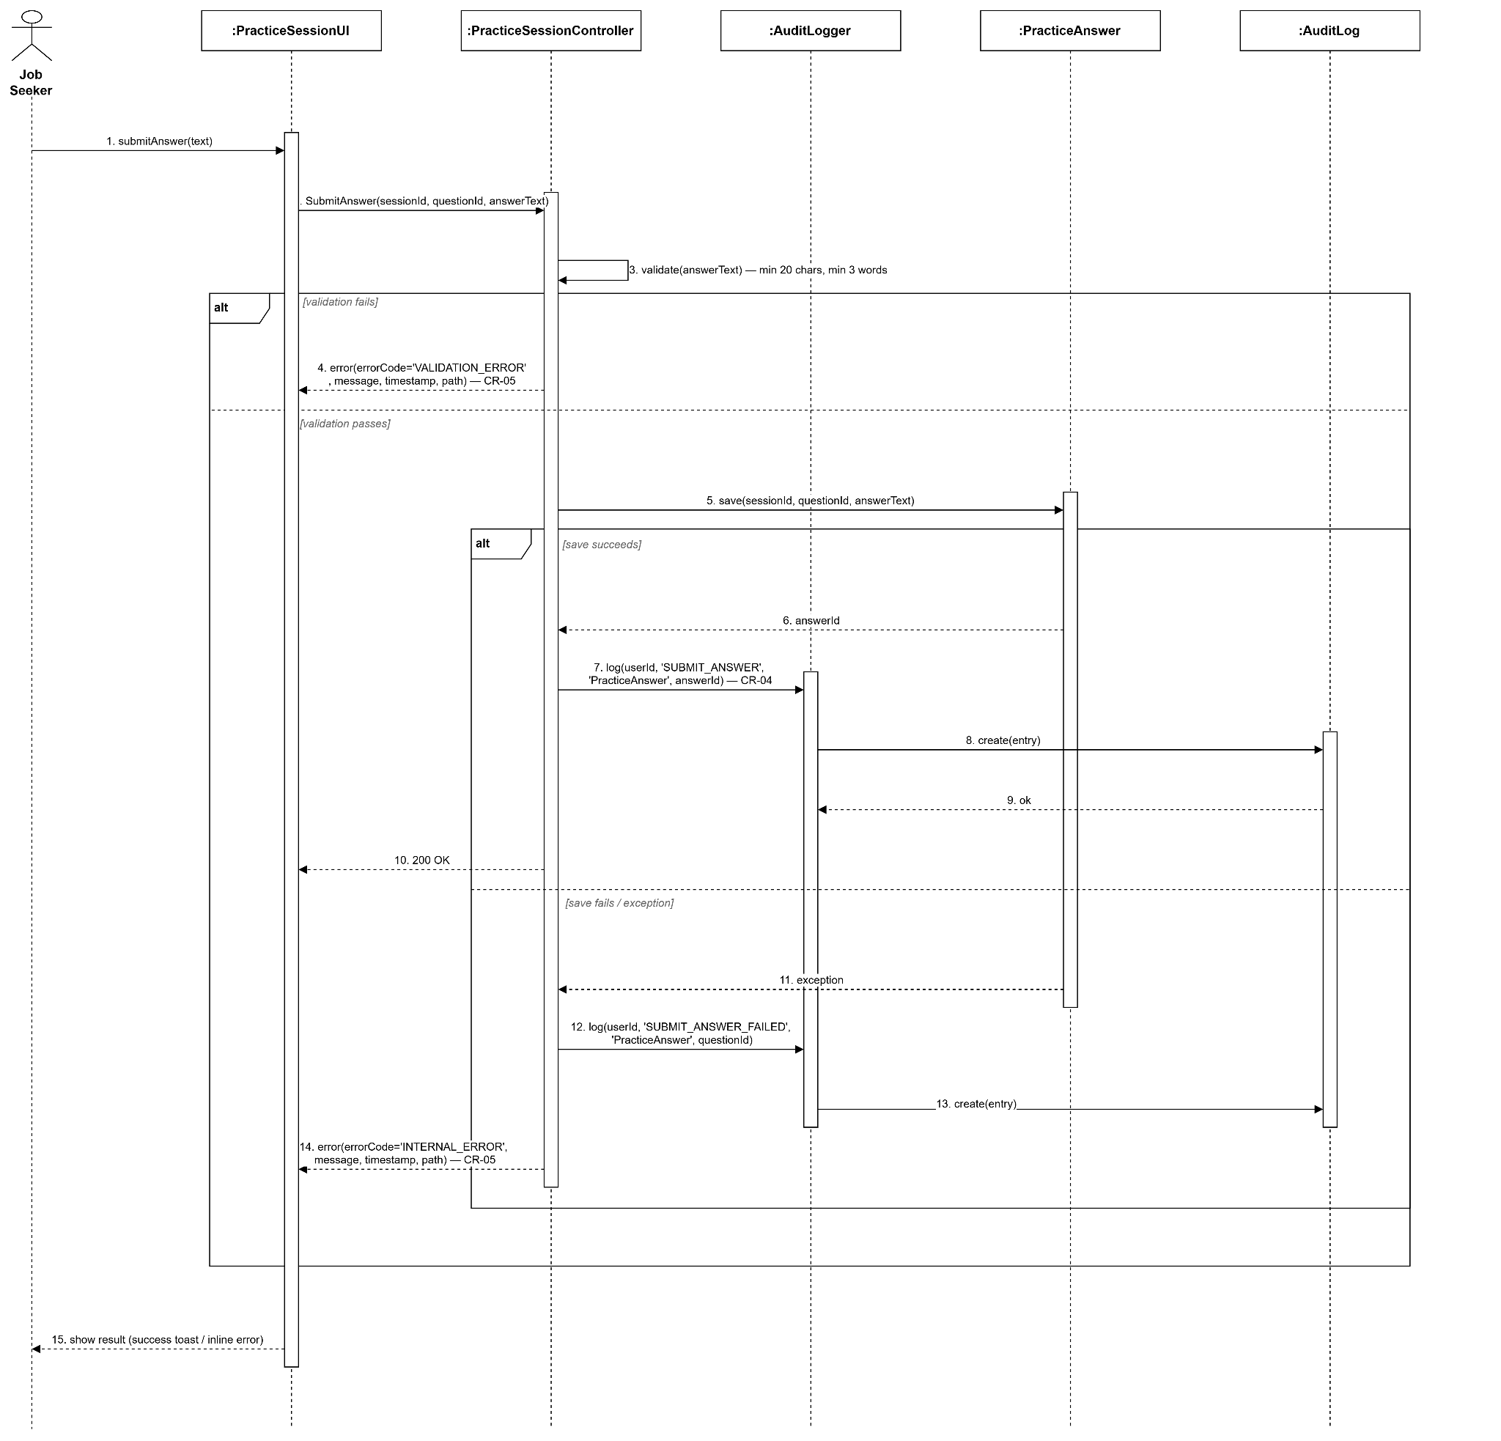
Figure : JobSeeker - AuditLogAndErrorHandling sequence diagram (Link)

3.18 System Configuration Management / Quản lý cấu hình hệ thống
3.18.1 Administrator - View Audit Trail
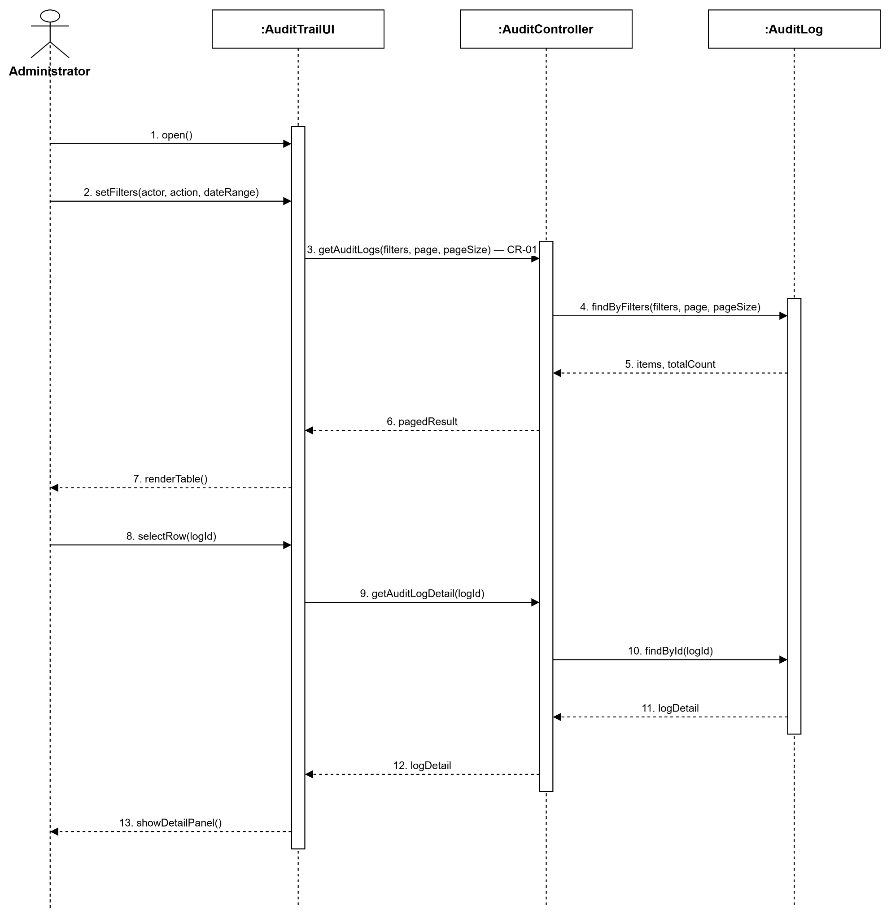
Figure : Administrator - View Audit Trail sequence diagram (Link)

3.18.2 Administrator - System Configuration
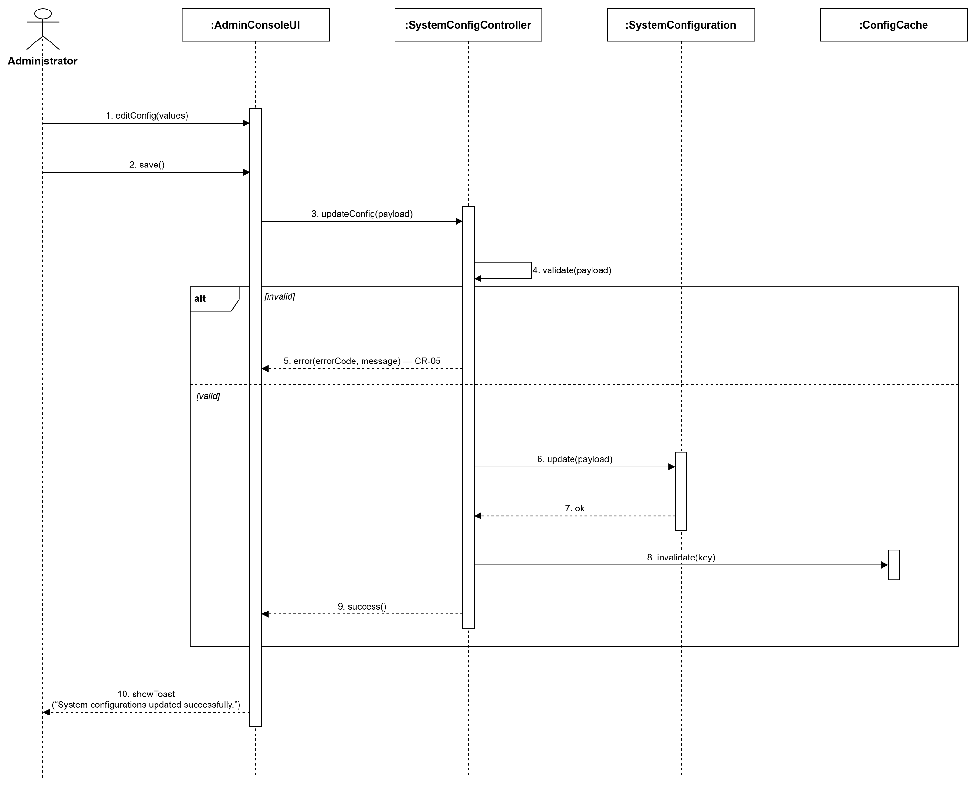
Figure : Administrator - System Configuration sequence diagram (Link)

V. Software Testing Documentation

1. Scope of Testing

1.1 In-Scope Items

1.2. Out-of-Scope Items

1.3. Test Levels

1.4. Assumptions & Constraints

2. Test Strategy

2.1 Testing Types

2.2 Test Levels

2.3 Supporting Tools

3. Test Plan

3.1 Human Resources

3.2 Test Environment

3.3 Test Milestones

4. Test Cases

5. Test Reports

5.1 Test Statistics

5.2 Test Analysis

5.3 Conclusion

VI. Release Package & User Guides

1. Deliverable Package
No. | Deliverable Item | Description
1 | Project Backlog | Jira SCRUM Board (Sprint Backlog)
2 | Source Codes (FE) | AI_Interview_Question_Generation_RAG_LLM_FE (Next.js)
3 | Source Codes (BE) | IQGS-SEP490-Backend (ASP.NET Core 8)
4 | Source Codes (RAG Service) | RAG (Python / FastAPI)
5 | Final Report Document | Report7_Final Project Report.docx
6 | Test Cases Document | Report5_Test Documentation.docx

2. Installation Guides

2.1 System Requirements
- Hardware:
    - Minimum 8 GB RAM (16 GB recommended when running Ollama locally)
    - At least 10 GB of free disk space
    - Stable internet connection (cloud LLM, Azure Blob, SePay gateway)
- Software: Windows 10/11, Linux or macOS
    - Docker Desktop
    - .NET 8 SDK
    - Node.js 20+ and npm 10+
    - Python 3.11+
    - Ollama runtime (local LLM + embedding models)
- Runtime:
  - Backend (ASP.NET Core 8, target framework net8.0):
  - .NET / WebAPI layer
    - Microsoft.EntityFrameworkCore.Design 8.0.0
    - Swashbuckle.AspNetCore 6.6.2 (Swagger / OpenAPI)
    - Microsoft.AspNetCore.Authentication.JwtBearer 8.0.0
    - Hangfire.AspNetCore 1.8.17
    - Hangfire.PostgreSql 1.20.10
    - Pgvector.EntityFrameworkCore 0.2.0
    - Npgsql 8.0.3
    - FluentValidation.AspNetCore 11.3.0
    - Serilog.AspNetCore 8.0.2, Serilog.Sinks.Console 5.0.1, Serilog.Sinks.File 5.0.0
  - Application layer
    - BCrypt.Net-Next 4.0.3 (password hashing)
    - Google.Apis.Auth 1.68.0 (Google OAuth)
    - FluentValidation 11.11.0
    - MailKit 4.10.0 (SMTP email)
    - ClosedXML 0.104.2 (Excel export)
  - Infrastructure layer
    - Microsoft.EntityFrameworkCore 8.0.0, Npgsql.EntityFrameworkCore.PostgreSQL 8.0.0
    - Azure.Storage.Blobs 12.23.0 (knowledge documents, CVs, image hints)
    - Hangfire.Core 1.8.17
    - UglyToad.PdfPig 1.7.0-custom-5 (PDF text extraction)
    - DocumentFormat.OpenXml 3.2.0 (DOCX parsing)
  - Domain layer
    - AutoWrapper.Core 4.5.1 (uniform API response wrapper)
    - Pgvector 0.2.0
  - Frontend (Next.js 16 / React 19):
  - Framework / build
    - next 16.2.6 (App Router)
    - react 19.2.4, react-dom 19.2.4
    - typescript ^5
  - Styling
    - tailwindcss ^4, @tailwindcss/postcss ^4
    - class-variance-authority 0.7.1, clsx 2.1.1, tailwind-merge 3.5.0
  - HTTP / Auth / Realtime
    - axios 1.16.1
    - @react-oauth/google 0.13.5 (Google OAuth)
    - @microsoft/signalr 10.0.0 (payment realtime hub)
  - UI / UX
    - lucide-react 1.8.0, react-icons 5.6.0
    - framer-motion 12.38.0
    - @dnd-kit/core, @dnd-kit/sortable, @dnd-kit/utilities
  - Data
    - recharts 3.8.1 (dashboard charts)
    - xlsx 0.18.5 (export)
  - RAG Service (Python 3.11+, FastAPI):
    - fastapi, uvicorn[standard] (API layer)
    - openai>=1.60.0 (Ollama OpenAI-compatible client)
    - psycopg[binary,pool]>=3.2, pgvector>=0.3 (PostgreSQL + vector similarity search)
    - pdfplumber==0.11.4, python-docx==1.1.2 (document parsing)
    - pydantic>=2.0, pydantic-settings>=2.0 (schemas & config)
    - numpy>=2.0.0, httpx>=0.27, python-dotenv, python-multipart
    - pytest>=8.0 (tests)
  - Docker / Infrastructure services:
    - postgres:16 — application database, also stores vector embeddings via the pgvector extension
    - Azure Blob Storage — knowledge documents, candidate CVs, question image hints (cloud service, not containerized)
    - Ollama — local LLM + embedding runtime (chat model for plan / question generation, nomic-embed-text for embeddings)
    - Hangfire — background job processing; uses PostgreSQL as its storage, no separate broker/queue container required

2.2 Installation Instruction
Backend (ASP.NET Core 8):
- Clone the repository and open IQGS-BE.sln.
git clone <backend-repository-url>
- Start PostgreSQL.
docker compose up -d postgres
If a plain postgres:16 image is used, enable pgvector once: CREATE EXTENSION IF NOT EXISTS vector;
- Configure WebAPI/appsettings.Development.json (or dotnet user-secrets).
ConnectionStrings:DefaultConnection, JwtSettings, GoogleOAuth:ClientId, EmailSettings (SMTP), RagService:BaseUrl, BlobStorage connection string, SePay settings, InternalApi:Key.
- Apply EF Core migrations (the app also auto-migrates on startup).
dotnet ef database update --project InfrastructureLayer --startup-project WebAPI
- Run the API.
dotnet run --project WebAPI
API: http://localhost:5248 (HTTPS https://localhost:7052). Swagger: /swagger. Hangfire dashboard: /hangfire.
- Seeded accounts for first login.
Admin: admin@iqgs.com / adminiqgs — HR: hr@iqgs.com / hriqgs — Candidate: candidate@iqgs.com / candidateiqgs
RAG Service (Python / FastAPI):
- Create a virtual environment and install dependencies.
cd RAG
python -m venv .venv
.venv\Scripts\activate (Windows)
pip install -r requirements.txt
- Configure environment variables.
Copy .env.example to .env and set DATABASE_URL (same PostgreSQL as Backend), BACKEND_INTERNAL_BASE_URL, INTERNAL_API_KEY (must match the Backend's InternalApi:Key), OLLAMA_BASE_URL, CHAT_MODEL, EMBEDDING_MODEL.
- Pull the required Ollama models.
ollama pull nomic-embed-text
ollama pull gemma4b:cloud (or the model configured in CHAT_MODEL)
- (Dev only) create the knowledge_chunks table if missing.
psql $DATABASE_URL -f scripts/init_knowledge_chunks.sql
- Start the service.
.\run-local.ps1 (Windows, recommended)
python -m uvicorn api.app:app --host 0.0.0.0 --port 8000 --reload
- Health check.
curl http://localhost:8000/health
Frontend (Next.js 16):
- Install dependencies.
cd FE/AI_Interview_Question_Generation_RAG_LLM_FE
npm install
- Configure environment variables.
Copy .env.example to .env.local and set NEXT_PUBLIC_API_BASE_URL, NEXT_PUBLIC_RAG_BASE_URL, NEXT_PUBLIC_GOOGLE_CLIENT_ID, NEXT_PUBLIC_CLOUDINARY_CLOUD_NAME, NEXT_PUBLIC_CLOUDINARY_UPLOAD_PRESET.
- Run the development server.
npm run dev
Go to: http://localhost:3000

3. User Manual

3.1 Overview
IQGS (Interview Question Generation System) is a dual-sided, AI-driven recruitment platform that connects HR recruiters and job seekers around a single asset: a high-quality bank of interview questions. Designing good, role-specific interview questions is time-consuming for HR teams, which often leads to reused, generic question lists that do not match the actual requirements of the role being hired for.

IQGS addresses this by combining Retrieval-Augmented Generation (RAG) with a Large Language Model (LLM). HR recruiters submit a Job Description; the system retrieves relevant context from a curated Knowledge Base (industry standards such as SWEBOK/ACM, plus HR's own uploaded materials) and uses it to generate an interview plan and a tailored set of interview questions. On the other side of the platform, job seekers browse published question sets, practice in timed simulations, and receive AI-generated feedback on their answers — closing the loop between better questions and better-prepared candidates.

The platform is built around three cooperating components: the Frontend (Next.js web application for Admin, HR and Candidate users), the Backend (ASP.NET Core 8, Clean Architecture — orchestrates authentication, business rules, persistence, background jobs and file storage), and the RAG Service (Python / FastAPI — a stateless, internal-only microservice for document chunking, embedding, vector retrieval and LLM-based generation, reachable only from the Backend through a shared internal API key).

IQGS supports three user roles: Administrator (manages users, companies, Knowledge Base and RAG health, subscription plans), HR Manager / Recruiter (uploads Job Descriptions, generates or manually builds question sets, manages a private Knowledge Base, invites candidates, reviews AI recommendations), and Job Seeker / Candidate (browses question sets, uploads a CV for AI parsing, practices in timed sessions, receives AI feedback, tracks progress).
The following sections describe, in detail, the twelve most representative workflows of the system — the ones that best illustrate how the AI/RAG pipeline, the background job system and the three user roles work together in practice.

3.2 Workflow 1: HR – Upload and Ingest Knowledge Base Document
Description: This process describes how an HR user enriches the RAG Knowledge Base with reference material (job standards, internal rubrics, past question banks). The HR user uploads a PDF, DOCX or TXT file from the Knowledge Base page; the Backend stores the original file in Azure Blob Storage and creates a knowledge_documents record with status QUEUED, then schedules a KnowledgeIngestJob on the dedicated knowledge-ingestion Hangfire queue so the upload request returns immediately. In the background, the RAG Service downloads the file through a time-limited Blob SAS URL, reports status PROCESSING, parses and splits the document into overlapping chunks, and embeds each chunk with Ollama. If parsing or embedding fails, the RAG Service reports status FAILED with an error message (and a watchdog job also reclaims documents stuck in PROCESSING for too long); otherwise the embeddings are written to PostgreSQL (pgvector) and the document is marked COMPLETED with its resulting chunk count, becoming available for future retrieval.
Workflow Diagram:
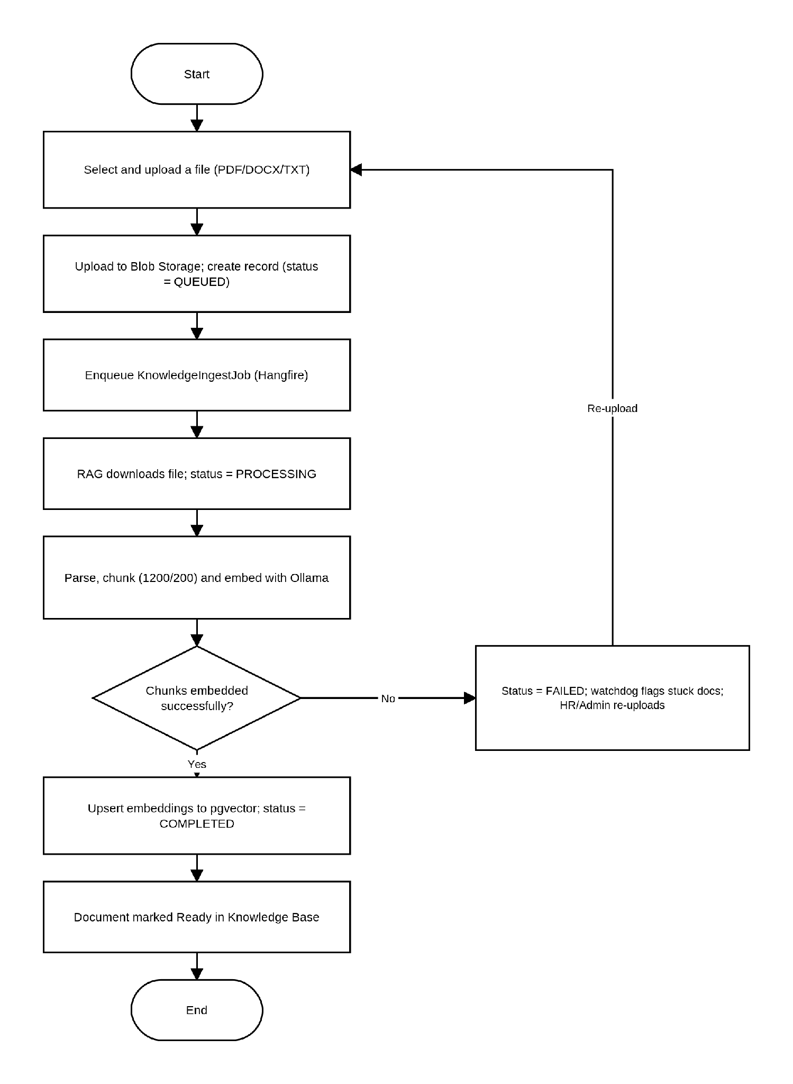

3.3 Workflow 2: HR – AI-Powered Interview Question Generation
Description: This is the platform's core workflow. The HR user enters or uploads a Job Description together with generation parameters (number of questions, difficulty, question types, required skills) and submits a generation request. If the request is invalid (JD too short, missing fields), the Backend returns a validation error and the HR user corrects the form. Otherwise, the Backend creates a Job, queues it as a Hangfire background task, and the RAG Service retrieves relevant Knowledge Base context and asks the LLM to draft an Interview Plan; on failure the HR user can retry plan generation without resubmitting the Job Description. Once the plan is ready, the HR user reviews and edits it (role, skills, question-type distribution, difficulty) and clicks Approve Plan. The Backend then asks the RAG Service to generate the actual interview questions from the approved plan; again, failures can be retried independently of the plan step. When question generation succeeds, the HR user reviews the generated questions — editing, adding, deleting or reordering them — and finally clicks Save Draft to persist the finished Question Set, after which further edits through this flow are locked.
Workflow Diagram:
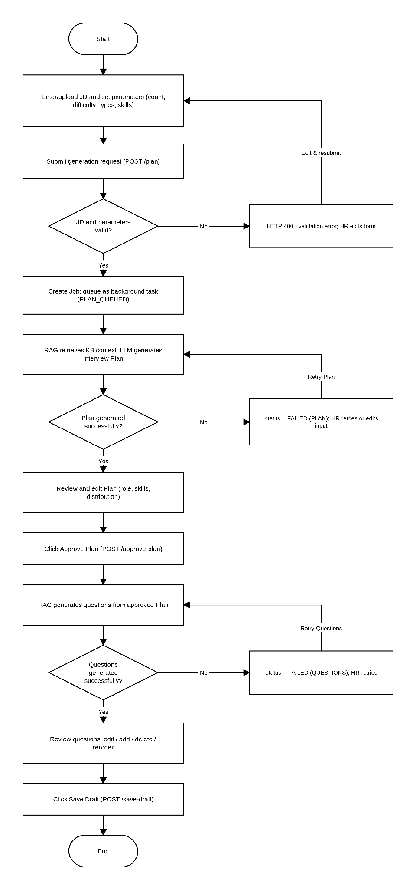

3.4 Workflow 3: HR – Ask AI (Chat-Assisted Question Refinement)
Description: This process lets an HR user fine-tune an individual generated question through a short AI conversation instead of editing it manually. From the Studio question list, the HR user opens a question and types a request in the Ask AI chat panel (for example, asking for a harder variant or a system-design angle). The Backend assembles the relevant context — the original Job Description, the interview plan, the current question, the target skills and difficulty, and the chat history — and forwards it to the RAG Service's question-assist endpoint, which uses the LLM directly without an additional vector search. The RAG Service returns a conversational reply together with a concrete suggested question, rationale, sample answer and difficulty. The HR user can accept the suggestion, which overwrites the question and marks it as manually edited, or continue the conversation to refine it further.
Workflow Diagram:
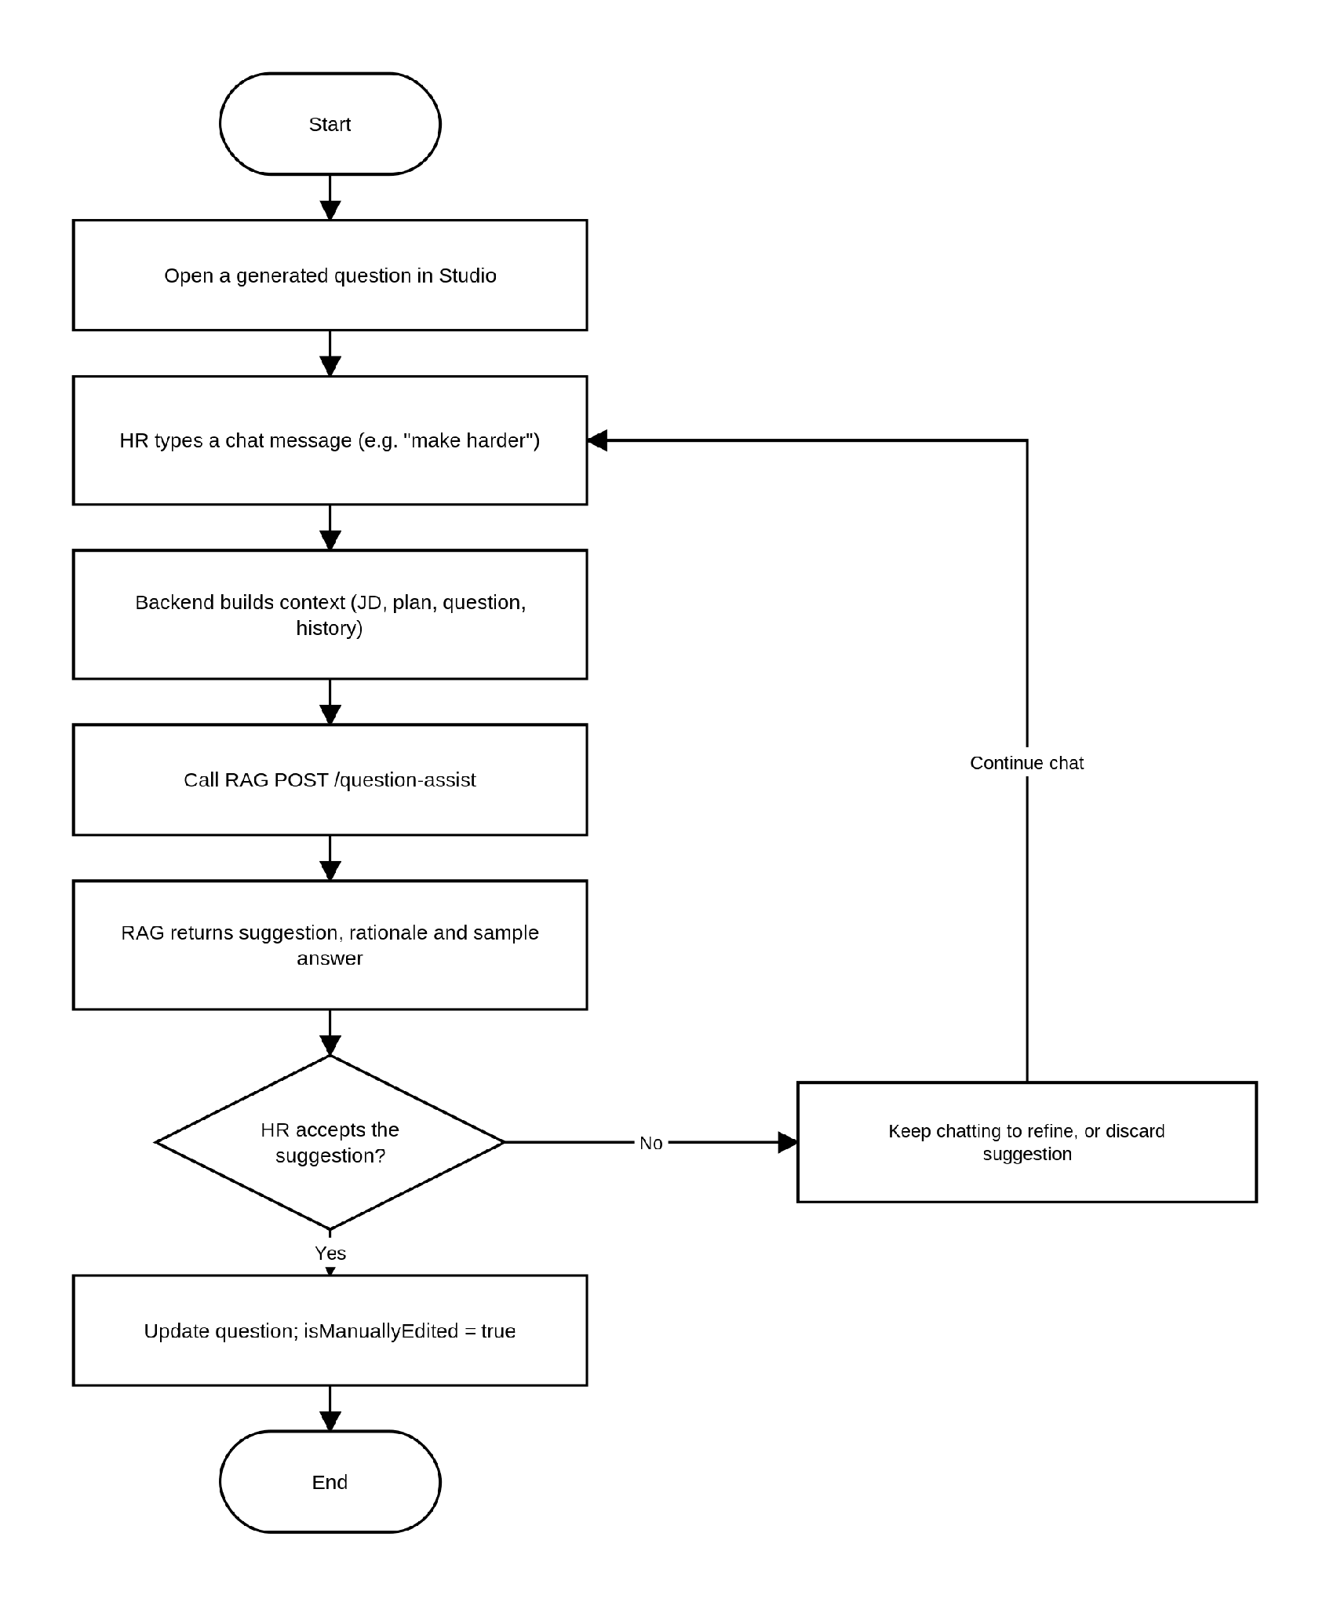

3.5 Workflow 4: HR – Manual Question Builder
Description: This process describes how an HR user creates an interview question set without relying on AI generation, useful for highly specific or proprietary question content. The HR user opens the Question Builder, creates a new Question Set with a title and target role, then adds questions one at a time, specifying content, type, difficulty, target skill, sample answer and evaluation criteria. Optionally, an image hint can be attached to a question, which is uploaded and stored in Azure Blob Storage. The HR user can drag and drop to reorder the question list at any time, and repeats the add-question step until the set is complete, finally publishing or saving the Question Set.
Workflow Diagram:
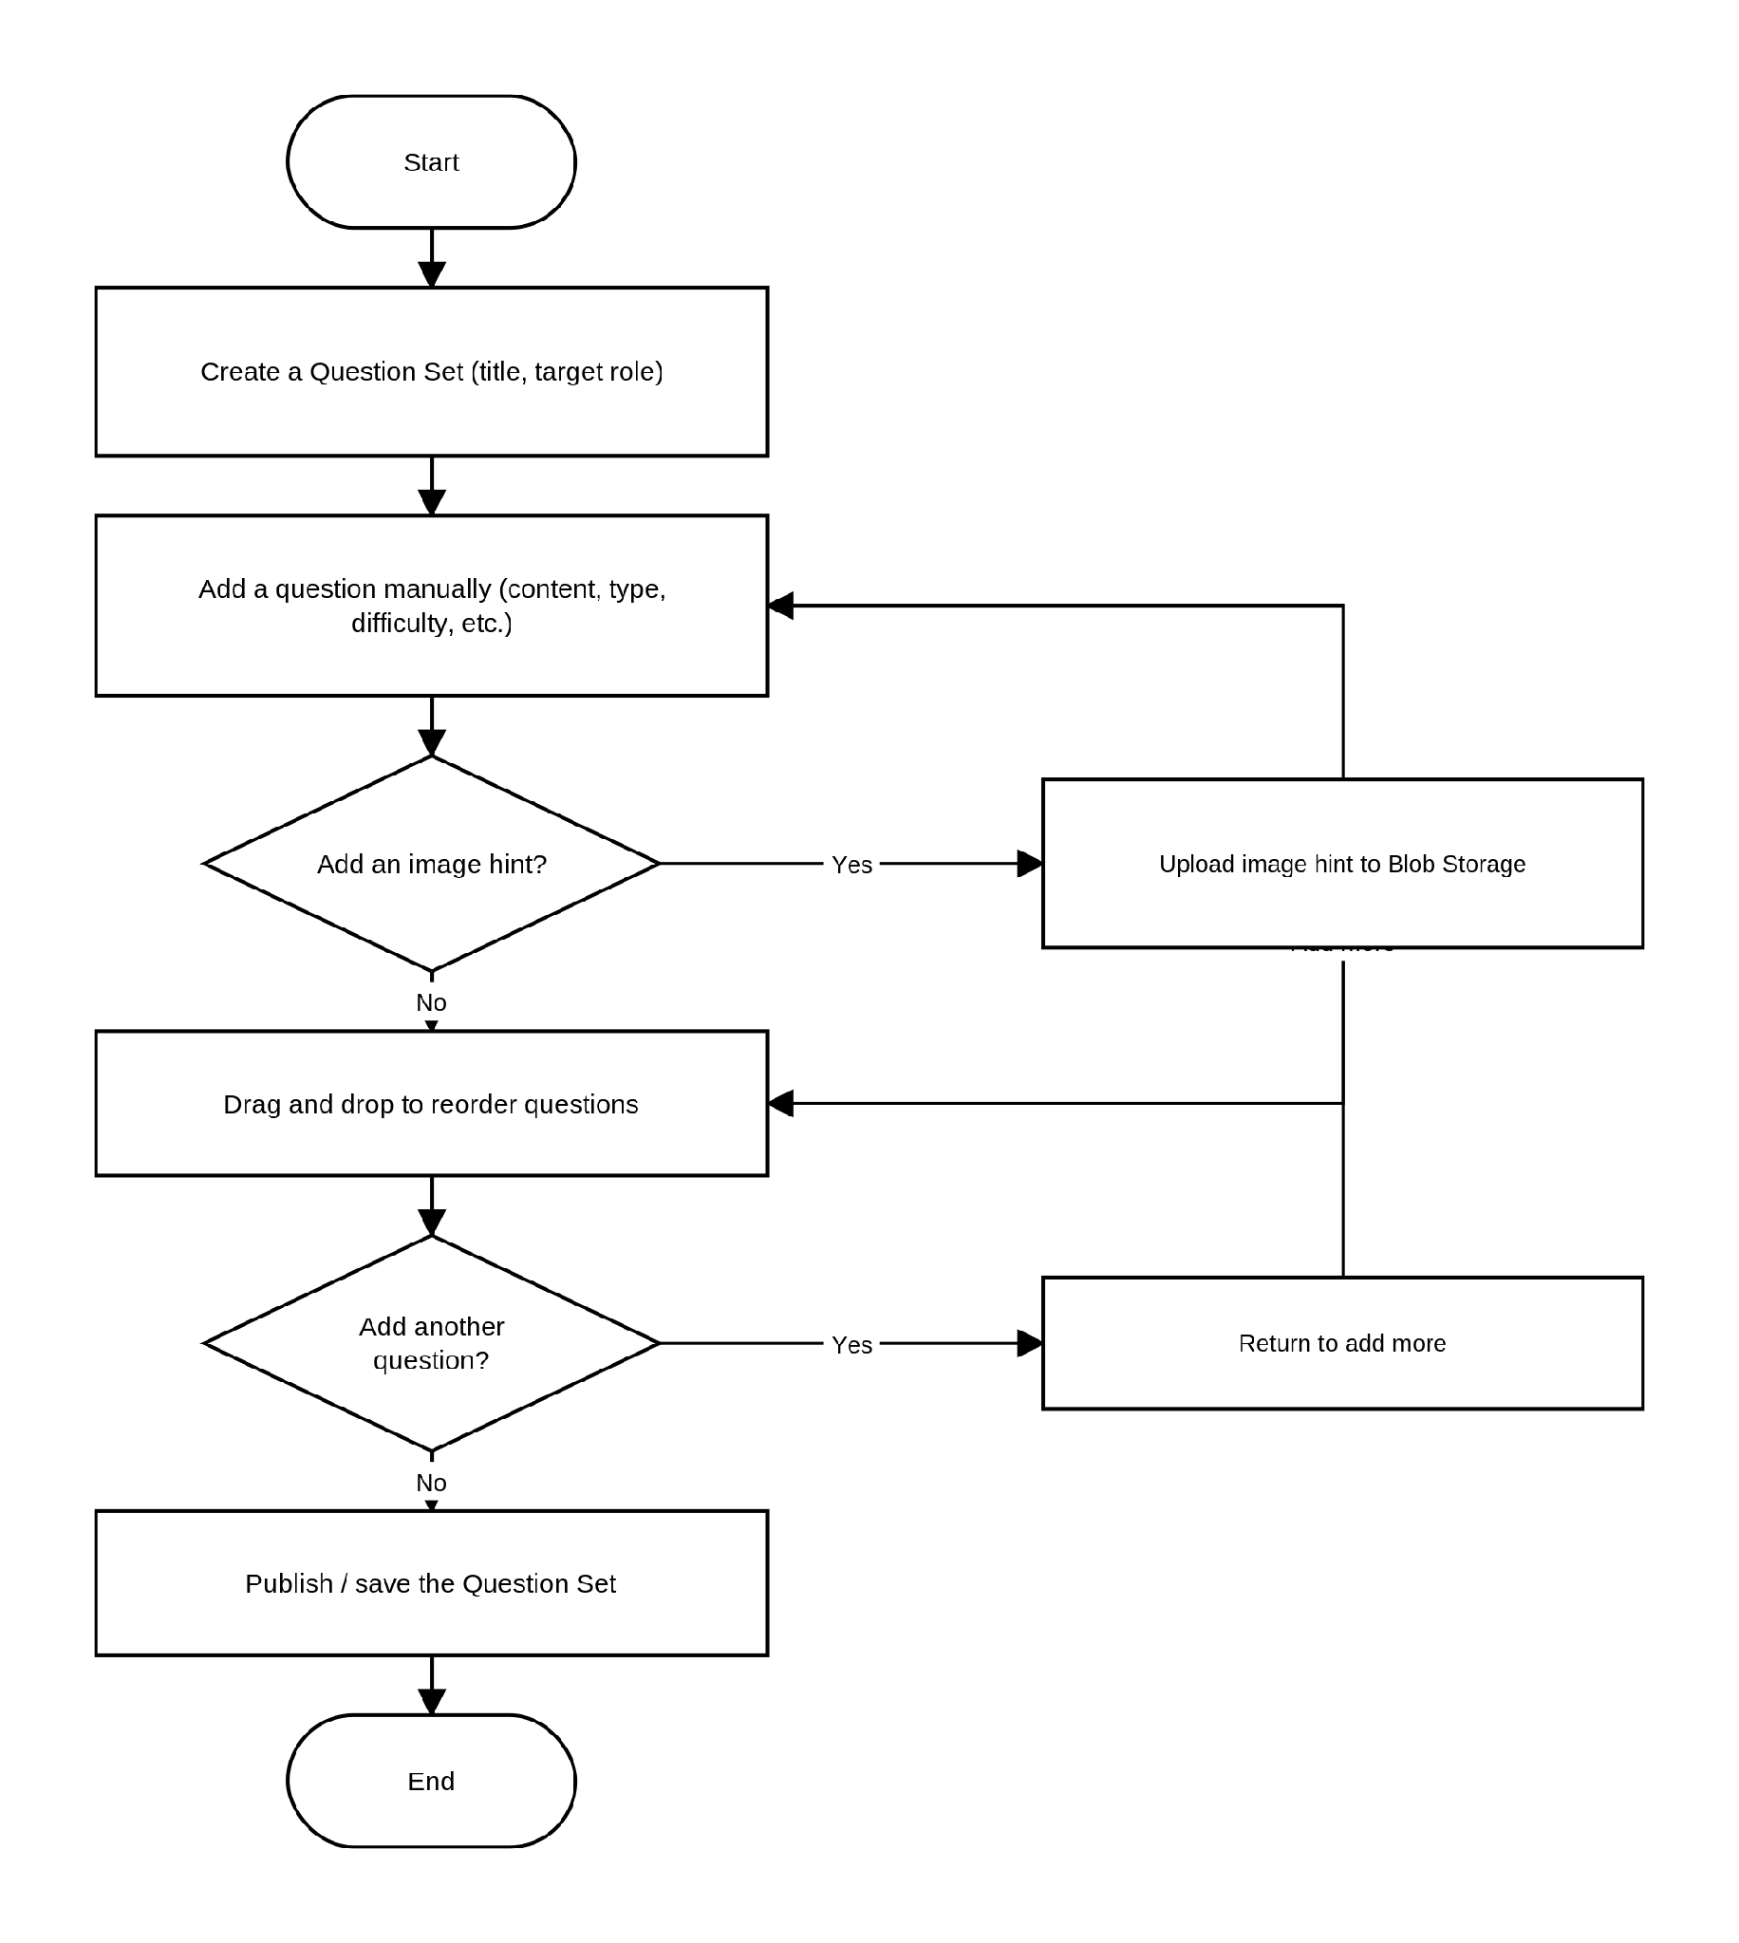

3.6 Workflow 5: HR – Invite Candidate to Practice
Description: This process describes how an HR user proactively invites a specific candidate to practice one of their published question sets, rather than waiting for the candidate to discover it on the marketplace. From a Question Set or a candidate's profile, the HR user clicks Invite Candidate, selects the candidate and the target Question Set, and the Backend creates a CandidateInvitation record and notifies the candidate. The candidate reviews the invitation on their Invitations page and can accept or leave it pending/declined. Once accepted, the candidate starts a Practice Session for the assigned Question Set, and the HR user can later view the candidate's results through the Candidate Overview page once the session is completed.
Workflow Diagram:
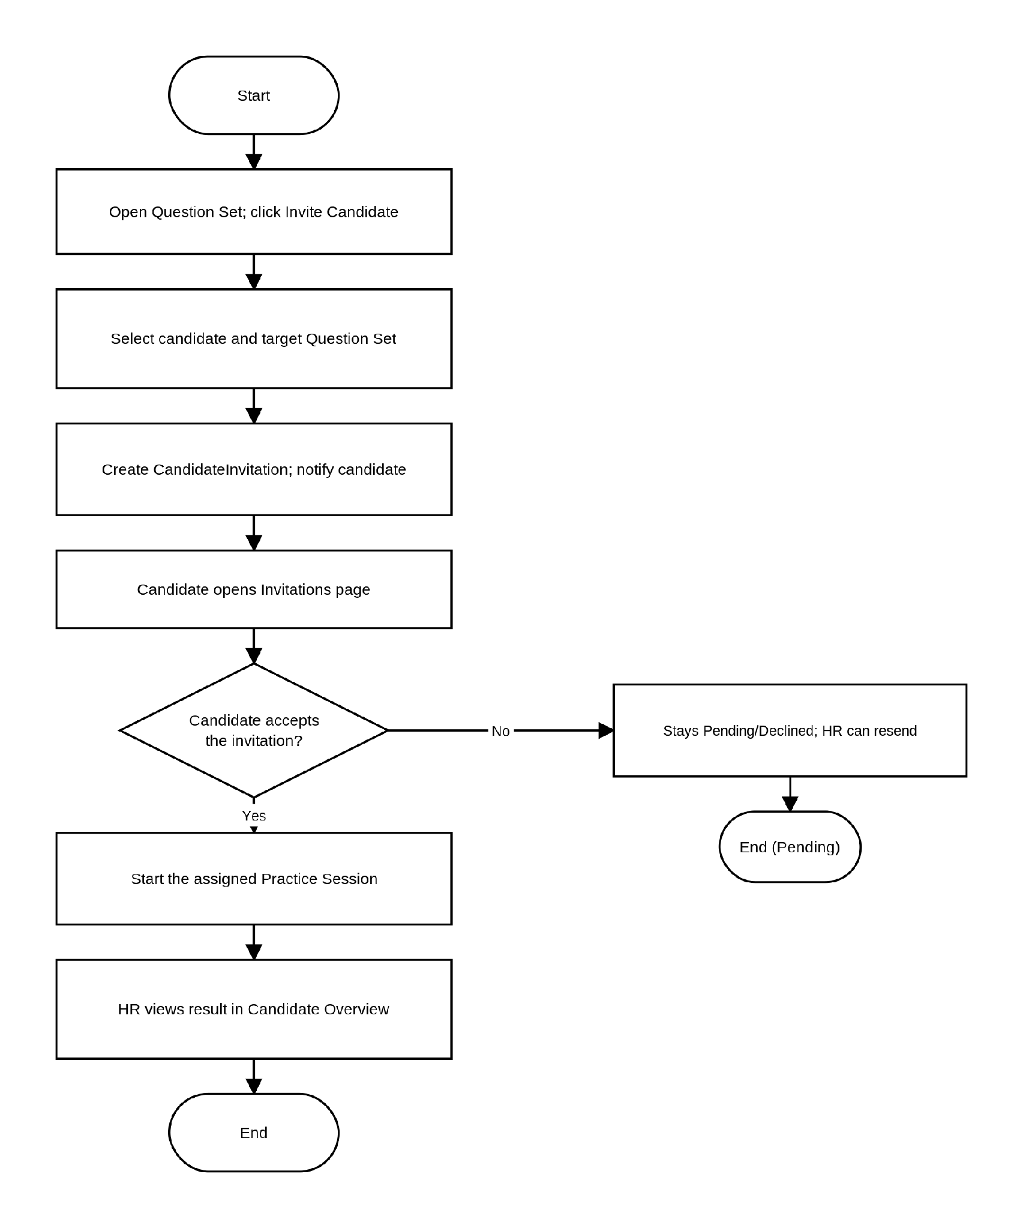

3.7 Workflow 6: HR – Candidate Overview and AI Recommendation
Description: This process describes how an HR user discovers and evaluates candidates who have practiced their question sets. The HR user opens the Candidate Recommendations page, where the Backend computes a list of candidates whose practice activity and skills best match the HR's question sets. Selecting a candidate triggers a consent and eligibility check — the candidate must have allowed recruiter visibility and completed at least one session on one of the HR's own question sets; if not, access is denied. When eligible, the Backend aggregates the candidate's profile, system-wide completed-session statistics, achievement badges, the sets practiced that belong to this HR, and a 52-week practice contribution heatmap, all rendered on a single overview screen so the HR user does not need multiple round-trips. The HR user can bookmark promising candidates for later follow-up.
Workflow Diagram:
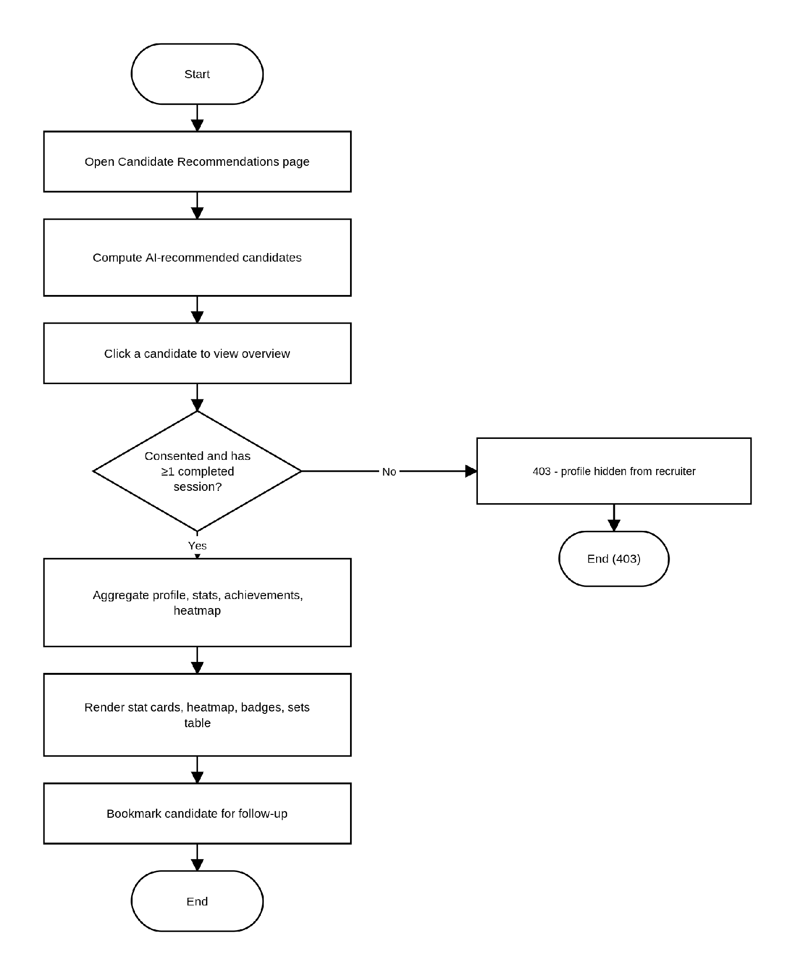

3.8 Workflow 7: Candidate – Upload and AI Parse CV
Description: This process describes how a candidate populates their profile automatically from an existing CV instead of typing everything manually. The candidate uploads a CV file (PDF, DOCX, JPG or PNG, up to 5 MB) from their Profile page; the file is validated client-side first. The Backend forwards the file to the RAG Service's CV-parsing endpoint. For PDF and DOCX files, RAG extracts the raw text and sends it to the LLM's chat-completion endpoint for analysis; for image files, RAG instead encodes the image as base64 and calls Ollama's native vision chat endpoint, since image input is not supported through the OpenAI-compatible interface. Either path returns a structured JSON result containing extracted skills and a short professional summary, which the candidate reviews and confirms on their profile.
Workflow Diagram:
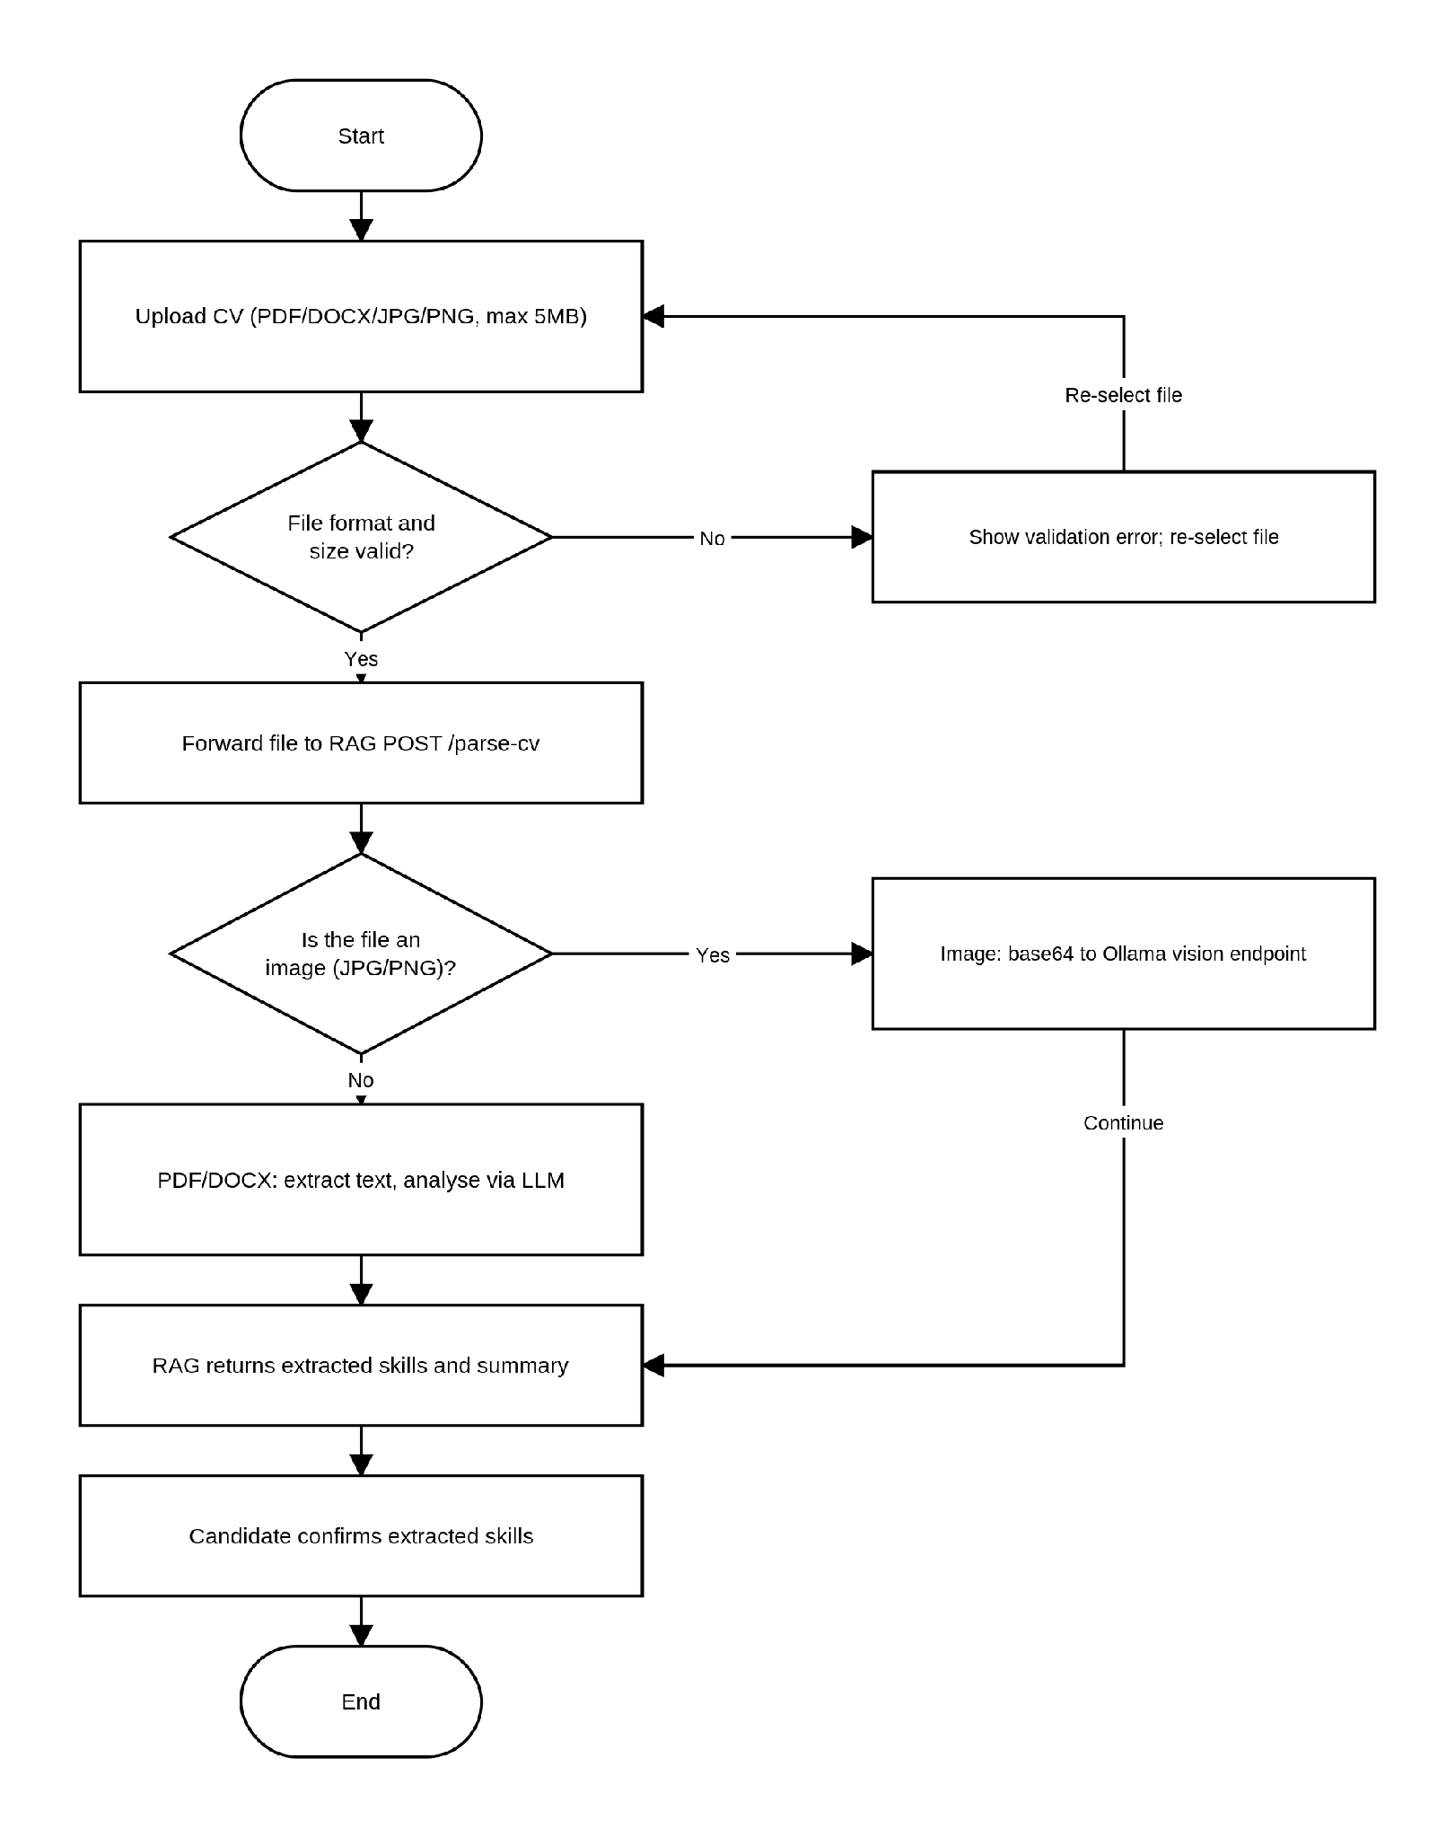

3.9 Workflow 8: Candidate – Browse Marketplace and Start Practice Session
Description: This process describes how a candidate discovers and begins a mock interview. The candidate opens the Practice Marketplace, searches and filters published question sets by role, skill or difficulty, and selects one to start. The Backend creates a Practice Session; Free-tier candidates can see and answer every question in the set. As the candidate answers each question, the answer is saved immediately with evaluationStatus set to Pending — the candidate is never blocked waiting for the AI while taking the test. The session ends either when the candidate clicks Complete or when the configured time limit is reached (an automatic watchdog job submits any session that the candidate leaves unattended), after which the Backend runs the AI batch evaluation described in the next workflow.
Workflow Diagram:
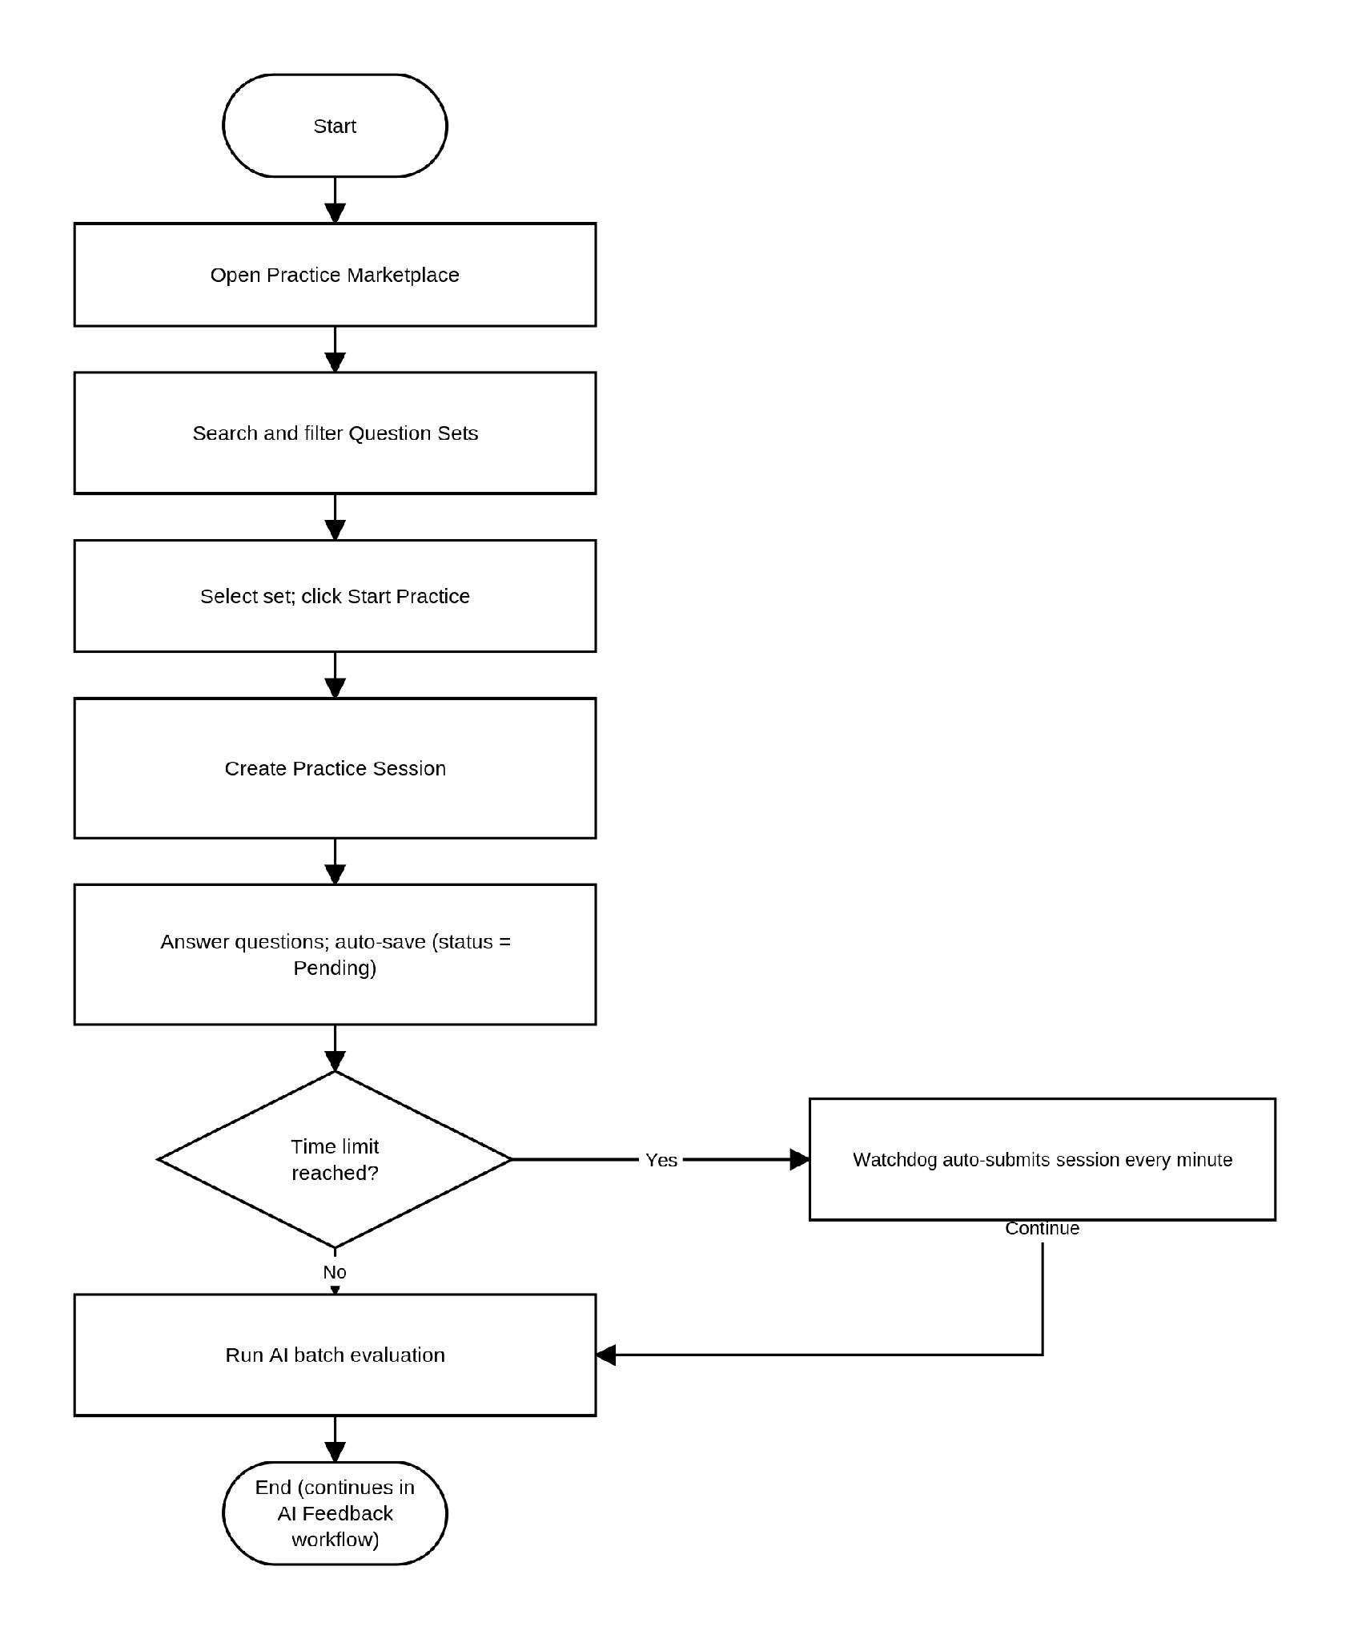

3.10 Workflow 9: Candidate – AI Evaluation and Feedback (Freemium vs Premium)
Description: This process describes how completed practice answers are scored and how the resulting feedback is gated by subscription tier. Once a Practice Session is marked complete, the Backend checks the candidate's subscription. Premium candidates have every answer evaluated by the AI, together with an overall insight and improvement recommendation. Free-tier candidates only have their single longest answer evaluated as a teaser; the overall score is derived from that one question, and the remaining questions stay locked. The resulting feedback is persisted with an access level of either FreeTeaser or Full. When the candidate opens the Feedback page, a FreeTeaser result shows one fully-graded question plus locked placeholders with an upgrade prompt, while a Full result shows AI feedback, a score and rationale for every question along with the overall insight.
Workflow Diagram: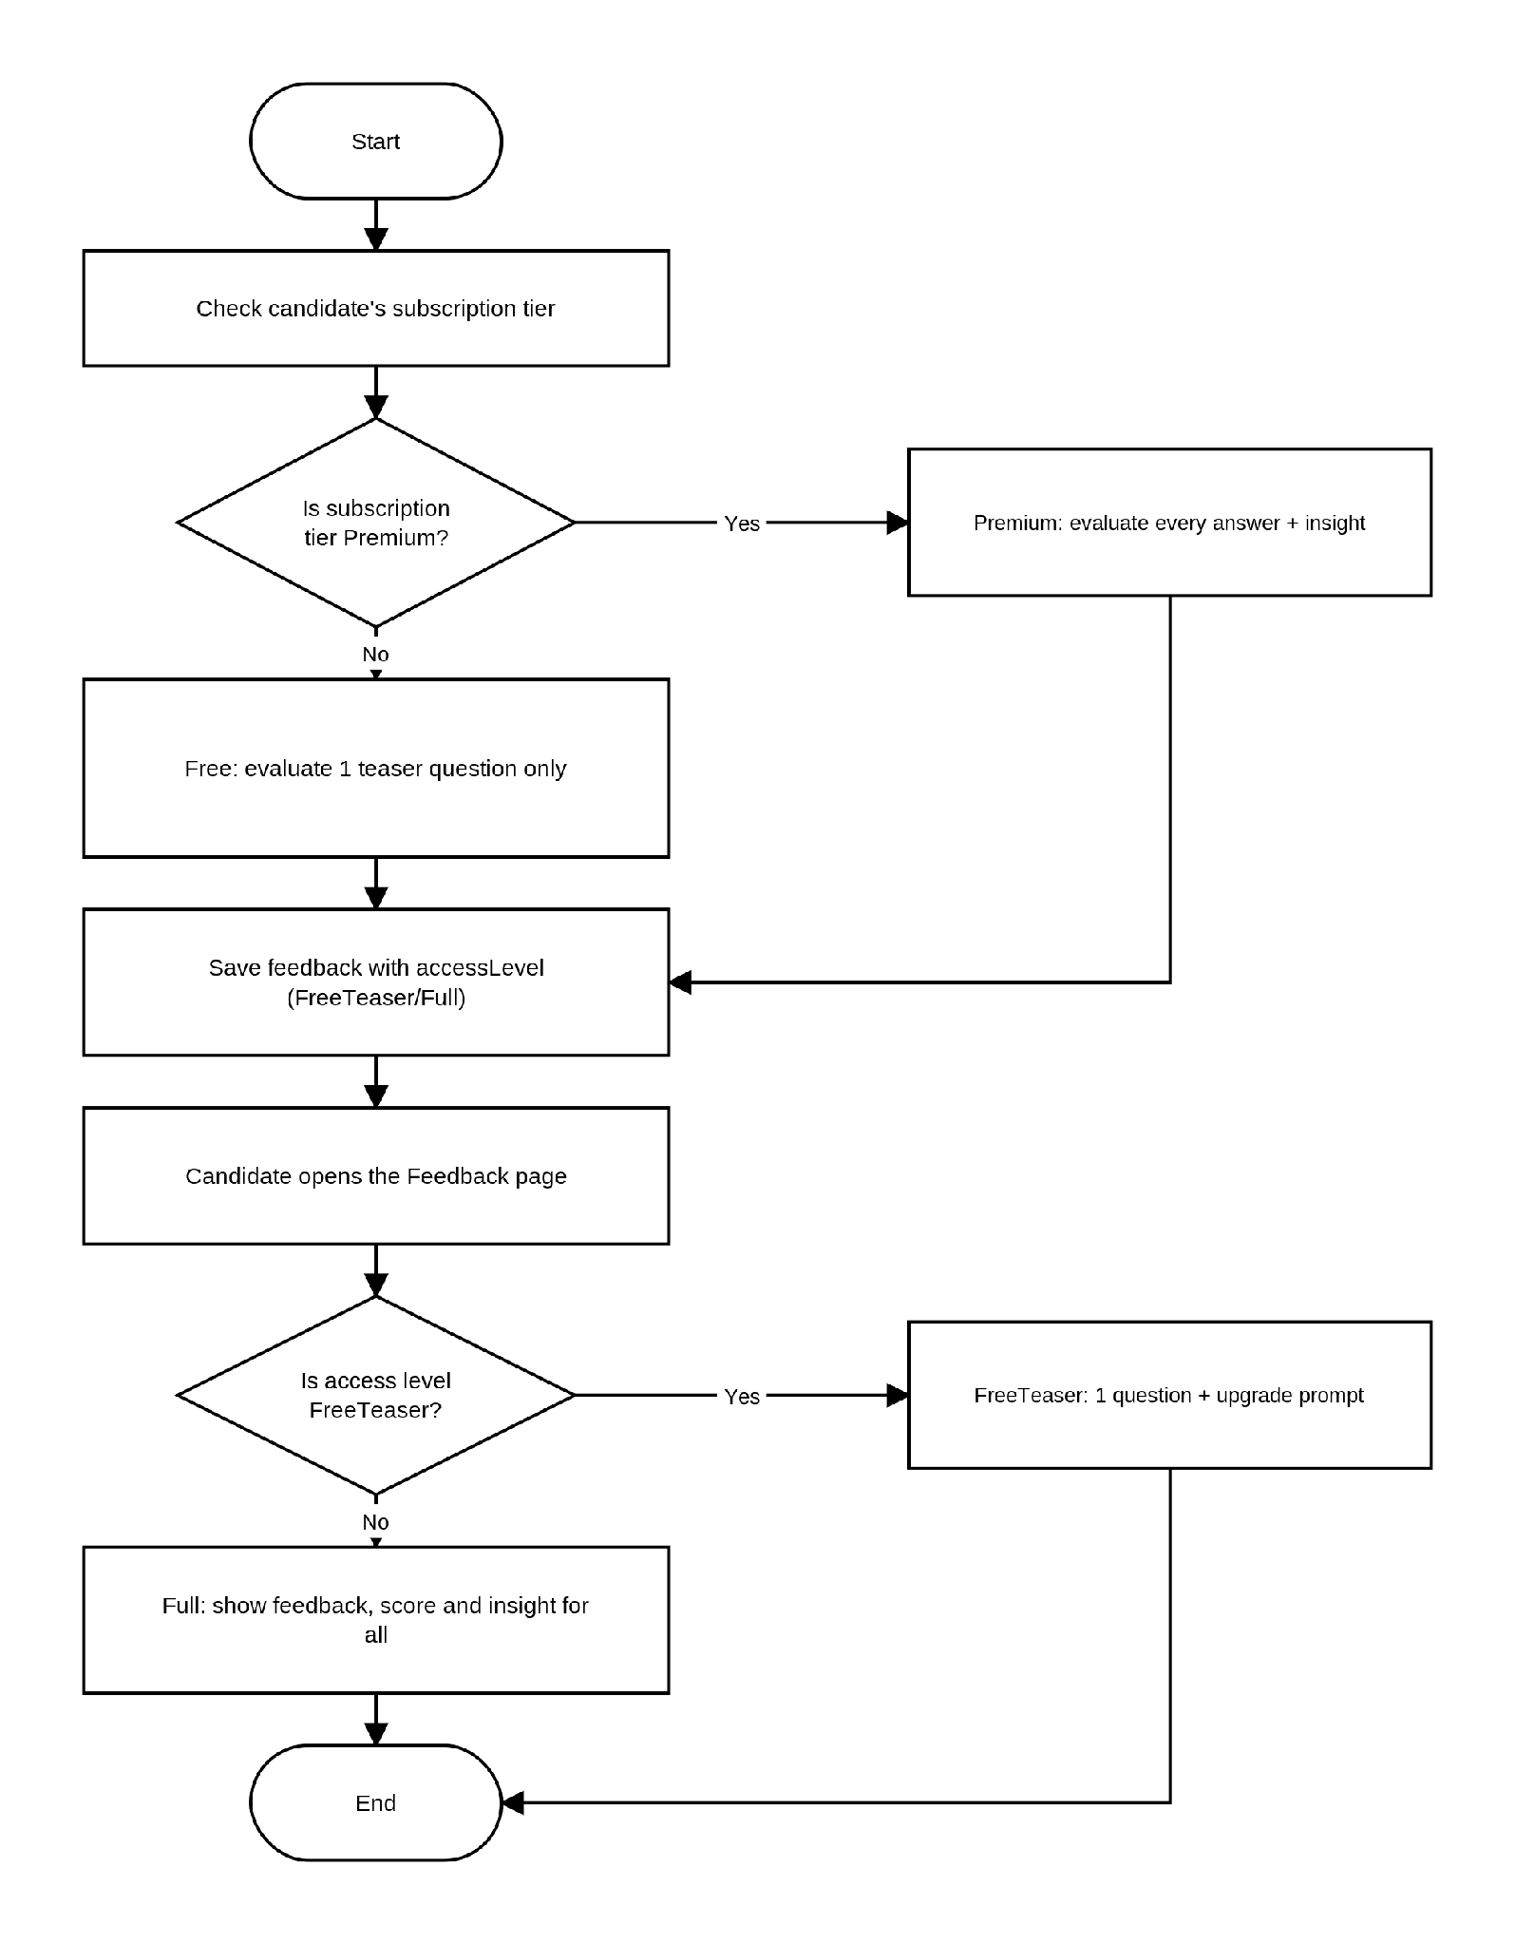

3.11 Workflow 10: Candidate – Dashboard and Practice History
Description: This process describes how a candidate tracks their interview-readiness over time. On the Dashboard, the Backend aggregates a readiness score, a skill radar chart, a KPI grid and a table of the candidate's weakest skills across all completed sessions, along with a 52-week practice contribution heatmap. From Practice History, the candidate can filter past sessions by date or status and open any of them to view the original questions, answers and AI feedback in a read-only view.
Workflow Diagram:
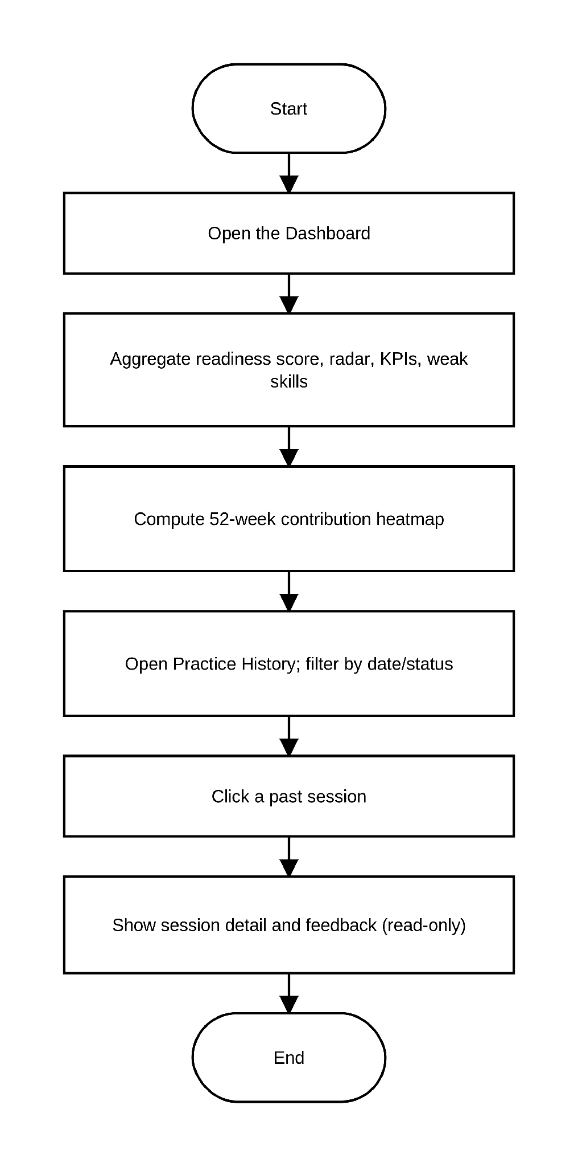

3.12 Workflow 11: Admin – Knowledge Base Oversight and RAG Status Monitoring
Description: This process describes how an administrator supervises the health of the AI pipeline and the shared Knowledge Base. From the Admin Knowledge and RAG Status pages, the Backend lists every knowledge document across both SYSTEM and HR scopes together with its ingest status, and proxies a health check to the RAG Service (database connectivity and configuration validity). If the RAG Service reports unhealthy, the administrator sees an alert and can escalate or restart the service. Documents that remain stuck in PROCESSING beyond a configured threshold are automatically reclaimed and marked FAILED by a recurring watchdog job every 15 minutes, so the administrator does not need to monitor this manually. When a document is no longer needed, the administrator deletes it; the Backend removes the file from Blob Storage and its metadata, then calls the RAG Service to purge the corresponding vector chunks.
Workflow Diagram:
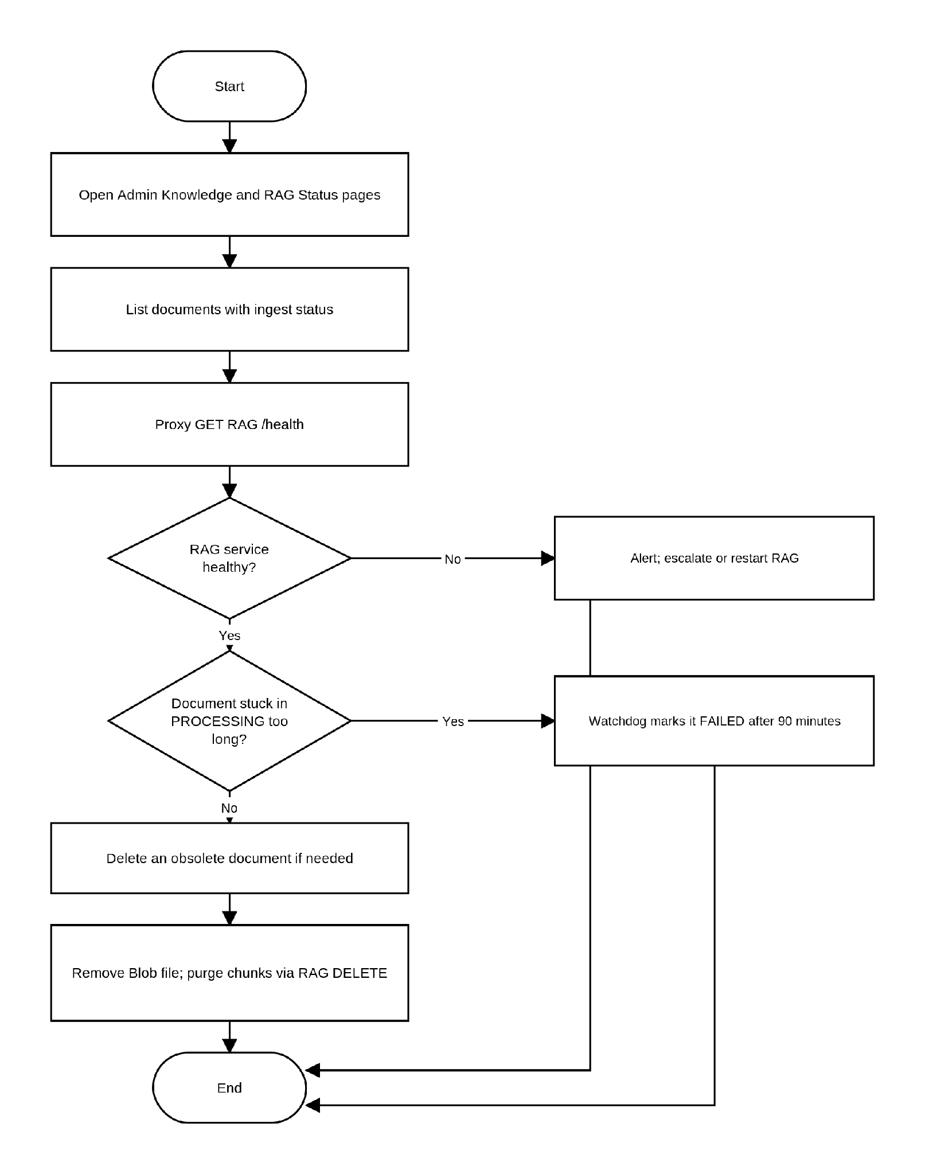

3.13 Workflow 12: Subscription Upgrade and SePay Payment (Realtime Confirmation)
Description: This process describes how an HR or Candidate user upgrades to a paid subscription plan through IQGS's Vietnamese bank-transfer payment integration. The user selects a plan from the Billing/Upgrade page; the Backend creates a pending order through the SePay gateway, returning a VietQR code and a time-to-live for the order, while the frontend simultaneously connects to a per-user SignalR group on the subscription-payments hub. The user scans the QR code and pays via bank transfer; SePay then calls the Backend's webhook endpoint. If the webhook signature is invalid, or the order is no longer pending, the callback is rejected — orders that are never paid are automatically expired by a recurring job every 5 minutes. On a valid, still-pending order, the Backend marks it Paid, activates the subscription, and pushes a PaymentPaid event through SignalR directly to the paying user, who sees the confirmation and gains access to premium features immediately, without needing to poll or refresh the page.
Workflow Diagram:
